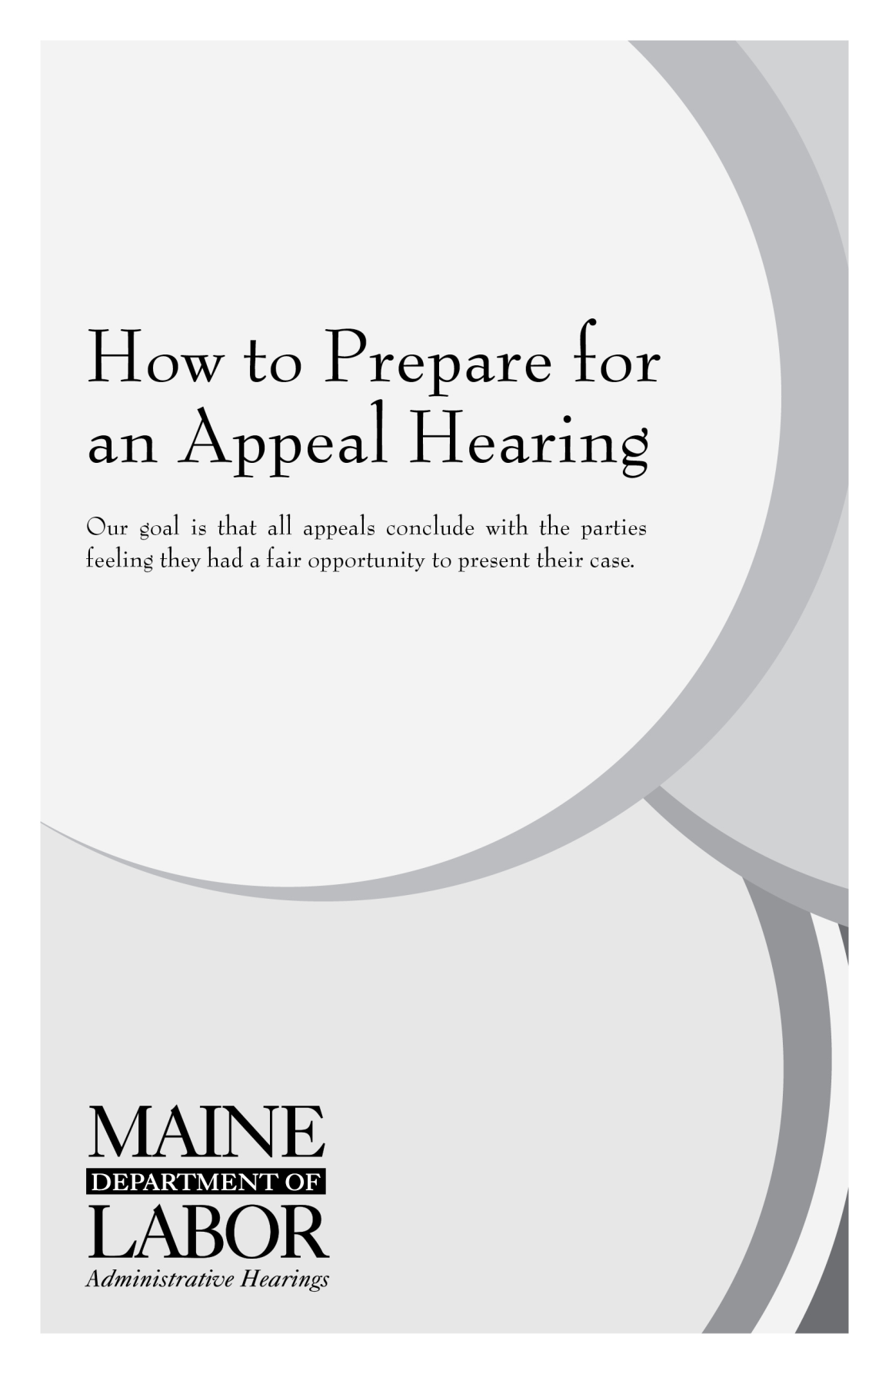

|  |
| --- |
| The Maine Department of Labor is a fragrance free zone. In consideration of chemically sensitive individuals, please refrain from wearing any scent bearing products to your hearing. |

***You have a right to appeal*** under federal and state law if you disagree with an initial unemployment Deputy’s Decision to grant or deny unemployment benefits. This pamphlet will give you basic information regarding your right to appeal and the appeals process. Reading this pamphlet will assist you in preparing for your hearing.

The Structure of a Hearing

An unemployment compensation appeal hearing is conducted by an impartial Administrative Hearing Officer. The purpose of the hearing is to decide whether unemployment benefits should be granted or denied. Anyone with an interest in the outcome of the hearing is a *“party”* to the hearing. Parties to hearings are typically the claimant, the employer, and the Bureau of Unemployment Compensation. It is the Administrative Hearing Officer’s job to see that all parties receive a fair hearing. A fair hearing means an impartial Administrative Hearing Officer will decide your case after considering the testimony of all witnesses and other evidence. The Administrative Hearing Officer will make sure you understand the proceedings and have the time you need to present information relevant to your case. Following the hearing, the Administrative Hearing Officer will issue a written decision, which will affirm, modify, or set aside the Deputy’s Decision.



*Present at an appeal hearing will be an Administrative Hearing Officer (center) and usually the employer and the claimant. All parties will have the opportunity to present their case before the Administrative Hearing Officer in a formal, but relaxed atmosphere.*

Scheduling an Appeal Hearing

Scheduling a Hearing – You Must Attend

After the filing of an appeal, you will receive a **Notice of Hearing** stating when and where the hearing will take place. Your hearing may be held by telephone (see page 8) or in person. Carefully note the **DATE, TIME,** and **LOCATION** of the hearing. With the Notice of Hearing, you will also receive a copy of the Deputy’s Decision and all of the documents in your file.

You must make every effort to attend the hearing. If you have a very serious conflict and cannot attend the hearing, let us know immediately. Only if you have a commitment which is both very important and absolutely cannot be changed should you request a postponement. Generally, hearings will **not** be postponed for personal reasons, vacations, plant shut downs, or business appointments. **Only written confirmation from the Division of Administrative Hearings can postpone a scheduled hearing.**

Preparing for the Hearing

Gather Your Evidence

**This appeal hearing most likely will be your last opportunity to present your case; therefore, you should be prepared to do it thoroughly.**

Unemployment compensation appeal hearings are said to be *“de novo,”* Latin for afresh or anew. This is done to keep your hearing impartial and independent of the Deputy’s Decision to grant or deny benefits. The Administrative Hearing Officer who conducts the hearing is not bound by the Deputy’s Decision and will base their decision only on the evidence and testimony presented at the appeal hearing.

If papers, letters, statements, or other evidence were presented previously to the unemployment insurance deputy, and could be helpful to your case, you must **present this information again** at your appeal hearing.

If there are witnesses with firsthand knowledge of the circumstances surrounding your case, make sure they will attend your hearing to present their information. Written statements of individuals with firsthand knowledge may not be admissible.

Obtaining Testimony and Documents through Subpoena

You may need witnesses to present the facts that are favorable to your case. If you ask someone to appear as a witness and they refuse, you may request that they be subpoenaed. This means they will be required by law to appear. You also have the right to request a subpoena for written documents or other evidence that you cannot obtain on your own. Subpoena requests must be submitted in writing, either by fax, e-mail, or hand-delivered to the Division of Administrative Hearings. Requests must include the names and addresses of witnesses or possessors of necessary documents. Subpoena requests should be received by the Division of Administrative Hearings at least 7 business days prior to the hearing date.

**Important:** Witnesses who are subpoenaed to testify at an administrative hearing cannot be penalized for their testimony. Maine’s ‘Whistleblower Protection Act’ protects them.

The Hearing

Be Prompt

It is important that you are ready and prepared to go forward with your hearing at the scheduled time. If you do not appear for either your in-person or telephone hearing and you are the appealing party, your appeal will be dismissed. If you do not appear and you are the nonappealing party, the hearing will continue without you. **Your failure to appear may result in a denial of all further rights of appeal.**

|  |
| --- |
| ***In consideration of people with chemical sensitivities, we request that you not wear fragrances to an in-person hearing.*** |

The Hearing Procedure

The hearing is like a court trial, but not as formal. The appeal hearing is controlled by the Administrative Hearing Officer. This is done to make sure each person has the same opportunity to present his/her case.

The hearing will begin with the Administrative Hearing Officer making an opening statement about what will happen during the hearing. The Administrative Hearing Officer will answer any questions you might have about the hearing process. The Administrative Hearing Officer will only use information presented at the hearing in reaching his/her decision. All testimony is given under oath or affirmation and the hearing is recorded.

The Administrative Hearing Officer will begin receiving testimony by swearing in the first witness, usually either the claimant or employer. The party carrying the burden of proof usually presents their case first. In a separation case, the burden of proof varies depending on the issue. If the claimant left work voluntarily, it is the claimant’s burden to show that they had “good cause attributable to the employment” for leaving their employment. If the employer dismissed the claimant, it is the employer’s burden to prove that the claimant was discharged due to the claimant’s misconduct connected with the work.

The Administrative Hearing Officer will usually question the witness first and allow them to tell their story. After answering all of the Administrative Hearing Officer’s questions, the witness will then be allowed to give additional relevant information. The party who requested the witness’s testimony will then have the opportunity to ask their own questions. Finally, the opposing party will be given the opportunity to “cross examine,” or question the witness. The next witness is then called and the same procedure is followed.

When one party has finished presenting their case, the opposing party will then be given the opportunity to present his/her case. The Administrative Hearing Officer will close the hearing when neither side has any additional information or evidence to present. Most hearings involving a separation from employment last between 30 and 60 minutes.



*All testimony given at the hearing is taken under oath or affirmation and recorded as part of the record.*

If you need clarification or have questions at any time during the hearing, **ask the Administrative Hearing Officer for assistance.** Finally, it is important to remember that the hearing is held to gather facts, not to get into an argument. Arguing or getting angry during a hearing prevents you from clearly stating the facts of your case.

Evidence Considered

Only evidence presented at the hearing will be considered by the Administrative Hearing Officer; therefore, you should **bring any documents or witnesses that can directly help your case.** Carefully think through your case. Ask yourself what information, documents, or witnesses will help to establish the facts in your favor.

Choose witnesses who have firsthand information: a person who directly saw or heard the event to which they are testifying. Someone who testifies about what someone else said, saw or heard has limited knowledge of the event in issue. A witness with firsthand information is generally considered more reliable than a witness who was not actually present at the time of the event.

Attorney Representation

You have the right to hire an attorney or another person who you authorize to represent you at your hearing. However, you are not required to have an attorney or other representative at the appeal. The Administrative Hearing Officer will make sure all parties are given an opportunity to present their case. It is the Administrative Hearing Officer’s job to make sure each party receives a fair and unbiased hearing, whether or not he/she chooses to have representation.

If you do have legal representation, contact your attorney immediately to allow them ample time to prepare for the hearing. It is your responsibility to notify them of the time and place of the hearing and to pay any fees charged for such representation.

**If you cannot afford to hire an attorney**, there are agencies that may be able to help you. Visit the website at [www.mainecareercenter.com/legal](http://www.mainecareercenter.com/legal) for a listing of agencies that you can contact.

Accommodations

Please notify us in advance if you need services that will assist you in presenting the facts at your hearing. These may include, but are not limited to, accommodations for people with disabilities, foreign language interpreters for people whose first language is not English, or sign language interpreters for people who are deaf or hard of hearing. We will make the necessary arrangements for your hearing.

Telephone Hearings

Telephone hearings allow you to participate in a hearing without the expense, time or possible hazard of traveling to a central hearing site.

Telephone hearings are scheduled by the Division of Administrative Hearings, based on many considerations, including, the number of witnesses and documents, the length of the hearing, the distance to a central hearing site, and the safety of the participants.

In a telephone hearing, your testimony and that of your witness is taken, under oath or affirmation, by telephone. All interested parties will be present at the telephone hearing, similar to a conference call. The Administrative Hearing Officer conducts the hearing in the same manner as an in-person hearing, using the same question and answer format. You will have the same opportunity to present your case and question the other people involved. If your hearing is to take place by telephone, it will be clearly marked as a **Telephone Hearing** on the official **Notice of Hearing.**

Your focused attention is just as important in a telephone hearing as in an in-person hearing. Please make appropriate arrangements so that you will not be dividing your attention between the hearing and, for example, caring for children, driving, or performing other tasks.

If you have a witness, it is recommended that a second telephone extension be available for you to hear the testimony given by your witness. An open line must be dedicated for the telephone hearing. Please provide the witness’ name and telephone number to the Division of Administrative Hearings prior to the hearing date. The Administrative Hearing Officer will conference call your witness when it is time for the witness to testify.

The Administrative Hearing Officer will call you at the number listed for you on the **Notice of Hearing. If this number is not correct, or if no number is listed, you must call the Division of Administrative Hearings at least one working day before your scheduled hearing time with the number where you can be reached.**

The Administrative Hearing Officer will call you at or near the time stated on the **Notice of Hearing.** Be near your telephone 15 minutes before your scheduled hearing time in order to avoid delay. However, you should also **be prepared for a delay** in the start of your telephone hearing.

**Important:** If your hearing will be by telephone, any documents or other similar types of evidence you would like to present should be sent to the Division of Administrative Hearings in time for the Division to distribute the documents to the opposing party before the hearing.

***Cell Phone Use***

You may use your cell phone for your telephone appeal hearing. **However, in the event that the reception is distorted or dropped, for whatever reason, the Administrative Hearing Officer will attempt one time to call you back.** If the Administrative Hearing Officer is unable to reach you on the call back or the reception is distorted or dropped a second time, the Administrative Hearing Officer will rule on the case in your absence.

After the Hearing

You will receive the Administrative Hearing Officer’s written decision, by mail, **after** the hearing. This decision will either affirm, modify, or set aside the Deputy’s Decision. The claimant should continue to file their weekly claims while awaiting the decision in their case.

If you do not agree with the Administrative Hearing Officer’s decision, you can appeal that decision to the Unemployment Insurance Commission. The appeal must be filed within 15 days by writing to:

**Unemployment Insurance Commission**

**57 State House Station**

**Augusta, ME 04333-0057**

**Tel: (207) 623-6786**

**Fax: (207) 287-4554**

The Commission does not hold hearings except on rare occasion. The Commission may affirm or set aside the decision of the hearing officer based on the evidence presented at the hearing before the hearing officer. The Commission also has the authority to remand the case to the hearing officer to take additional evidence and then return the case to the Commission for decision.

Questions regarding how the Division’s decision will affect your benefits can be directed to the Benefits Division at 1-800-593-7660.

Review Tips

⚫ Prepare yourself for the appeal hearing.

⚫ Think about your case and ask yourself what information, documents, or witnesses will help establish your case.

⚫ Choose witnesses who have direct, personal knowledge of events about your case.

⚫ Stick to the facts.

⚫ Make a list of the important points you would like to present at the hearing.

⚫ Make another list of the points you think the opposing party may make. Consider what you will say or ask in response.

⚫ When submitting documents, remember to retain copies for your records. Documents submitted to the Administrative Hearing Officer become part of the permanent record and cannot be returned at the hearing. Copies submitted must be clear and legible.

* If you need a subpoena, an interpreter, or have other special needs, write or call the Division of Administrative Hearings at (207) 621-5001.
* If you have questions about this booklet, call the Division of Administrative Hearings.

For More Information, Write or Call:

# For more information, write or call:

Maine Department of Labor

Bureau of Unemployment Compensation

**Division of Administrative Hearings**

30 State House Station

Augusta, ME 04333-0030

Tel: (207) 621-5001

Fax: (207) 287-5949

TTY Users Call Maine Relay 711

Website: [www.Maine.gov/labor/appeals/](http://www.Maine.gov/labor/appeals/)

E-mail: [Admin.Hearings@Maine.gov](mailto:Admin.Hearings@Maine.gov)



The Maine Department of Labor provides equal opportunity in employment and programs. Auxiliary aids and services are available, upon request, to individuals with disabilities.

Me. A-12 (rev. 12/2014)