STATE OF MAINE
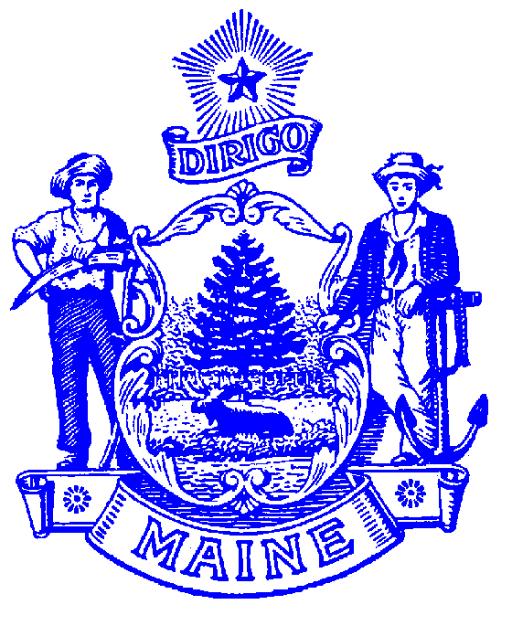
DEPARTMENT OF LABOR

Jeanne S. Paquette
COMMISSIONER

BUREAU OF EMPLOYMENT SERVICES
55 STATE HOUSE STATION
AUGUSTA, MAINE 04333-0055
Paul R. LePage
GOVERNOR

MAINE WORKFORCE DEVELOPMENT SYSTEM
Subject of Policy: | Common Identifier for One-Stop System | Policy No. | PY16-06
To: | - Local WDBs  - Chief Elected Officials  - One-Stop Operators  - WIOA Service Providers and Partners | From: | Edward D. Upham, Director  Bureau Employment Services
Issuance Date: | - November 17, 2016 | Status: | ACTIVE
Reference: | - WIOA §121(e)(4)  - 20 CFR 678.900  - 34 CFR 361.900 and 463.900  - TEGL 36-11

Purpose: This policy explains requirements pertaining to the use of the American Job Center (AJC) tagline “A proud partner of the American Job Center network.”

Background: WIOA §121 (e) (4) and 20 CFR 678.900 require partners of the one-stop delivery system to utilize a common identifier, Maine requires that one-stop partners utilize the tag-line identified in bold above. Having a common identifier provides continuity across Maine’s workforce systems and enables businesses and individuals to easily identify and connect with workforce resources and the various agencies and professionals that provide workforce services and make up the one-stop system. A common identifier will reassure individuals and businesses that they will receive the same, high-quality services from any comprehensive or satellite one-stop location.

Requirement: All one-stop partners must adopt and prominently display the common identifier “A proud partner of the American Job Center network” in accordance with the terms of use for the American Job Center Logo Trademark established by the U.S. Department of Labor Employment and Training Administration and the U.S. Department of Education. The terms of use of the trademark logo can be found at https://www.dol.gov/ajc/ which clarifies the terms and establishes permissions for usage.

By or before November 17, 2016 all primary electronic resources used by the one-stop delivery system must contain the tagline, this includes websites and desktop logos, and any informational materials purchased or printed after this date must also contain the tagline. Existing printed materials may continue to be used until they are depleted.

By or before July 1, 2017, every existing one-stop center or satellite must clearly and prominently display a sticker or poster containing the tagline. Existing signage may continue to be used as long as a sticker or poster containing the tagline is clearly and prominently displayed in entryways and windows of the one-stop center or satellite center in a way that it can be easily viewed from the building exterior. Any new signage created going forward must include the tagline.

One-stop partners may use additional identifiers on their products, programs, activities, services, facilities and related property or materials. An outreach toolkit created by the U.S. Department of Labor provides logo templates that can be downloaded for use in electronic and/or printed materials at https://www.dol.gov/ajc/

Refer to TEGL 36-11 for more information at: https://wdr.doleta.gov/directives/corr_doc.cfm?DOCN=7695

Contact:

Ginny Carroll, Division Director
Bureau of Employment Services
Maine Department of Labor
55 SHS, Augusta ME 04333-0055
Virginia.A.Carroll@maine.gov
Phone: 207-623-7974
TTY: Maine Relay 711

