STATE OF MAINE
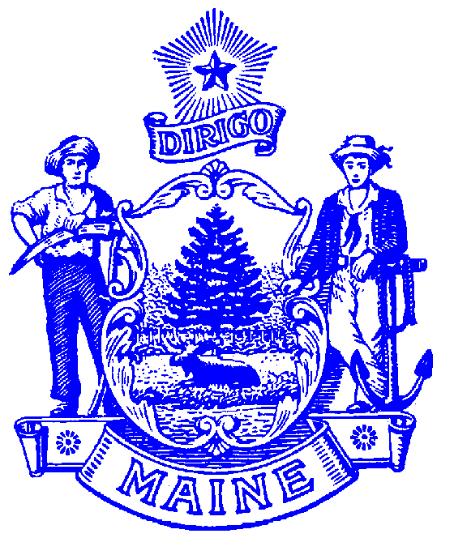
DEPARTMENT OF LABOR

Jeanne S. Paquette
COMMISSIONER

BUREAU OF EMPLOYMENT SERVICES
55 STATE HOUSE STATION
AUGUSTA, MAINE 04333-0055
Paul R. LePage
GOVERNOR

MAINE WORKFORCE DEVELOPMENT SYSTEM
Subject of Policy: | Youth Requires Additional Assistance | Policy No. | PY16-05
To: | - Local WDBs  - Chief Elected Officials  - WIOA Service Providers | From: | Edward D. Upham, Director  Bureau Employment Services
Issuance Date: | - October 25, 2016 | Status: | ACTIVE
Reference: | - WIOA §129(a)(1)(B) (iii)(VIII); 129(a)(1)(C)(iii)(VII); and 129(a)(3)(B)  - 20 CFR 681.210(c)(8); 681.300; and 681.310 | Rescinds: | PY13-10

Purpose: To provide guidance to Local Boards regarding youth eligibility under the Youth barrier for a “Low-income individual who requires additional assistance to enter or complete an educational program or to secure or hold employment.” §681.210(c)(8)

Background: Under the Workforce Investment Act (WIA) local boards implemented policy defining additional barriers for “youth who requires additional assistance,” for youth eligibility purposes. Local Board policy identified significant barriers to youth employment that were prevalent in the local and identified the documents required to validate the specific youth barrier(s) defined.

The Workforce Innovation and Opportunity Act (WIOA), identifies multiple youth barriers for eligibility purposes for both In-school (ISY) and Out-of-School (OSY) Youth. WIOA requires the State or Local Boards to establish definitions for additional youth barriers pertaining to youth most-in-need and places a limitation on the percent of In-School-Youth eligibility using the locally-defined barrier not to exceed five percent (5%) of all ISY enrollments.
For In-School-Youth the barrier must pertain to low-income students who require additional assistance to complete an educational program. §681.310

For Out-of-School-Youth the barrier must pertain to low-income youth who require additional assistance to enter or complete an educational program, or to secure and hold employment. §681.300

To accommodate WIOA changes Local Boards must:
- Rescind and/or revise the old policy to create a new policy for “Low-Income Youth requires additional assistance…” ensuring that the local definition does not duplicate any youth barriers already identified under WIOA and that it identifies barriers faced by youth in the local area;
- Title the policy “Local Definition of Youth Requires Additional Assistance” and not the “sixth barrier” as it is no longer the sixth barrier;
- Clearly define the specific barrier(s) and list the documentation to be used to validate the barrier;
- Clearly articulate that the local barrier can only be used as an eligibility barrier for up to 5% of all In-School Youth (ISY);
- Establish a method for tracking ISY enrollments under this barrier to ensure that the 5% limitation is not exceeded;
- Provide a copy of the new policy to the Maine Department of Labor Bureau once it has been reviewed and approved by the Local Board; and
- Provide evidence that local area Youth Service Provider staff have been made aware of the new/revised policy, that they understand the limitation on its use for eligibility for In-School-Youth, and they are able to implement it accordingly.

Contact:

Ginny Carroll, Division Director
Bureau of Employment Services
Maine Department of Labor
55 SHS, Augusta ME 04333-0055
Virginia.A.Carroll@maine.gov
207-623-7974

