STATE WORKFORCE DEVELOPMENT BOARD
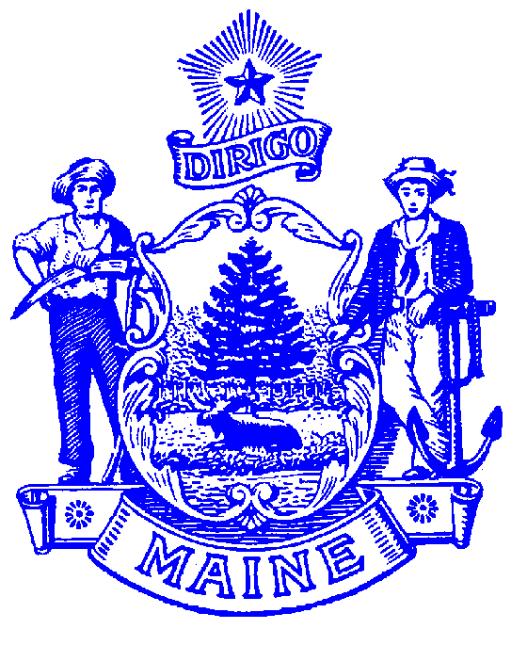
120 STATE HOUSE STATION

Garret J. Oswald
DIRECTOR

AUGUSTA, MAINE 04333-0120
www.maine.gov/swb/
Paul R. LePage
GOVERNOR

MAINE WORKFORCE DEVELOPMENT SYSTEM
Policy Subject | Youth Service Provider Criteria | Policy No: | PY16-03
To: | - State WDB  - Local WDBs  - Chief Elected Officials  - Youth Committees | From: | Garret J. Oswald, Director  State Workforce Board
Issued On: | - September 30, 2016 | Status | ACTIVE
Authority: | - WIOA §129  - 20 CFR 681.400-510

Purpose: To provide guidance to local areas and local youth committees regarding criteria that must be considered in the procurement of youth service providers for WIOA Title I youth services.

Background: In addition to the requirements delineated under WIOA Section 129 and Final Regulations 20 CFR 681.400-510, the State Workforce Development Board has identified the following criteria that must be considered in the procurement of Title I youth services:

- For the purpose of identifying appropriate youth service elements and career pathways for each youth participant, the youth provider must be able to conduct an objective assessment of each youth that includes an evaluation of:
- Academic and literacy levels, including English language proficiency;
- Pre-employment competencies and employability skills;
- Prior work experience and transferrable skills;
- Occupational skills, aptitudes (including occupational interests, work preferences, and aptitude for and interest in non-traditional occupations);
- Developmental needs;
- Supportive services necessary to successfully participate in all aspects of the youth program;
- Barriers to transition to employment or post-secondary education.
- Need for each of the fourteen youth service elements;
- Need for comprehensive counseling and coordinated referrals to programs and services such as:
  - Mental health services
  - Substance abuse counseling
  - Temporary Assistance for Needy Families (TANF)
  - Supplemental Nutrition Assistance Program (SNAP)
  - Housing and homeless assistance programs
  - Programs that address juvenile recidivism
  - Programs providing assistance to individuals with disabilities
  - Parenting and childcare programs
  - Programs that provide guidance to youth whose parent/guardian is incarcerated or affected by addiction or mental illness.

- Must show evidence of ability to provide services that are age-, needs-, and ability-appropriate, including provision of suitable accommodations for individuals with disabilities.

- In partnership with the youth participant, development of youth employment plans articulate goals, benchmarks, activities, and service elements that will launch the youth on a defined career pathway and that will result in the youth meeting or exceeding locally negotiated performance measures. Such plans must include identification of short and long term goals, including goals for measurable skill gains, credential attainment, employment, and/or transition to post-secondary training or education.

- Document active involvement of family members, community service members, and others who play a critical in the youths’ success, as part of program service design.

- Demonstrate how opportunities for youth to practice leadership and citizenship skills, including providing peer mentoring, project leadership, and community service activities are provided.

- Demonstrate strong business/employer involvement including specific examples of long-term relationships with employers who provide:
  - Work experience opportunities that include regular assessment of work readiness and employment competency skills;
  - Opportunities for job shadowing or informational interviewing;
  - Occupationally specific internships or On-the-Job Training opportunities;
  - Practice employment interviews that result in constructive feedback for youth;
  - Adult mentoring;
  - Actual employment opportunities;
  - Apprenticeship and pre-apprenticeship opportunities;
  - Participation in youth career exploration events and job fairs;
  - Participation in youth committees and other youth advisory boards.

- Demonstrate an atmosphere of inclusion, appreciation of diversity, and commitment to youth advocacy through examples and anecdotal evidence of such.

- Demonstrate significant relationships with, and ability to package the services of, a variety of community organizations that serve at-risk youth through formal memoranda of understanding, contracts or other formal agreements that provide evidence of such relationships, including relationships with Adult Education, Vocational Rehabilitation, the juvenile justice system, DHHS, post-secondary education providers, financial aid providers, employer organizations, and others.

- Demonstrate the ability to offer work-based learning experiences that stress the connection between academic knowledge and work activities, through provision of examples of work-site agreements.

- Provide evidence accessible facilities, programs, technology, and ability to provide appropriate accommodations for youth with special needs.

- Demonstrate ways in which the youth program establishes high expectations for youth participants, including evidence showing the majority of youth participants who enter the program - participate in and complete the activities identified on the youth employment plan, and showing the program meets identified performance measures.

- Documentation of ability to connect youth participants with all fourteen required youth service elements, either through direct provision or through partnerships, MOUs, or other methods, to include provision of:
  - Tutoring and/or Study Skills;
  - Access to drop out recovery programs or alternative education;
  - Work-based learning;
  - Occupational Skills Training;
  - Education offered concurrently with and in the same context as occupational training;
  - Leadership development;
  - Adult Mentoring;
  - Support Services;
  - Follow-up Services;
  - Comprehensive guidance and counseling;
  - Financial Literacy;
  - Entrepreneurial Skills/ Training;
  - Career guidance and counseling, including provision of local and state labor market information and information about how to prepare to enter occupations that are in demand in the local area and in Maine; and
  - Activities that prepare youth for entry into post-secondary education.

- Evidence of employment of professional staff, including requisite credentials and experience and demonstration of a commitment to staff development that prepares staff to deliver the services identified above.

Contact:
Garret Oswald, SWB Director
120 State House Station
Augusta, Maine 04333-0120
Garret.J.Oswald@maine.gov
207-621-5087

