STATE WORKFORCE DEVELOPMENT BOARD
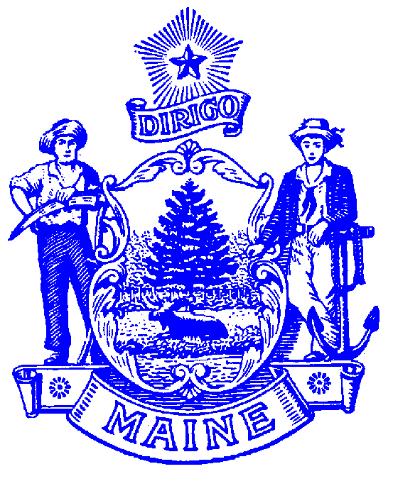
120 STATE HOUSE STATION

Garret J. Oswald
DIRECTOR

AUGUSTA, MAINE 04333-0120
SWIB.DOL@MAINE.GOV
Paul R. LePage
GOVERNOR

Policy Subject | Local Board Certification | Policy No: | PY15-22
To: | - Local Workforce Development Boards  - Chief Elected Officials | From: | Garret Oswald, Director  State Workforce Development Board
Issued On: | - April 01, 2016 | Status | ACTIVE
Authority: | - WIOA Sections: 107 (b)(1); 107 (c)(2); 107(c)(3); 107(d) and 116(g)(2)  - NPRM 20 CFR 679.300-350 proposed

Purpose:
This policy identifies requirements for ongoing Local Board Certification.

Background:
The Local Board serves as a strategic leader and convener of local workforce development system stakeholders for the purpose of providing strategic and operational oversight in collaboration with and to help develop a comprehensive and high-quality workforce development system in the local area and planning region. The Local Board assists in achievement of the State’s strategic and operational vision and goals as outlined in the State plan and works to improve the quality of services, customer satisfaction, and effectiveness of the services provided.

The certification process reviews the extent to which the local board has ensured that the workforce investment activities carried out in the local area have enabled the local area to meet performance accountability measures and achieve sustained fiscal integrity.

At the onset of WIOA, local boards that met the requirements for initial designation and local board membership were granted initial certification under WIOA on July 1, 2015. Evaluation and granting of subsequent Local Board Certification will occur once every two years from that date, with subsequent certification occurring on July 1, 2017, 2019, and so on.
Policy:
In order for the State Workforce Development Board, on behalf of the Governor, to certify a Local Board for a second or subsequent period the Local Board must ensure that it has:
- Maintained local board membership requirements as identified in WIOA Section 107(b);
- Performed successfully by meeting or exceeding negotiated performance measures;
- Sustained fiscal integrity as defined in WIOA Section 106(e)(2); and
- Performed the functions required under WIOA Section 107(d).

Process:
On or before July 1, of each biennial certification period (2017, 2019, 2021 and so on) the local board must submit a request for Board Certification and provide documentation and assurances that the above criteria have been met; including:
- A current list of local board members and the categories they represent;
- Assurance that the local board has sustained fiscal integrity (citing fiscal reviews and audits as evidence);
- Assurance, citing reports, that negotiated performance goals have been met for two consecutive years; and
- A brief report explaining how the local board has carried out required functions.

Compliance:
Compliance with the requirements of local board certification will be reviewed as part of regular, ongoing quarterly and annual monitoring and oversight conducted for program review compliance by the Bureau of Employment Services and for fiscal compliance by the Department of Administrative and Financial Services – Security and Employment Service Center.

Technical Assistance:
Technical assistance will be provided by the Bureau of Employment Services as a first measure to address identified issues. The nature and/or persistence of non-compliance may result in sanctions ranging from additional reporting requirements to termination of grant funds.

Decertification:
The State Board, on behalf of the Governor, has the authority to decertify a Local Board (after providing an opportunity for public comment) for the following reasons:
- Fraud or abuse;
- Failure to carry out the functions of the local board as specified in WIOA Section 107(d)
- Failure to meet local performance accountability measures for two consecutive years

Failure to Achieve Certification will result in appointment and certification of a new Local Board for the local area pursuant to the process described in WIOA Section 107(c)(1).

Contact:
Garret Oswald, SWDB Director
120 State House Station
Augusta, Maine 04333-0120
Garret.J.Oswald@maine.gov
207-621-508

