,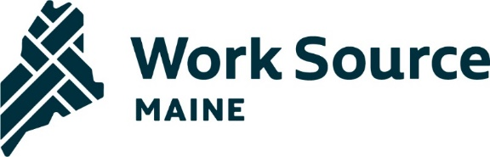

**State Workforce Board**

**Meeting Agenda**

**June 14, 2024**

**MDOL, 45 Commerce Drive, Augusta**

*Pre-reads:*

* *WIOA Reauthorization materials*
* *10-Year Plan Refresh*
* *Proposed Policy to rescind & replace PY 12-04*
* *Current CSSP High Wage/In Demand List, CSSP Rules, &* High Wage/In Demand jobs website - <https://www.maine.gov/labor/cwri/data/oes/hwid.html>

9:00 Welcome, introductions, agenda review

9:10 Director’s Report

9:15 WIOA Reauthorization update – Tim Carlton, NGA Legislative Director

9:40 ACTION ITEM – Rescind & Replace Maine Workforce System Policy - PY 12-04 “Chambers of Commerce as required partner in local workforce areas”

9:50 CSSP High Wage/In Demand list discussion

10:10 Break

10:15 10-Year Strategy – Implementation strategy governance and SWB role moving forward

10:30 10-Year Strategy – Implementation Planning Breakouts

11:30 10-Year Strategy – Report out

11:50 Public Comment Period

Noon Adjourn

Next SWB Meeting  
September 13, 2024, 9:00am - Noon

Location TBA