,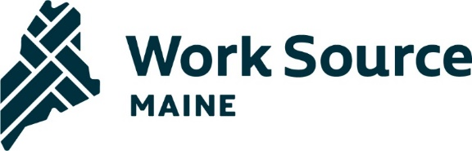
STATE WORKFORCE BOARD
September 8, 2023
Meeting - 9:00am – Noon
Lunch & Tour – Noon – 2:00pm
Jackson Labs, Bar Harbor, ME

9:00 Welcome, Introductions & Get to know your new SWB members, Agenda review

9:15 Approve minutes from June 9, 2023, SWB meeting

9:20 Director’s Report

9:25 Context setting for 5-year “Refresh” of Strategic workforce & 10-year economic development plans

10:00 Break

10:05 Breakout Groups - Strategic workforce & 10-year economic development plan tactical goal posts discussion

11:20 Presentation from Jackson Labs – “Talent Acquisition to Build the Maine Research and Development Workforce”

11:50 Public comment

11:55 Meeting evaluation & closing remarks

12:00 Adjourn

12:00 – 1:00 – Lunch provided by Jackson Labs

1:00 – 2:00 – Tour of Jackson Labs research facility
Next Meeting:
December 8, 2023
9:00am - 12:00pm
Location: MDOL, 45 Commerce Drive, Augusta

