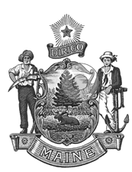
Department of
the Secretary of State

Bureau of Motor Vehicles

Shenna Bellows Catherine Curtis
Secretary of State Deputy Secretary of State

Working Group to Evaluate the Potential Regulation of the Towing Industry

Meeting Agenda
9/25/25
1:00 to 2:30

  - Introductions

  - Review the purpose of the working group

  - Discuss what problems need to be resolved

  - Review current abandoned vehicle title laws

  - Discuss next meeting - 10/9/25 1:00 to 2:30

  - Adjourn

