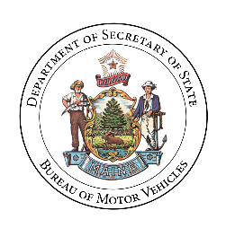**Department of the Secretary of State**

**Bureau of Motor Vehicles**

Shenna BellowsCatherine Curtis

*Secretary of State Deputy Secretary of State*

Working Group to Study the Safety and Use of

Nonconforming Vehicles on Maine Roadways and Highways

Remote Meeting Policy

October 6, 2025

The Working Group to Study the Safety and Use of Nonconforming Vehicles on Maine Roadways and Highways (the “Working Group”) allows participation in its public meetings by remote methods in accordance with 1 M.R.S.A. §403-B(1).

"Remote methods" means by telephone or video technology allowing simultaneous reception of information and may include other means when such means are necessary to provide reasonable accommodation to a person with a disability.

In-person participation by individual Working Group members is preferred. A Working Member may attend a meeting of the Working Group by a remote method when a member determines that their physical presence is not practical.

Members of the public will be provided a meaningful opportunity to attend by remote methods when members of the Working Group participate by remote methods, and reasonable accommodations may be provided when necessary to provide access to individuals with disabilities. When the Working Group allows or is required to provide an opportunity for public input during a meeting, an effective means of communication between the members of the Working Group and the public will be provided, such as access to microphone, chat feature or other method.

Notice of the meeting will be provided as required in Section 406 of the Freedom of Access Act. When the public may attend by remote methods, the meeting notice will include the means by which members of the public may access the meeting using remote methods.  For individuals with disabilities seeking a reasonable accommodation, the notice will identify the specific individual to contact about arranging for the accommodation. The notice will also identify a location for members of the public to attend in person.

The Working Group will make all documents and other materials considered by the Working Group available, electronically or otherwise, to the public who attend by remote methods to the same extent customarily available to members of the public who attend the proceedings of the public body in person.