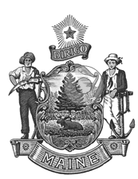
Department of
the Secretary of State

Bureau of Motor Vehicles

Shenna Bellows Catherine Curtis
Secretary of State Deputy Secretary of State

Non-Conforming Vehicles Working Group
Meeting Agenda
10/6/25
1:00 to 2:30

  - Introductions

  - Review the purpose of the working group

  - Identify the operating standards that prohibit nonconforming vehicles from being operated on the State's roads and highways

      - Review current relevant laws and rules related to definitions, registration, inspections, operations.

  - Discuss next meeting - 10/20/25 1:00 to 2:30

  - Closing remarks

  - Adjourn

