**65-407 PUBLIC UTILITIES COMMISSION**

**Chapter 323: ELECTRONIC BUSINESS TRANSACTIONS STANDARDS**

**SUMMARY:** This rule establishes business processes and defines electronic transactions necessary to support retail competition as of March 1, 2000. The rule adopts the Maine Electronic Business Transactions (EBT) Standards appended to this rule.

**1. EBT Standards**

The Maine Electronic Business Transactions (EBT) Standards appended to this rule apply to transactions between competitive electricity providers and transmission and distribution utilities.

**2. Filing Requirements**

The Maine Electronics Business Transactions Working Group shall file at the Commission technical specifications necessary to implement the EBT Standards. These technical specifications will be available through the Commission’s web page. Any updates or revisions to these technical specifications shall be filed at the Commission. The Commission will ensure that the revised or updated technical specifications are available through its web page.

**3. Waiver**

Upon the request of any person subject to this Chapter or upon its own motion, the Commission may, for good cause, waive any requirement of this Chapter that is not required by statute. The waiver may not be inconsistent with the purposes of this Chapter or Title 35-A. The Commission, the Director of Technical Analysis, or the Presiding Officer assigned to a proceeding related to this Chapter may grant the waiver.

**STATUTORY AUTHORITY:** 35-A M.R.S.A. §§ 104, 111, 1301, 3202(1) and (2), and 3203(9).

**EFFECTIVE DATE:**

This rule was approved as to form and legality by the Attorney General on August 29, 2005. It was filed with the Secretary of State on August 30, 2005 (filing 2005-358), and became effective on September 4, 2005.

**EFFECTIVE DATE:** This amendment was approved as to form and legality by the Attorney General on April 26, 2007. It was filed with the Secretary of State on May 1, 2007, and became effective on May 6, 2007, filing 2007-177.

Nonsubstantive edits made by agency to ensure accessibility; APAO Accessibility Check: August 20, 2025



Maine EBT Standards Document

Maine EBT Standards

Maine EBT Standards

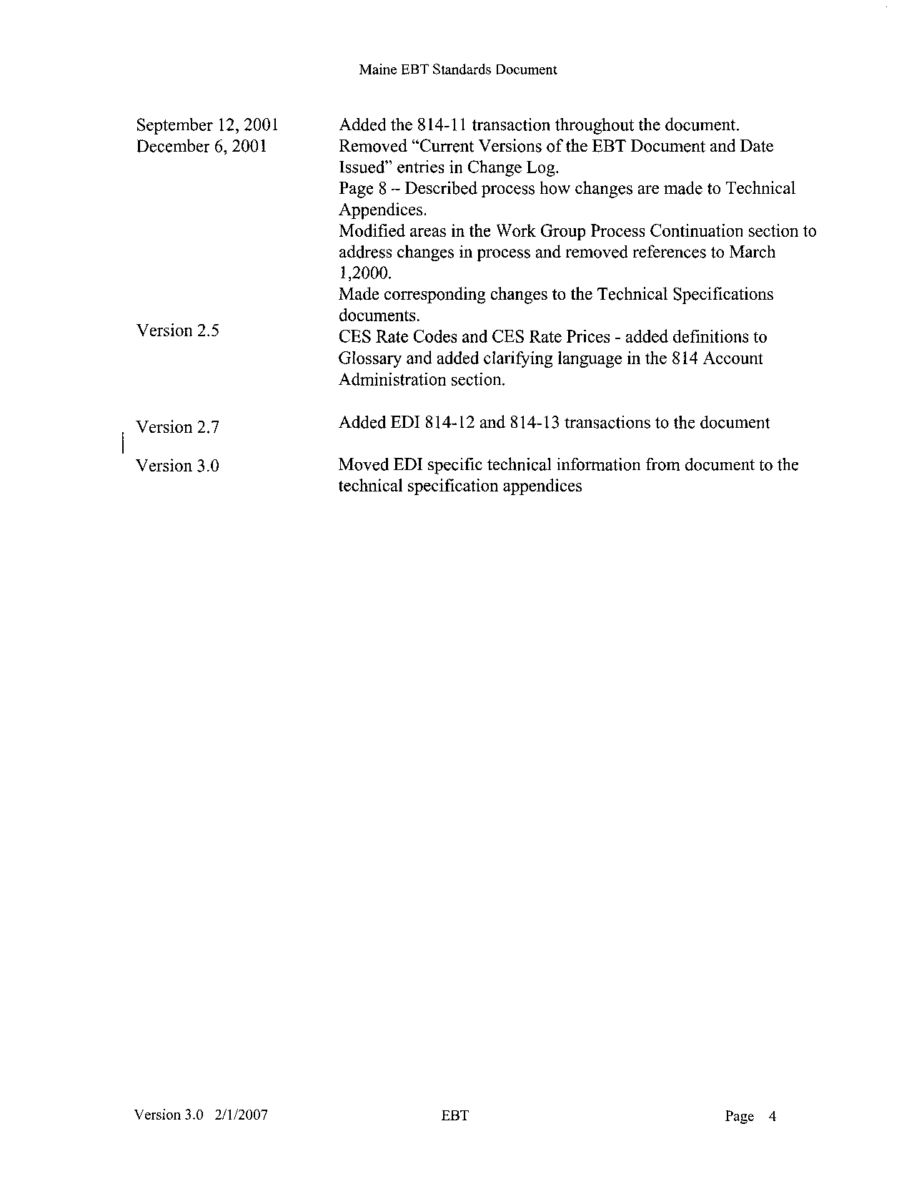

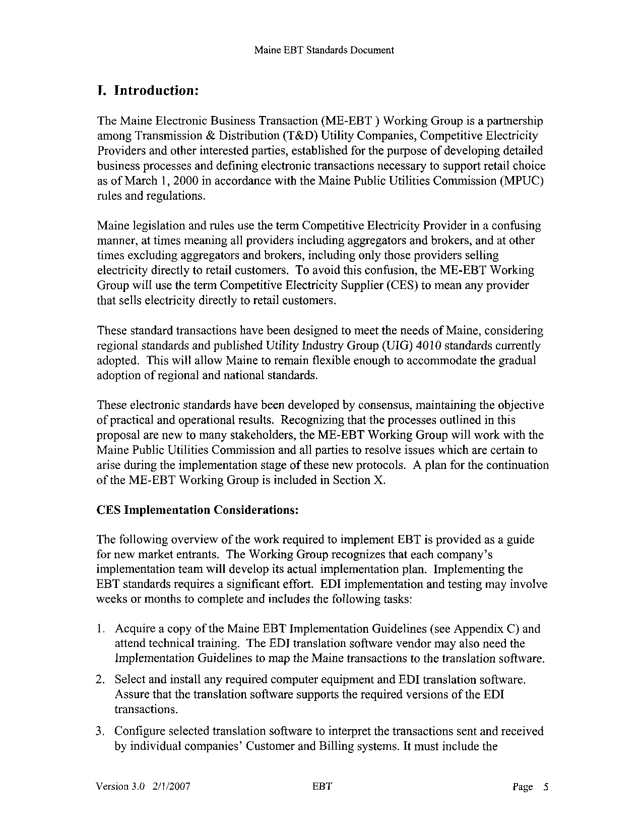

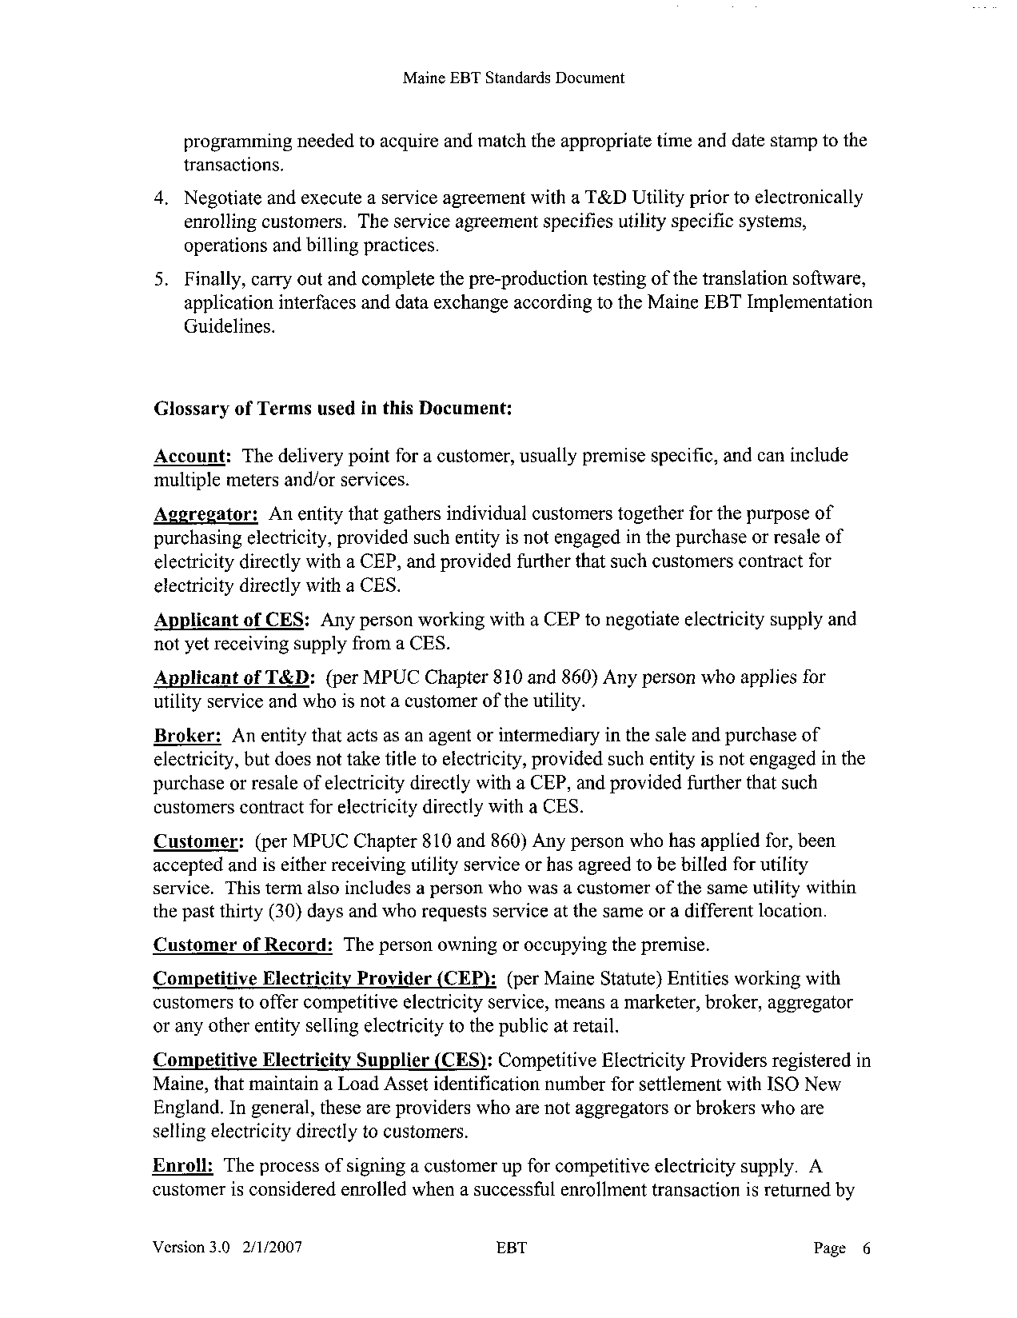

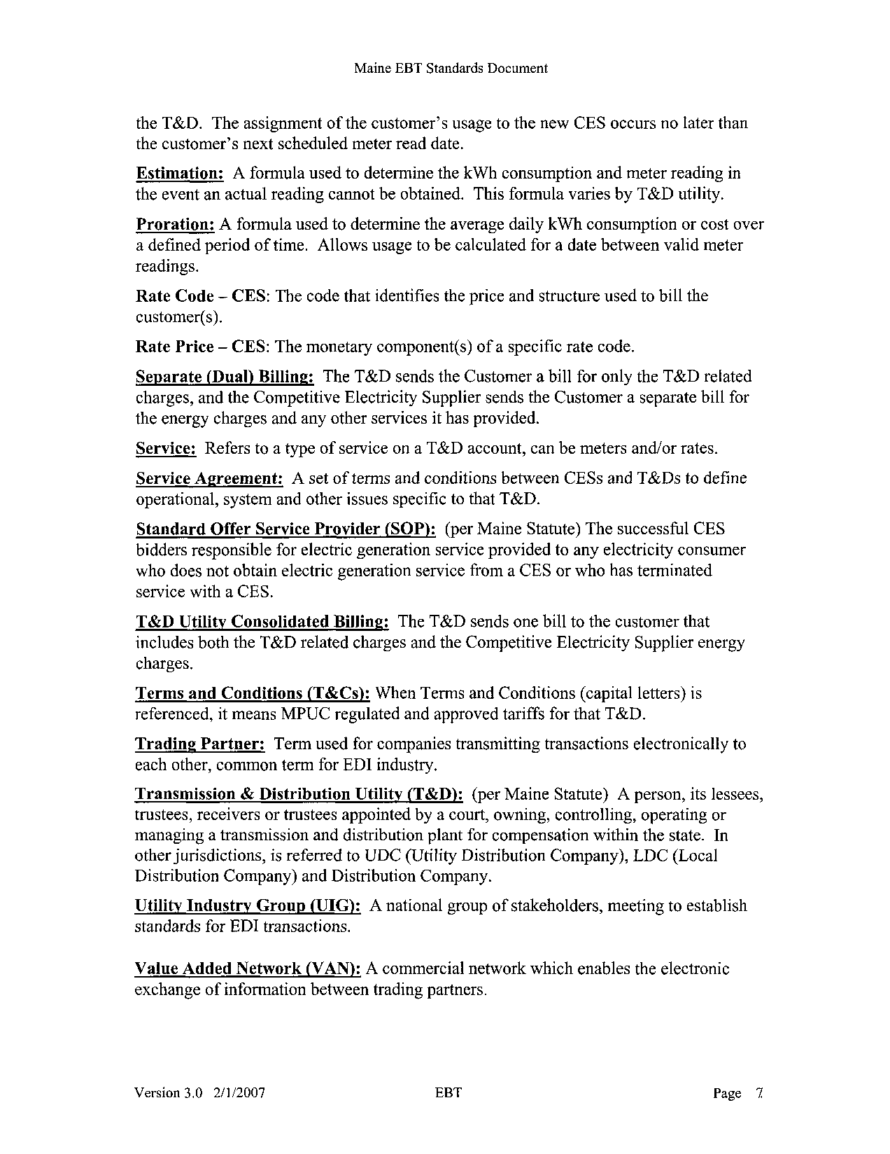

Maine EBT Standards Document
Summary

Maine EBT Standards Document
Business Relationships Diagram

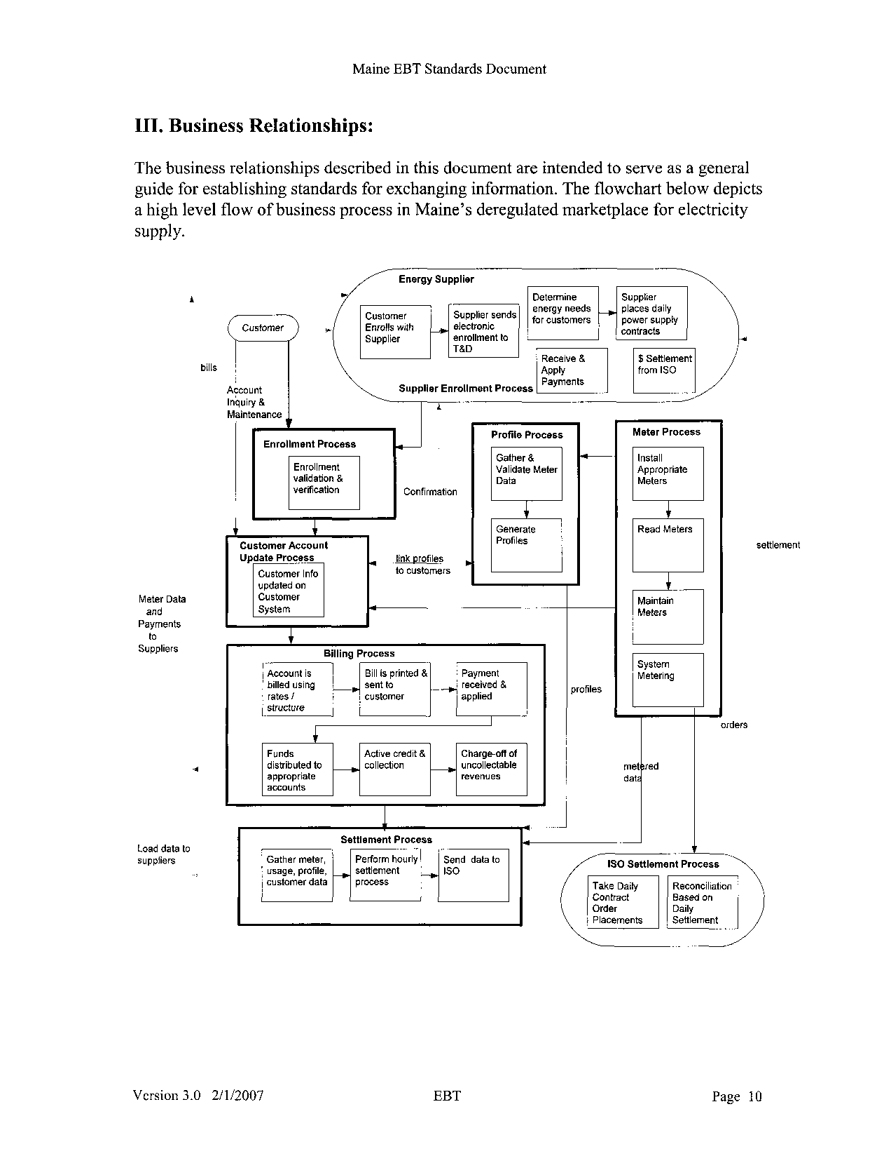

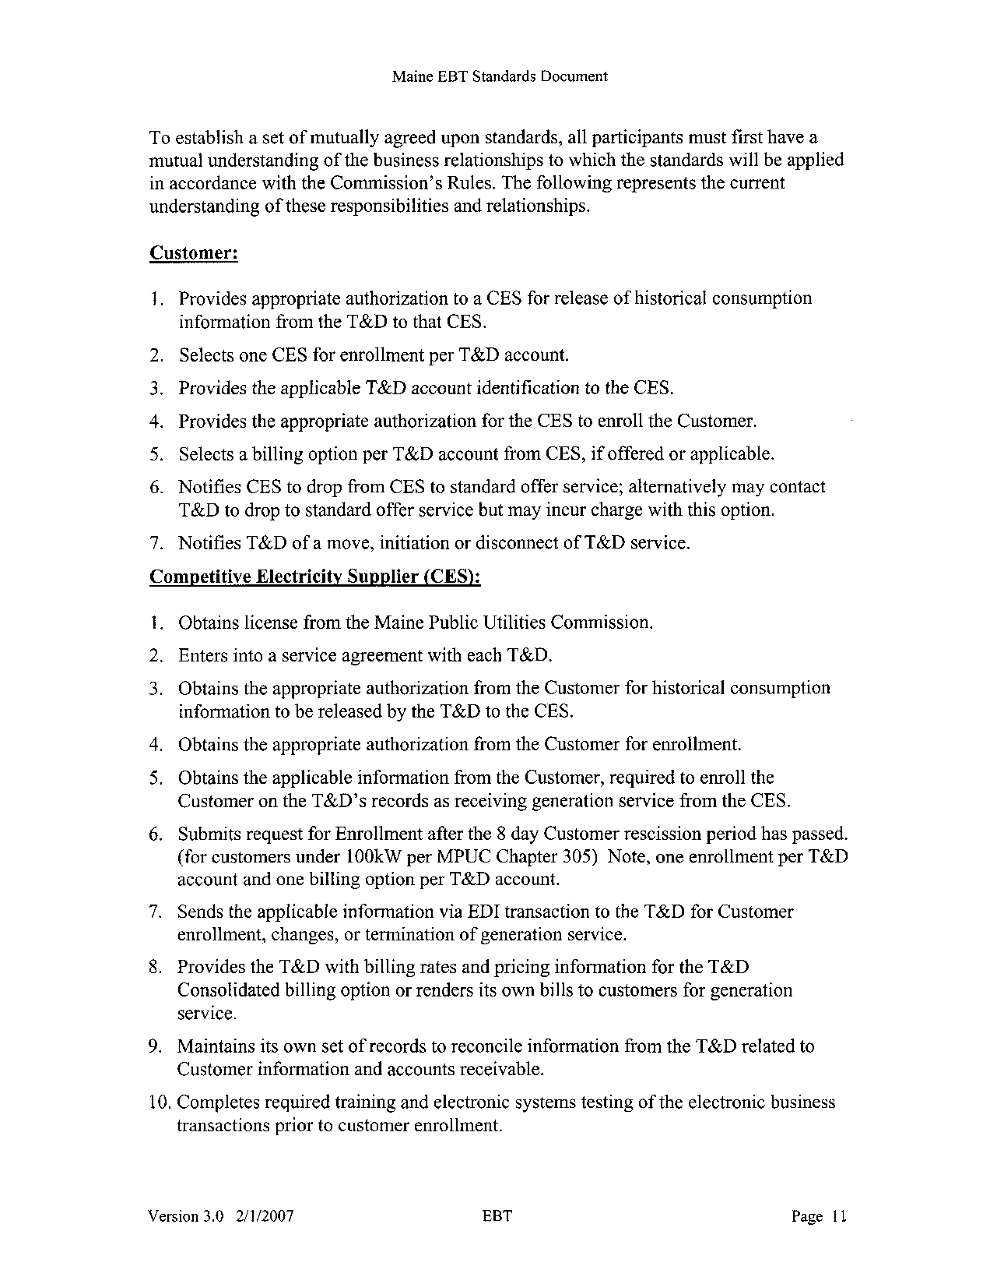

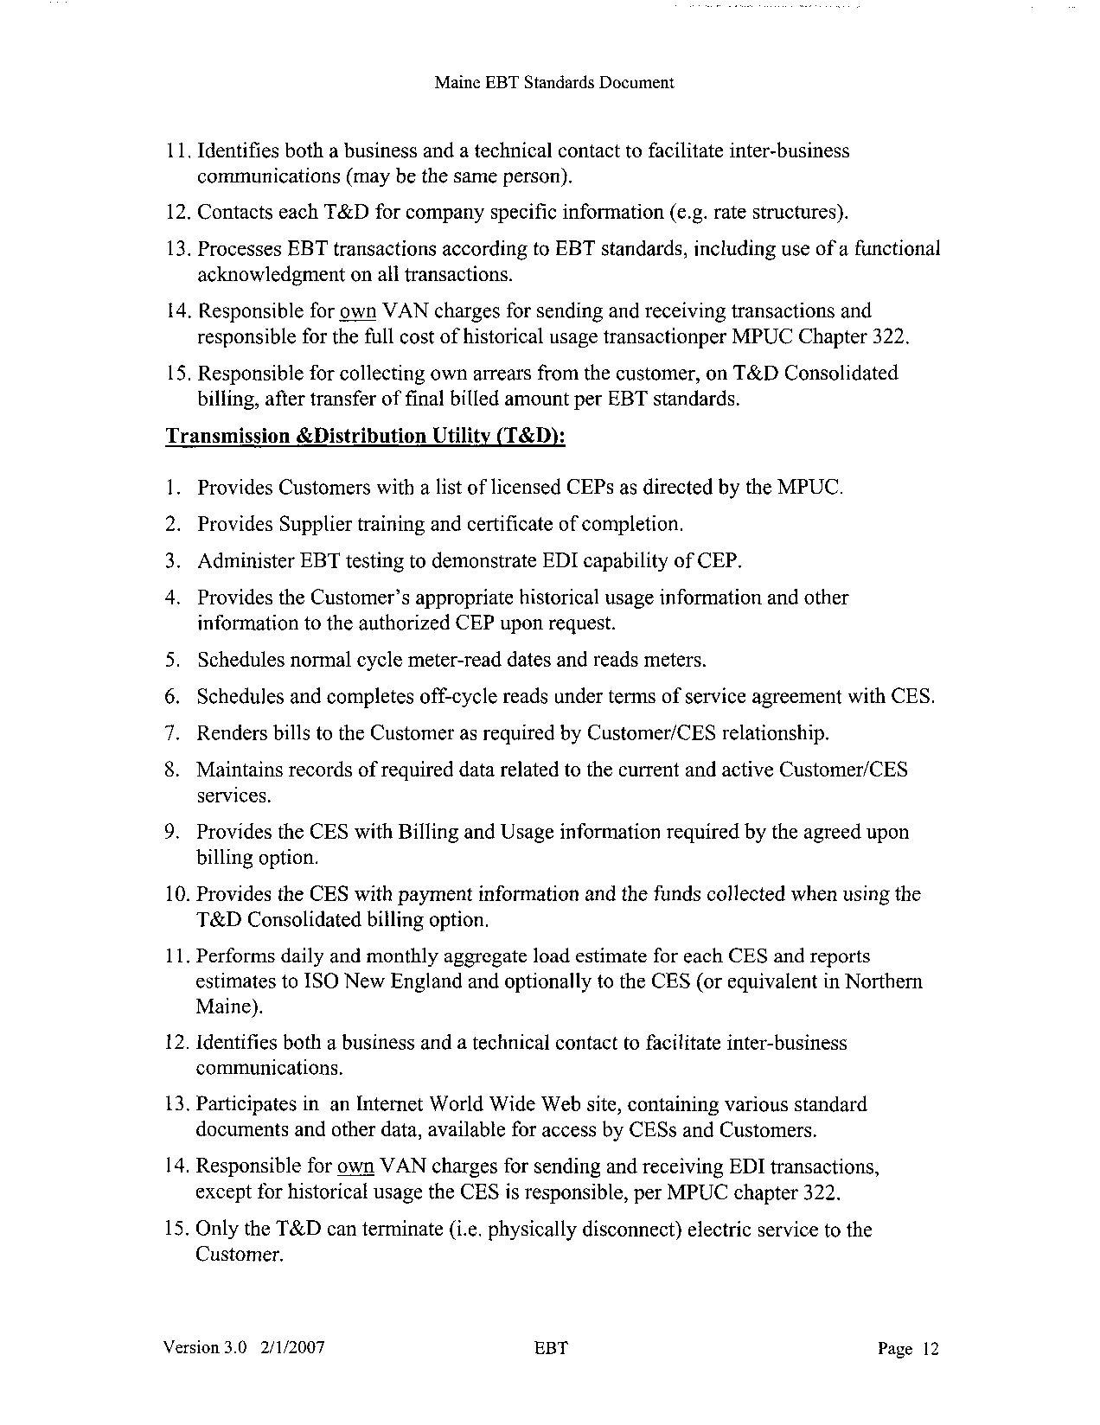

Maine EBT Standards Document
Competitive Electric Supplier

Maine EBT Standards Document
Account Administration

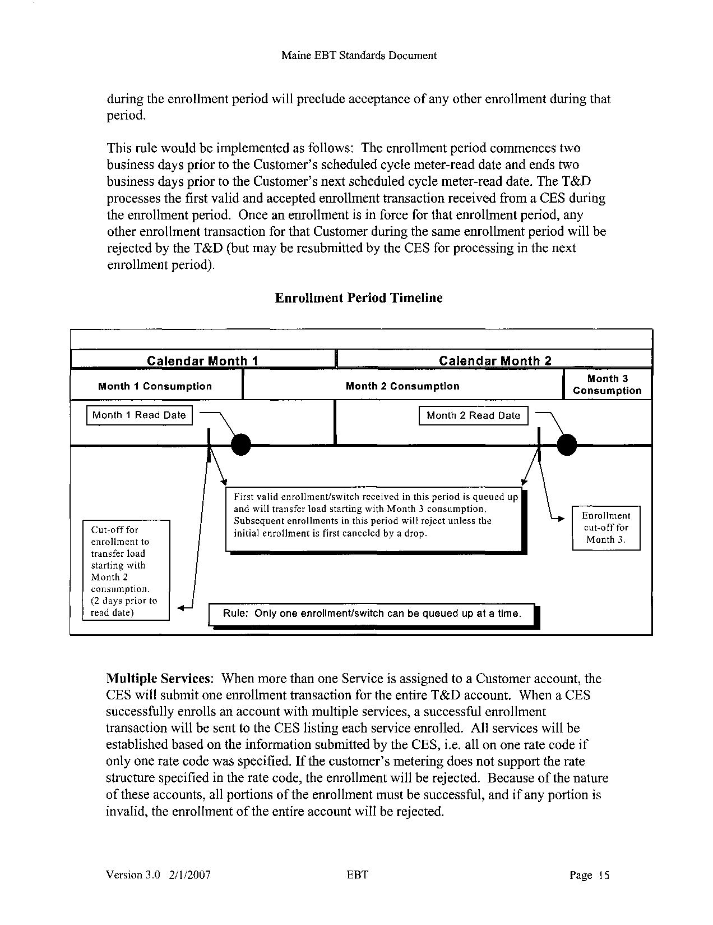

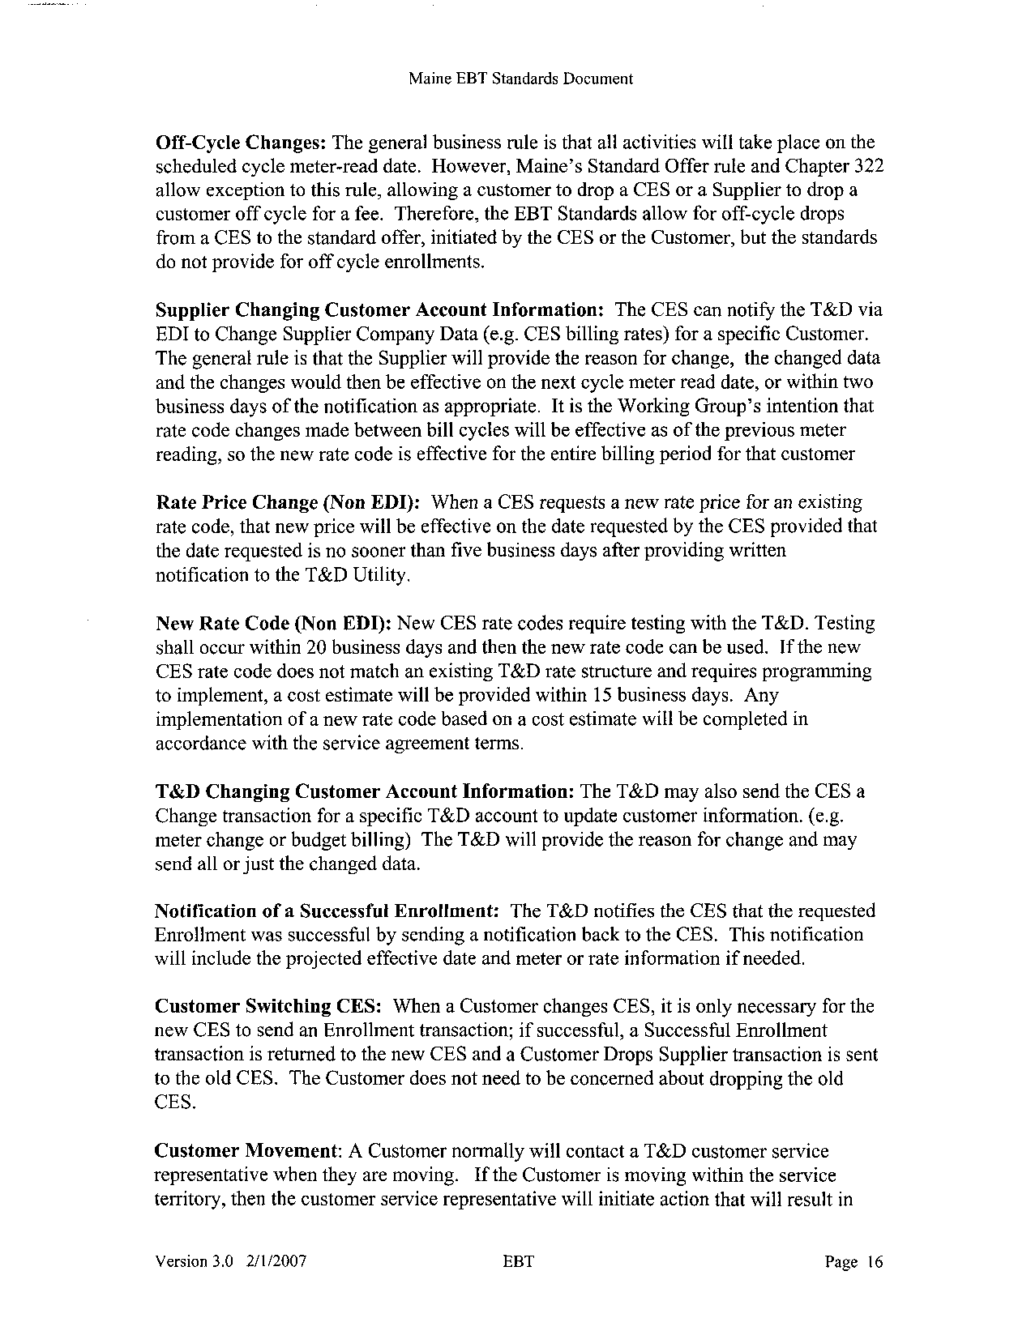

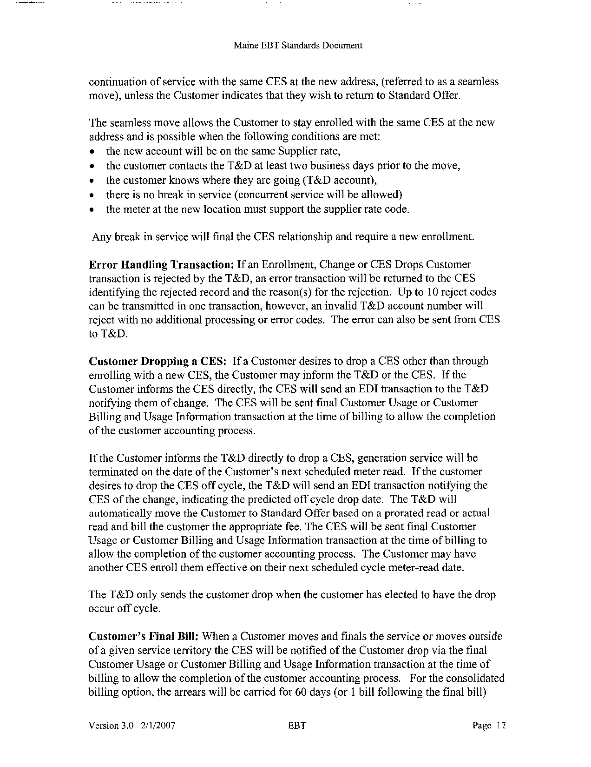

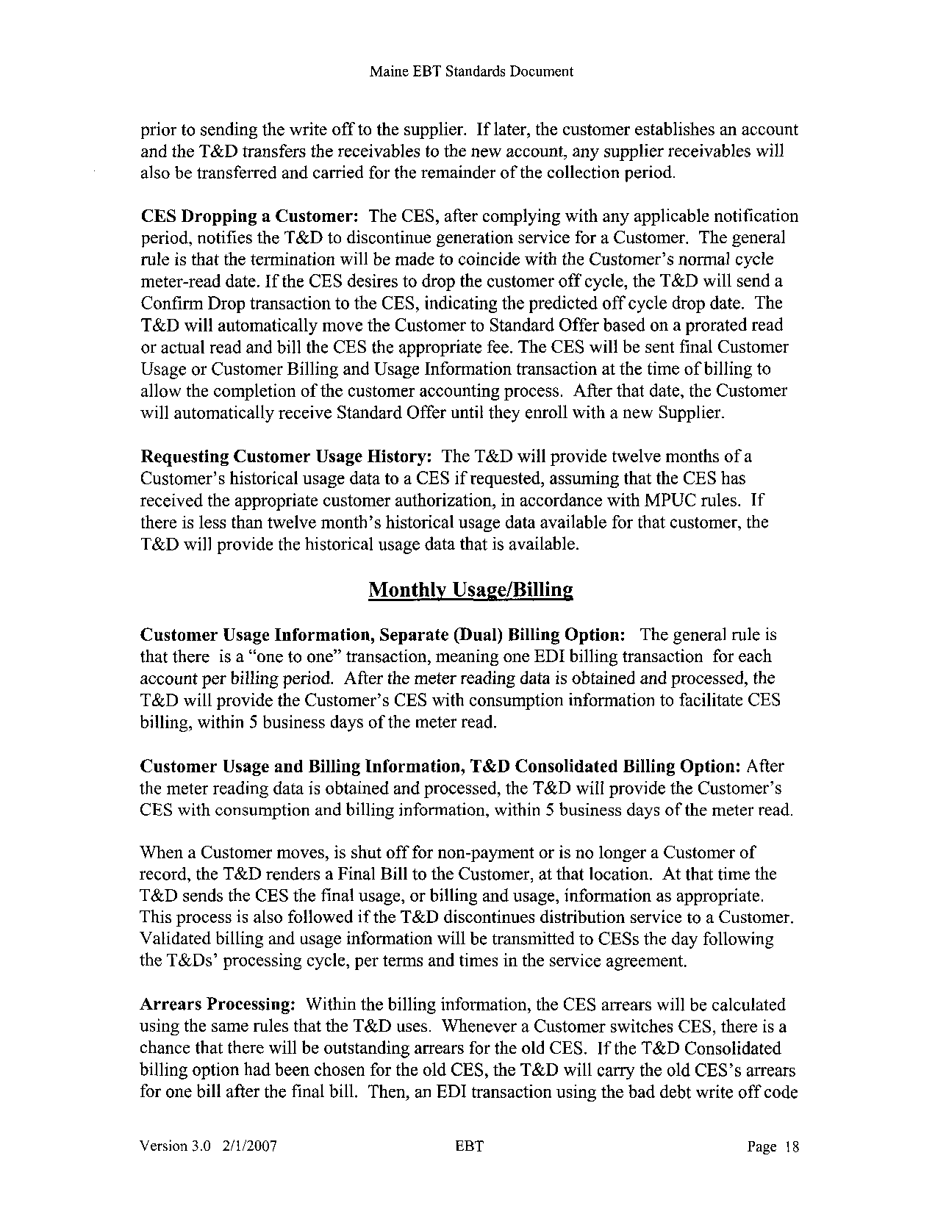

Maine EBT Standards Document
Error Responses

Maine EBT Standards Document

Maine EBT Standards Document
Electronic Transmission Standard Approach

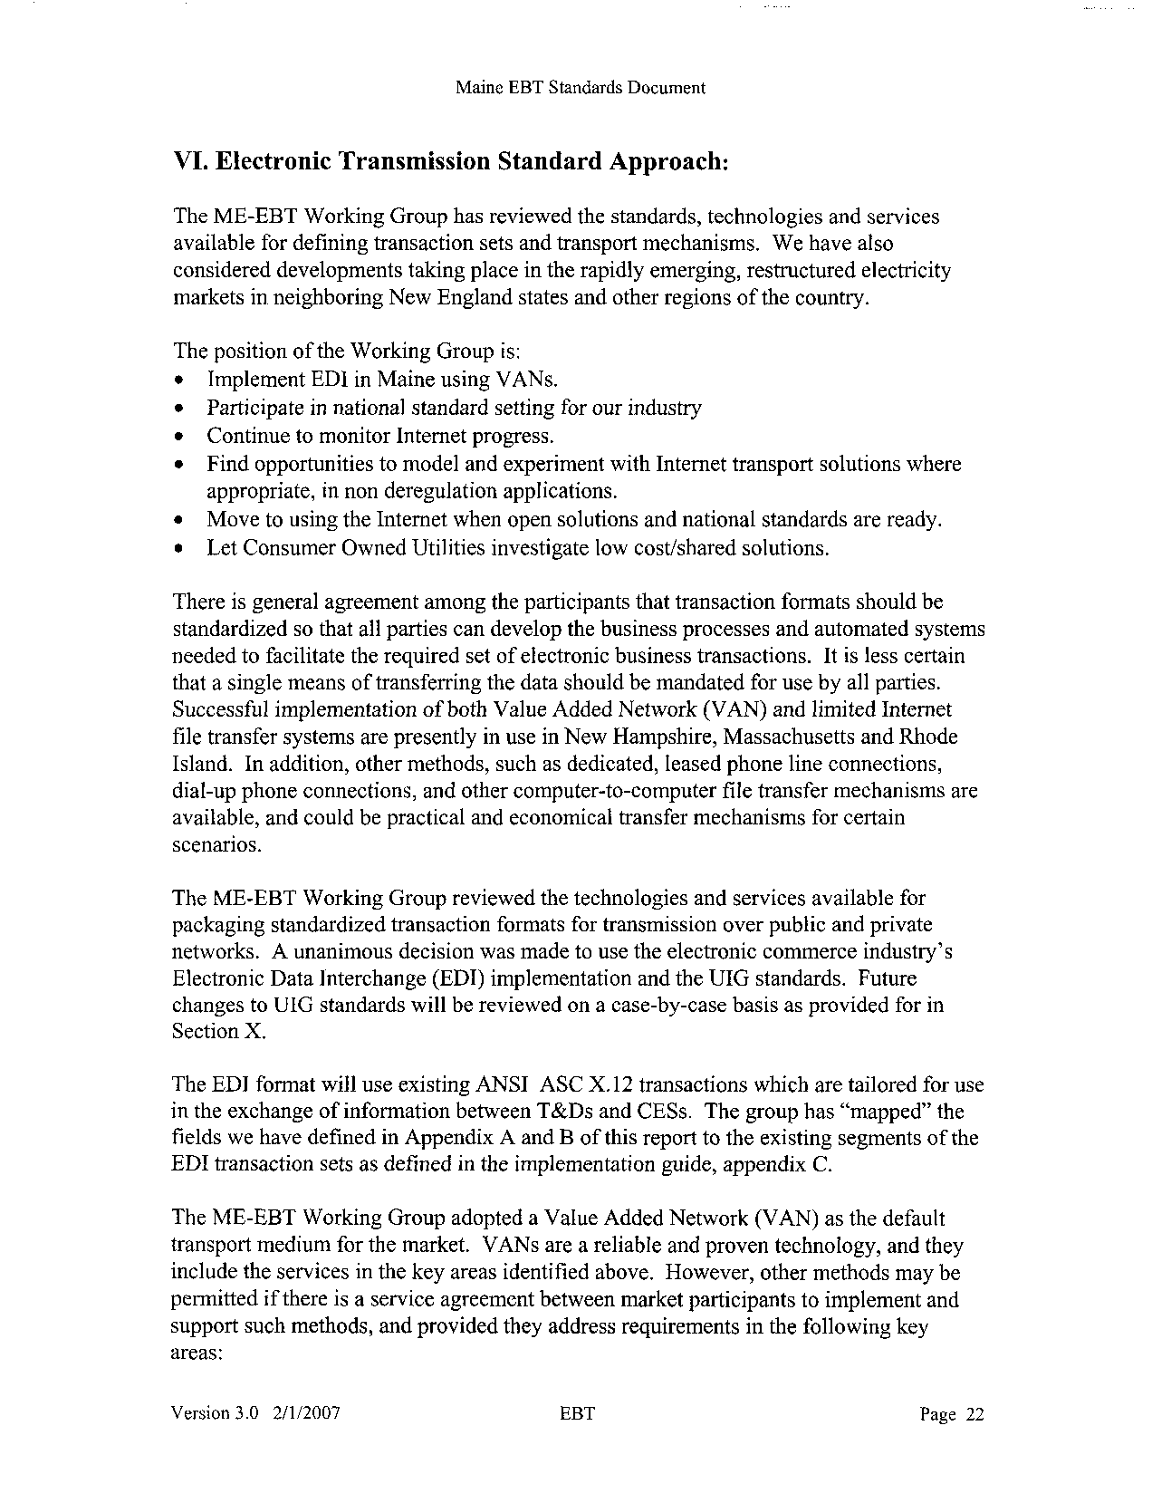

Maine EBT Standards Document
Computer Operations

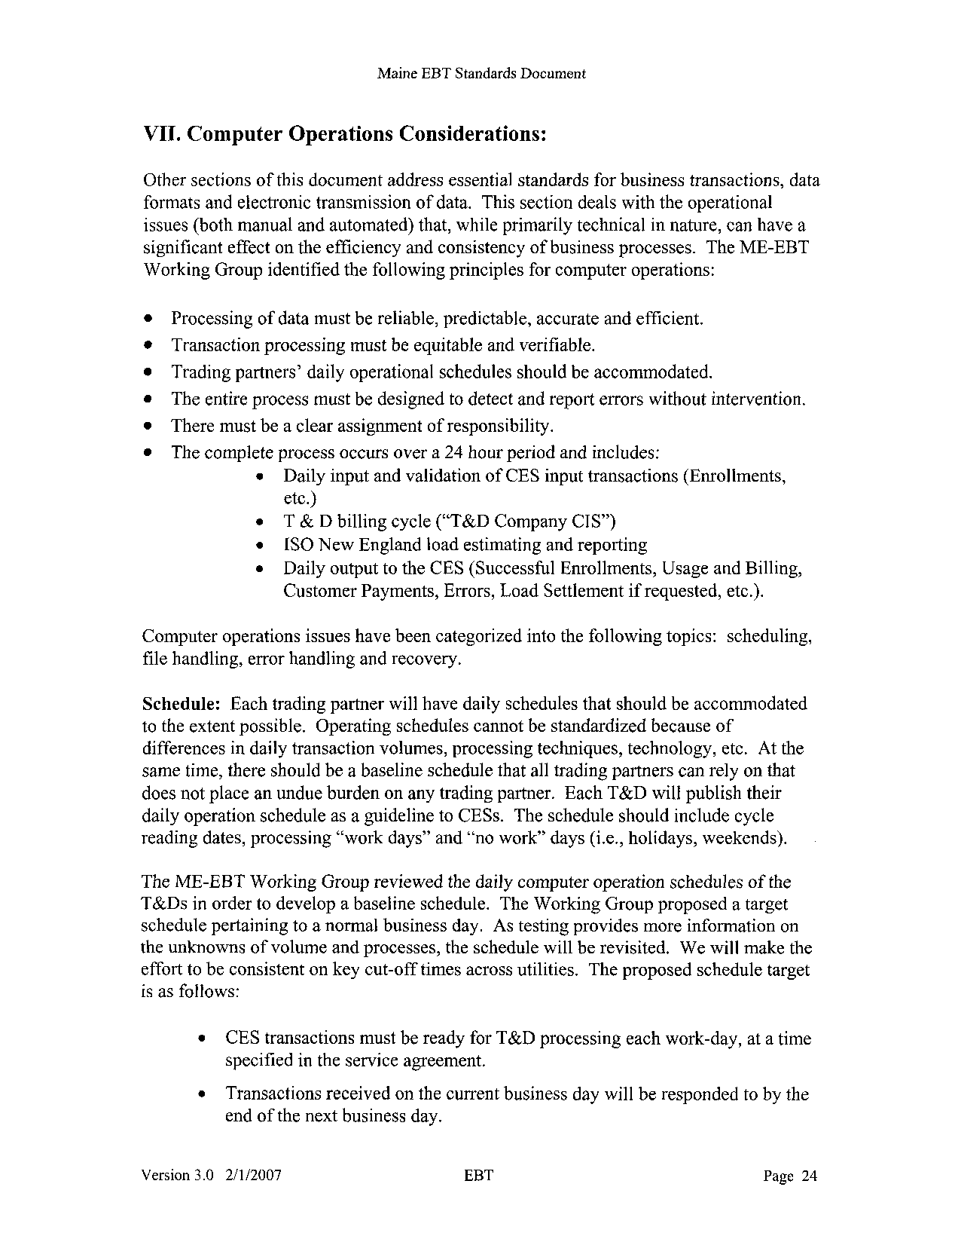

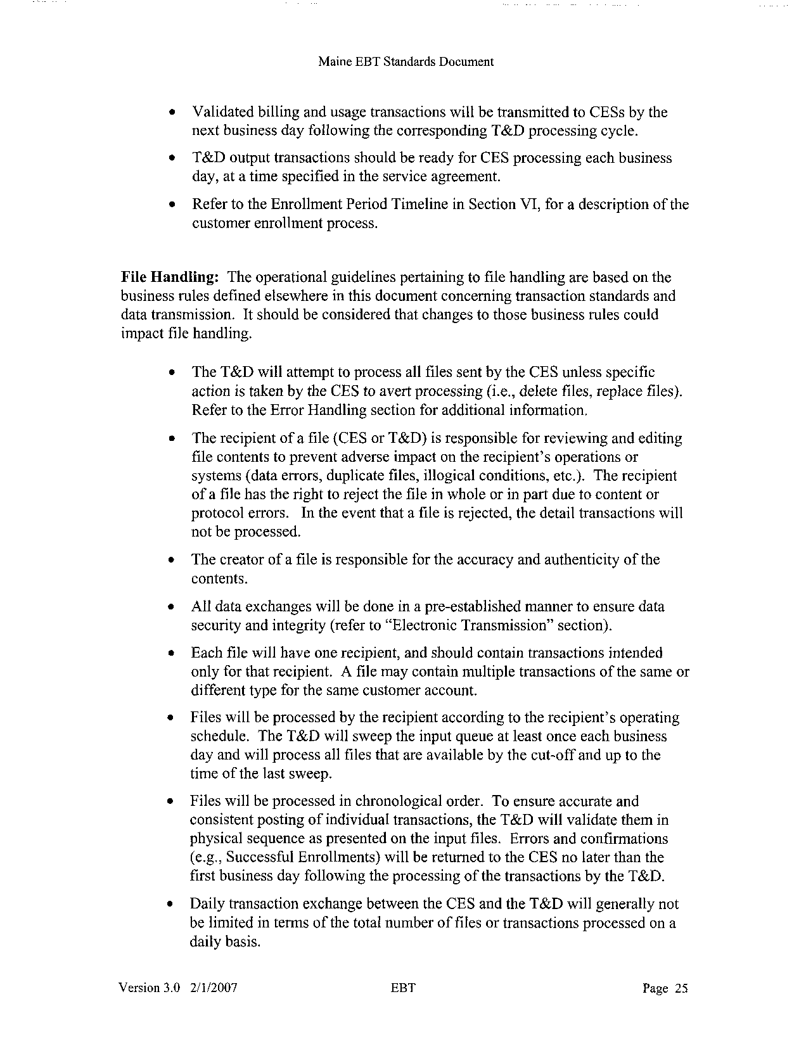

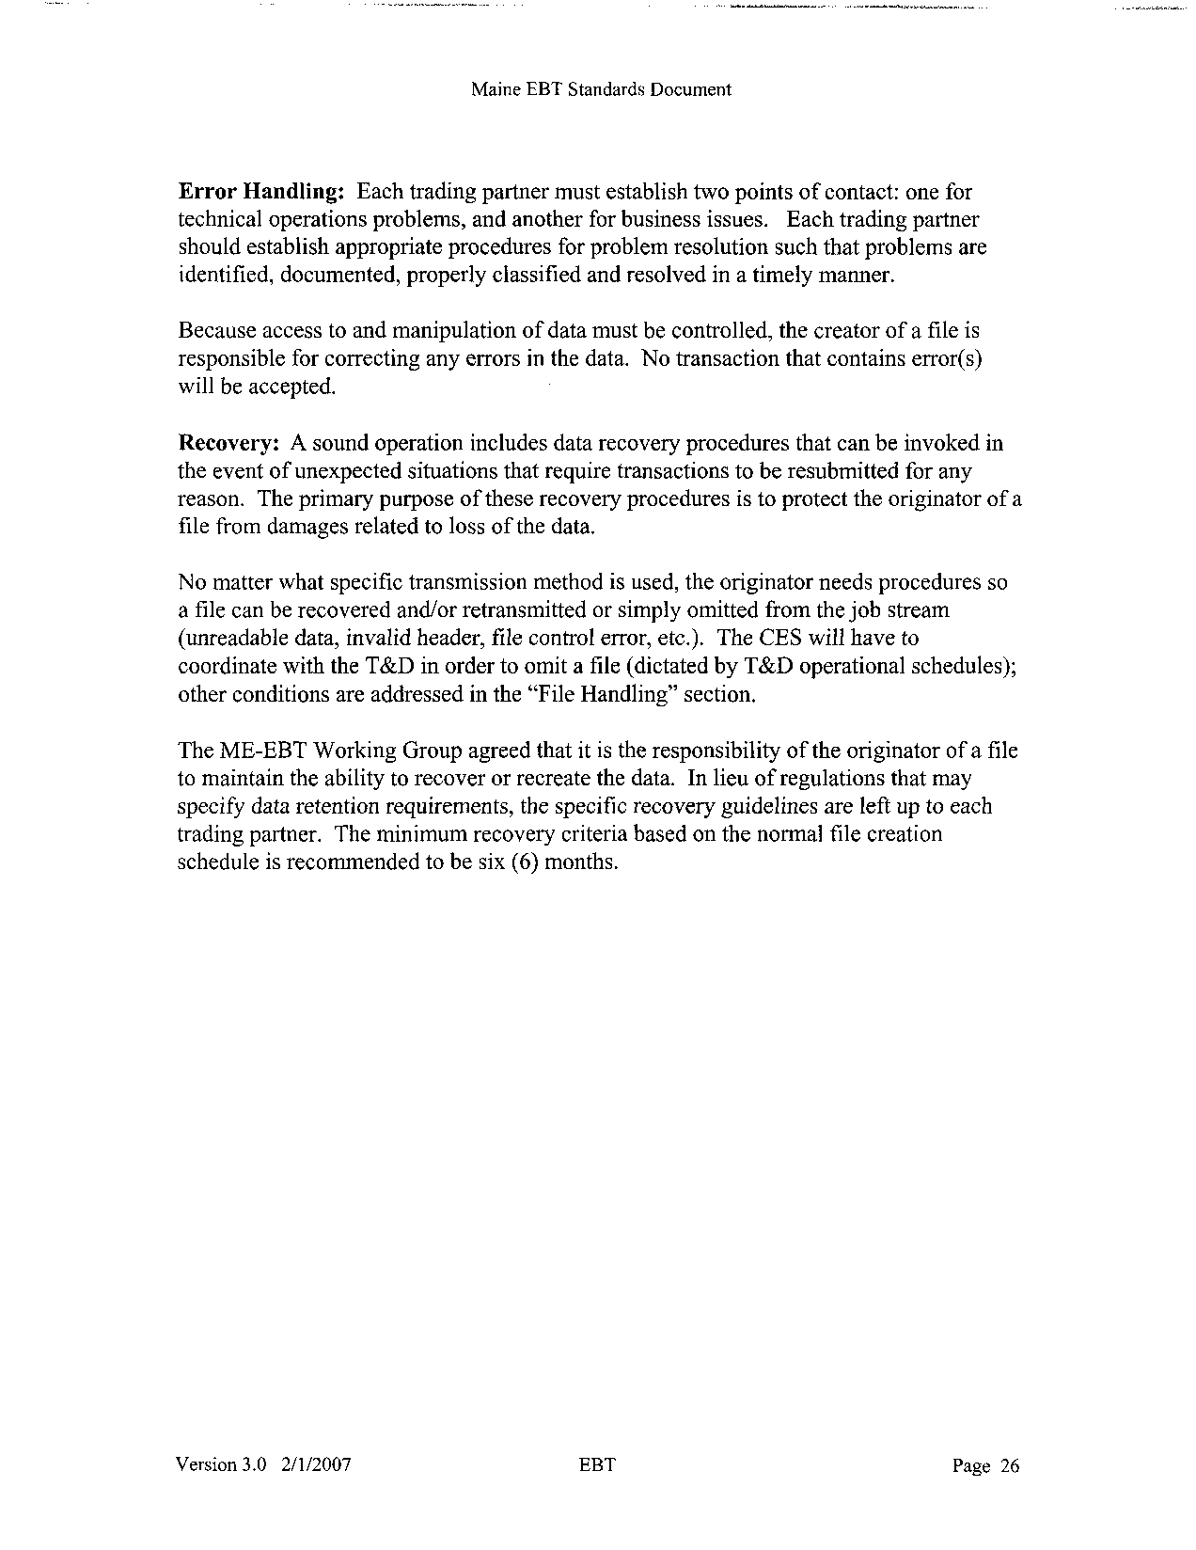

Maine EBT Standards Document
Supplier Testing

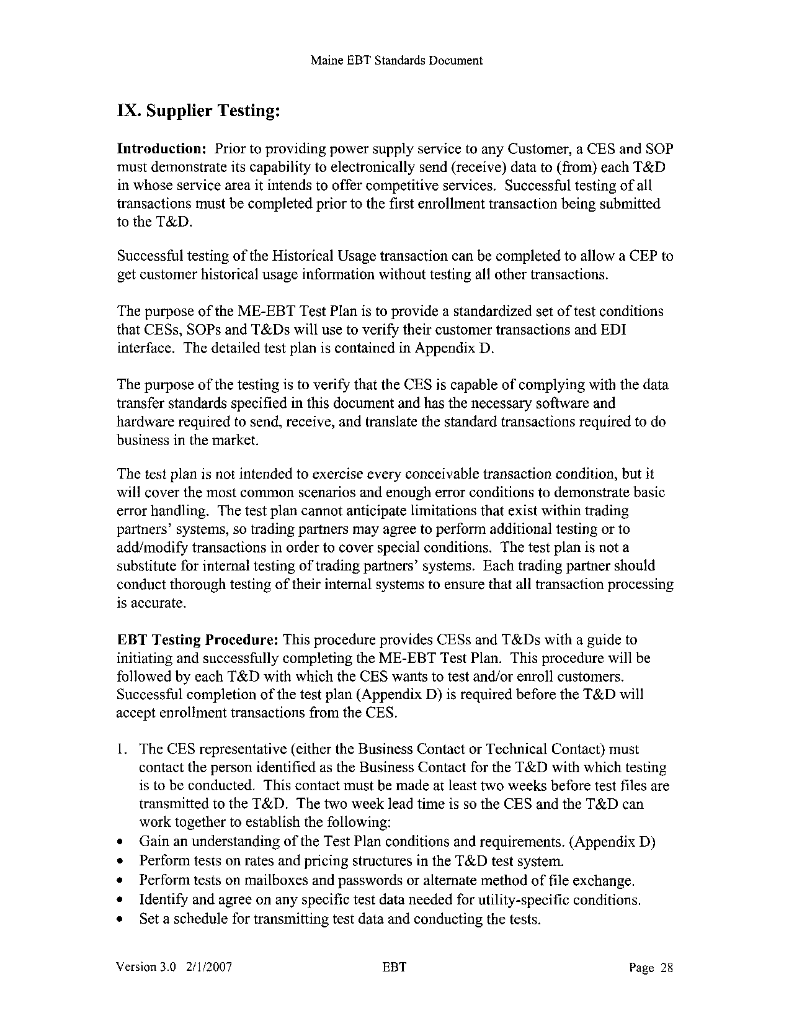

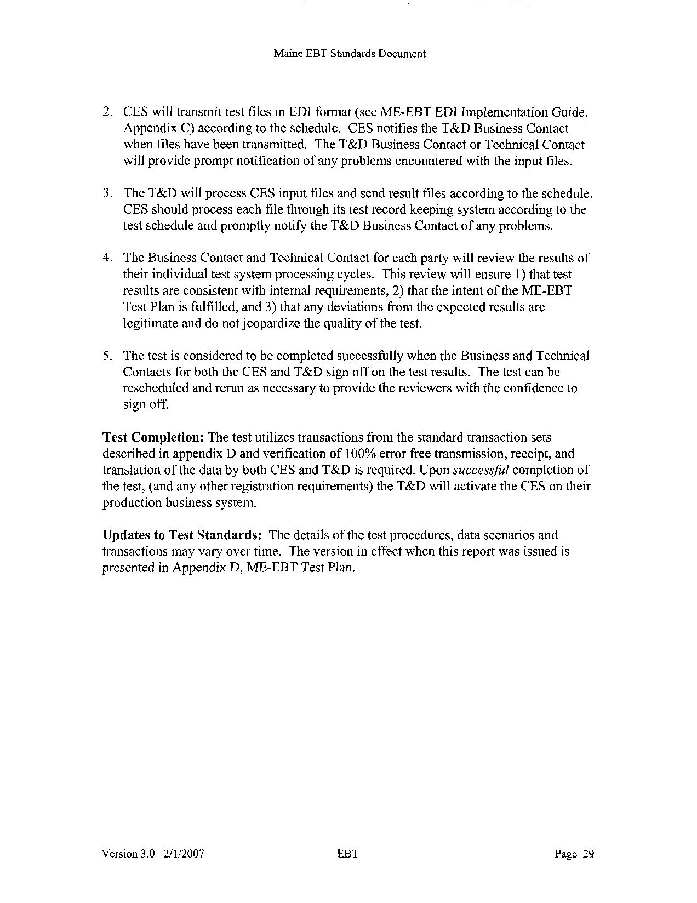

Maine EBT Standards Document
Work Group Process

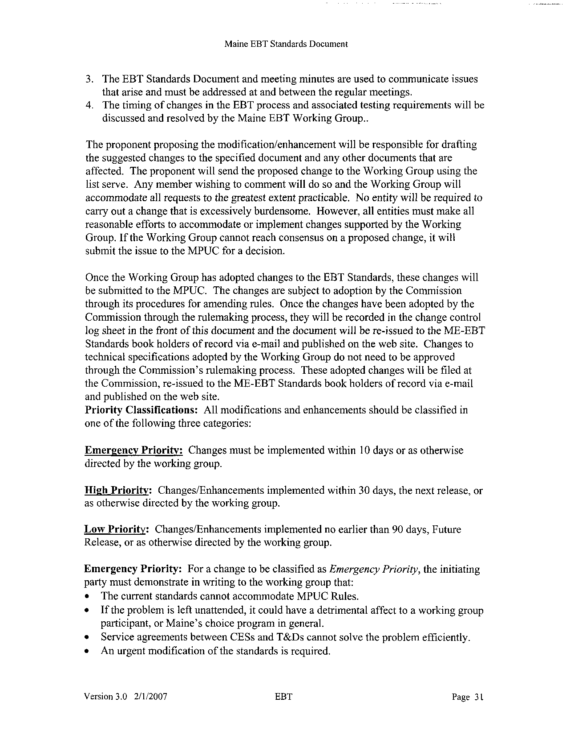

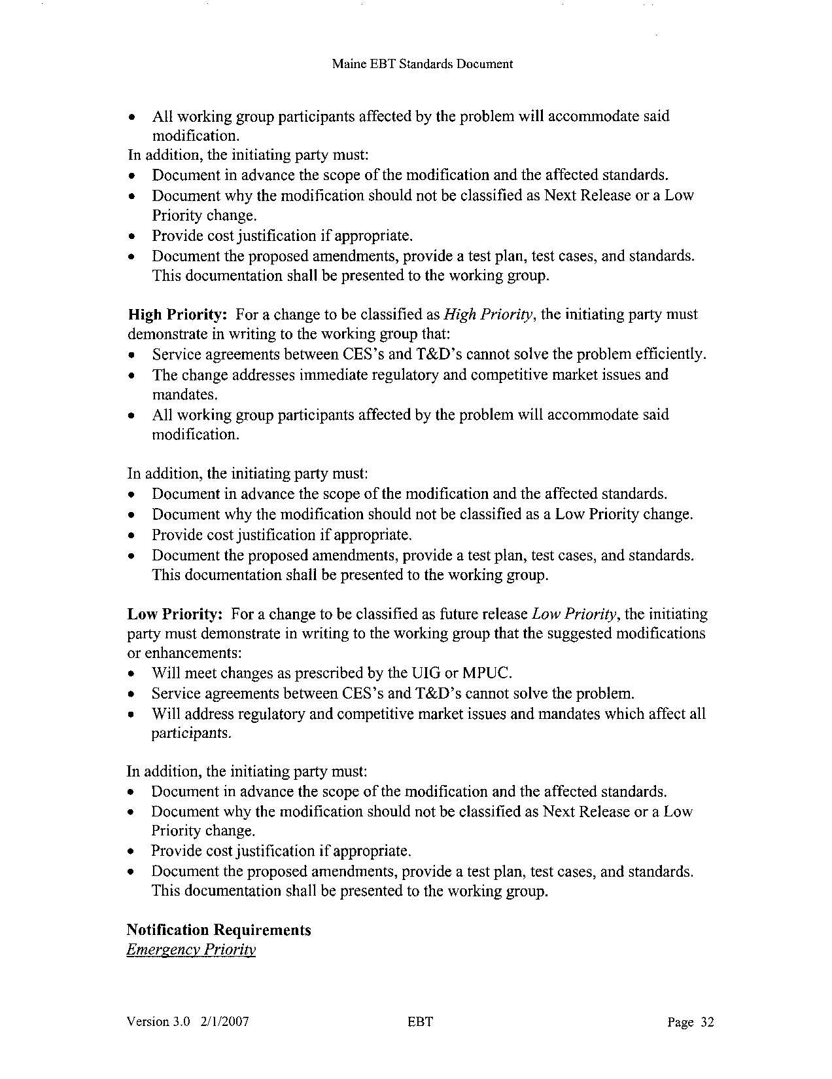





Maine EBT Standards Document
Table of Contents

Maine EBT Standards Document

Maine EBT Standards Document

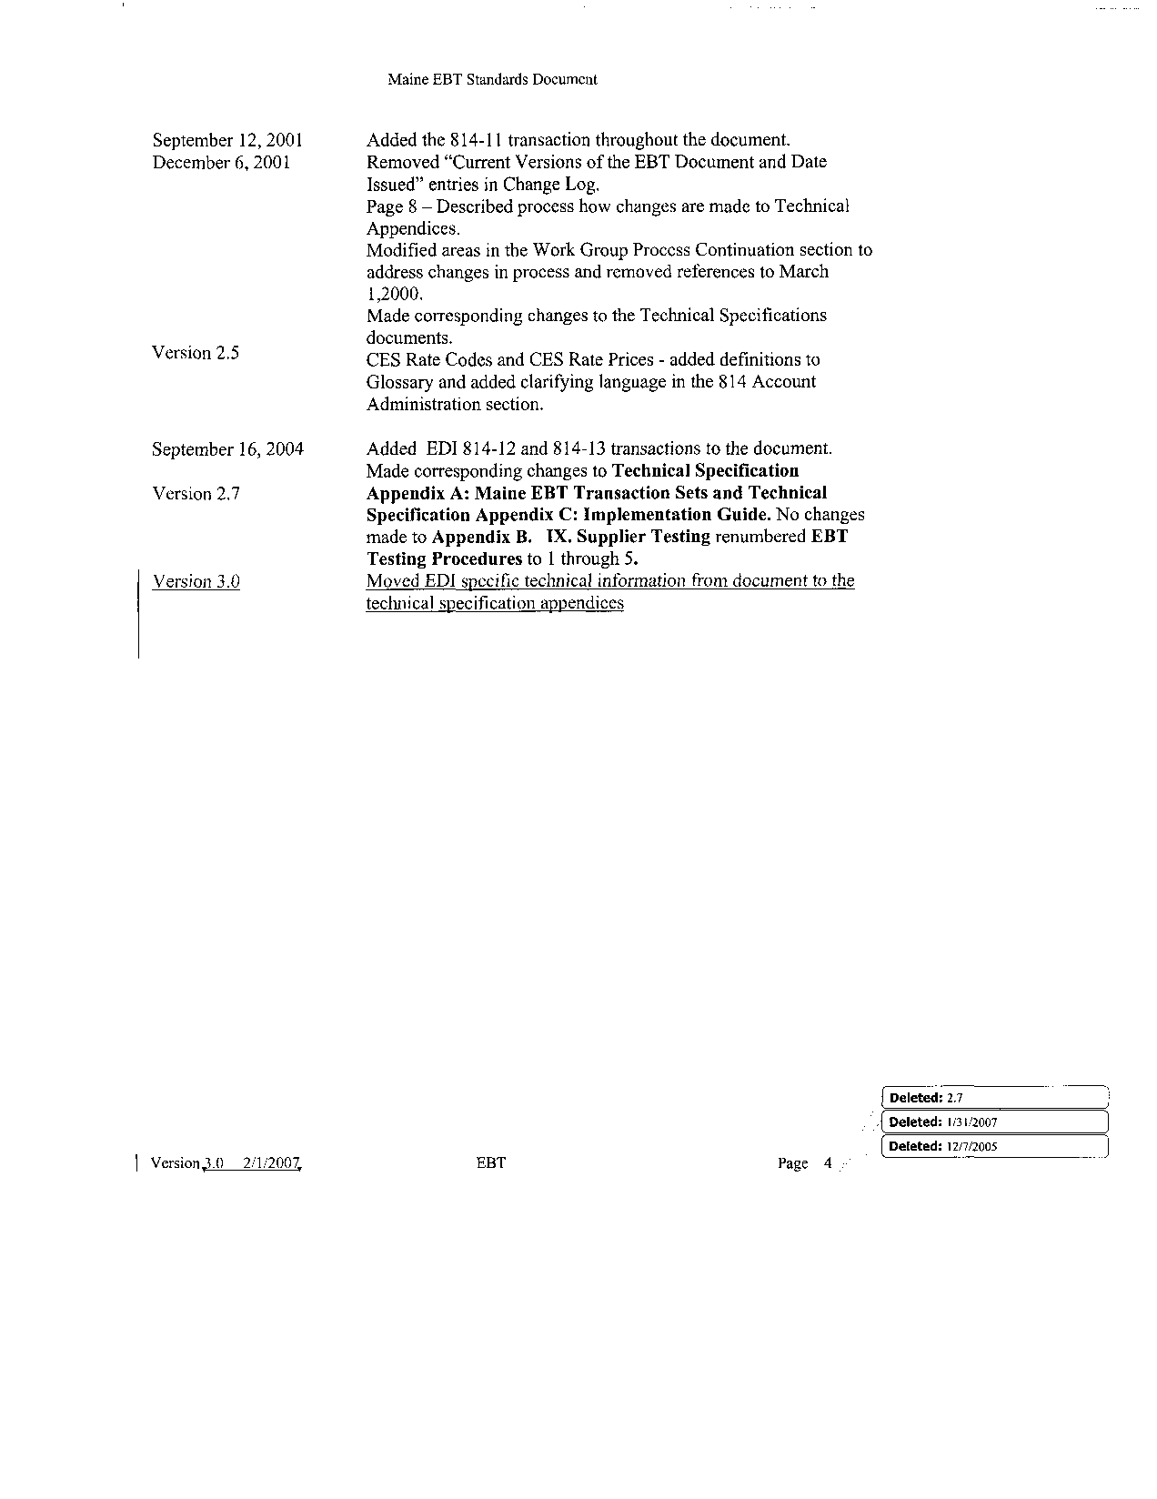

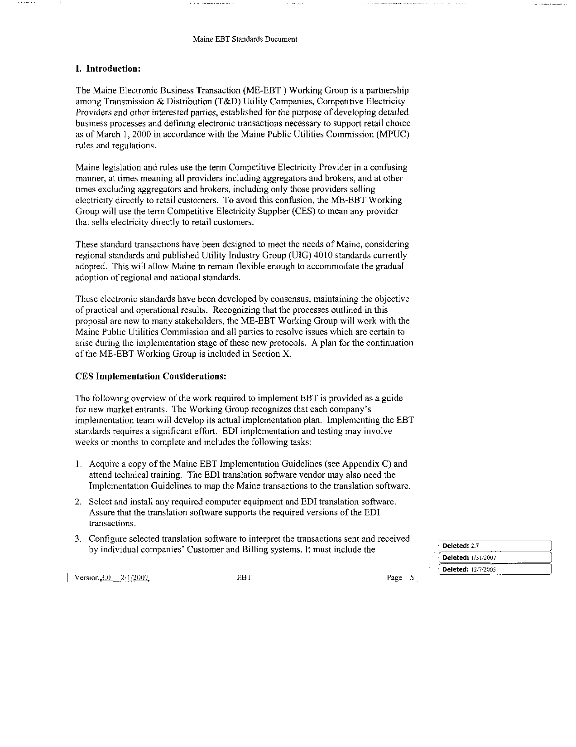

Maine EBT Standards Document
Glossary

Maine EBT Standards Document
Summary

Maine EBT Standards Document

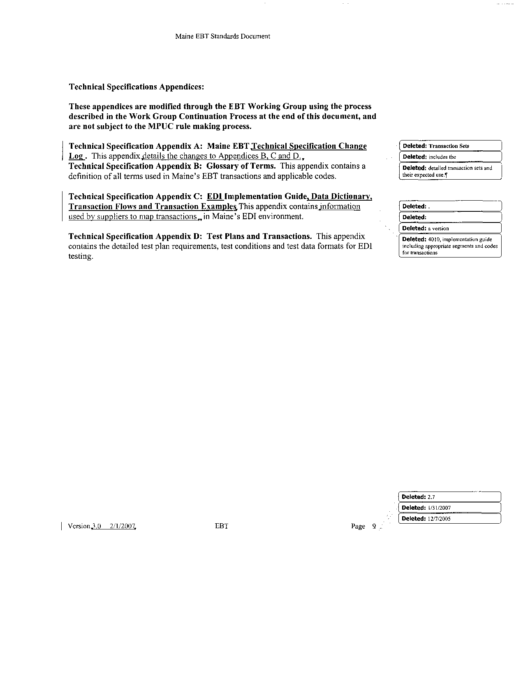

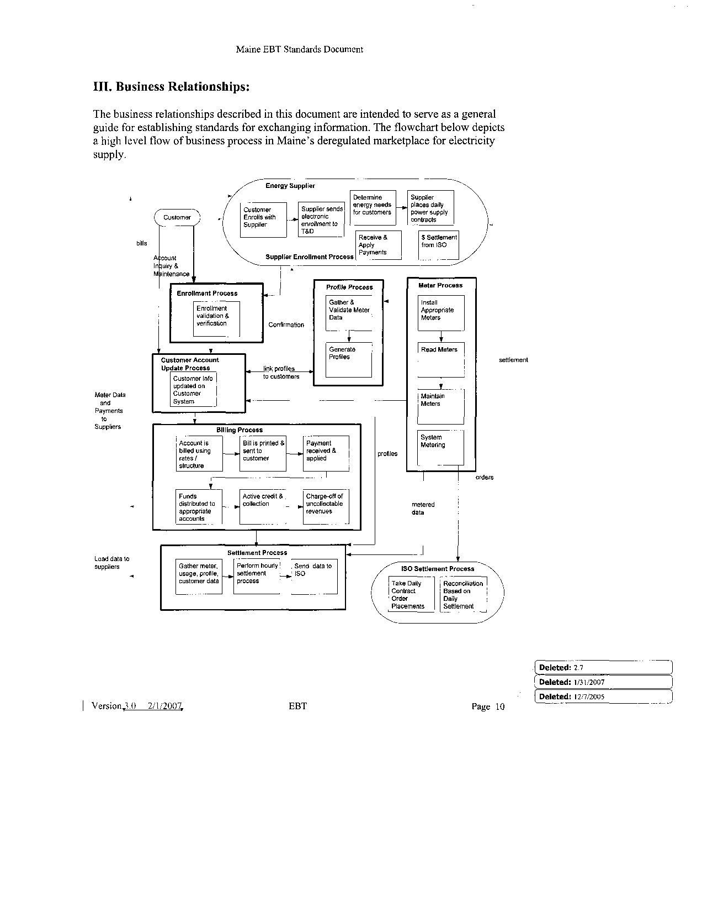

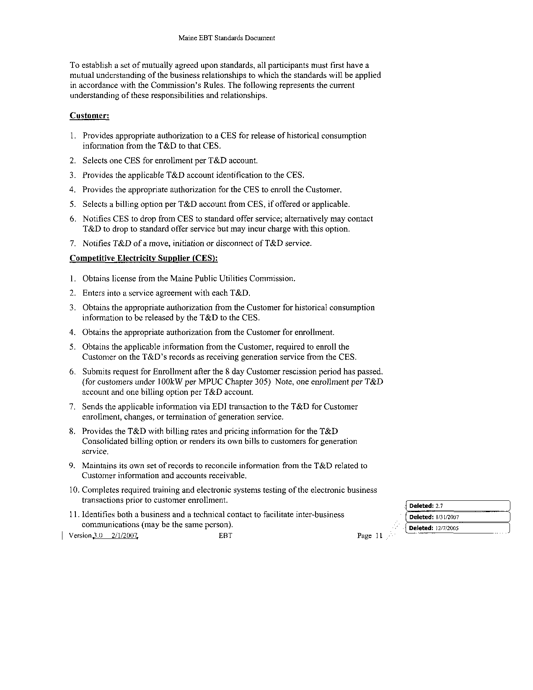

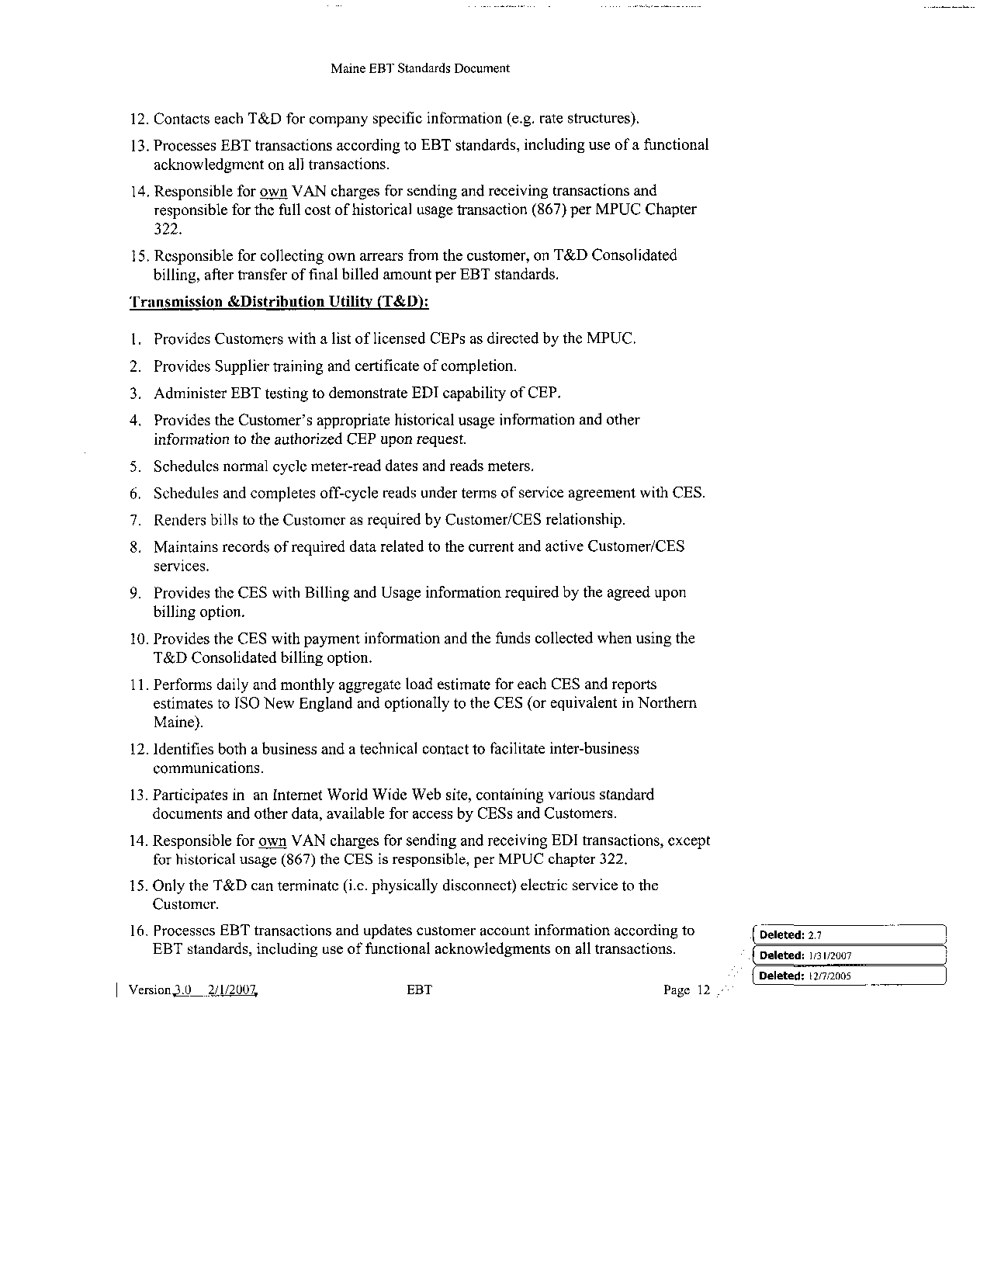

Maine EBT Standards Document
Account Administration

Maine EBT Standards Document





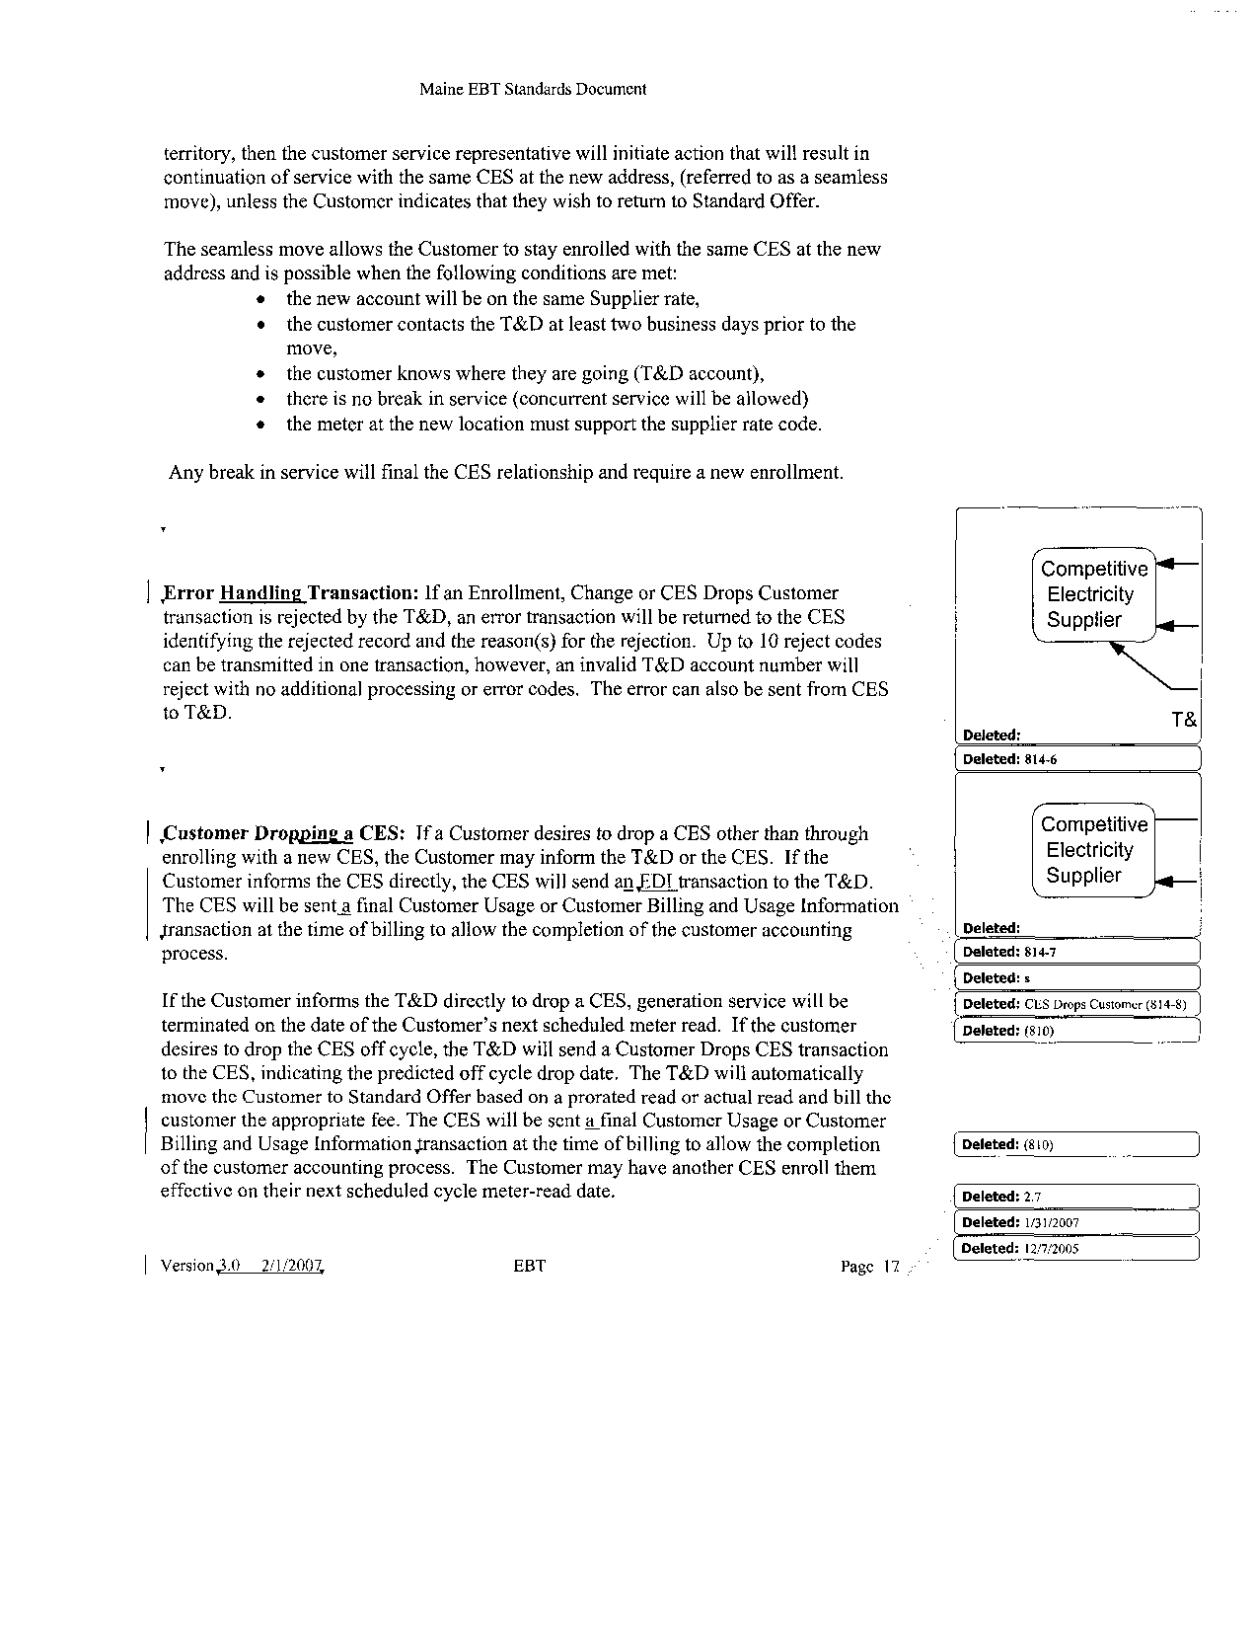

Maine EBT Standards Document

Maine EBT Standards Document

Maine EBT Standards Document

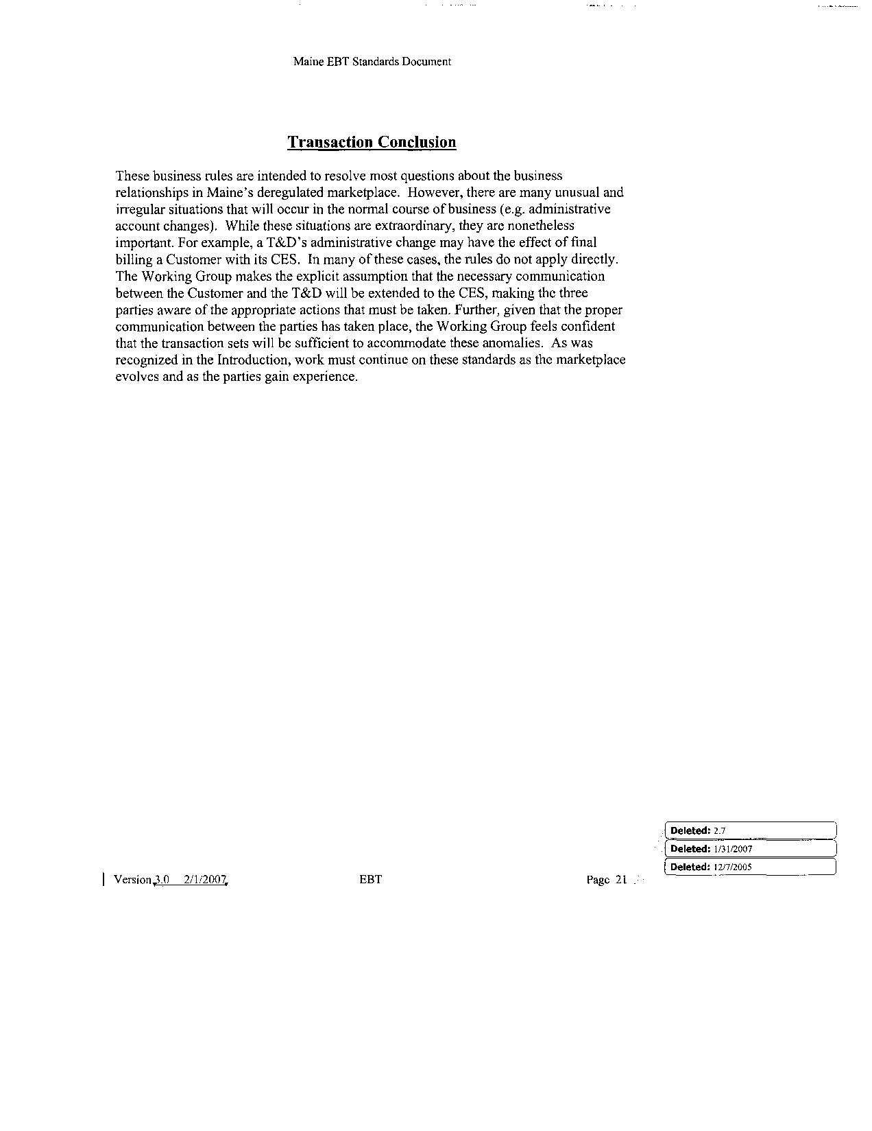

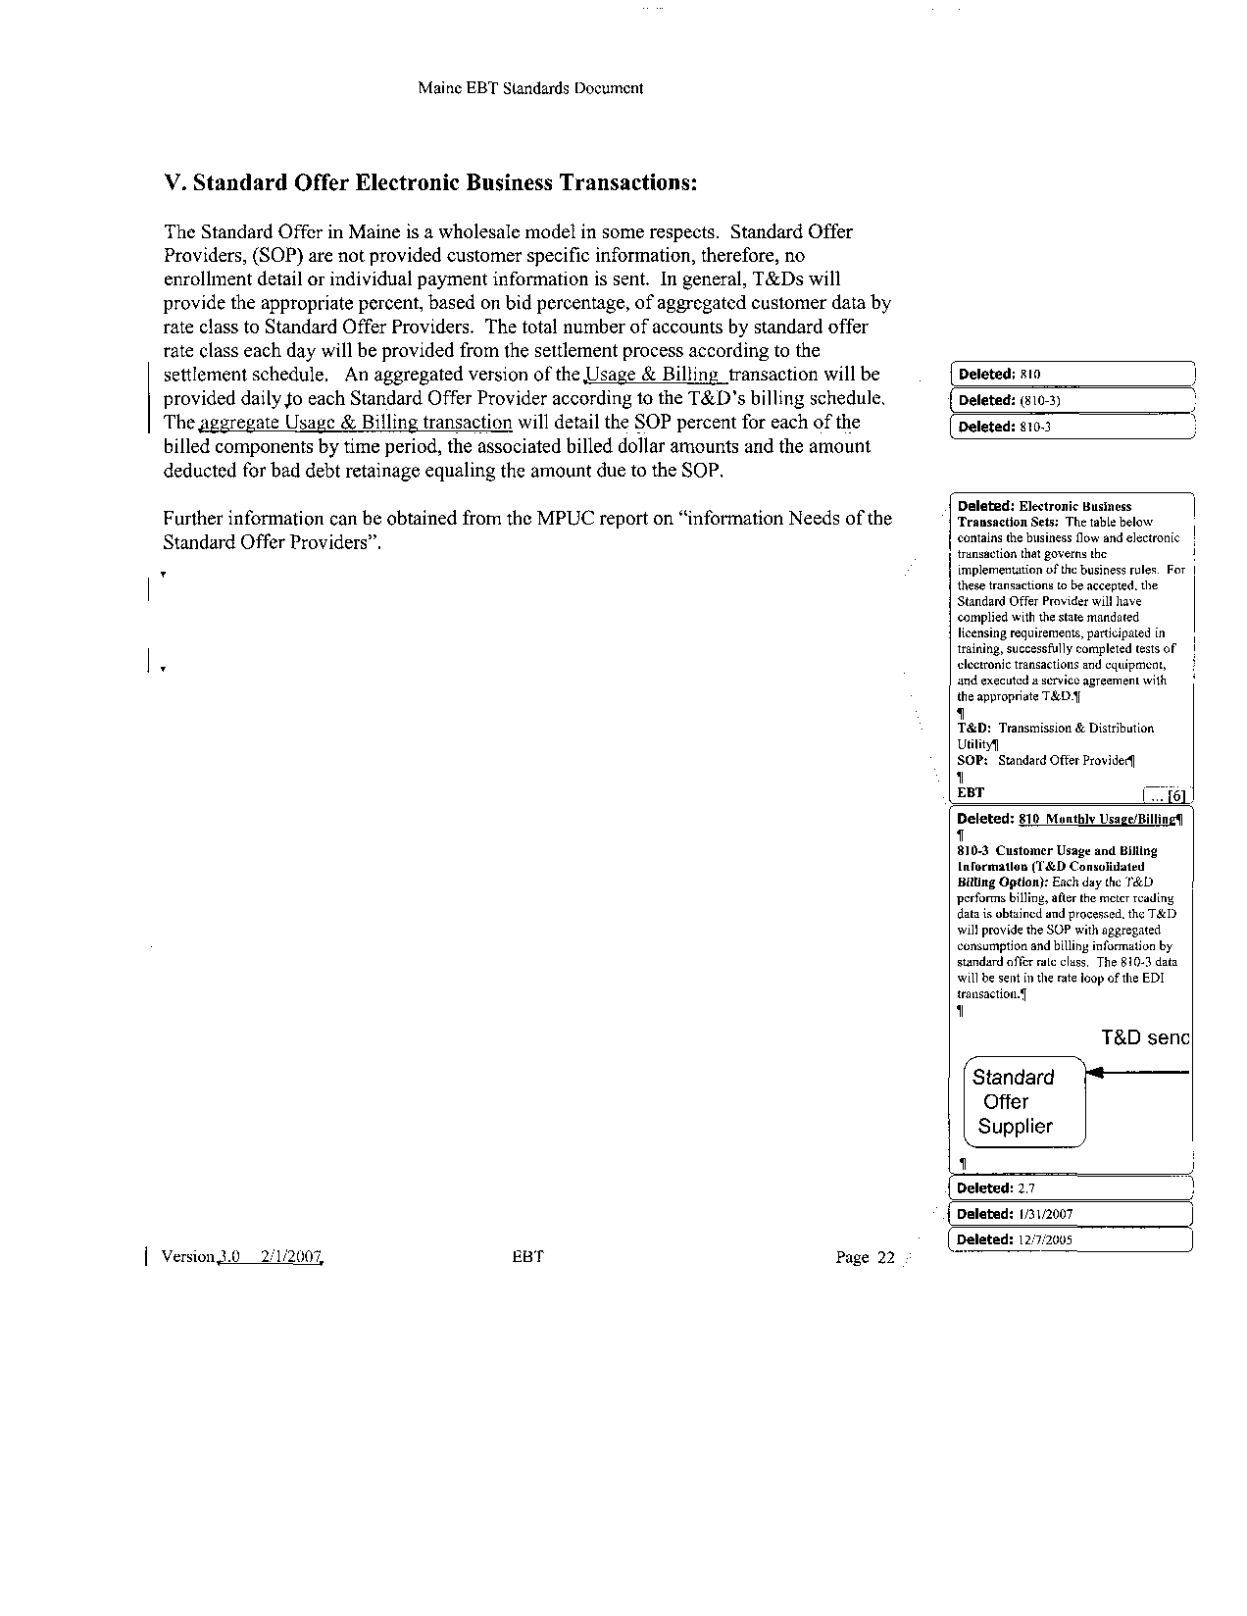

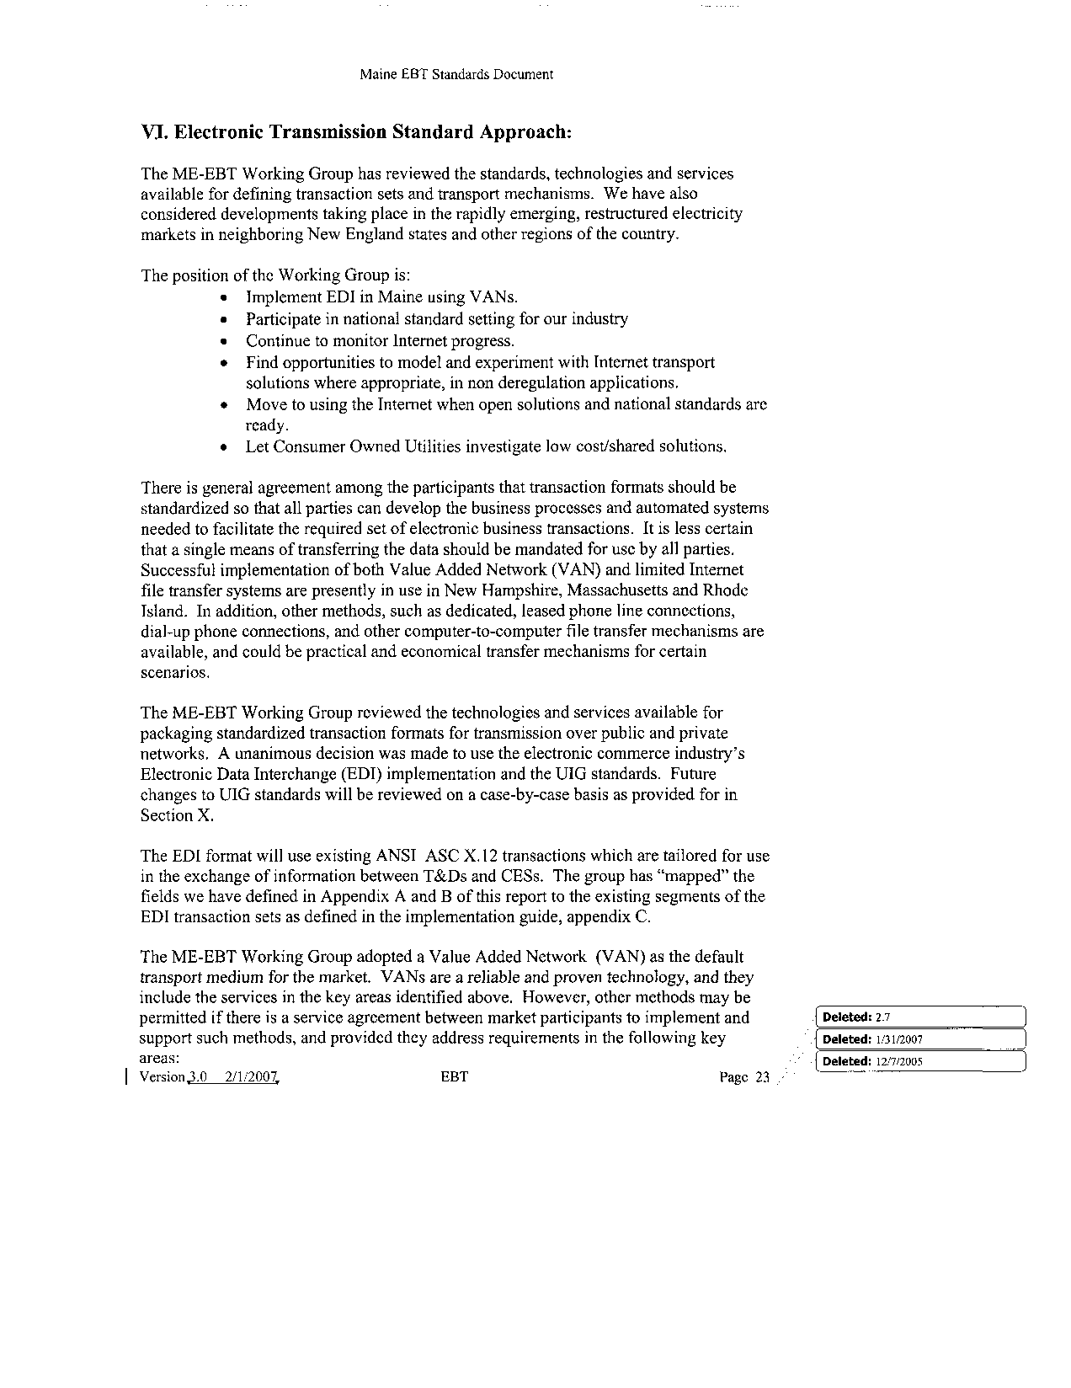

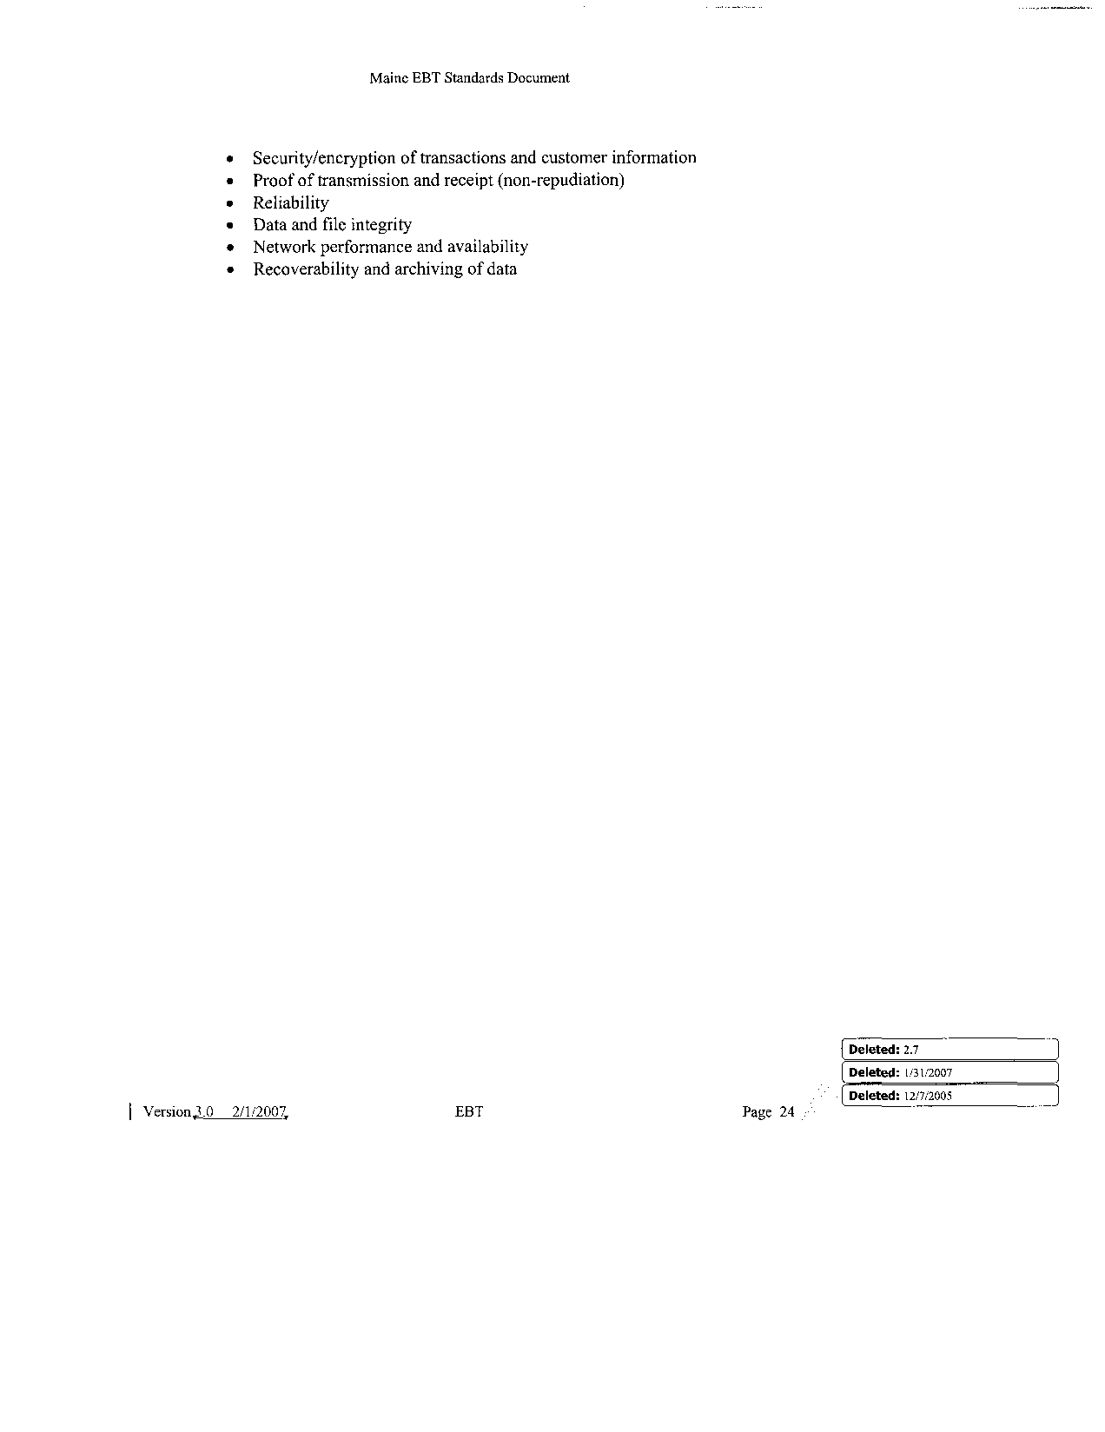

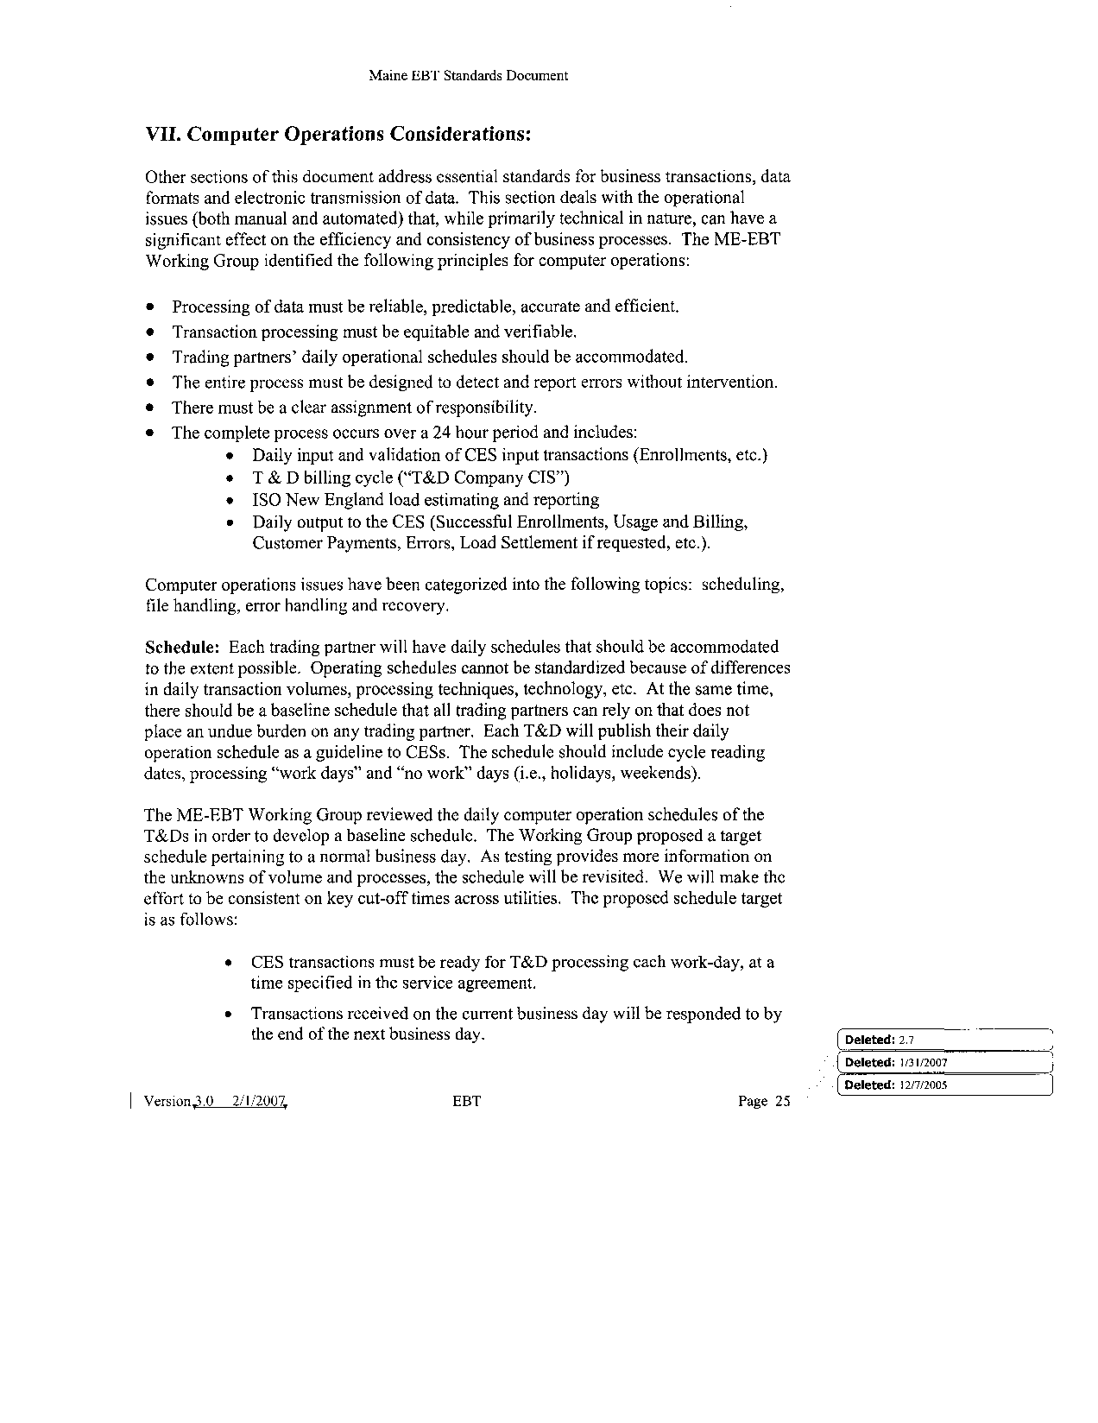

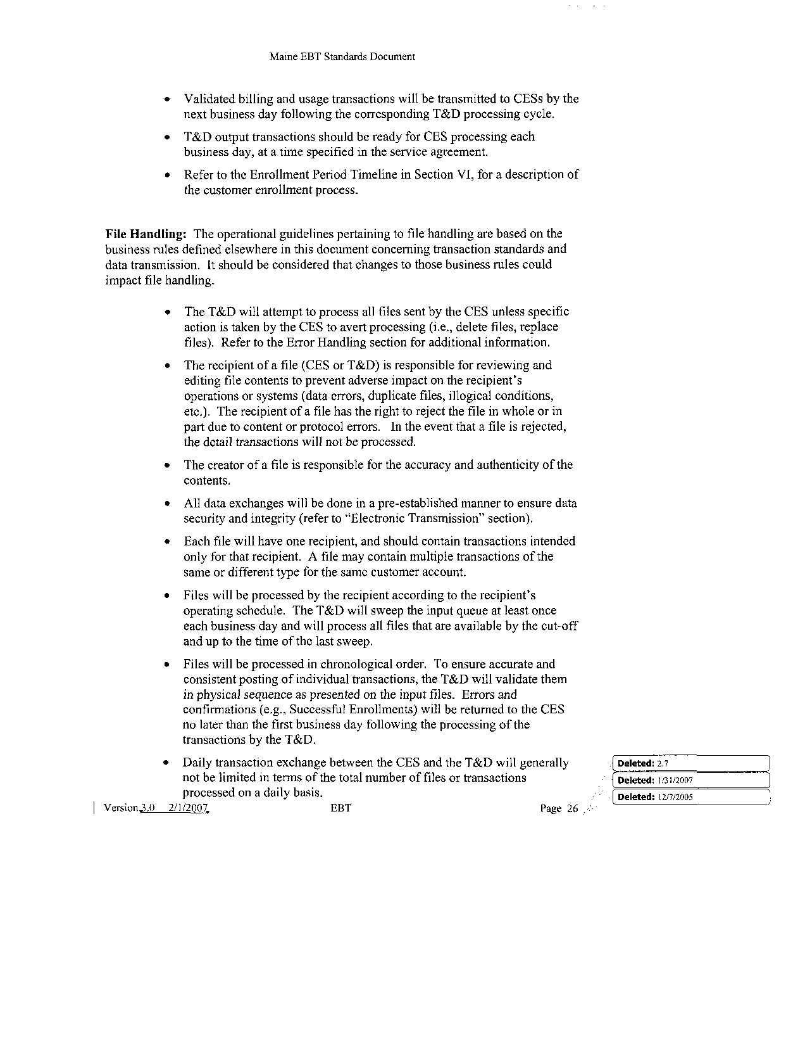

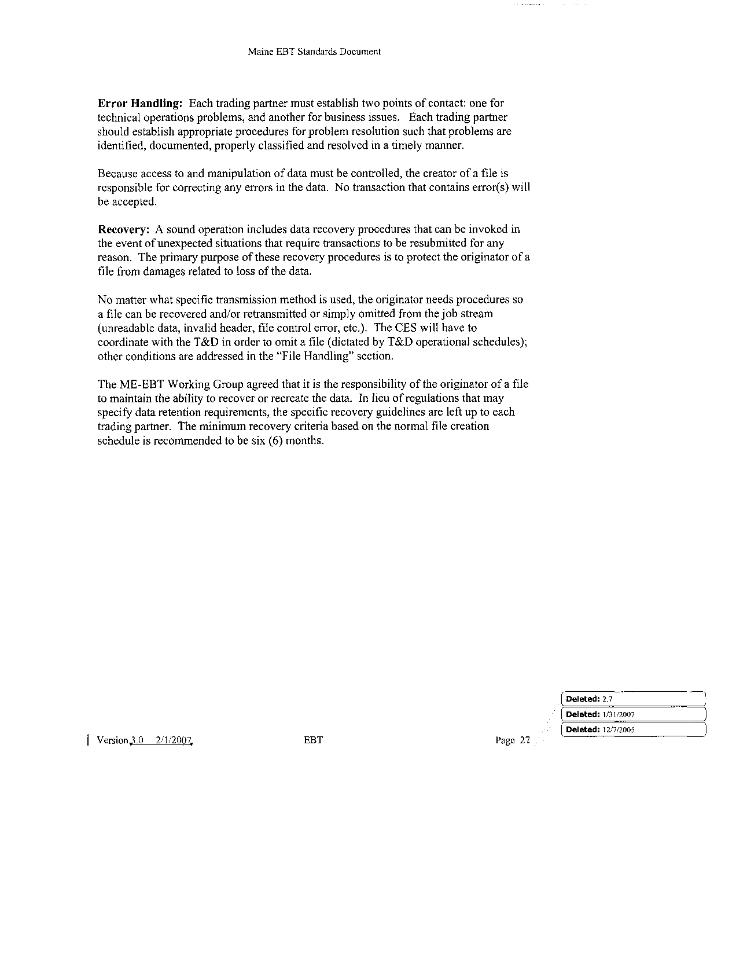

Maine EBT Standards Document

Maine EBT Standards Document

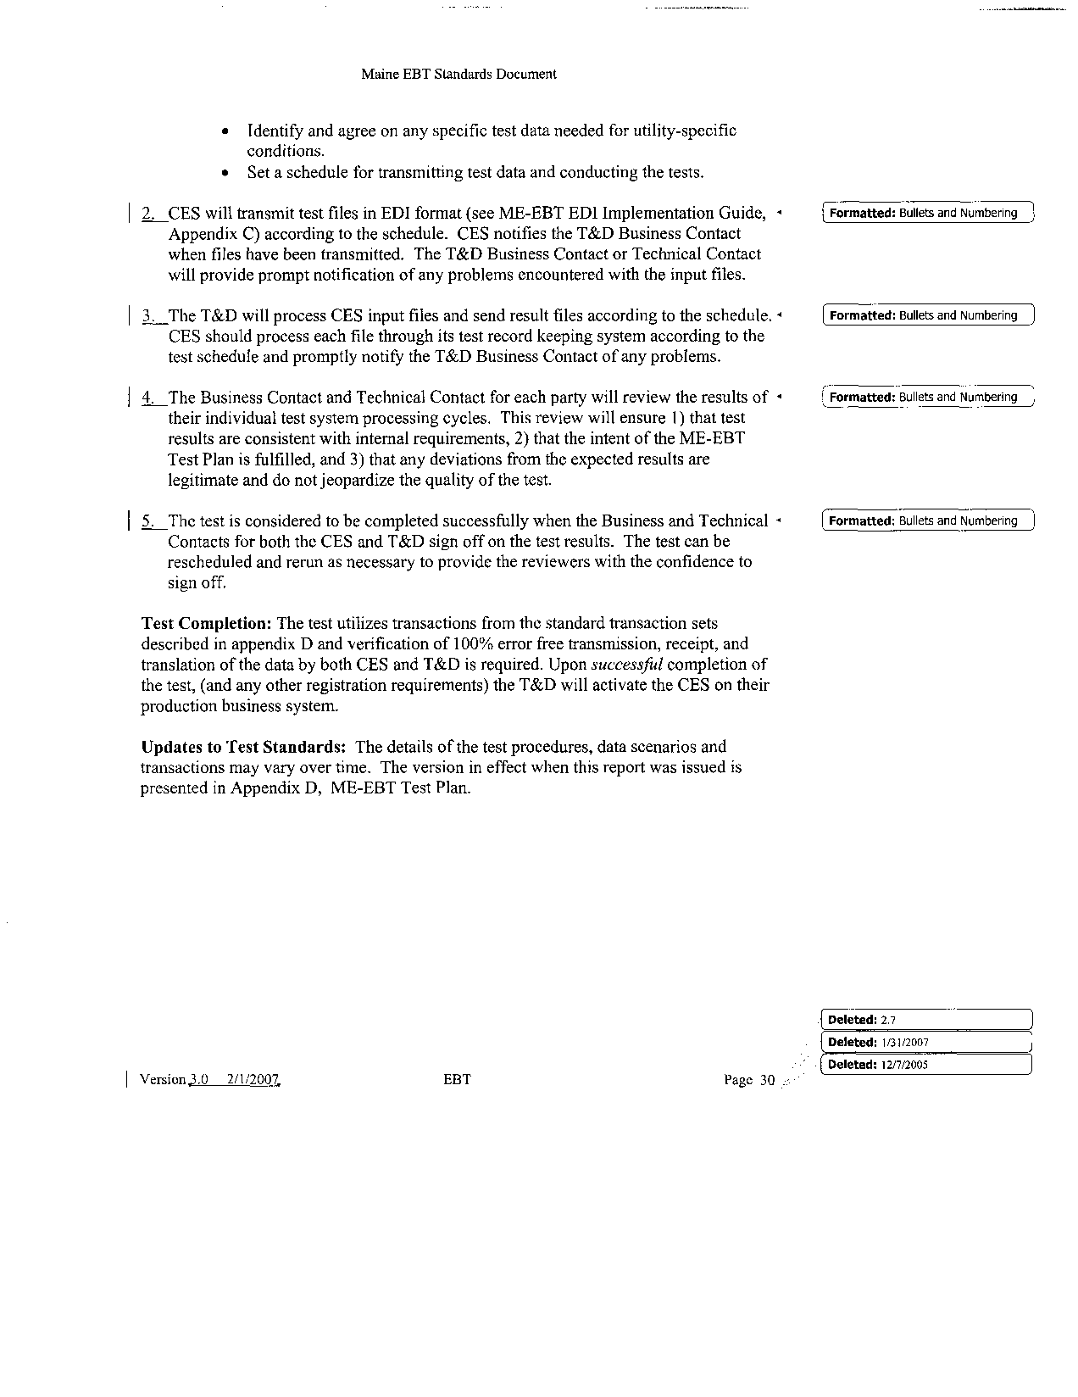

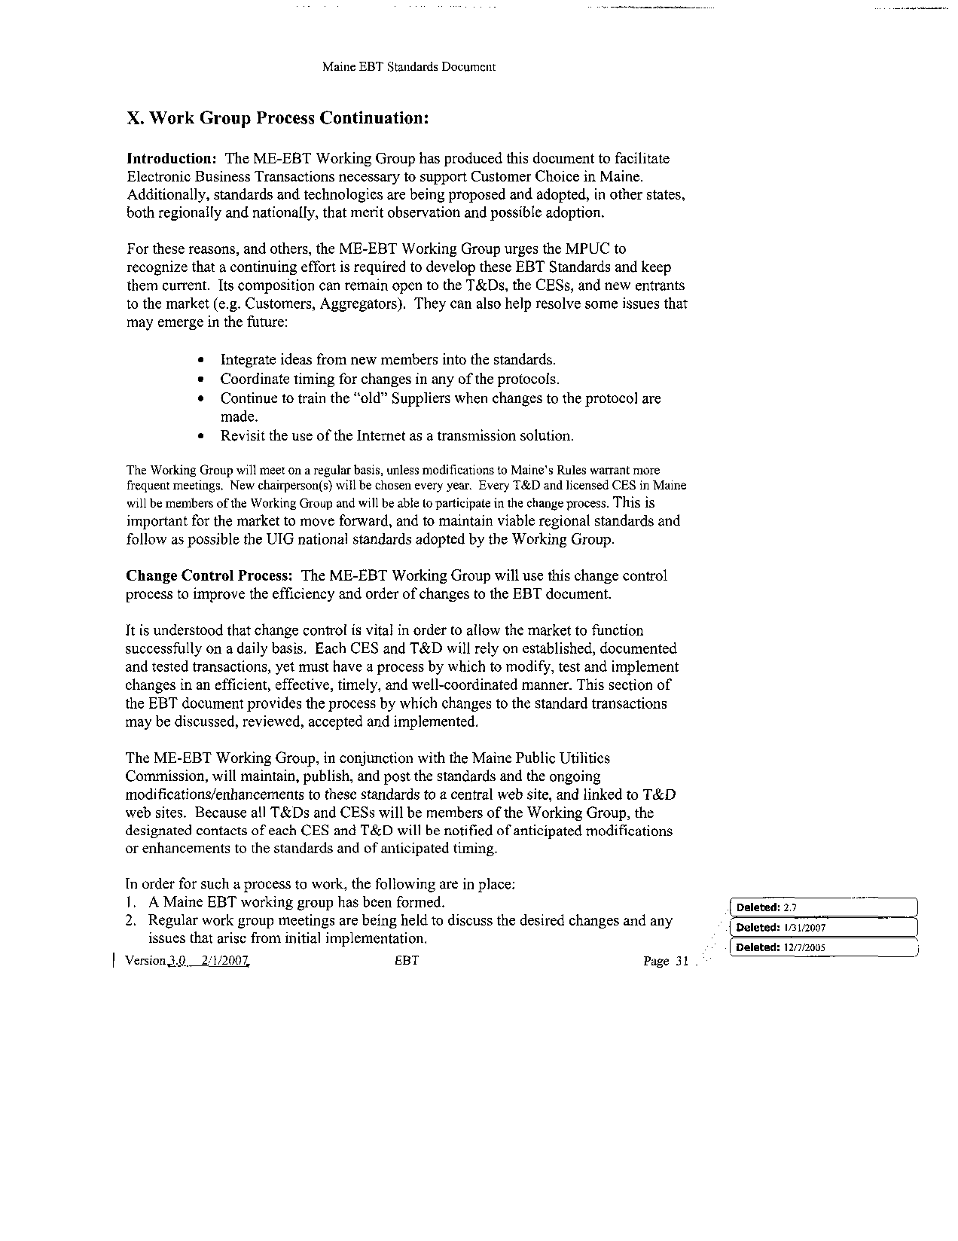

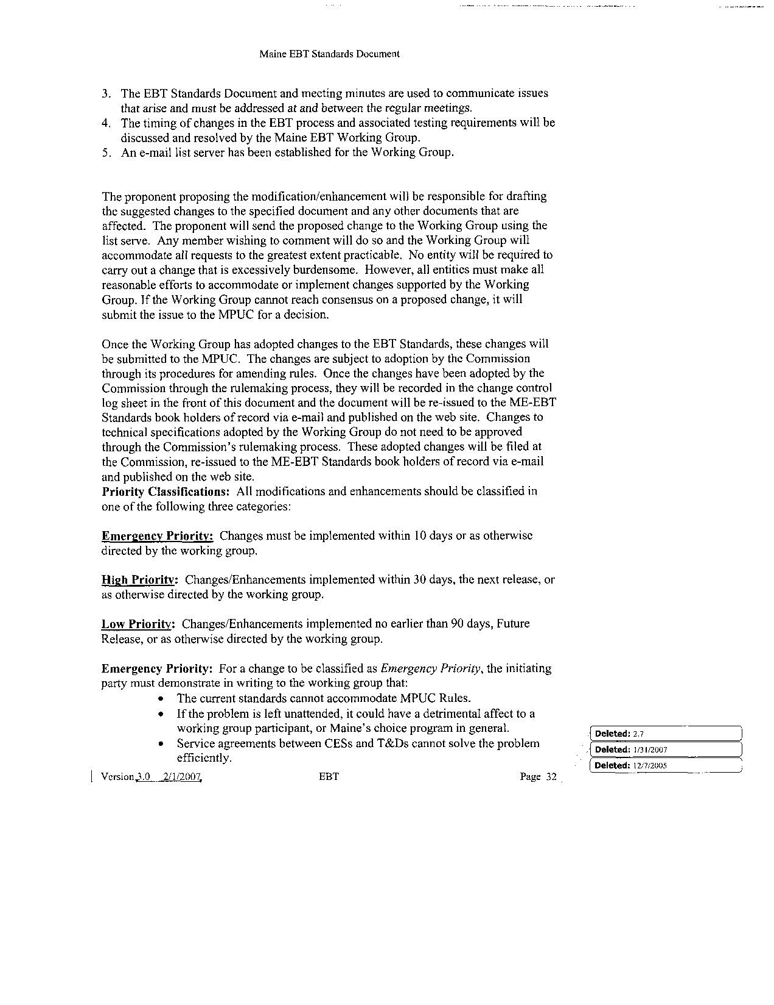

Maine EBT Standards Document

Maine EBT Standards Document



New CES Sends 814-1 Enrollment

Maine EBT Standards Document