13-188 DEPARTMENT OF MARINE RESOURCES
CHAPTER 36: ATLANTIC HERRING

TITLE INDEX

36.01 Atlantic Herring

APPENDICES

Appendix A Map: Atlantic Herring Management Areas

36.01 Herring Management Plan

- Definitions

- Herring. “Herring” means Atlantic Sea Herring, particularly the Clupea Harengus harengus.

- ICNAF gonad stages. “ICNAF gonad stages” are the official stages adopted by the International Commission for the Northwest Atlantic Fisheries in 1964.

Excerpt from ICNAF, 1964, Table 2 definitions:
Stage V. Gonads fill body cavity. Eggs large, round; some transparent.
Ovaries yellowish; testes milk white. Eggs and sperm do not flow,
but sperm can be extruded by pressure.

Stage VI. Ripe gonads. Eggs transparent; testes white; eggs and sperm flow
freely.

- Spawn herring. “Spawn herring” is a sexually mature herring (male or female) in ICNAF gonad stages V or VI.

- Herring harvester. Any person or vessel operator in command of any type of gear used to harvest herring.

- Management Area 1. Management Area 1 is all U.S. waters of the Gulf of Maine encompassed by the shoreline and an imaginary line beginning at the intersection of the 41º 35' N parallel with the eastern shore of Monomoy Island; thence along a straight line in a northeast direction to its intersection with the U.S.-Canada boundary at the point 42º 53' 14" N parallel of latitude and 67º 44' 35" W meridian of longitude; thence in a northerly direction along the U.S.-Canada boundary.

Management Area 1 is subdivided into Area 1A (inshore) and Area 1B (offshore). The line dividing these areas is described by the following coordinates:

Beginning at 70º 00' W Longitude on the Cape Cod shoreline; thence due north to
42º 38.4' N Latitude, 70º 00' W Longitude; thence due northeasterly to
42º 53.0' N Latitude, 69º 40' W Longitude; thence due northeasterly to
43º 12.0’ N Latitude, 69º 00' W Longitude; thence due northeasterly to
43º 40.0’ N Latitude, 68º 00' W Longitude; thence due northeasterly to
43º 58.0’ N Latitude, 67º 22' W Longitude at the U.S.-Canada boundary; thence northerly along the irregular U.S.-Canada boundary.

- Management Area 2. South Coastal Area: All waters west of 70 º 00' W Longitude and south of 41 º 35' N Latitude, to include state and Federal waters adjacent to the states of Massachusetts, Rhode Island, Connecticut, New York, New Jersey, Delaware, Maryland, Virginia, and North Carolina.

- Management Area 3. Georges Bank: All U.S. waters east of 70º 00' W Longitude and southeast of the line that runs from a point at 70º 00' W Longitude and 41º 35' N Latitude, northeasterly to the Hague Line at 67º 44' 35” W Longitude and 42º53' 14” N Latitude.

- Herring dealer. Any person who purchases herring directly from a herring harvester for other than their own use and then sells the herring as a wholesale or retail product.

- GSI. “GSI” means the gonadosomatic index calculated by the following formula:

(Gonad Weight/ Total Body Weight – Gonad Weight) X 100 percent.

- Spawning sample. Sample means a batch of 100 adult herring taken randomly from commercial catch or fish surveys.

- Landing. To come to shore, float or a dock and offload herring; or to transfer herring at sea to a vessel utilizing the herring for bait.

Exception. Fixed gears may transfer at sea to a vessel utilizing the herring as bait.

- Permits and reporting

- Dealer permit. All herring dealers shall obtain a herring dealers permit as part of the Wholesale Seafood License issued by the Department of Marine Resources. There will be no additional charge for this permit. The Commissioner may require that dealer permit holders report volumes of herring bought and sold and other information as required.

- Herring harvester permit. All herring harvesters must possess a Herring Harvester Permit on their Commercial Pelagic and Anadromous Fishing License issued by the Department of Marine Resources.

- Reporting of catch. All harvesters must report all landed or retained fish daily to the Department via an approved electronic reporting option by 11:59 PM the day of landing or retention. If no landings or retention occurred on a calendar day, a negative report is required.

Harvesters. See Chapter 8.20(17) and 8.20(18).

Dealers. See Chapter 8.10 Landings Program.

- Gear and vessel restrictions

- Gear type prohibition. It shall be unlawful to use otter trawls, beam trawls, pair trawls, or midwater trawls to fish for herring within the territorial waters of Maine.

- Vessel Size and Shaft Horsepower. It shall be unlawful for any vessel that exceeds 165 feet length overall (LOA) or no more than 750 gross registered tonnage (GRT) to fish for or take herring within Maine territorial waters or to land herring in any Maine port. It shall be unlawful for any vessel possessing more than 3000 shaft horsepower to fish for or take herring within Maine territorial waters or to land herring in any Maine port.

This rule does not prohibit the landing of herring that are lawfully imported from other countries, territories or states provided the origin of fish is documented.

- Catch restrictions. License holders shall be informed by public notice in a newspaper circulated in the area affected of any restrictions herein.

- Spawning herring protection. It shall be unlawful to fish for, take, possess, transfer or land in any State of Maine port or facility, or to transfer at sea from any Maine registered vessel, any catch of herring harvested from the following described areas within Management Area 1A during a spawning area closure:

- Spawning area boundaries:

Eastern Maine spawning area means:

All waters bounded by the following coordinates:
Maine coast 68° 20.0' W,
43° 48.0' N 68° 20.0' W,
44° 25.0' N 67° 03.0' W,
North along the U.S./Canada border, terminating at the Lubec International Bridge.

Western Maine spawning area means:

All waters bounded by the following coordinates:
43° 30.0' N Maine coast,
43° 30.0' N 68° 54.5' W,
43° 48.0' N 68° 20.0' W,
North to Maine coast at 68° 20.0' W.

Massachusetts/New Hampshire spawning area means:

All waters bounded by the Massachusetts, New Hampshire and Maine coasts, and 43° 30.0' N, 70° 00.0' W.

- Closure Timing. To protect spawning sea herring, the commissioner shall close the Eastern Maine, Western Maine, or Massachusetts/New Hampshire Spawning Areas to directed Atlantic herring fishing effort when it is determined that Atlantic herring are in later stages of maturity just prior to spawning. A closure date will be projected based on a formula and process set forth in the Atlantic States Marine Fisheries Commission’s Amendment 3 (Section 4.2.6) Interstate Fishery Management Plan for Atlantic Herring.

- Closure duration. Once the closure is enacted, it shall remain in effect for 42 days.
- Closure extension. Sampling of Atlantic herring taken from Eastern Maine, Western Maine, or Massachusetts/New Hampshire Spawning Areas shall begin during the last week of the initial closure period or at the end of the initial closure period. If one sample taken from the Eastern Maine or Western Maine Spawning Areas is comprised of 20% or more spawn herring then the closure may be extended for an additional 14 days.

- Closure prohibitions. During the Eastern Maine, Western Maine, or Massachusetts/New Hampshire Spawning Area Closure or an extension thereof, it shall be unlawful for any vessel to possess or land more than 2,000 pounds of sea herring caught within the Eastern Maine, Western Maine, or Massachusetts/New Hampshire Spawning Area.

- Closure procedure. The initial closure date shall be announced 5-days prior to the closure being enacted and any closure extension shall be announced immediately to be enacted the day following the announcement.

- Default closure date ranges: If sufficient samples are not available, spawning area closures will begin and end on area specific dates as follows: Eastern Maine (August 28th – October 8th), Western Maine (September 23rd – November 3rd), Massachusetts/New Hampshire (September 23rd – November 3rd).

- Exemptions

- Transport. Any herring vessel having onboard herring, which were caught outside of a management area that is under a herring spawning closure, may transit the closed or restricted area and land at a Maine port, only if all of its fishing gear has been stowed.

- Fixed gear. The fixed gear (stop seines and weirs) fishery east of Cutler is exempt from spawning area restrictions.

- Catch quota. Fishing for herring in Management Areas 1A, 1B, 2 and 3 is subject to the sub-annual catch limit (ACL) and fishing effort restrictions specified by the ASMFC Atlantic Herring Board and the NEFMC in accordance with their respective Fisheries Management Plans (FMP). The ACL is established annually by July 1 for the following year by ASMFC and NEFMC. Any reduction in the harvest will be determined in consultation with the ASMFC and NEFMC. No person shall land herring taken from a management area when 92% of the area’s seasonal or sub- annual catch limit will be exceeded or if 95% of the coastwide annual catch limit will be exceeded.

- Exception. Up to 30 mt of the Area 1A sub-ACL is allocated for the fixed gear fisheries in Area 1A (weirs and stop seines) west of Cutler. This set-aside is available for harvest by fixed gear within the fishing year until the fixed gear set aside is fully utilized. No person shall land herring taken from Area 1A with fixed gear when 92% of the fixed gear set-aside portion of the Management Area 1A sub-ACL will be exceeded.

- Effort restrictions

- Management Area 1A, January 1st – May 31st. For the period of January 1st through May 31st, 0% of the sub-ACL is allocated annually. Herring may only be landed from Management Area 1A on days that have been designated landing days by the Atlantic States Marine Fisheries Commission (ASMFC). ASMFC designates zero landing days between January 1st and May 31st, annually.

- Management Area 1A, June 1st – December 31st. For this period, 100% of the sub-ACL is allocated annually and further sub-divided into two seasonal periods. Season 1 is June 1st through September 30th and is allocated 72.8% of the sub-ACL. Season 2 is October 1st through December 31st and is allocated 27.2% of the sub-ACL. Atlantic herring may only be landed from Management Area 1A on days that have been designated landing days by the ASMFC. All vessels landing herring caught in Season 1 of Management Area 1A in any Maine port will be limited to fishing for and landing herring on days that have been designated landings days by the ASMFC. All vessels landing herring caught in Season 2 of Management Area 1A in any Maine port will be limited to landing herring on days that have been designated landing days by ASMFC.

All vessels landing herring caught in Management Area 1A in any Maine port are limited to one landing per 24 hour period (6 pm to 6 pm).

- For the purpose of this subsection, the following terms shall be defined as follows:

- At-sea transfer. “At-sea transfer” means to transfer herring from a vessel to another vessel before the harvester vessel has landed.

- Harvester vessel. “Harvester vessel” is a purse seine vessel that is required to report the catch it has aboard (along with effort data under a gear code other than CAR) as the harvesting vessel on its Federal Vessel Trip Report.

- Carrier vessel. “Carrier vessel” is a vessel that has received herring from another vessel and is not required to report that catch as its own on its Federal Vessel Trip Report; and, not rigged as a purse seine vessel.

- Purse seine vessel. “Purse seine vessel” is a vessel currently rigged and capable of harvesting fish with an encircling net with floats on the top edge, weights and a purse line on the bottom edge, and associated gear to set, purse and haul such a net, which may include, but not limited to, a hydraulically-driven block, roller gear, and/or skiff.

- Truck. “Truck”, as a unit of measurement, is equal to 40,000 lbs.

- Harvester vessels. There are zero landing days designated from October 1, 2026 through October 11, 2026. Harvest begins on Monday, October 12, 2026, at 12:01 a.m. through Tuesday, October 13, 11:59 p.m. then followed by zero landing days from October 14, 2026 through November 8, 2026. Four consecutive landing days have been designated starting Monday, November 9, 2026 at 12:01 a.m. through to Thursday, at 11:59 p.m., weekly.

- For all harvesters issued a state Commercial Pelagic and Anadromous license with a Herring Harvester Permit that do not possess a Federal Limited Access Herring Permit:

No vessel may land, take or possess more than 25,000 lbs per week. No permit holder may land, take or possess more than 25,000 lbs per week.

Exception. Harvesters using fixed gears (fishing weirs, stop seines), and pound nets are not subject to the harvest schedule detailed above. Weekly landing limits apply.

- For all vessels issued a Federal Limited Access Atlantic Herring Permit Category A:

The permit holder must have declared into the Atlantic Herring fishery by April 15th, annually, to be eligible to harvest.

- For all vessels issued a Federal Limited Access Atlantic Herring Permit Category C:

Daily trip limit shall not exceed 55,000 lbs per day.

- For all vessels issued a Federal Limited Access Atlantic Herring Permit Category D:

Daily trip limit shall not exceed 6,600 lbs per day.

- Carrier Vessels. Carrier vessels shall not operate as a harvester vessel on the same trip when operating as a carrier vessel.

- Exceptions. Any vessel may possess herring as an incidental catch and land herring caught in Management Area 1A, 1B, 2 or 3, in any Maine port, as long as such herring do not comprise more than 10% of the total weight of the catch and not to exceed 2000 lbs per trip.

An individual may fish or take by hook and line up to 100 Atlantic herring per day for personal use only.

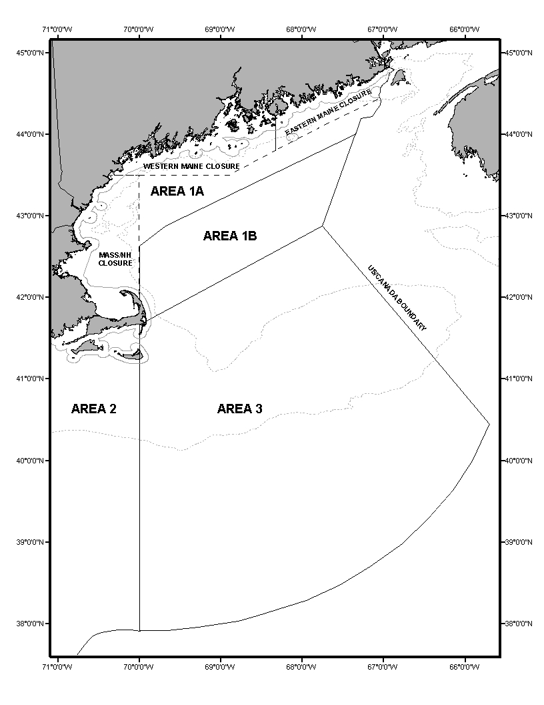
Appendix A:
Atlantic Herring Management Areas

INDEX

STATUTORY AUTHORITY
12 M.R.S. § 6171

EFFECTIVE DATE:
July 27, 1979
AMENDED:
October 1, 1979 – Artificial lights exception
June 30, 1980
June 30, 1981
July 4, 1981 – Section 36.01
October 26, 1981
November 23, 1981 – Section 36.15
April 28, 1983 – Section 36.01
September 15, 1983 – Section 36.16 (EMERGENCY)
October 1, 1983 – Section 36.01 (EMERGENCY)
August 13, 1984 – Section 36.01
September 21, 1995 – Section 36.01(B) (EMERGENCY)
September 21, 1996
August 19, 1997 – Section 36.01(A)
September 16, 1997 – Section 36.01(B), map
November 19, 1997 – Section 36.01(C), renumbering
August 25, 1998 – Section 36.01, chart
August 28, 1999 – Section 36.01amended; Sections 36.05, 36.15 repealed
July 29, 2000 – Section 36.01(A-D)
August 15, 2001 – Section 36.01(D)(1)(a) (EMERGENCY)
November 25, 2001 – Section 36.01(D)(a)
December 17, 2003 – Section 36.01(B)(3)
January 1, 2005 – Section 36.01(D)(2)(a)
August 15, 2006 – Section 36.01(D)(1)
January 1, 2007 – Section 36.01(A)(5-7)
September 24, 2007 – Section36.01(D)(1,3)
June 21, 2010 – Section 36.01(D)(2) (EMERGENCY)
August 23, 2010 – Section 36.01(D)(2)
October 26, 2010 – Section 36.01(B)(2,3)
June 22, 2016 – Section 36.01(D)(2) (EMERGENCY)
July 2, 2016 – Section 36.01(A)(5-7,10), 36.01(D)(1)(2,3)
July 9, 2016 – Section 36.01(D)(3)
September 25, 2016 – Section 36.01
June 2, 2017 – Section 36.01(A)(11), 36.01(B)(2), 36.01(D)(3)(a), 36.01(D)(3)(b)
(EMERGENCY)
June 30, 2017 – Section 36.01(D)(3)(a,b) (EMERGENCY)
July 28, 2017 – Section 36.01(D)(3) (EMERGENCY)
August 8, 2017 – Section 36.01(A)(11), 36.01(B)(2,3), 36.01(D)(3)(a), 36.01(D)(3)(b)
September 17, 2017 – Section 36.01(D)(3)(ii)(B), 36.01(D)(3)(iii)(c) (EMERGENCY, Expires
December 16, 2017)
December 18, 2017 – Section 36.01(D)(3)(c) (EMERGENCY, Expires March 17, 2018)
June 2, 2018 – Sections 36.01(D)(3)(b), 36.01(D)(3)(b)(ii), 36.01(D)(3)(B-D)(iii)(c)
(EMERGENCY)
September 12, 2018 – Section 36.01(D)(3)(b) (EMERGENCY, Expires December 11, 2018)
September 29, 2018 – Section 36.01(D)(3)(c) (EMERGENCY, Expires December 11, 2018)
November 16, 2018 – Section 36.01(D)(3)(c) (EMERGENCY, Expires February 14, 2019)
March 13, 2019 – Section 36.01(B,D)
June 1, 2019 – Section 36.01(D) (EMERGENCY, Expires August 29, 2019)
July 17, 2019 – Section 36.01(D)
August 17, 2019 – Section 36.01(D) (EMERGENCY)
September 15, 2019 – Section 36.01(D) (EMERGENCY)
November 2, 2019 – Section 36.01(D) (EMERGENCY)
November 13, 2019 – Section 36.01(B)(2)
November 30, 2019 – Section 36.01(D) (EMERGENCY)
March 15, 2020 – Section 36.01(A)(8,11), (B)(2,3), (D)(2,3),(3)(b)(ii)
August 22, 2020 – Zero landing days (EMERGENCY)
October 6, 2020 – Season 2 opens (EMERGENCY)
November 3, 2020 – Modify season 2 (EMERGENCY)
June 1, 2021 – 2021 Harvest rules (EMERGENCY)
October 1, 2021 – Season 2 Closed (EMERGENCY)
November 6, 2021 – Season 2 Open (EMERGENCY)
May 31, 2022 – 2022 Season 1 Open (EMERGENCY)
September 29, 2022 – 2022 Season 2 Harvest Controls (EMERGENCY)
March 18, 2023 – Section 36.01(B)(3), 36.01(D)(3)(b)
May 31, 2023 – 2023 Season 1 Open (EMERGENCY)
September 30, 2023 –2023 Season 2 Opens (EMERGENCY)
March 19, 2024 – Section 36.01B(3), (D)(1)(a,b), (3)(b)(ii)
May 31, 2024 – 2024 Season 1 Open (EMERGENCY)
October 1, 2024 –2024 Season 2 Opens (EMERGENCY)
May 31, 2025 – 2025 Season 1 Open (EMERGENCY)
September 30, 2025 – 2025 Season 2 Effort Controls (EMERGENCY)
November 4, 2025 – 2025 Season 2 Effort Controls (EMERGENCY)
November 23, 2025 – 2025 Season 2 Effort Controls (EMERGENCY)
December 18, 2025 – 2025 Season 2 Effort Controls (EMERGENCY)
May 30, 2026 – 2026 Season 1 Open (EMERGENCY) – filing 2026-126

NONSUBSTANTIVE FORMATTING UPDATES; RULE HISTORY SECTION UPDATES:
September 3, 2026

AMENDED:
September 30, 2026 – 2026 Season 2 Effort Controls (EMERGENCY, Expires December 29,
2026) – filing 2026-212

