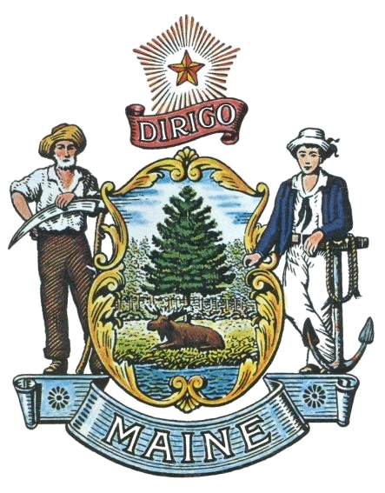
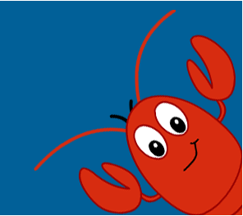
State of Maine
Office of the Secretary of State
2022-2023
Student Programs

SHENNA BELLOWS
SECRETARY OF STATE
At the Secretary of State, we are excited to offer a variety of free educational programs designed to promote civic participation and awareness of Maine’s history. To learn more, please visit our website: www.maine.gov/sos/kids/ or contact our office at (207) 626-8400 or sos.office@maine.gov.

To sign up, please fill out the attached participation sheet.

Maine Student Mock Election - www.maine.gov/sos/kids/mockelection/
Election years are great opportunities for learning about democracy. We’re excited to host a VIRTUAL Maine National Student/Parent Mock Election on October 25, 2022. Participating schools will receive mock ballots for the gubernatorial and Congressional races as well as materials for tallying the vote. We are also producing video content to be shared with classes and student cohorts. Voting can happen up to and including on October 27 to accommodate student cohorts. Use the enclosed sheet to sign up and watch for registration details soon.

Native American History and Culture Essay Contest - maine.gov/sos/kids/programs/nativeamerican
Open to both middle and high schools, this contest is designed to give students an opportunity to showcase what they have learned in Maine Native American Studies. Each student will receive a participation certificate. Selected essays in both middle and high school categories receive an award certificate. Essays due by November 10, 2022.

Donate Life Maine High School Poster Contest - donatelifenewengland.org/poster-contest/
This contest, sponsored by New England Donor Services, asks students to create a poster that brings awareness to organ and tissue donation. Prizes are awarded to the top three entries and teachers may earn a prize for the most student submissions. Visit the link above for contest rules and application. Entries are due March 3, 2023.

Maine Symbols and History Poster Contests - maine.gov/sos/kids/programs/constitution-essay
One of our most popular programs, this contest gives students in grades K-6 an opportunity to show what they know about Maine through poster art. Each student will receive a participation certificate. Students submitting winning entries receive an award certificate. Submissions are due March 10, 2023.

Maine Constitution & Democracy Essay Contests - maine.gov/sos/kids/programs/constitution-essay
One of our most popular programs for middle and high school students, this contest gives students in grades 6-12 an opportunity to show what they know about Maine. Each student will receive a participation certificate. Students submitting winning entries receive an award certificate. Submissions are due March 10, 2023.

Eighth-Grade Citizenship Awards - maine.gov/sos/kids/programs/eighth-grade-citizenship-award
This program recognizes students for their civic awareness, scholastic achievements, and community service. In 2022, 121 schools honored an eighth-grader with the Secretary of State’s Citizenship Award. Only one student will receive an award per school. Nominations for next year’s program are due by May 18, 2023.

John Lewis Youth Leadership Award - maine.gov/sos/kids/programs/award
The Secretary of State’s Office will be accepting nominations for the John Lewis Youth Leadership Award recognizing one Maine resident, age 25 or younger, who demonstrates leadership abilities, has a passion for social justice, and is improving the quality of life in their community. Visit the John Lewis Youth Leadership Award webpage for more information. Nominations are due by May 5, 2023.

Congressional Medal of Honor Project - maine.gov/sos/kids/programs/cmoh
A great idea for a service-learning project: Students study a local Congressional Medal of Honor recipient and, then work with the community to bring attention to an existing memorial or establish a memorial for the recipient. Students engage in research, design, presentations, fundraising and planning for an enduring memorial.

Maine State Archives Educational Programs

The Maine State Archives offers a variety of educational programs that can be tailored to your specific interest or research focus. Each presentation begins with a discussion of the necessity of a state archive and the different types of records in our holdings. The archivists will display and explain primary source documents and tailor the discussion to your region of the state. If you have a particular topic that you are interested in exploring with your class, just let us know! To schedule a program, contact State Archivist Katherine McBrien at 287-5790 or katherine.mcbrien@maine.gov.

Statehood for Maine
The effort to separate the District of Maine from the State of Massachusetts took many years and much negotiation, including at the federal level. This program looks at the reasons behind Maine’s separation from Massachusetts and the process in which we formed our own state. Recommended for grade 4 and above.

Malaga Island
State Archivist Kate McBrien is a leading expert on the community who lived on Malaga Island. This 40-minute presentation and discussion explores the true history of the community who lived on Malaga Island, off the coast of Phippsburg, in the late 1800s. The program examines the individuals who were part of this community and the state’s actions to evict them from their homes through the complex history of racism and eugenics in Maine.

Maine in the Civil War
This program explores the impact that Maine had on the Civil War and the impact the Civil War had on Maine. The presentation brings the topic to a local level, with accounts of people in your town or neighboring towns who contributed to or participated in the war effort. Recommended for grade 5 and above.

Topic of your choice
What is your group or class studying about Maine’s history and the role of our state government? How can we help? Maine State Archives staff are available to discuss and explore additional program topics, based on your need and our documents. Give us a call at 287-5790.

Ask the Archivist
Learners of all ages need help with research from time to time. If you are stuck in your research or need suggestions on where to start, our archivists are here to help! This can be especially helpful for school projects, including National History Day, or genealogy research. Contact maine.archives@maine.gov or call 287-5790 to schedule a one-hour work session.

