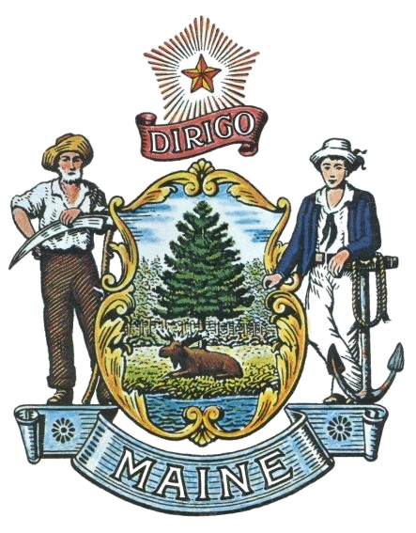
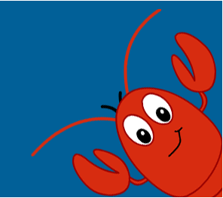
State of Maine
Office of the Secretary of State
2022-2023
Student Programs

SHENNA BELLOWS
SECRETARY OF STATE
Save the Dates!
Maine Secretary of State Educational Programs

Dates | Events & Deadlines | Ages
October 19, 2022 | Registration Deadline for Mock Election | Grades 4-12
October 25, 2022 | Maine Mock Election Day | Grades 4-12
November 10, 2022 | Native American History and Culture Essay Contest Submissions Due | Grades 6-12
December 16, 2022 | Native American History and Culture Essay Contest Winners Announcement | Grades 6-12
March 3, 2023 | Donate Life Poster Contest  Submissions Due | Grades 9-12
March 10, 2023 | Maine Symbols Poster Contest Submissions Due | Grades K-3
March 10, 2023 | Maine History Poster Contest Submissions Due | Grades 4-5
March 10, 2023 | Maine Constitution Essay Contest  Submissions Due | Grades 6-8
March 10, 2023 | The Importance of Voting and Democracy Essay Contest Submissions Due | Grades 9-12
April 14, 2023 | Maine Symbols Poster Contest  Winners Announcement | Grades K-3
April 14, 2023 | Maine History Poster Contest  Winners Announcement | Grades 4-5
April 14, 2023 | Maine Constitution Essay Contest  Winners Announcement | Grades 6-8
April 14, 2023 | The Importance of Voting and Democracy  Essay Contest Winners Announcement | Grades 9-12
May 18, 2023 | Eighth Grade Citizenship Award  Nominations Due | Grade 8
May 5, 2023 | John Lewis Youth Leadership Award Nominations Due | Ages 25 or younger
June 1, 2023 | John Lewis Youth Leadership Award  Winner Announcement | Ages 25 or younger

