29 DEPARTMENT OF SECRETARY OF STATE

250 BUREAU OF MOTOR VEHICLES

Chapter 173: RULES FOR THE SALE, PURCHASE, REMOVAL, TRANSPORT, AND DISPOSAL OF CATALYTIC CONVERTERS

1. SUMMARY: This rule establishes the requirements for the sale, purchase, removal, and transport of catalytic converters. The rule sets forth required marking methods, pertinent information to marking, and reporting requirements to be utilized by licensed recyclers, scrap metal processors, new and used car dealers, as well as private individuals.

2. Definitions: Unless otherwise defined, terms have the same meaning as in Title 29-A.

A. Accessible: In a location where any surface of the catalytic converter can be marked without dismantling any part of the vehicle.

B. Engrave: To inscribe a VIN onto an accessible surface by means of carving or etching.

C. Legible: Letters and numbers that are clear and distinct.

D. Manifest: Written document required for the transport of catalytic converters.

E. Permanent Marking: Once marked, the information will not wear off through normal handling, transportation, or weather conditions.

F. Vehicle Identification Number (VIN): Means a seventeen-digit number assigned to a vehicle by the manufacturer or a Maine assigned identification number.

G. Visible: Conspicuous and easy to see.

H. Wholesale: Transactions conducted between two licensed dealers.

3. REQUIREMENTS AND METHODS FOR MARKING CATALYTIC CONVERTERS FOR PRIVATE INDIVIDUALS

A. Requirements: Private individuals who detach a catalytic converter for replacement shall legibly mark the catalytic converter.

B. Marking Standard: The marking shall consist of the complete and legible VIN in a single line. If there is not adequate space to mark on one line, the VIN may be marked in multiple lines in the correct number sequence.

C. Marking Errors: A straight line shall be drawn through the entire VIN when an error is made in marking. The correct VIN shall be marked directly below; if there is not adequate space, the correct vin shall be marked in the general area.

D. Method: The marking shall be made by engraving or a method of permanent marking.

E. Missing Number: Individuals who own catalytic converters that do not have a legible or complete 17-digit VIN may request an assigned number from the Secretary of State Enforcement Division through the process outlined in section 4 of this rule.

4. REQUIREMENTS FOR REQUESTING A CATALYTIC CONVERTER IDENTIFICATION NUMBER FROM THE SECRETARY OF STATE

Individuals in possession of catalytic converters that have damaged or missing 17-digit vehicle identification numbers shall request an assigned identification number.

A. Process

1. A requestor must complete the online request form (MVI-29) found on the Bureau of Motor Vehicles website and submit supporting documentation listed in subsection B of this section.

2. Once the MVI-29 is received by the Bureau, an acknowledgment will be provided to the requestor and a temporary VIN number will be issued for a temporary period of up to 30 days.

3. The investigation will consist of reviewing and analyzing all relevant information and supporting documentation.

4. Once confirmation of information and review of documentation is complete, the responsible detective will contact the requestor to arrange a time to permanently mark the catalytic converter, at no cost to the requestor. The detective will complete an MVI-30 form at the time of marking which must be signed by the requestor attesting to the accuracy of the information.

5. The Secretary of State shall maintain a record of all requests made for a period of five years.

6. Transportation: Transportation of a catalytic converter is prohibited without an identifying number engraved or marked.

(a) A catalytic converter may be transported without identifying markings if it is being returned to a manufacturer of the vehicle in accordance with manufacturer specifications as a core part, which will be replaced with a new converter.

7. Recovery and Disposal: Catalytic converters for which a detective determines that an identification number may not be assigned will be handled in accordance with 29-A M.R.S. §1113(15).

B. Supporting Documentation

1. A requestor submitting a request for a state-issued identification number must submit documentation sufficient to prove ownership of a catalytic converter(s) at the time of the request.

2. This documentation may include, but is not limited to:

a. Sworn affidavit by the requestor, or witness detailing the circumstances as to how the catalytic converter came into the requestor’s possession;

b. Copy of dealer contract showing proof of purchase of the vehicle containing unmarked catalytic converter;

c. Photographic evidence;

d. Other documentation showing proof ownership of the property.

C. Marking: The Secretary of State shall permanently mark the catalytic converter.

D. Disposal: Once a catalytic converter receives a state-issued number, all forms given to the requestor must remain with the catalytic converter.

5. REQUIREMENTS AND METHODS FOR MARKING CATALYTIC CONVERTERS FOR LICENSED NEW AND USED CAR DEALERS

A. Requirements: Except for when a motor vehicle is sold at wholesale or when a catalytic converter is not in a location that is clearly visible from the underside of the motor vehicle, licensed New and Used Car Dealers who are selling vehicles through retail sale shall legibly mark all catalytic converters that are visible and accessible for all vehicles in their inventory. No disassembly is required to gain access to or mark a catalytic converter.

B. Marking Standard: The marking shall consist of the complete and legible VIN in a single line. If there is not adequate space to mark on one line, the VIN may be marked in multiple lines in the correct number sequence.

C. Marking Errors: A straight line shall be drawn through the entire VIN when an error is made in marking. The correct VIN shall be marked directly below; if there is not adequate space, the correct vin shall be marked in the general area.

D. Method: The marking shall be made by engraving only. There is no set standard on the type of tool used to engrave the catalytic converter; however, the chosen tool must be sufficient to permanently mark the catalytic converter.

E. Materials: Both standard catalytic converters and diesel particulate filters shall be marked.

6. REQUIREMENTS AND METHODS FOR MARKING CATALYTIC CONVERTERS FOR LICENSED RECYCLERS

A. Detached Catalytic Converter Requirements: Recyclers buying detached catalytic converters shall:

1. Verify Marking: Verify that the full VIN is legibly engraved or permanently marked on the catalytic converter. A completed form MVI-30 must accompany a catalytic converter with a Maine assigned identification number. The MVI-30 is a business record and shall be retained by the purchasing recycler for a period of five years.

2. Reporting: The identifying information as outlined in law must be reported in accordance with Section 7.

3. Prohibited Activity: An unmarked detached catalytic converter may not be purchased. A Recycler shall report an attempted sale to the Division of Enforcement, Anti-Theft, and Regulations.

B. Whole Vehicle Requirements: Recyclers buying whole vehicles shall:

1. Requirements: Immediately and legibly mark the catalytic converter upon removal from the vehicle.

2. Marking Standard: The catalytic converter will be marked with the complete 17-digit VIN; or the catalytic converter will be marked with the recycler’s license number and the stock number. A manifest that denotes the correlation between the full 17-digit VIN and the stock number must accompany the catalytic converter when in transit.

3. Marking Errors: A straight line shall be drawn through the entire VIN when an error is made in marking. The correct VIN shall be marked directly below; if there is not adequate space, the correct vin shall be marked in the general area.

4. Method: The marking shall be made by engraving or a method of permanent marking.

C. Catalytic Converters for Final Disposition: Recyclers buying a catalytic converter for final disposition and deconstruction shall legibly mark the catalytic converter with the recycler’s license number by engraving or other method of permanent marking. Catalytic converters that are already marked are exempt from this requirement.

7. RECYCLERS REPORTING REQUIREMENTS

A. Reporting Mechanism: Recyclers shall report any purchase of catalytic converters through retail sales within ten days using an electronic mechanism that is administered by NESPIN (New England State Police Information Network) and approved by the Secretary of State or a comparable program that will report the required information to NESPIN on their behalf.

B. Requirements for Reporting Retail Acquisitions: Recyclers purchasing catalytic converters through retail sales shall submit a report to NESPIN to include:

1. The name and address of the acquiring recycler;

2. The date and time of acquisition;

3. The name, address, date of birth, telephone number, and dentification of the seller;

4. The VIN or selling recycler’s license number and stock number; and the price paid.

C. Requirements for Wholesale Transactions: Recyclers purchasing catalytic converter through wholesale shall:

1. Purchases of detached catalytic converters shall be reported to NESPIN by the purchasing recycler.

a. The report to NESPIN shall include the name and address of the acquiring recycler, date and time of acquisition, name, address, telephone number of the selling recycler, the identification of the seller, the VIN or selling recycler’s license number and stock number, and the price paid.

b. Recyclers may submit bulk purchases in a single entry if they upload an image of the VINs contained on the manifest.

2. Purchases of whole vehicles shall be reported to NMVTIS and are exempt from NESPIN reporting.

8. RECORDS REQUIREMENTS FOR RECYCLERS FOR CATALYTIC CONVERTER TRANSACTIONS

A. Retention Period: Licensed recyclers shall maintain records of all detached catalytic converter transactions for a period of five years.

B. Availability Requirement: Records shall be maintained at the established place of business and shall be available for inspection during posted business hours by any law enforcement officer of the state, municipality, or county. Recyclers which do not have business hours between 8:00 a.m. and 5:00 p.m. shall make records available upon reasonable demand and advance notice by the Secretary of State, the Office of the Attorney General or law enforcement agencies.

C. Content Requirement: Records of individual purchases of detached catalytic converters shall include the name and address of the seller, the date of sale, a description of the catalytic converter, the weight, quantity or volume of the catalytic converters purchased, the consideration paid, a statement that the seller is the owner of the catalytic converter presented, the make, model, state of issue of the license plate of the vehicle used in delivering the catalytic converter, and a copy of government issued photo identification of the seller.

D. Wholesale Requirement: Records of catalytic converters purchased from other recyclers shall contain the selling recycler’s license number. Recyclers conducting wholesale transactions are exempt from maintaining individual records for a series of catalytic converter purchase transactions made pursuant to a contract or bill of sale.

Appendix A. Flow chart of Catalytic Converter Processes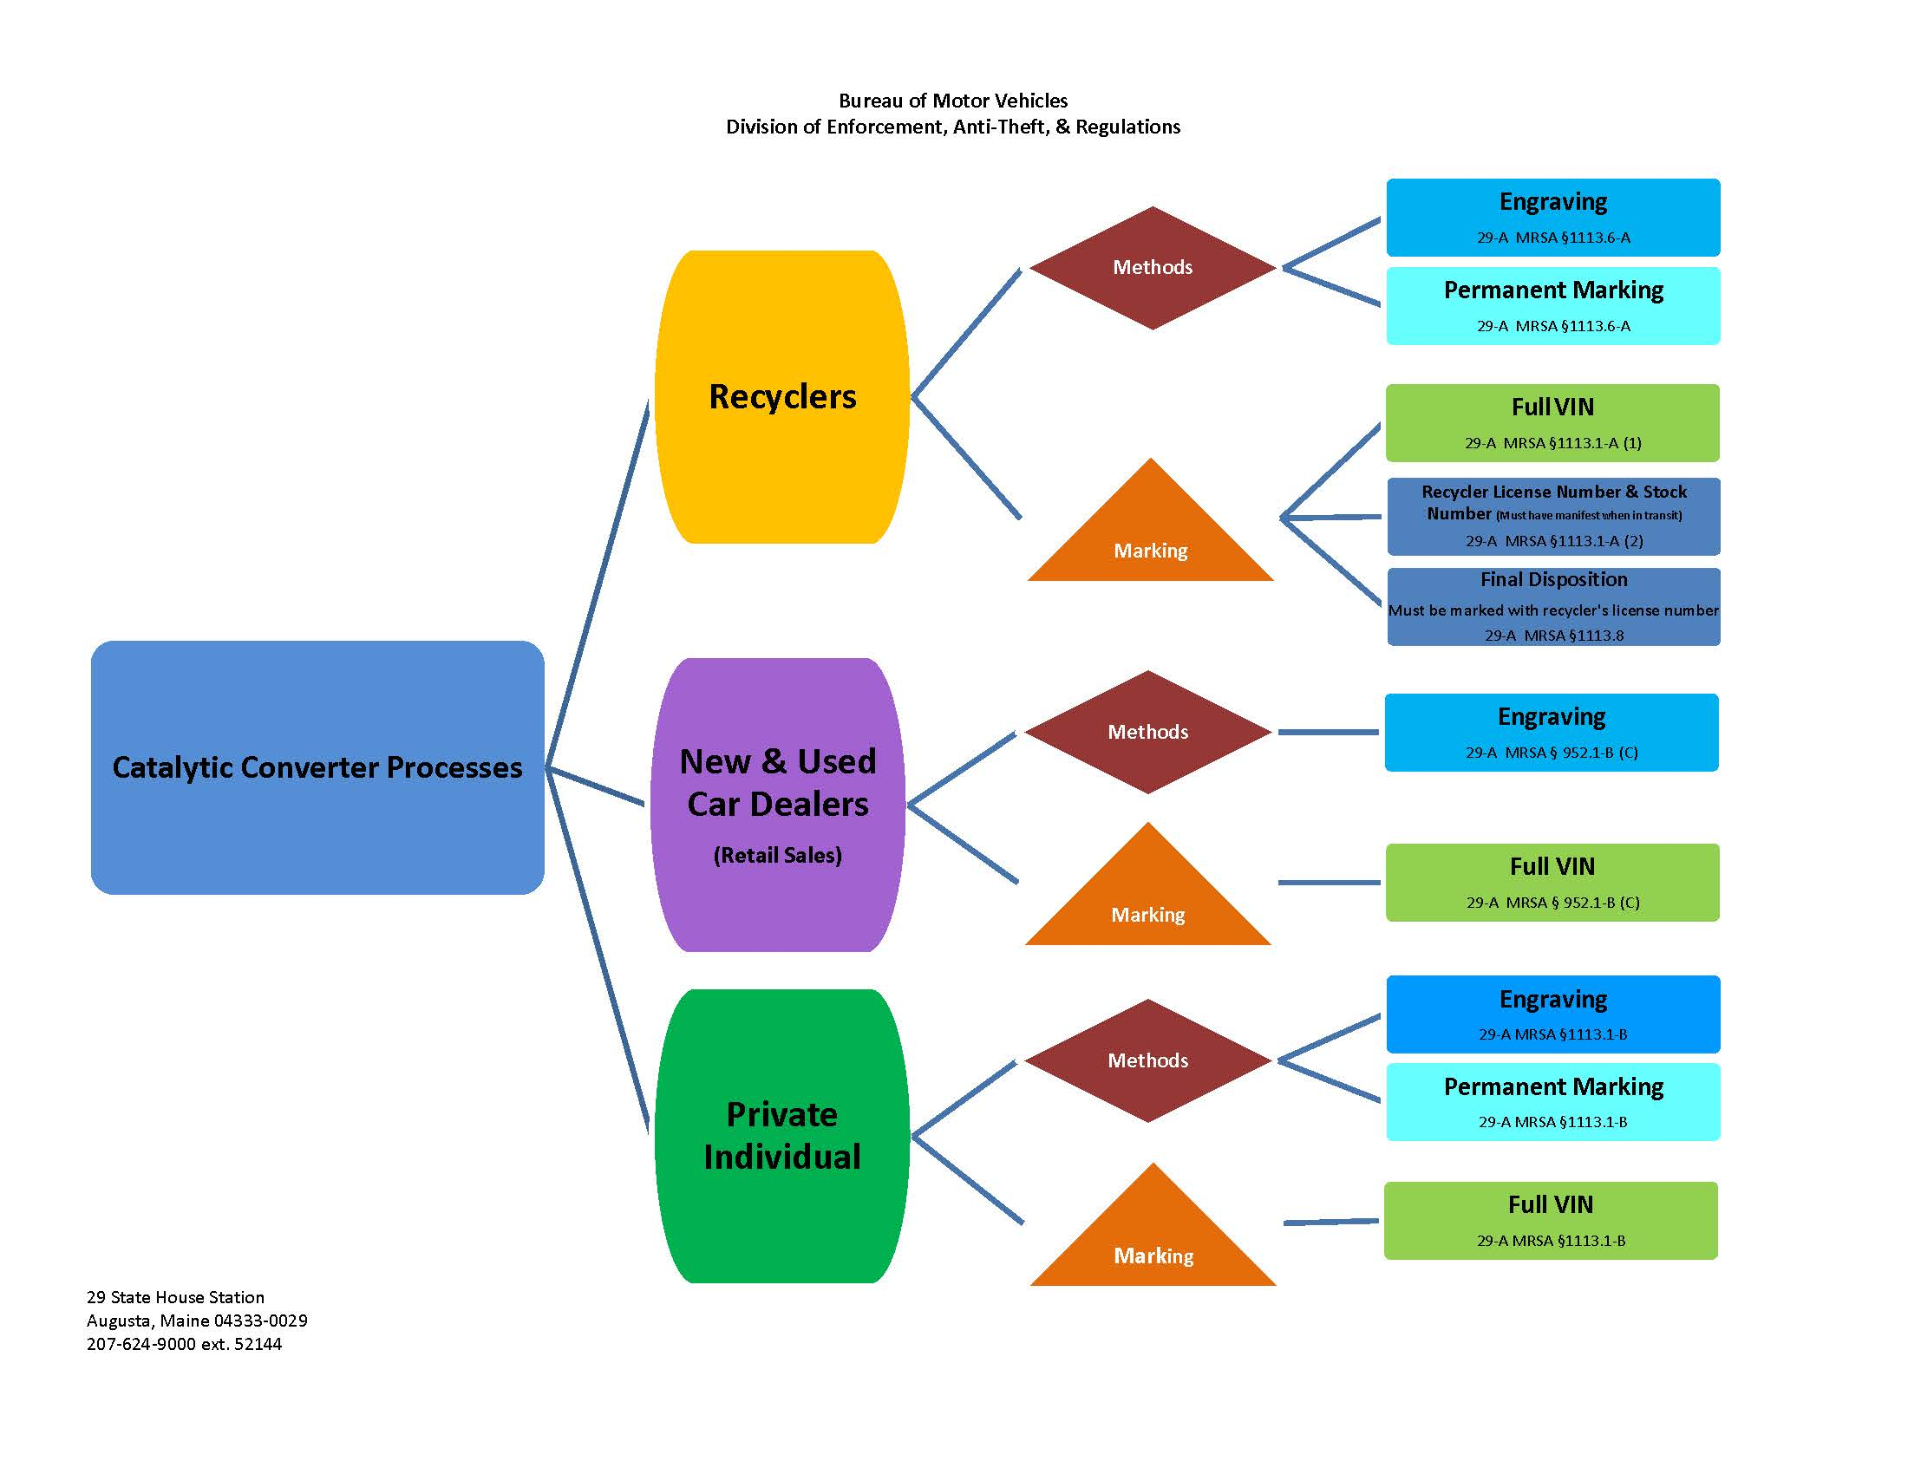
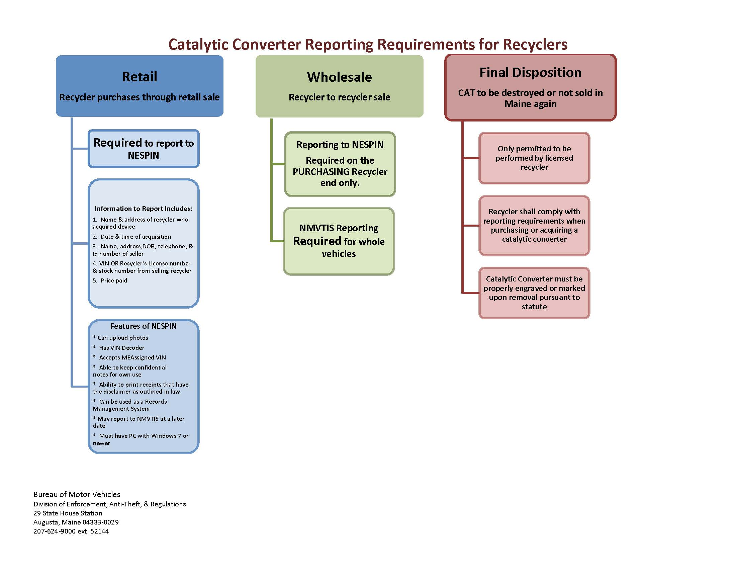

STATUTORY AUTHORITY:
29-A M.R.S. §§ 153, 1113(14)

EFFECTIVE DATE:
April 17, 2023 – filing 2023-057

