

**Absentee Ballot Request (ABR) Service**

**Clerk Instructions**

**Updated for November 3, 2020 General Election**

**August 2020**

Prepared by:

Elections Division

Bureau of Corporations, Elections, and Commissions

Office of the Secretary of State

**Table of Contents**

OVERVIEW 3

ACCESSING THE ADMIN SITE 4

ADMIN SITE HOME PAGE 6

PRINT REQUEST FORMS 7

PROCESS ELECTRONIC REQUESTS 9

ACCEPT REQUESTS 10

REJECT REQUESTS 12

SEARCH RESULTS 14

MAINTAIN CONTACT INFO 16

DOWNLOAD DATA 17

APPENDIX: SAMPLE VOTER NOTIFICATIONS 20

# Overview

When voters use the online Absentee Ballot Request (ABR) Service they will fill out an online form with the same information required by the standard paper application. There are validation constraints in the online form to ensure that all required voter information is included in the request. Once the voter hits the “Submit Request” button a confirmation email is sent to the voter at the email address they entered.

To access the public ABR service, go to

[**https://apps.web.maine.gov/cgi-bin/online/AbsenteeBallot/index.pl**](https://apps.web.maine.gov/cgi-bin/online/AbsenteeBallot/index.pl)

Not all voters are comfortable with submitting electronic requests. An additional option is provided on the ABR homepage to allow voters to print a fillable or blank PDF request form. The printed form must be signed by the voter or immediate family member of the voter and mailed or delivered to the municipal clerk for processing.

Voters (other than Uniformed Service and Overseas Voters) may not submit electronic requests after 5:00 p.m. on the Thursday before Election Day. The system will disable the option for these voters to enter an electronic request at that time. A message will be displayed on the ABR service homepage advising them to contact their municipal clerk directly in order to obtain an absentee ballot.

**Municipal clerks should process all electronic requests using the following steps. Do not leave any voter requests in a “Pending” status indefinitely or for an extended length of time. Detailed instructions for each step are contained in the appropriate sections of this guide.**

1. Log into the ABR admin site.
2. If your current password has been reset by the administrator, you will be prompted to create a new password.
3. On the admin home page, click the “Print Requests” button to print all pending requests.
4. Using the printed request form, verify the voter’s eligibility in CVR and add the request in that system according to the directions on **page 9** of this user guide.
5. Return to the ABR admin site and either accept or reject the voter’s request. This will generate a notification to the voter.
6. Treat the printed request form from the ABR just as you would process a paper request received via postal mail.

# NEW FEATURE FOR NOVEMBER 2020: In an attempt to prevent voters from submitting duplicate requests in the Absentee Ballot Request Service, new functionality has been added that will alert the voter that they already have an accepted or pending request and the site will not allow the voter to submit another request. The voter will see the following alert messages after submitting the duplicate request. Voters will not receive this message if the first request is rejected.

# 

# Accessing the Admin Site

NOTE: Only electronic absentee ballot requests submitted through the online form approved by the Secretary of State are to be treated as valid electronic requests. If you receive an email request directly from a voter, contact the voter and instruct them to use the online form at:

<https://apps.web.maine.gov/cgi-bin/online/AbsenteeBallot/index.pl>

1. Electronic requests are saved in a database accessible through the municipal clerk administrative site. A municipality may log into the administrative site to search, view, and download their absentee ballot requests.

The URL is <https://apps.web.maine.gov/cgi-bin/online/AbsenteeBallot/munilogin.pl>

1. To enter the site, you must type in a username and password. Designated person(s) should log onto the admin site at least once a day (more often as Election Day approaches). If the person designated to perform this task is out of the office for the day or a longer period, please ensure that another person is designated and is provided with the logon and password. You will be sent a daily notification via email (if you provide an email address in your contact information) of pending requests.

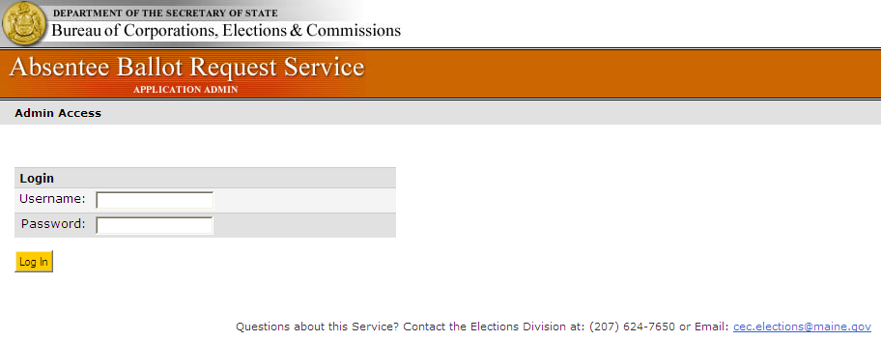

1. If your password has been reset by the CEC administrator, you will be provided with a temporary password. You will be prompted to create a new password when you log in. To ensure accuracy, type in your new password in both fields. The system will not allow you to copy and paste into these fields. Your password must be at least 8 characters long and include 1 letter and 1 number.

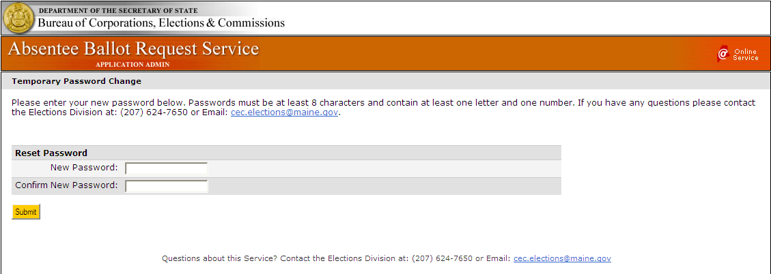

### Create a Shortcut to the Admin Site

Once you are on the login page, you may add the URL to your Internet “Favorites” or create a shortcut link on your desktop, as follows:

1. To add to Favorites, go to the administrative site, click on the “Favorites” menu and “Add to Favorites”.
2. To add a shortcut to your desktop, go to the administrative site, right-click anywhere on the page, and choose “Create Shortcut”.

Creating a shortcut will make it easier to access the Admin Site as you will not have to enter the address each time.

# Admin Site Home Page

Upon logging into the system, you will be presented with a web page that displays a list of all pending requests for the current election cycle. Requests that have been previously accepted or rejected do not display by default. On the right side of the page is a search panel that will allow you to enter search criteria. To view requests that have already been processed, use the search panel (see instructions on **page 14)**.

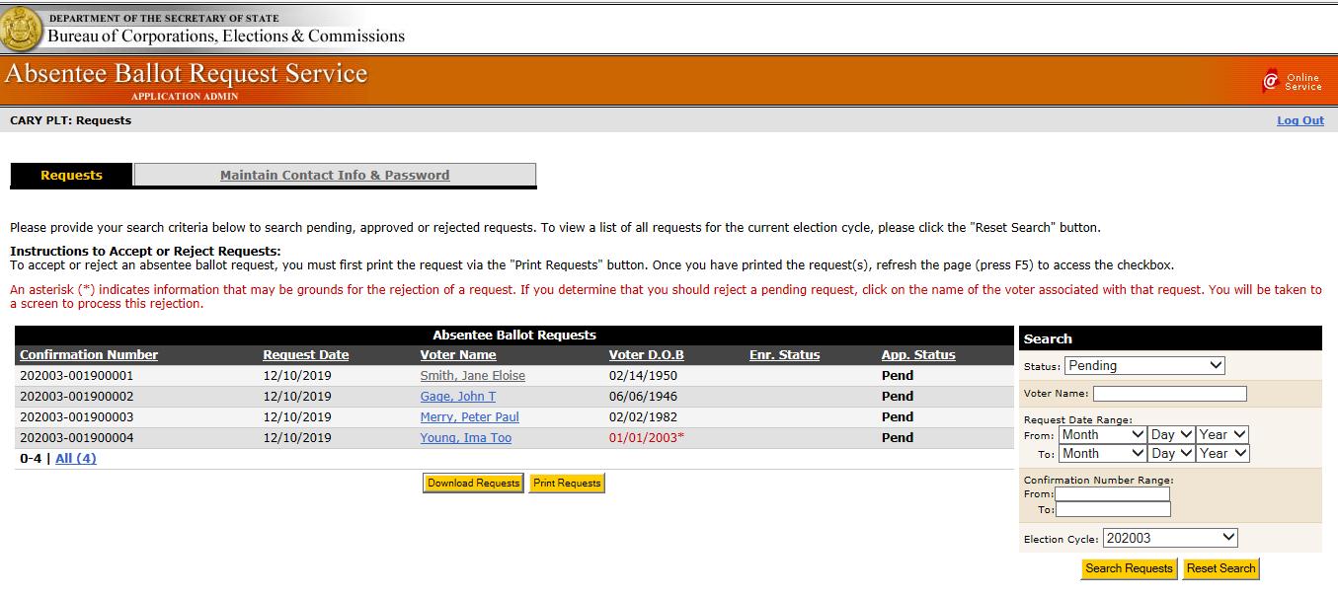

Click on the column headings to re-sort the list by the information in that column.

Results lists that are greater than a quantity of 25 will display links below the list that will allow you to navigate between pages. Click “Next” to display records 26 through 50, 51 through 75, etc. Click on “All (####)” to view the entire list on one page.

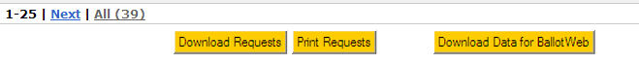

# Print Request Forms

Each time you log into this site, you should print all pending requests received since the last time the account was accessed. Adobe Reader is required to do this. You can download Adobe Reader for free at <http://get.adobe.com/reader>.

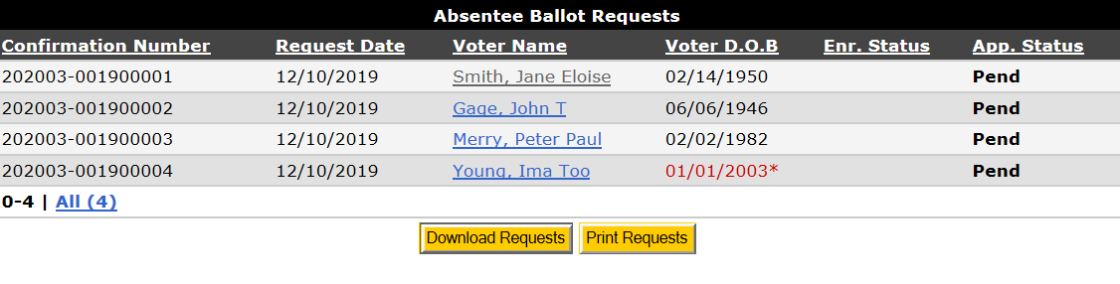

1. Click the button “Print Requests” to view and print the PDF file using Adobe Reader. Print the entire file to generate a paper copy of each pending request on the screen. The requests are formatted exactly like the printed request form and are processed just as if they were received by postal mail. The electronic confirmation number will print directly below the heading. (See sample electronic request on **page 8**). The requests may not be processed until the PDF file is generated for you to either print or save.
2. ***Please note that the “Accept” checkboxes on the right are disabled until the voter request is printed.*** The requests may not be processed until the PDF file is generated for you to either print or save.
3. Once the requests have been printed, press the F5 key or click the Refresh button on your browser.

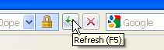  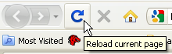

**Internet Explorer Google Chrome Mozilla Firefox**

1. A single request may be reprinted from the voter detail page, but only after the request has been processed. Reprints may be necessary if the original copy is damaged, lost, etc.

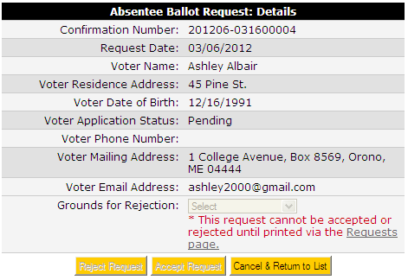

### Sample Electronic Request

# Process Electronic Requests

1. All requests either must be accepted or rejected using the ABR admin site. Before determining whether a request should be accepted or rejected, you must check the voter’s status in CVR. Based on the information provided in the electronic request form and the results of your CVR search for each voter, you will decide to accept or reject each electronic absentee ballot request accordingly. The ABR system will automatically send a notification to the voter telling the voter the status of the request (i.e. accepted or rejected). Detailed instructions for either accepting or rejecting the requests are provided later in this guide.
2. In the Central Voter Registration system (CVR), go to Activities – Absentee Ballots – Search Absentee Ballots and search for the voter.
   * If the voter is registered to vote in your municipality and qualified to receive an absentee ballot -- add the request for the absentee voter in CVR as described in the CVR User Guide, chapter six. You must then return to the ABR admin and **accept** the electronic request (see **pages 10-11**).
   * If the voter is not registered in your municipality, or is otherwise not qualified to vote, you must **reject** the electronic request using the ABR admin (see **page 12**)**.** A request that is rejected because the request comes from a voter who is not registered in your municipality is not entered into CVR.

* Title 21-A, Maine Law on Elections, §122, sub-§5 provides that receipt of a written absentee ballot application that is **signed by the voter** establishes a presumption of qualification to register to vote, and authorizes the clerk to issue the ballot and a voter registration application to the applicant at the same time.
* **However, an electronic or telephone request for an absentee ballot that is received from a person who is not registered to vote will not establish a presumption of qualification to be registered to vote.**
* If you receive an electronic request from a person not currently on your voter list, you must reject the request using the Admin Site. The email notification automatically generated by the ABR system will instruct the voter how to register to vote.
  + If the voter is not old enough to vote in the election for which the ballot is requested (i.e. will not be 18 years of age by the General Election), you must **reject** the voter’s request using the Admin Site (see **page 12**). The date of birth for possibly underage voters will display in red with an asterisk next to the date of birth; however, you must calculate and verify what their actual age will be on Election Day.

Once you have searched for the voter and entered the absentee ballot request information in CVR (if applicable), you either will accept or reject a request from a specific voter in the ABR system. Rejecting and accepting a request using the ABR admin site involves different functionality and each is described in the following sections.

## 

## Accept Requests

Requests that are to be accepted can be processed as a batch directly from the list of pending voter requests on the ABR admin home page, as long as the requests have been printed. If a request has not been printed, the checkbox associated with that line will be grayed out.

To accept a request:

1. Print the requests as described in the previous section “Print Request Forms” (page 7).
2. For each request you are accepting (you may accept multiple requests at the same time), check the box at the far right side of the voter’s information (column labeled “Accept”).
3. Click the “Accept Request(s)” button at the bottom of the screen.
4. Upon accepting the request(s), the system will automatically send an email notification to the voter stating that their absentee ballot request has been accepted for processing by their municipal clerk.
5. The list of requests will re-display with any remaining pending requests that were not selected.
6. Once you have accepted the request in the ABR system, treat the paper copy of the request just as you would any other absentee ballot request.

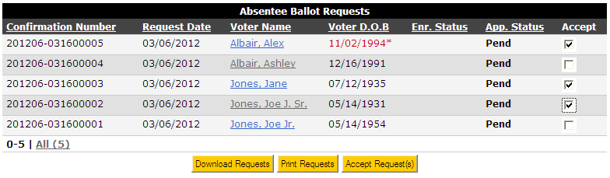

In some cases, you may need to accept a request from the voter detail screen. Click on the voter’s name to access the screen below. Click on the “Accept Request” button.

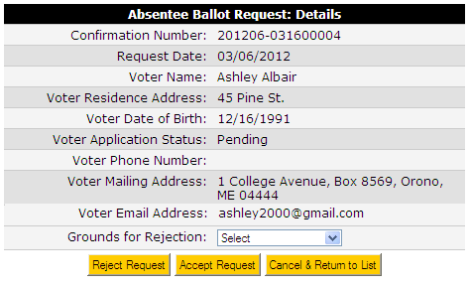

Once the request has been accepted, the Voter Application Status will change to “Accepted” and the button options will change. The automated notification will be sent to the voter.

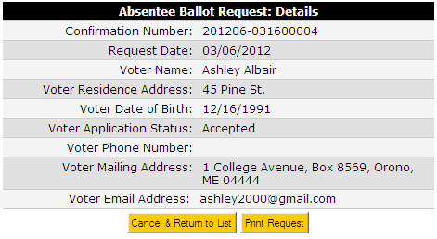

***Reject Requests***

If a request is submitted by a person who is not qualified to vote in your municipality, then the request MUST be rejected. Any necessary actions to become qualified must be performed prior to the voter submitting another request.

To reject a request for an absentee ballot, follow the procedure below.

1. Print the request as described in the previous section “Print Request Forms” (see **page 7**).
2. Access the Voter Detail Page for the voter whose request you want to reject by clicking on the voter’s name in the list of pending requests.
3. The Voter Detail Page for the selected voter will be displayed.



1. To reject a request, select a reason from the Grounds for Rejection drop-down list. The valid grounds for rejection are:
   1. Duplicate submission received;
   2. Voter is UOCAVA – the Division of Elections sends all State ballots to UOCAVA voters. The municipal election official must reject a request from a UOCAVA voter so that voter will receive an email instructing the voter to request an absentee ballot using the “UOCAVA Voter Online Request” button.
   3. Voter is not a registered voter in this municipality; or
   4. Voter Under 18 years (and will not be 18 by General Election).
2. Click the “Reject Request” button after selecting the grounds for rejection.

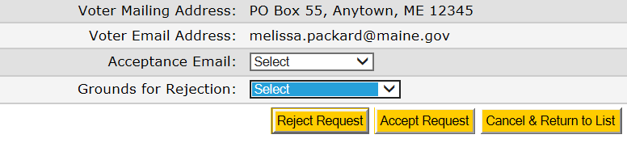

1. The application will prompt you to verify that you would like to proceed with the rejection. Click “OK” to proceed or “Cancel” to return to the voter detail screen. After clicking “OK”, the voter notification screen will display.

NOTE: The email notification will provide instructions to the voter.

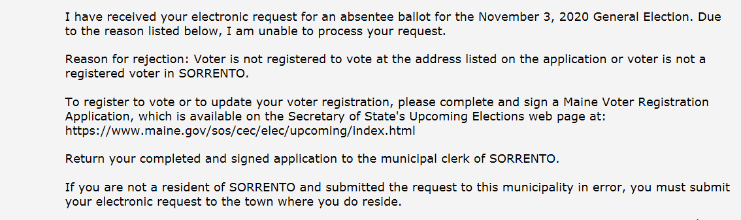

Title 21-A, §753-B, sub-§7 provides that whenever an absentee ballot application is denied, the municipal clerk shall immediately notify the applicant in writing of the reason for the denial. This system-generated email notification fulfills that requirement. Please print this screen using your browser’s print function (pressing Ctrl+P works in most browsers) and attach it to the voter’s printed electronic request form. Both the request and notification should be retained and kept with all other rejected absentee ballot applications.

If a request is rejected because the person submitting the request is not a registered voter in your municipality, the email notification will advise the voter to print a Maine voter registration application from the Division of Elections website in order to register to vote. **Clerks are no longer required to send the voter a green Maine Voter Registration application.**

Click the “Confirm and Send Notification” button to initiate an emailed notification to the voter. The system will send the email and return to the list of pending requests. The Voter Application Status will change to “Rejected”. If you determine that the request should not be rejected before you send the notification, click “Cancel and Return to Search Results”. From the Search Results page, you may accept the request as described in the previous section entitled **Accept Requests** or Reject the ballot for a different reason by selecting the appropriate reason from the dropdown list.



# Search Results

The Search panel will always display on the right side of the web page. You may specify your search results by selecting one or more criteria on the Search panel. The more criteria you select, the narrower your search results will be. To initialize the Search panel to the default (pending requests for the current election cycle), click the button to “Reset Search”.

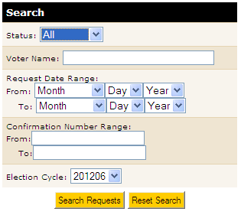

1. Request Status – select a status to display, or select All.

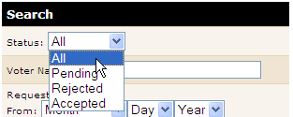

1. Voter Name – Enter all or part of a voter’s name to narrow the search to any voter record containing the entered text as all or part of the voter name. For example, entering “John” in this field will generate a voter list that will include voters with similar first names such as “John” and “Johnnie” and will also include voters with last names like “Johnson”.
2. Request Date Range – To search for records within a specific date range, use the “From” and “To” date drop-down fields.
3. Confirmation Number Range – Enter a beginning and ending confirmation number. To find a single request, enter the same number in the From and To fields. The confirmation numbers must be formatted to include the election cycle.

(Example: 202007-XXXXXXXXX)

1. Election Cycle – Previous election cycles created by the State administrator will be included in the drop-down box. You may search for records specific to an election cycle or leave the cycle unselected to search ALL election cycles within the database. These records are kept in the database for five years, after which time they will be purged.

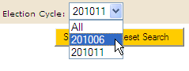

Click “Search Requests” to display the list of voters meeting the criteria entered. The list automatically will be sorted by confirmation number. Click on the column headings to re-sort the list by the information in that column.

# Maintain Contact Info

The other tab on your main admin page is “Maintain Contact Info”. Please take a few minutes to fill out this information. If an email address is entered on this page, the automated email notifications sent to voters will include the Clerk’s email so that the voter can contact the Clerk with questions. Also, for your convenience, the system will send you a daily email notification if you have any requests pending in the system. If you do not have pending requests, you will not receive this email message.

Click on the “Maintain Contact Info” tab to view the screen below.

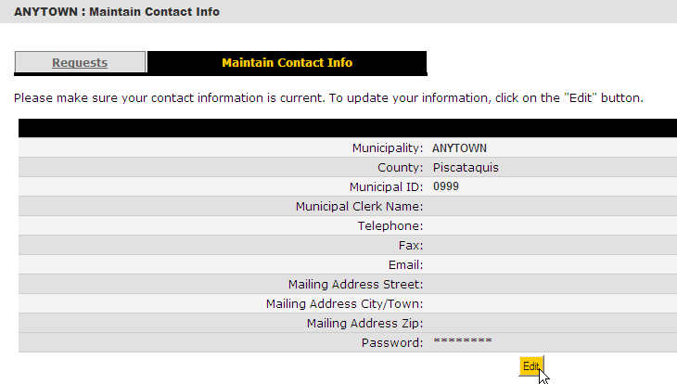

Perform the following steps to update your information or change your password at any time:

1. Click the Edit button.
2. Enter or edit your contact information; or
3. Enter your new password, then re-enter the same password to confirm. (Passwords must be at least 8 characters long, contain a letter and a number, and are case sensitive.)
4. 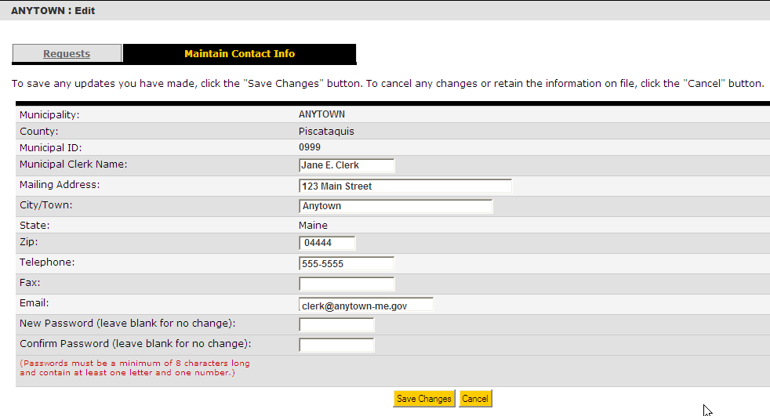Click the Save Changes button.

# Download Data

***Note: This is an optional function. You are not required to download this election data.***

The search results are downloadable to a pipe-delimited file (PSV) that can be imported easily into Microsoft Excel or Access, as well as other electronic databases. Click on the “Download Requests” button to save the data to your computer. Click “Save” when prompted and select a location on your computer.

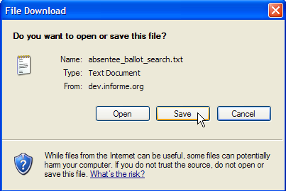

You may rename the file if desired and choose a location on your computer.

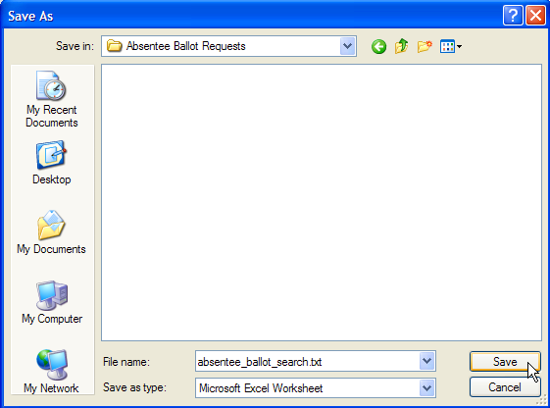

To import the delimited text file into Excel:

1. Open Excel and select “File>Open” from the menu.
2. Browse to the file at the location where you saved it.

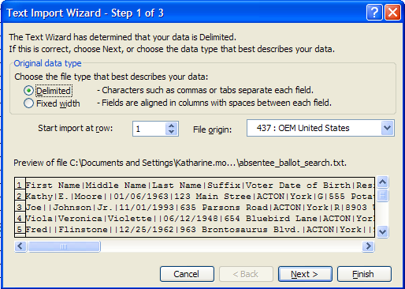

1. Step 1 of 3 - The Text Import Wizard will automatically display. Click “Next”.

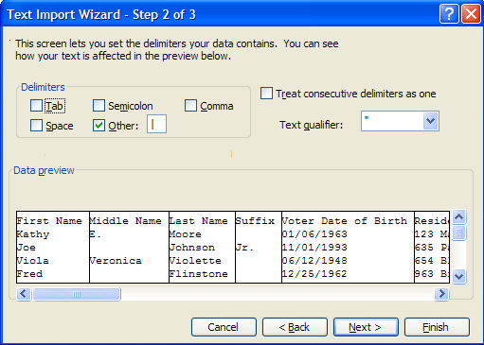

1. Step 2 of 3 - Under “Delimiters”, uncheck “Tab”. Check “Other” and enter a pipe character ( | ) in the box. The pipe character is on the key just above the Enter key. (Press Shift + \)

Click “Finish”.

1. Once you have successfully imported the text file into Excel, save it in the xls format to enable you to open it in the future without going through the import process. Click “File>Save As” and then select the Excel format.
2. Click “Save”. The data will now be stored on your local computer as an Excel worksheet.

### 

# Appendix: Sample Voter Notifications

**Initial Voter Notification**

Thank you for requesting your Absentee Ballot by using the State of Maine Absentee Ballot Request Service. Your application has been received. Your Municipal Clerk will review the application to determine if you are eligible to receive an absentee ballot. You will be sent another email informing you of whether your application was accepted or rejected. Absentee ballots for the November 3, 2020 General Election will be available on or about October 2, 2020.

Sincerely,

Division of Elections, Maine Secretary of State

**Acceptance Notification**

The absentee ballot request submitted by John Q. Voter on August 31, 2020 has been processed and accepted by the Municipal Clerk in Bangor.

Absentee ballots for the November 3, 2020 General Election will be available on or about October 2, 2020. The absentee ballot will be sent via postal mail to the address listed below. Date and times of delivery may vary depending on local mail service.

Mail to:

John Q. Voter

PO Box 123

Bangor, ME 04401

Please contact your Municipal Clerk or the Elections Division if the ballot is not received in a timely manner.

Sincerely,

Bangor Municipal Clerk

Town Email: [Clerk@Bangor.ME.Com](mailto:Clerk@Bangor.ME.Com)

**Voter is Not Registered**

I have received your electronic request for an absentee ballot for the November 3, 2020 General Election. Due to the reason listed below, I am unable to process your request.

Reason for rejection: Voter is not registered to vote at the address listed on the application or voter is not a registered voter in Bangor.

To register to vote or to update your voter registration, please complete and sign a Maine Voter Registration Application, which is available on the Secretary of State's Upcoming Elections web page at:

https://www.maine.gov/sos/cec/elec/upcoming/index.html

Return your completed and signed application to the municipal clerk of Bangor.

If you are not a resident of Bangor and submitted the request to this municipality in error, you must submit your electronic request to the town where you do reside.

**Voter is Underage**

I have received your electronic request for an absentee ballot for the November 3, 2020 General Election. Due to the reason listed below, I am unable to process your request.

Reason for Rejection: Voter is not old enough to vote

Town Email: Email address will print if Clerk has entered in ABR

Thank you for your interest in the electoral process, but you are not eligible to vote in this election.

**Duplicate Submission**

I have received your electronic request for an absentee ballot for the November 3, 2020 General Election. Due to the reason listed below, under Maine law, I am unable to process your request

Reason for Rejection: Duplicate request submitted.

**Voter is UOCAVA**

I have received your electronic request for an absentee ballot for the November 3, 2020 General Election. Due to the reason listed below, under Maine law, I am unable to process your request.

Reason for Rejection: You are designated as, or your mailing address indicates that you are, a UOCAVA (Uniformed Service or Overseas) voter.

The State of Maine sends all State ballots to UOCAVA voters, and you need to request your ballot from the State of Maine by clicking on the "UOCAVA Voters Online Request" button on the Absentee Ballot Request Service at the following address:

https://apps.web.maine.gov/cgi-bin/online/AbsenteeBallot/index.pl

If you should not be designated as a Uniformed Service or Overseas Voter, please contact your Town Office for a voter registration card so you can update your voter information.

Please contact the Elections Division at 1-888-VOTESME or UOCAVA.CEC@maine.gov if you need additional assistance.