Getting Started
Chapter 1
Downloads, Macros, and Plugins Revised 9-2008 13
MeadCo’s ScriptX Revised 9-2008 13
Change Internet Security Options Revised 9-2008 14
Download MeadCo’s ScriptX Revised 9-2008 15
Restore Default Security Settings 17
ActvScan.Cab Revised 9-2008 18
Delete “old” ActvScan Version Revised 9-2008 18
Install “new” ActvScan Version Revised 9-2008 20
TIFF Viewer Registration Revised 9-2008 23
Index New 9-2008 26

Downloads, Macros, and Plugins Revised 9-2008

ElectioNet™ performs tasks like printing, viewing, batch scanning and using a Dymo label printer. However, the first time ElectioNet™ is used to perform these tasks, other small applications called “plug-ins” are required, and must be downloaded from the Internet. These “plug-ins” are mini applications that enhance usability and functionality within ElectioNet™.

MeadCo’s ScriptX
This one-time download is from Mead and Company Limited, and is required to print the VRAN and other correspondence for voters. The prompt to download (figure 12 below) is initiated the first time the user selects to print a VRAN or Voter Registration Certificate from the Final Tasks screen. To download ScriptX, follow the instructions for changing Security Options (next page).
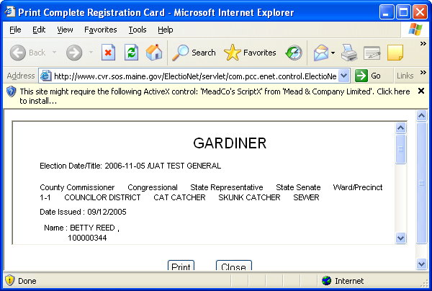

Figure 12: Downloading ScriptX

Change Internet Security Options

Security settings on the user’s computer must be custom set to enable the mini applications to be installed.

- In the CVR application or other Internet Explorer web page, go to the Tools menu and click on Internet Options (figure 13-A), which is generally the last item in the drop-down menu.

Note: If you do not know whether you have Internet Explorer Version 6.0 or 7.0, go to the Help Menu and click on About Internet Explorer.
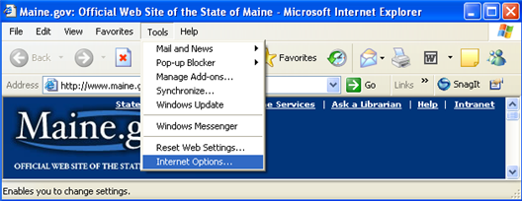

Figure 13-A: Internet Explorer – Tools Menu – Internet Options

- Click on the Security tab, and then on Custom Level (figure 13-B).
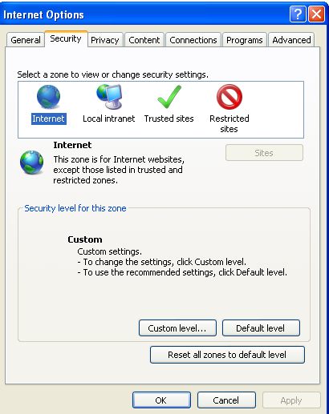
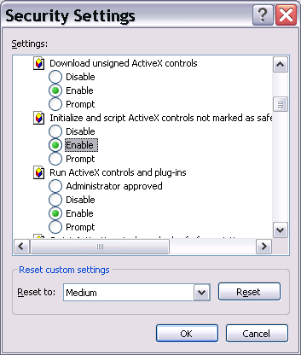

Figure 13-B: Internet Options Figure 13-C: Security Settings
Security Tab
- Click the Enable radio buttons for the following (figure 13-C):

Internet Explorer Version 6.0
  - Download unsigned ActiveX controls
  - Initialize and script ActiveX Controls not marked as safe
  - Run ActiveX controls and plug-ins
Internet Explorer Version 7.0
  - Download unsigned ActiveX controls
  - Initialize and script ActiveX Controls not marked as safe
  - Run ActiveX controls and plug-ins
  - Allow websites to prompt for information using scripted windows
- Click the OK pushbutton at the bottom of the screen.
- Click Yes on the Warning pop-up window.
- Click OK to close the Security Settings window.

Note: Use the scroll bar on the right side of the Security Settings window to move down the list.

Download MeadCo’s ScriptX
- After these security settings are enabled, return to the CVR correspondence you want to print (figure 14). Click anywhere inside the message box; a small menu will appear.

Figure 14: Downloading ScriptX
- Select “Install ActiveX Control…” from the menu (figure 15-A). Press ENTER or mouse click to Install ActiveX Control.
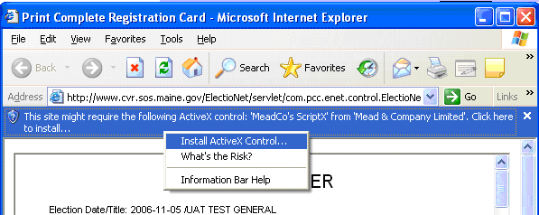

Figure 15-A: Selecting “Install ActiveX Control”

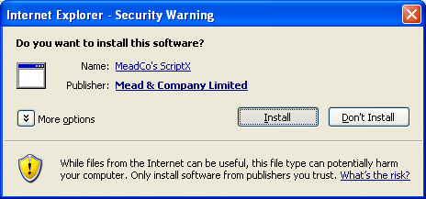
- On the Security Warning pop-up window, click the Install button to install ScriptX (figure 15-B).

Figure 15-B: Security Warning
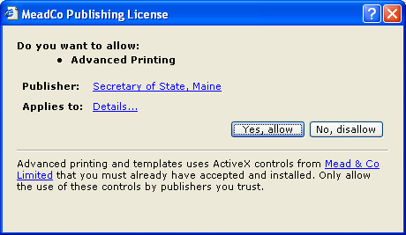
- On the MeadCo Publishing License screen, click the Yes, Allow button to allow Advanced Printing (figure 15-C).

Figure 15-C: Allowing Advanced Printing

IMPORTANT! After the MeadCo ScriptX is downloaded to your computer, reset the Internet security options to the default settings (see instructions, next page). This will help protect the computer against harmful viruses and spyware.

Restore Default Security Settings
- In the CVR application or other Internet Explorer web page, go to the Tools menu (figure 16-A).

Figure 16-A: Internet Explorer – Tools Menu – Internet Options

- Click on Internet Options.
- Click on the Security tab.
- Click on the Default Level button and click OK, to return your security settings back to the original settings (figure 16-B).

Internet Explorer Version 6.0 Internet Explorer Version 7.0
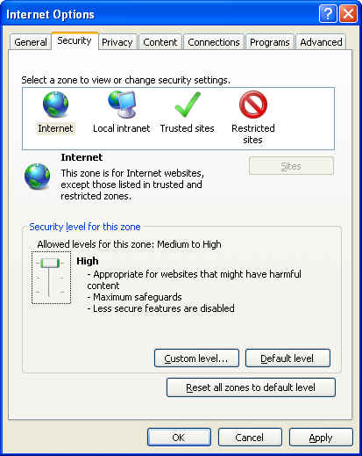
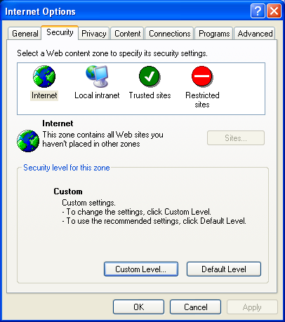

Figure 16-B: Restoring Default Security Settings
Note: When the default security setting is restored, users may get messages alerting them to the fact that these ActiveX controls are detected by the computer. These are expected and OK. If the security setting is “Medium High”, then the “Default Level” will not be enabled to the users. “Medium High” is the “Default Level” for IE 7.0 and “Medium” is the “Default Level” for IE 6.0.

ActvScan.cab Revised 9-2008
ElectioNet™ performs scanning with the help of the ActvScan application. ActvScan also is needed to view voter registration cards and use the Scan/Print process through Inquiries.

Periodically, a new version of the ActvScan application must be downloaded (installed) in order to use updated application functions. A new version of ActvScan is needed to use updated bar code technology provided in the May 18, 2008, update of ElectioNet™.

Note: If the user has not installed a new version of ActvScan since May 18, 2008, the user must delete the old version of ActvScan and install the new version. If you are unsure if this step has been done, do it now.

Delete the “old” ActvScan Version Revised 9-2008
- Restore the Internet Explorer security settings to the “Default Level” by following the instructions on the previous page.
- To locate the existing ActvScan File, go to Internet Explorer and click on Tools, and then click on Internet Options (figure 16-A).
- Under the General tab, click on the Settings button in the “Browsing History” or Temporary Internet History” section, and the click OK (figure 17-A).
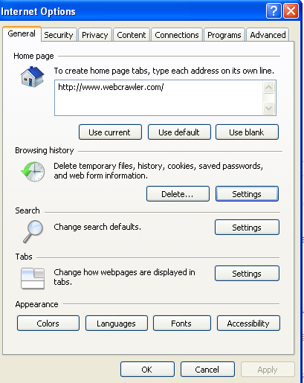

Figure 17-A: Internet Options – Settings Button
- On the “Temporary Internet Files and History Settings” page, click on the View Objects button (figure 17-B).
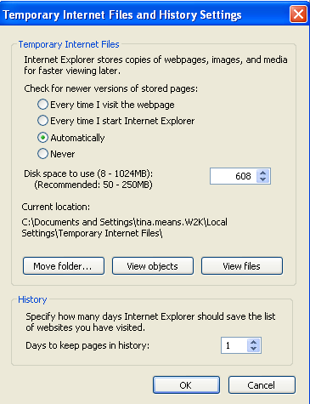

Figure 17-B: Temporary Internet Files – View Objects Button

- On the list of Program files, highlight the current Active Scan Control file, right click on the mouse, and choose remove (figure 17-C).
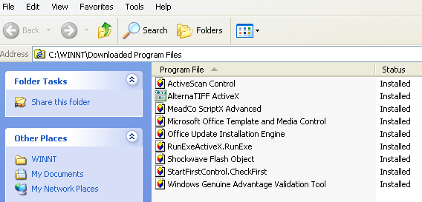

Figure 17-C: ActiveScan Control file

Install “new” ActvScan Version Revised 9-2008
Note: There are several places within CVR that use ActvScan. When there is a new version of the ActvScan application, the prompts to install it will look the same as in the following example.

- In the ElectioNet™ application, select Inquiries from the Main Menu, and then select Voter Registration (figure 18).
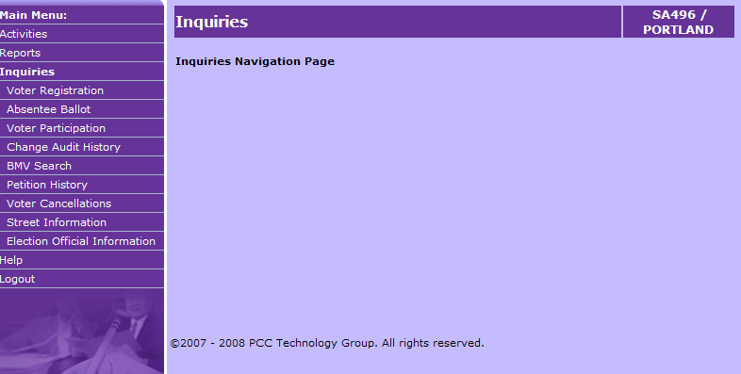

Figure 18: Inquiries Menu – Voter Registration
- Type in the Voter Record # or last name of the voter on the Inquiry Voter Registration screen and click Search (figure 19).
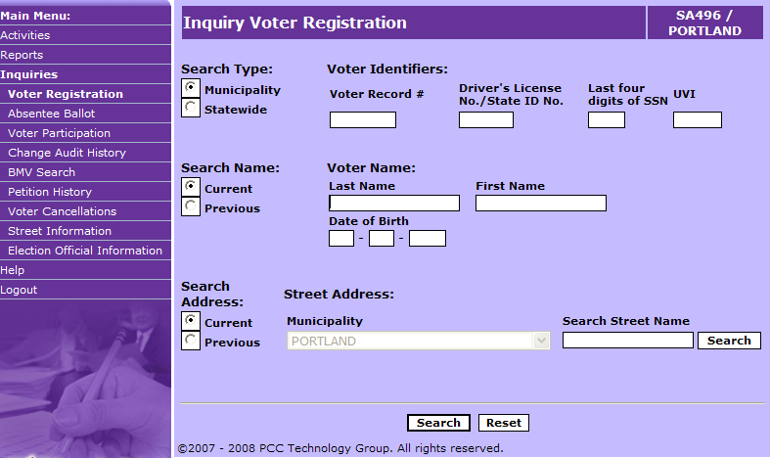

Figure 19: Inquiry Voter Registration - Search Screen

- If there is a match for the search criteria, the Select Voter screen will appear. Select the voter and click View (figure 20).
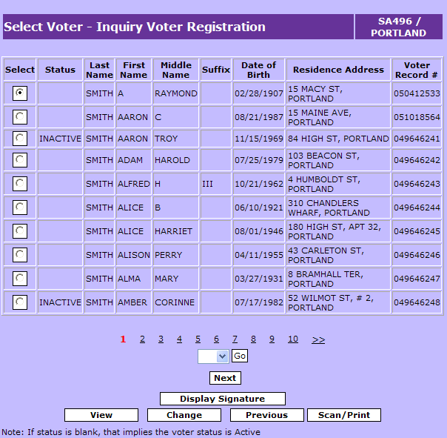

Figure 20: Inquiry Voter Registration - Search Result Screen

- The ActiveX installation information will appear at the top of the Inquiry - View Voter Registration screen (figure 21). Click anywhere inside the message box; a small menu will appear.
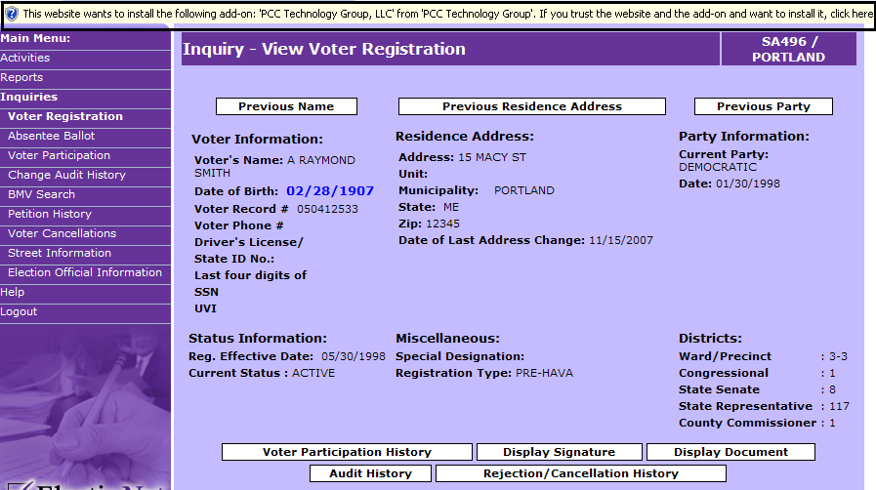

Figure 21: Downloading ActvScan

- Select “Install ActiveX Control…” from the menu (figure 22). Press ENTER or mouse click to Install ActiveX Control.
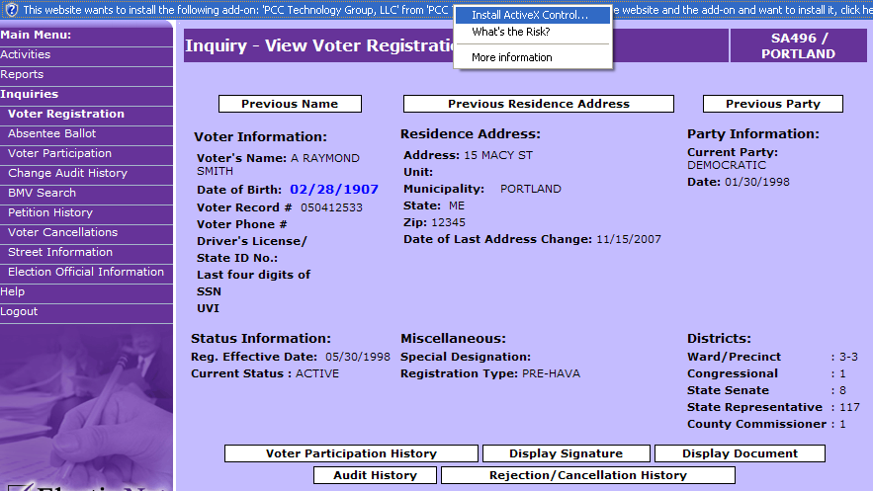

Figure 22: Selecting “Install ActiveX Control”

- On the Windows Internet Explorer pop-up window, click the Retry button
(figure 23-A).
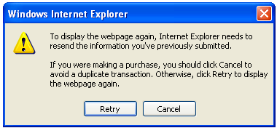

Figure 23-A: Windows Internet Explorer Pop-up Window
- On the Security Warning pop-up window, click the Install button to install ActvScan (figure 23-B).
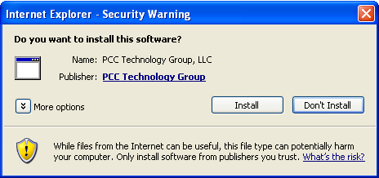

Figure 23-B: Security Warning

Note: Once the ActvScan control is successfully installed, the application will only prompt the user to install the control again if the user manually removes the control from Internet Explorer or if a newer version of the ActvScan control is made available in the ElectioNet™ application.

TIFF Viewer Registration Revised 9-2008
ElectioNet™ includes a special pop-up viewer (TIFF Viewer) to allow users to see images and signatures after the voter registration applications have been scanned and uploaded (see Chapter 13, Scanning, for details on how to scan voter cards). In order to see your scanned images, you must first register the TIFF Viewer. This process is done only one time (per computer) and takes just a couple of moments. You will be prompted in the pop-up window that your TIFF Viewer must be registered.

There are many different places within the ElectioNet™ application where users are able to view scanned images. You may register your TIFF Viewer at any time or in any module the first time you are trying to view a scanned image. Below are general directions on how to complete this process.

Register TIFF Viewer through Inquiries Module
Upon successfully uploading a batch of scanned images to ElectioNet™, you may go directly into the Inquiry Module, search for and select a voter whose voter registration application has been scanned and uploaded. Within the Inquiry module you will have options to view the signature image and/or the registration card image (figures 24-A and 24-B).

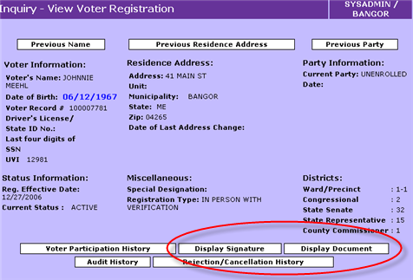
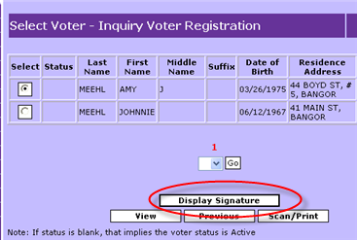
Figure 24-A: Inquiry – Select Voter – Figure 24-B: Inquiry – View Voter -
Display Signature Option Display Signature and
Display Document Options

When selecting one of these options the first time you attempt to view a scanned image, a pop-up window will display with a message that the TIFF Viewer is not registered. This is where you will proceed to register the TIFF Viewer (figure 25).

Note: Figure 25 will also display through Batch Scanning and all other modules where images may be viewed. Registration can be done through any module.
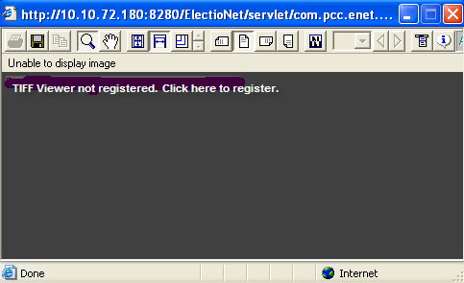

Figure 25: View Image Pop-up Window
After clicking to register the viewer, the system will present another pop-up window where you will enter your name, address, email, etc. information. (This information is not shared with any other organization and will not be used to send mailings or email notifications of any kind.) Once you complete the short form and close the pop-up window, your TIFF Viewer will be registered and you will not need to go through this process again in any module of ElectioNet™. Thereafter, whenever you select an option to view a signature or document (figures 24-A and 24-B) you will see the actual scanned image (figure 26).

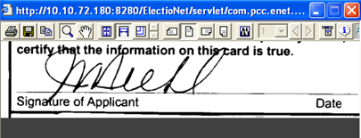

Figure 26: Scanned Signature Pop-up Window

