DS200™ Precinct Scanner
Pre-Election Day Manual - 2016

EVS 5.2.1.0
Version 2.12.1.0
Table of Contents
Supplies and Equipment 3
Cleaning the Scanner 3
Cleaning the Ballot Box 4
Attaching the DS200 to the Ballot Box 4
Checking the Scanner Battery 5
Charging the Scanner Battery 5
Changing the Printer Paper…..………………………………………………………………………………………………………………………6
Clearing and Initializing the DS200 7
Loading the Election Definition (Poll Media) 8
Configuration Report 8
Public Count/Protected Count 8
Setting the Date and Time 9
Calibration of the Touch Screen (Only use if the touch screen is not responding) 10
Testing the Election Definition 11
Opening the Polls 11
Blank Ballots 13
Over voted Ballots 13
Closing the Polls 14
Clearing the Test Results 15
Shutdown 15


Please contact the Elections Division or ES&S Hardware Support with any questions at 1-877-ESS-VOTE Option 4, Option 1, or email hardware@essvote.com

Supplies and Equipment
- 1 spool NCR 3.13” by 80’ thermal paper per scanner per election
- USB Flash Drives – EQC Media (1 per municipality) and Polling Place stick (1 per tabulator)
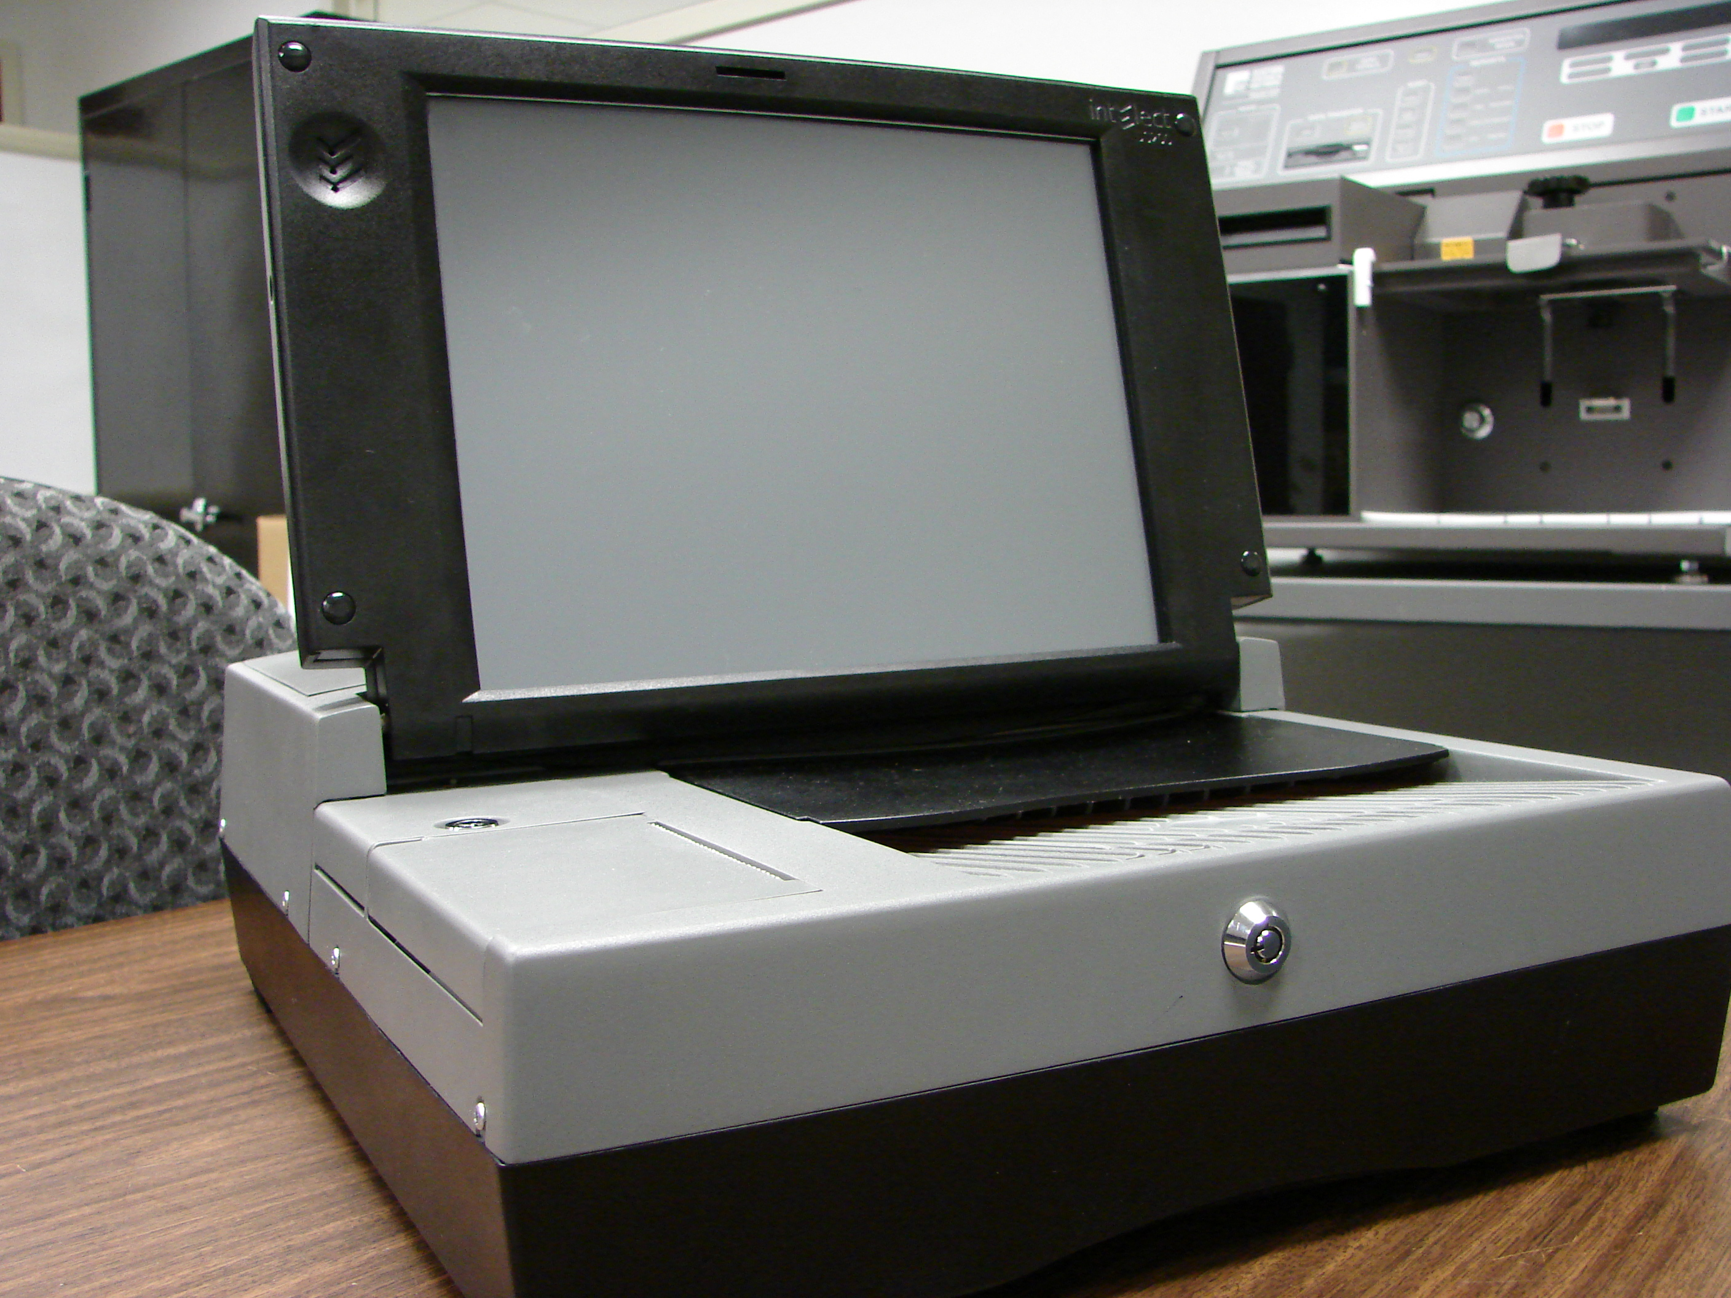
- Ballot marking pens
- Pressurized can of air
- 1 clean lint-free cloth
- 1 bottle of Isopropyl rubbing alcohol
- 1 set of DS200 scanner keys
- 1 ballot box per scanner & keys
- DS200 power cord
- Extension cord if required – Commercial Grade Only

Cleaning the Scanner
- Remove the scanner and power cord from the carrying case.
- Clean the ballot entrance and exit slots with a can of pressurized air. Aim the air spray tube into the ballot entrance and exit slots and blow out all the debris.
- Use the cloth and cleaning solution to clean the outer casing of the scanner. Do not spray directly on the tabulator. Always spray on the cloth.
- Use a lint-free cloth and isopropyl alcohol to clean the LCD touch screen. Do not spray directly onto the screen. Always spray on the cloth.
- Unlock the rear access door on the back cover of the DS200.
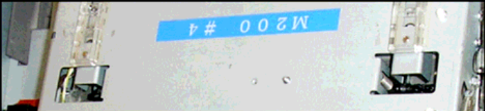
- Once this door is unlocked and the back cover of the DS200 is raised, the ballot transport mechanism can be opened.
Ballot Transport Cover

- Lift up the blue latches on the left and right side of the ballot transport and lift the top cover to access the ballot transport area.
- Use a lint-free cloth and isopropyl alcohol to clean the glass surface of the contact image sensors. Again, do not spray directly into the tabulator.
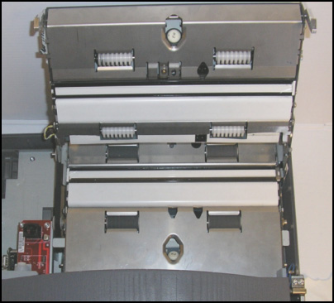
Rollers
Glass Areas

- Wipe the rubber rollers on the bottom surface of the ballot transport.
- Close and lock the rear access door.

Cleaning the Ballot Box
- Wipe dust and debris out of both of the ballot box’s bins.
- Clean the outside of the ballot box with a soft cloth.

Attaching the DS200 to the Ballot Box
- Unlock and open the hinged access panel on the front of the ballot box. Place scanner about 1/4 of the way into the recessed area and slide it on the mounting rails until it is four to five inches from the back of the recessed area.
- Unlock and open the ballot access flap (aka “barn door”) on the back of the ballot box. Position this flap in the up position so ballots can pass into the ballot box.
- Plug the diverter cable (attached to the ballot box) into the diverter port on the back of the scanner.
- Inspect the power cord for damage. If the cord is damaged, contact the Division of Elections or ES&S for a new cord.
- Thread the cord through the opening on the side of the ballot box until it appears inside the opening behind the scanner.
- Plug the power cord into the power port on the back of the scanner (flat side of the plug facing up).
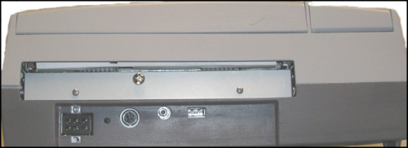
POWER PORT
DIVERTER PORT

- Slide the scanner until it is against the back of the ballot box, making sure that both cables do not block the ballot entrance slot.
- Plug the AC power cord from the external power supply into a grounded, three-pronged, 120-volt wall outlet.

WARNING: Only plug the scanner into a grounded, three-pronged electrical outlet. Plug only one scanner into an outlet. It is recommended that you do not use an extension cord.

- Close and lock the hinged access panel in the closed (up) position.

Checking the Scanner Battery
The DS200 uses an 18-volt, 5 amp lithium ion battery to power the scanner in case of an electrical power failure.
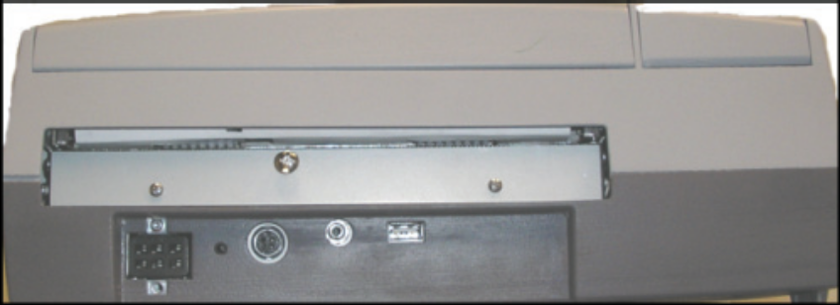
- To externally check the charge of the backup battery, view the indicator light at the back of your DS200 machine.
INDICATOR LIGHT

- Green Light = Battery is charged
- Amber Light = Battery is charging
- Flashing Red Light = Battery is defective or not hooked up
- You can also check the battery charge on the screen by viewing the Battery Power Icon in the upper right area of the screen when the unit is NOT plugged into an electrical outlet.
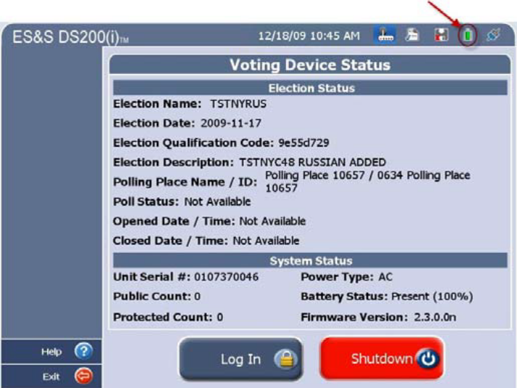





Full Battery Charge (green)

75% Battery Charge (yellow)

50% Battery Charge (orange)

25% Battery Charge (red)

No Battery Charge

Charging the Scanner Battery
The amount of time to charge a battery can be up to seven (7) hours if completely discharged. Plug the scanner into an outlet. An election definition flash drive is not required to charge the battery.
Changing the Printer Paper


NOTE: ES&S recommends that you begin each election with a new, full roll of paper on every scanner.

- Unlock and open the DS200 screen.
- Unlock the access door, located above the printer. This will allow you to access the printer release lever.
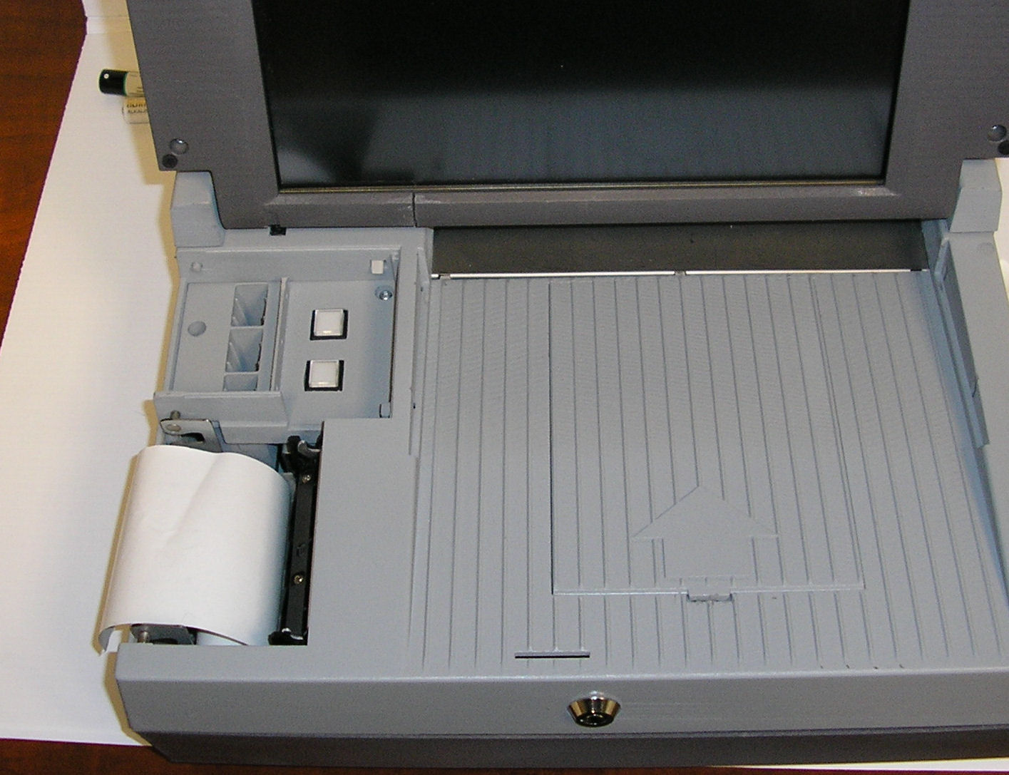
Thermal Printer
- Press the lever to unlock and open the printer door.
- Drop the paper into the printer paper compartment.
- Pull the end of the paper roll out toward the ballot input tray of the DS200.
- Close the printer door by pressing firmly to assure it locks into place.

IMPORTANT: Make sure the glossy side of the thermal paper is facing the thermal printer. You will know the glossy side by scratching the tape. The glossy side will leave a gray streak when scratched.

Clearing and Initializing the DS200
Before loading the election definition, you will need to clear and initialize the DS200 using the Election Qualification Code Device (EQC Flash Drive). Clearing and initializing the scanner assures the following:
- The election log from the previous election is cleared.
- The public count is reset to zero.
- Loads the Election Qualification Code for the DS200.
- Loads all the passwords that were set in ElectionWare.
- Resets bypass settings (if applicable)

- Open the access door on the front left of the scanner to access the USB flash drive area (if not already open.)
- Insert the Poll Media flash drive into slot B (middle). Do not force the flash drive into the slot.
- Turn on the DS200 by pressing the Power button. The Clear and Initialize Screen will appear.

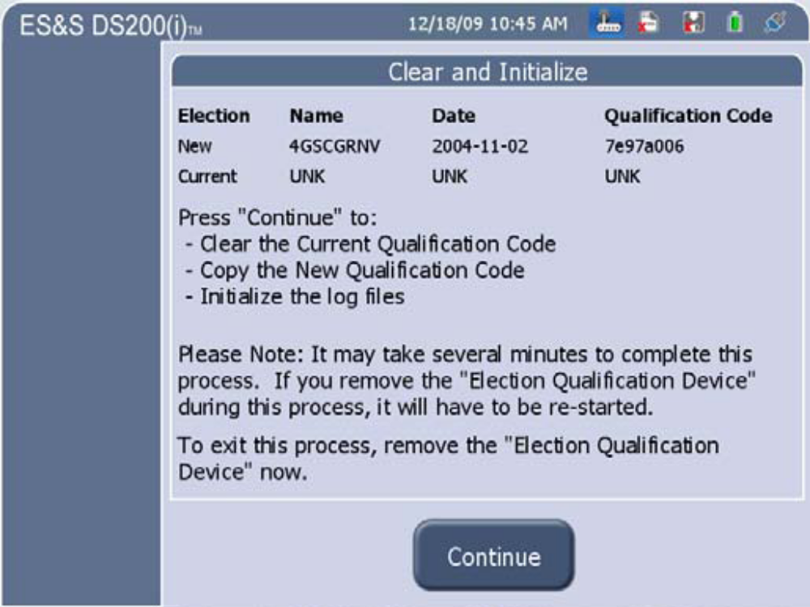

- Press Continue and enter the Qualification Code using the touch screen.
- Press Accept when finished entering the code and the system will begin the initialization process. When complete, the Initialization Complete screen will appear. Remove the Election Qualification Device. This is the ONLY time you may remove the flash drive while the tabulator is powered on.

Loading the Election Definition (Poll Media)
- Open the access door on the front left of the scanner to access the USB flash drive area (if not already open.)
- Insert the Poll Media flash drive into slot B (middle). Do not force the flash drive into the slot.
- Enter the Election Code to access the Polling Place Media and press Accept.
- The following screen will appear and the Configuration Report will print.
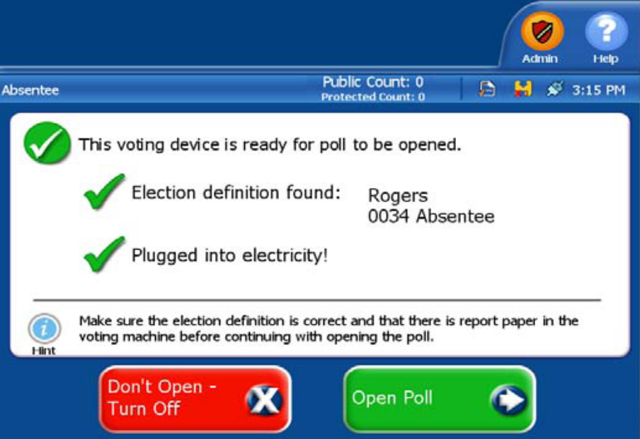

Configuration Report
The Configuration Report is automatically generated when the DS200 is turned on and the Poll Media is accessible. This report was previously referred to as the Initial State Report. Validate the information in categories below:
  - Hardware Configuration
  - Election Qualification Information
  - Election Status
  - Election Information
  - Ballot Information
  - Election Settings
  - Exception Ballot Settings

Public Count/Protected Count
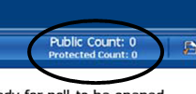
The Public Count still appears on the screen while the tabulator is in use. The Public Count is the number of ballots that have been inserted and counted by the tabulator for a specific election. There is now a Protected Count showing below the Public Count. The Protected Counts is like an odometer in a car and keeps a count of all ballots that have ever been counted by the tabulator. This includes ballots used for testing and for maintenance, as well as every election for which that tabulator was used.

Setting the Date and Time
- From the Administration Menu, select System Settings to access the System Settings menu and enter the password when prompted.
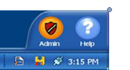

- Select Change Date to proceed with updating the date.
- Enter the correct date and save by pressing Apply. Press Back to return to the Date and Time Options screen.
- Press Change Time to proceed with updating the time.
- Select the field to update (hour, minute or AM/PM) by pressing the field.
- Correct time by using the arrows to make adjustments.
- Press Apply to save the changes. Press Back to return to the Date and Time Options screen.
- Make sure the Current Time Zone is set for (EST) Eastern Standard Time (New York).
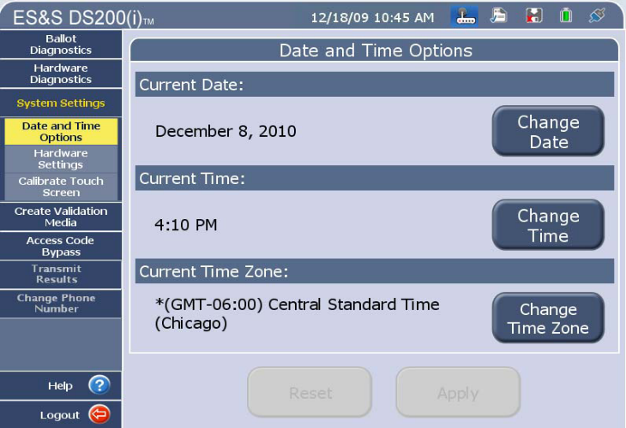
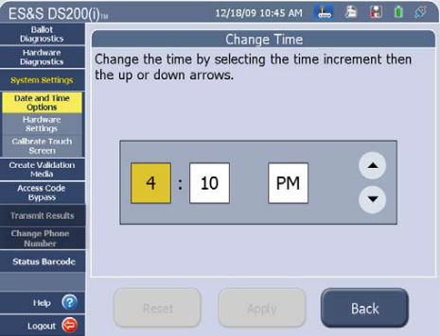
- Once you have made all changes, review the settings from the Date and Time Options screen and press Apply.
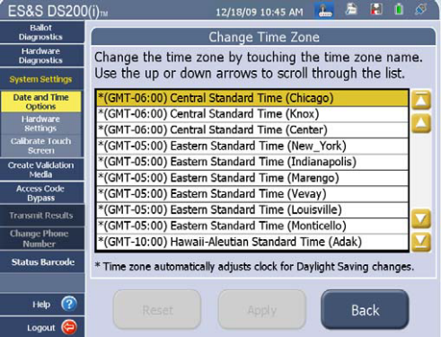

Calibration of the Touch Screen (Only use if the touch screen is not responding)
- From the Administration Menu, select System Settings.
- Press Calibrate Touch Screen and the following screen will appear.
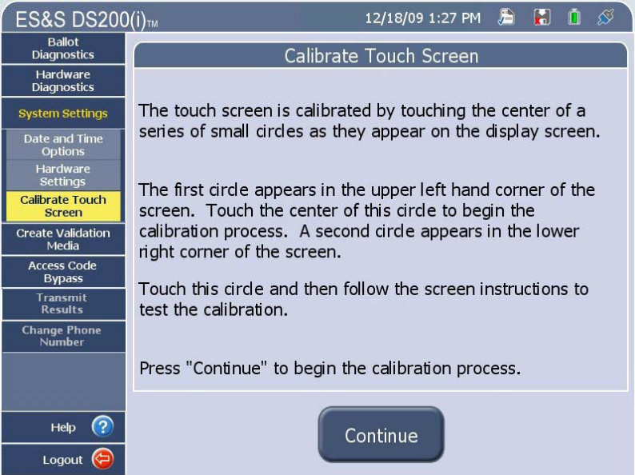

- Press Continue to commence with the touch screen calibration.
- On the calibration screen, press the circle in the upper-left corner. The circle will turn black. Then press the circle in the lower-right corner that circle will turn black and a confirmation screen will appear.
- From the confirmation screen press SAVE & EXIT to save the calibration settings or press RECALIBRATE to repeat the calibration process.
- Press OK to confirm the calibration process is complete.
- Press Logout in the lower left of the screen to return to the Voting Device Status screen.
- Press Exit to exit from the Administration Menu of the DS200.

Testing the Election Definition
Testing the Election Definition is completed manually by opening the polls, scanning a test deck of ballots and then closing the polls. You will use the results report to compare against the test deck hand tallied results to assure set up and tabulation is correct

Opening the Polls
There is no longer a “Test Mode” under the Admin Menu. All testing will take place by opening the polls. (Do not forget to zero your test totals at the end of each test.)
- After the Polling Place Media (thumb drive) has been installed and the Election Code has been entered and accepted, the following screen will appear:
NOTE: If the Polling Place Media is not inserted, the screen will tell you the Election Definition was not found and require you to insert the Polling Place Media.

- Press Open Poll and the scanner performs the following functions:
- The scanner checks available memory and scans the election definition for errors.
- Depending on options set for your election definition, the DS200 prints a Ballot Status Accounting Report and a Zero Totals Report on activation.
NOTE: Press Cancel Printing at any time to cancel the printing of the report.

- After the reports finish printing, the following screen appears.
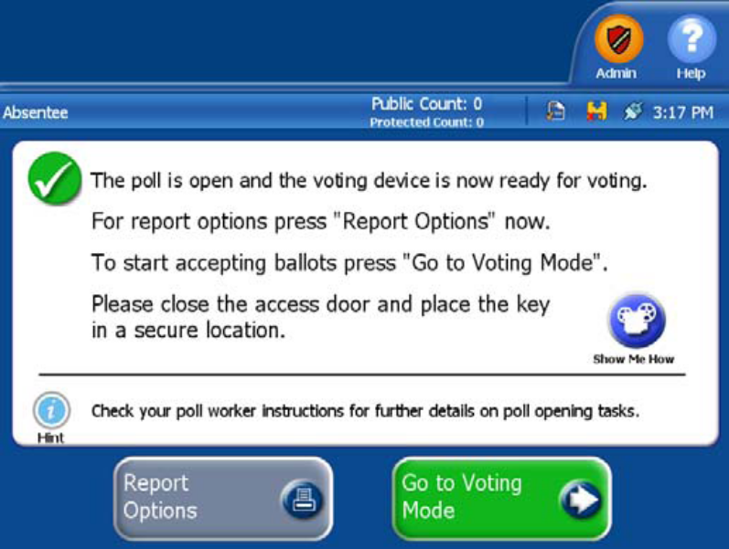
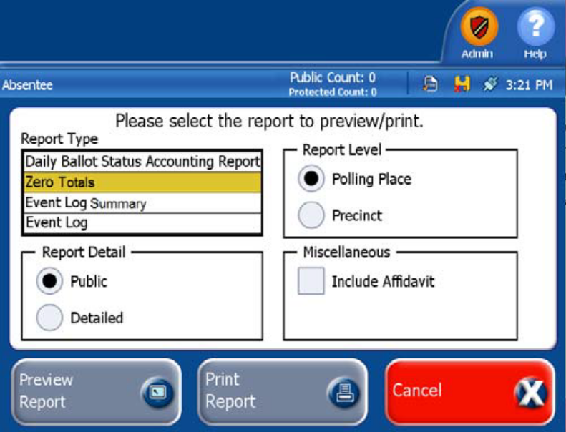
- If you need to print a second Zero Report, you can press Report Options for the following screen.

- Press Go to Voting Mode to continue with the testing.
- Insert the Test Deck of ballots into the scanner one at a time. The DS200 can scan ballots inserted in any orientation. As ballots are scanned, the Public Count will increase by one for each ballot inserted.

Blank Ballots
The DS200 precinct tabulator is coded to detect and notify the voter when it encounters a blank ballot. The display will indicate that the ballot has no selections and will offer the voter two choices, Return or Cast Blank Ballot.
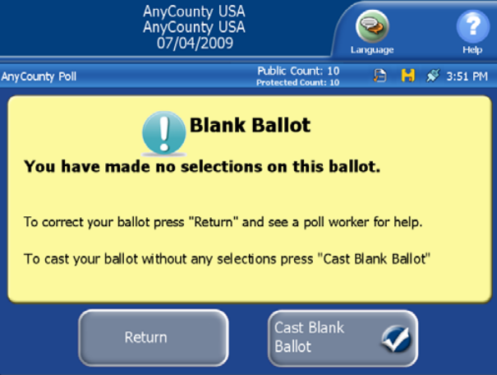

If it is the voter’s intent to cast a blank ballot, they would select Cast Blank Ballot.
If it was not the voter’s intent to cast a blank ballot, they would select Return. The ballot will be returned to the voter uncounted, and the voter can then mark their choices and re-feed the ballot.

Over voted Ballots
The DS200 precinct tabulator is coded to detect and notify the voter when it encounters an over voted race or issue on the ballot. An over vote is when more than the allowed number of selections in a contest or issue has been marked. The display will indicate that one or more contests have too many votes cast and offer the voter two choices, Return or Cast.

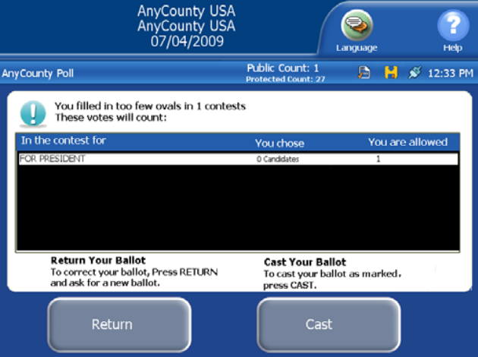

If the voter selects Cast, the ballot will be counted, all properly marked contests and issues will receive the appropriate votes, and the over voted races and issues will receive a blank vote. The individual candidates or issue choices in an over voted race will not receive any votes.

If the voter selects Return, the ballot will be returned uncounted, and the ballot will be “Spoiled” and the voter will be issued a new one.

Closing the Polls
- After you finish scanning test ballots, press the Close Poll button to close the polls. The following screen will appear.
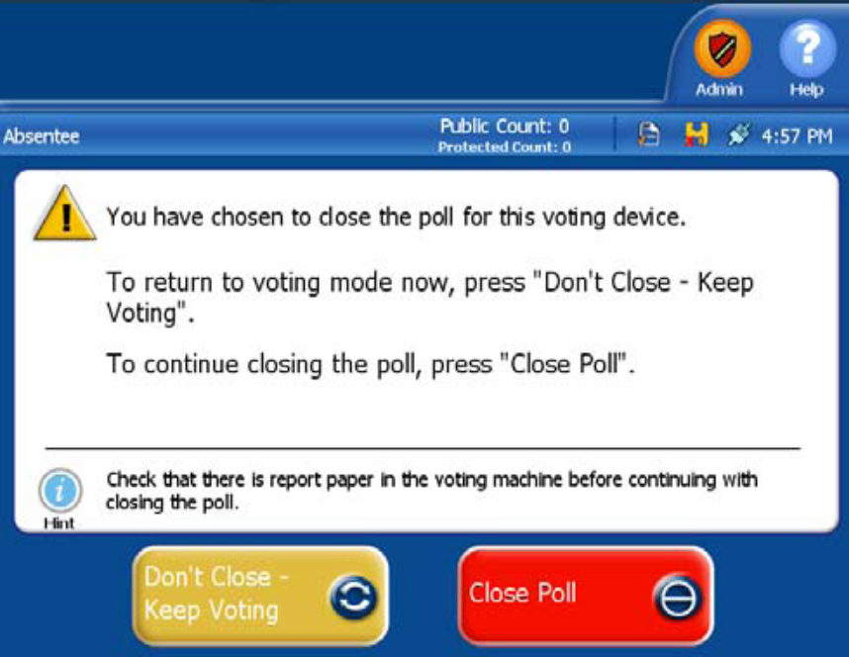

- Press Close Poll to continue. The system will automatically print the report requested during the coding process.
- If any additional reports or additional copies are necessary choose Report Options from the closed poll screen to select and print additional reports for the testing:

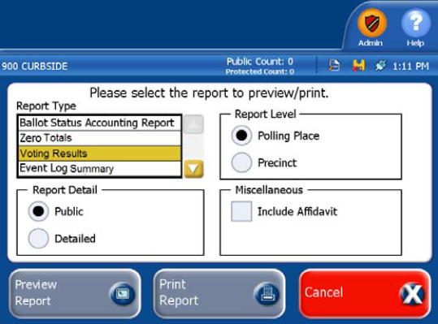
  - Report Format – these reports include the results for each contest broken down by Election District or Polling Place (see Report Level). The Media report will not include counts for blank votes, while the Summary report will break out those counts on individual lines per contest.
  - Report Level– defines whether the report includes results by Election District or for the entire Polling Place. You will need to choose Polling Place, rather than Precinct.
  - Miscellaneous—you may choose Include Affidavit to print the Election Official signature lines at the bottom of the report. When printing additional tapes, you should not include the Affidavit.
- Verify your results by comparing the test deck results to the DS200 printed report results.
  - If the results match, Zero the Totals, and then press Finished – Turn Off to turn off the DS200.
  - If the results do not match, review the test ballots for errors, zero the totals and repeat the test steps. If the results do not match after the 2nd test, contact the Elections Division.

Clearing the Test Results
Only use “Re-open Poll” and “Clear Votes” during testing. If it is necessary to re-open the polls on Election Day, you MUST contact the Elections Division prior to reopening.
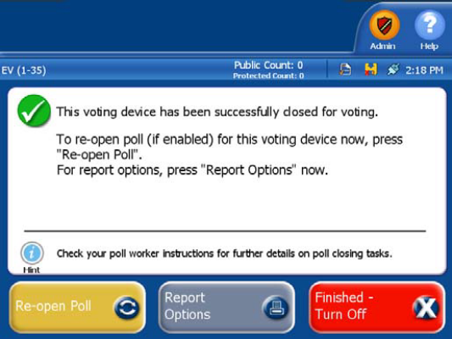
- From the close poll screen, choose Re-Open Poll.

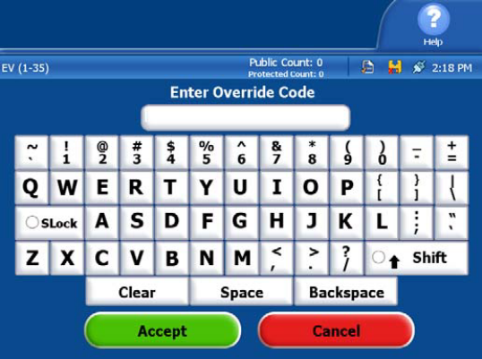

- Enter the Override Security Code on the touch screen and press Accept.

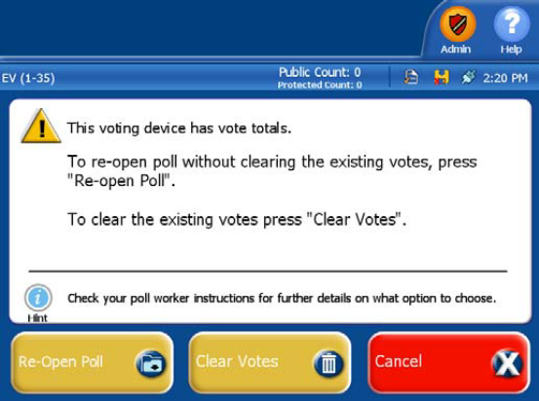
- Press Clear Votes then confirm by pressing Clear Votes & Continue to clear the testing results from the election definition stick.
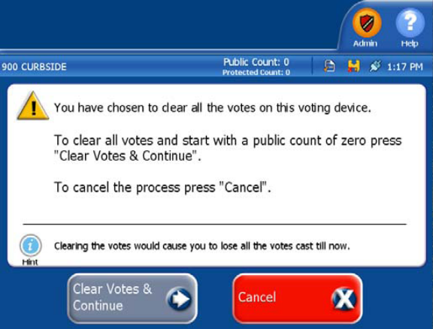

Shutdown
- Shutdown the DS200 by pressing Finished - Turn Off.
- Store the DS200 in accordance to Maine’s procedures.
WARNING: Do Not Remove the DS200 flash drive before the equipment is completely powered off (the Power button will not be luminated). Prematurely removing the flash drive could result in damage to the equipment.

