NEW - Absentee Ballots Batch Update Process
September, 2015

A. Absentee Ballot processing

- Small batches.

- If you have just a few absentee requests, generate both a mailing label and a barcode label as you enter the requests in CVR. All requests must be entered in CVR as you receive them.

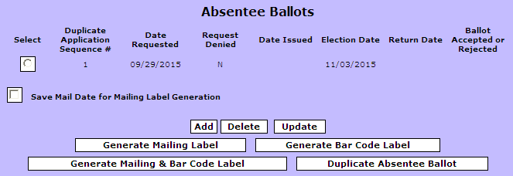

- Affix the mailing label to the outside (CIV-O) envelope, and the barcode label on the flap of the inside (CIV-I) envelope. This can be done ahead of time, even if you do not yet have ballots to issue. By doing this, your envelopes will be all ready to go when ballots do become available.
- After requests have been entered in CVR, print an Absentee Voter File report and PROOFREAD the absentee ballot applications against the requests you have entered in CVR.
The Absentee Voter File can be generated using date ranges. Your first report might have a range of August 1, 2015 to October 1, 2015 (or the date ballots become available). Your next report might be from October 1, 2015 to October 5, 2015. As requests increase, you will generate a report each day, using the same start and end date (i.e. October 6, 2015 to October 6, 2015).

- After PROOFREADING and making any necessary changes, you are ready to issue the ballots. At this point, if you want to use the new Absentee Ballots Batch Update process, you should generate a set of barcode labels for the same date range as the requests you are filling. The labels are found under Public Reports, Absentee, and Absentee Mailing Labels – there is an option to print barcode labels. Print these on plain paper, not label sheets. You will use this to scan barcodes.

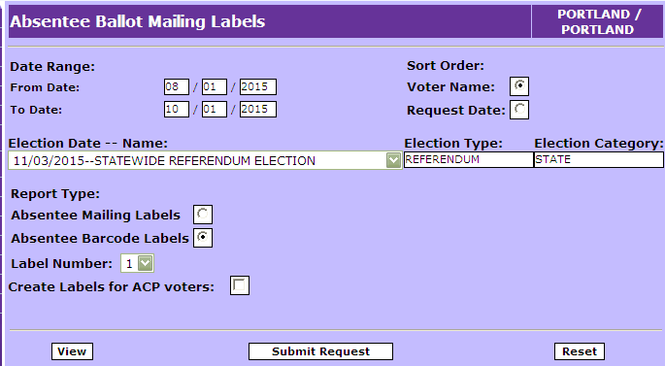
- Large batches.

- If you have a large number of requests, it may be more efficient for you to generate mailing labels and barcode labels as a batch, after entering all of the requests for a specific time period. All requests must be entered in CVR as you receive them.

- After a group of requests have been entered in CVR, print an Absentee Voter File report and PROOFREAD the absentee ballot applications against the requests you have entered in CVR.
The Absentee Voter File can be generated using date ranges. Your first report might have a range of August 1, 2015 to October 1, 2015 (or the date ballots become available). Your next report might be from October 1, 2015 to October 5, 2015. As requests increase, you will generate a report each day, using the same start and end date (i.e. October 6, 2015 to October 6, 2015).

- After PROOFREADING and making any necessary changes, you can generate both mailing labels and barcode labels for the voters in that same date range from the Absentee Ballot Mailing Labels report. The report is found under Public Reports, Absentee, and Absentee Mailing Labels. You will need to print these on label sheets and affix them to their appropriate locations on the absentee envelopes.

- After you print the mailing labels and barcode labels you need for the absentee ballot envelopes, if you want to use the new Absentee Ballots Batch Update process, you should generate an additional set of barcode labels for the same date range. Print these on plain paper, not label sheets. You will use this to scan barcodes.

B. The NEW Absentee Ballots Batch Update process
1. The Absentee Ballots Batch Update process is found under Activities, Absentee Ballots:

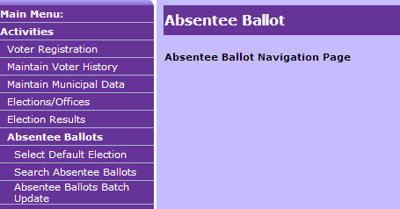

- On the first screen, select the election date—name from the dropdown list. (Note: the election you have chosen as the default election under the Absentee Ballot module will be the election that automatically appears in the field; either go back out and first change the default election, or be careful to select the correct election each time.) Select whether you want to enter Ballots Issued or Ballots Returned.

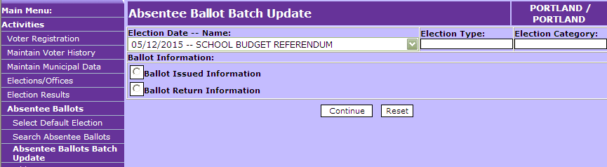

- When you select Ballot Issue Information, this screen appears (note that the Issued Date defaults to the current date; you will need to enter the correct date, if different):

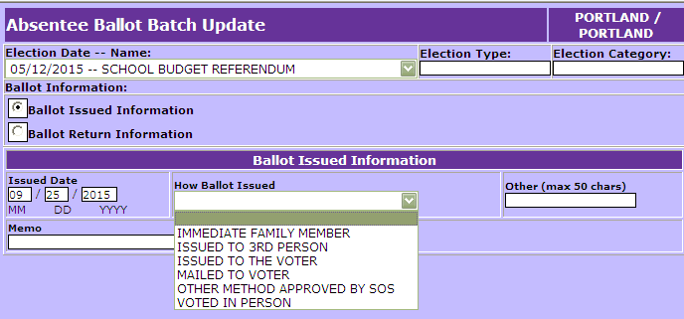

- After selecting the issue type, and confirming the Issue Date is correct, click the Continue button:

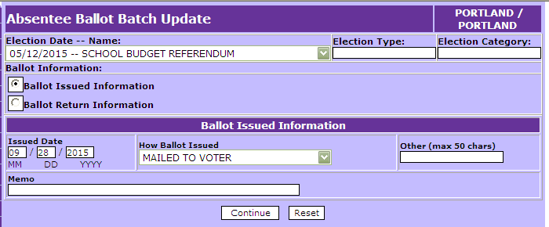

- 10 blank boxes will appear. Using the barcodes you printed on plain paper in steps A(1)(d) or A(2)(c), scan the barcodes for the voters who are being issued ballots by the method you have selected (in the example below, by Mail).
If you prefer, you may manually enter the voter ID numbers in the boxes. To do this, you would need to print an Alpha List and get the Voter ID numbers from that.
Make sure the cursor is in the first box before scanning or entering manually. After entering the 10th number, or when you are otherwise done, click Insert.

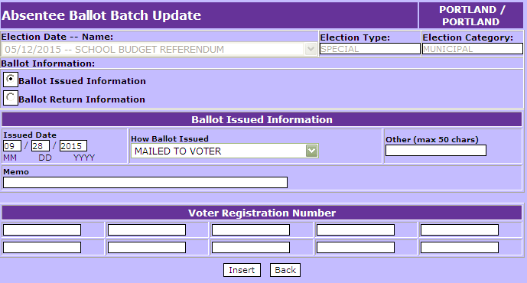

TIP: If you are going to scan the barcodes, make yourself a scanning template out of a 7” x 7” piece of cardboard. In the center of that piece of cardboard, cut out a rectangle large enough to capture one barcode, leaving a little extra room around the barcode. You can then use this to scan barcodes one at a time without accidentally picking up surrounding barcodes.

- You will get confirmation messages for each of the voters entered, and another 10 blank boxes.

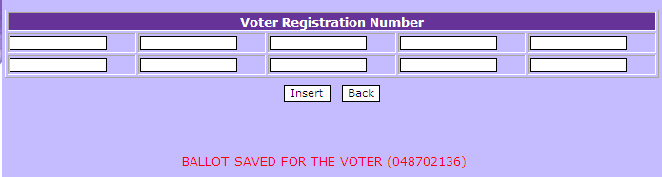

- After you are done scanning/entering each batch of Issued Ballots, print an Absentee Voter File report and PROOFREAD the absentee ballot applications against the report to confirm that you have captured the correct issuance method for each voter.

- Each voter’s absentee ballot record will be automatically updated with the issue information you have scanned/entered. If you discover that an error was made, you will need to into the voter’s absentee ballot record and make the correction there.

- Repeat the process for ballots issued by other methods and/or on other dates.

- You will use the barcodes affixed to the absentee ballot return envelopes to scan Ballot Return Information. As ballots come in, batch them up according to date/time received and how they were received.

- When you select Ballot Return Information, this screen appears. Again, note that the Date Ballot Received and Time defaults to the current date and time; you will need to enter the correct date and time, if different):

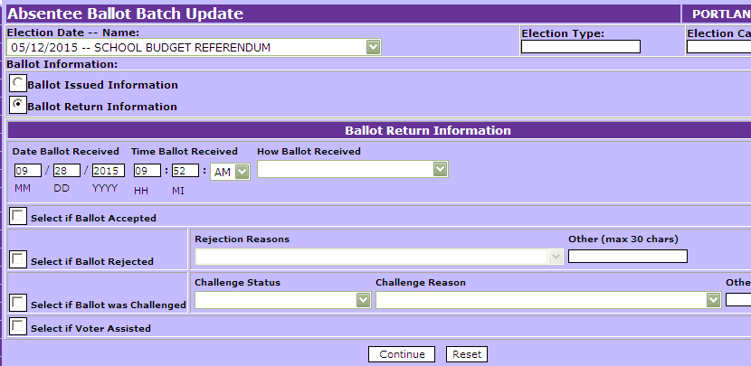

- Select the return method (and correct date/time), check the Ballot Accepted Box, and click Continue:

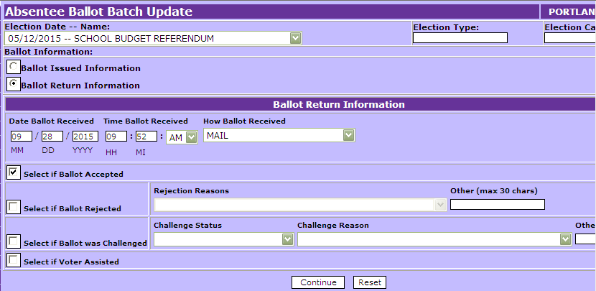

- 10 blank boxes will appear. Scan the barcodes (or manually enter the voter ID numbers) in the boxes. Make sure cursor is in the first box before scanning/entering. After entering the 10th number, or when you are otherwise done, click Insert.

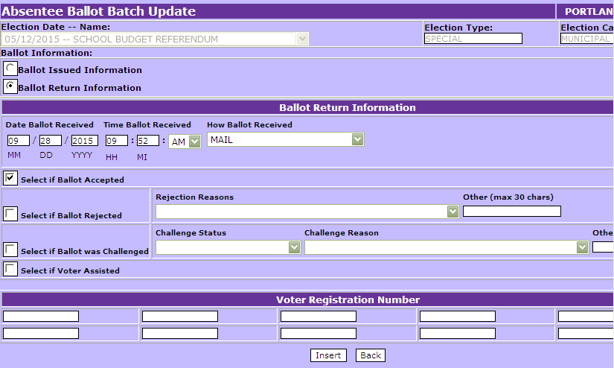

- You will get confirmation messages for each of the voters entered, and another 10 blank boxes.

- After you are done scanning/entering Returned Ballots, print an Absentee Voter File report and PROOFREAD the absentee ballot envelopes against the report to confirm that you have captured the correct return method for each voter.

- Each voter’s absentee ballot record will be automatically updated with the return information you have scanned/entered. If you discover that an error was made, you will need to access the voter’s absentee ballot record in CVR (through the Absentee Ballots module) and make the correction there.

- Repeat the process for ballots received by other methods and/or other dates/times.

- Rejected ballots may be captured through the Absentee Ballots Batch Update process. Check the Ballot Rejected box, and select the rejection reason. Repeat the process for ballots returned by other methods and/or different dates/times, and other rejected reasons.

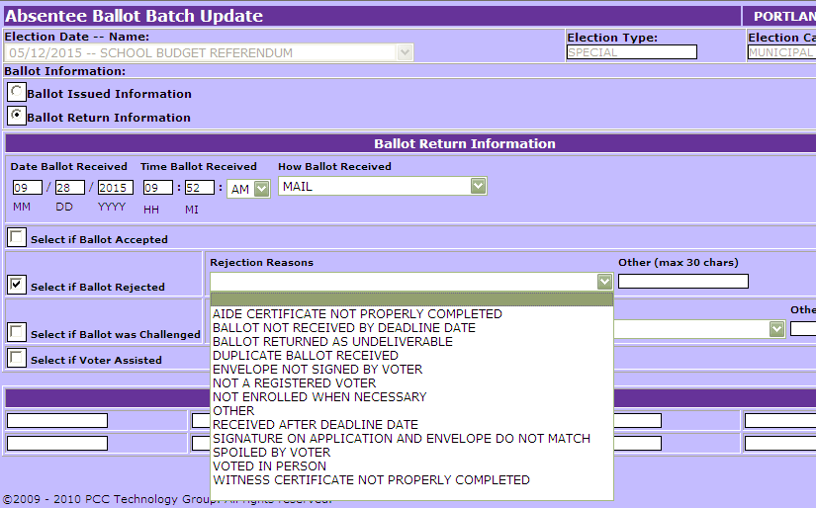

- Challenged status may also be captured. Check the Challenged Ballot box, indicate whether the challenge was removed or not, and select the challenge reason.

- Voter Assisted may also be captured. Check the Voter Assisted box.

Important:

ALWAYS watch the screen as you are scanning in barcodes.
The scanner will beep even if barcodes are not being inserted in the boxes.
Also, a complete barcode might not be captured, or you might forget and scan the same barcode a second time, which will populate the next box with the same number. Taking the time to watch the screen as you are scanning helps you avoid spending additional time later to resolve a discrepancy.

Notes:

The same rules that apply when entering absentee voter information in the Absentee Ballots module apply to the Absentee Ballots Batch Update process. If you scan a barcode for a voter who does not qualify to receive a ballot by the selected Issue type, or who does not qualify to return a ballot by a selected Return method, you will get an error message when the barcodes are confirmed after hitting Insert.

Whether you use the Absentee Ballots module to enter absentee ballot information, or you use the Absentee Ballots Batch Update process,
ALWAYS print an Absentee Voter File report after data entry to confirm that absentee ballots have been entered correctly for all voters.

