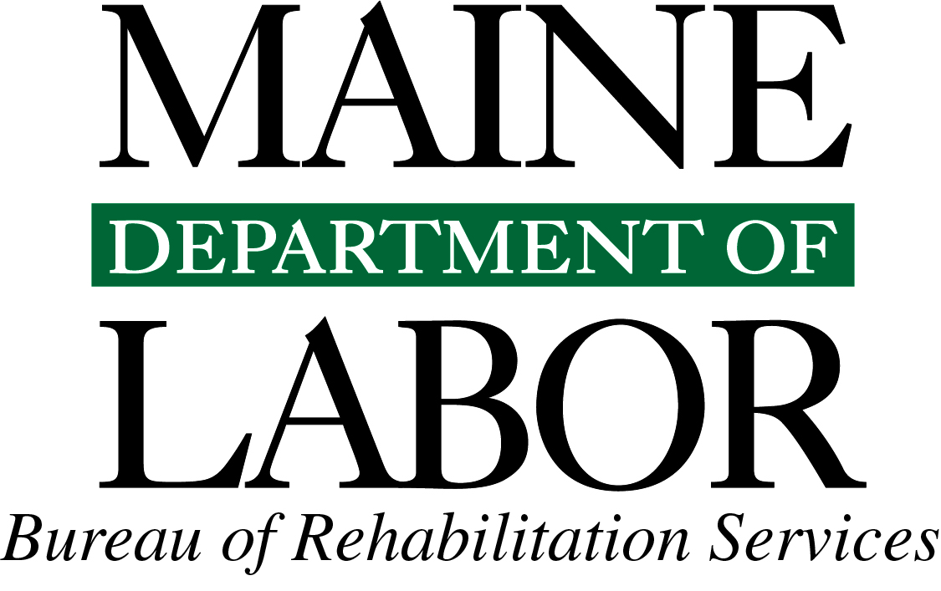
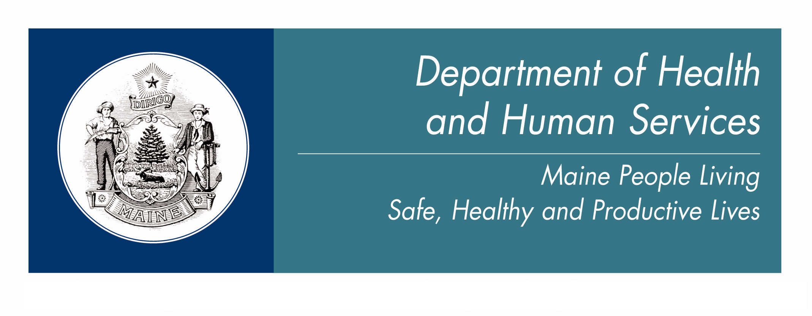
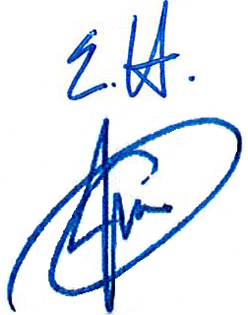
Joint Procedural Directive – Employment Services and Long Term Support
Date: 10/2014
From: Elizabeth Hopkins, Director, DOL Division of Vocational Rehabilitation
James Martin, Director, DHHS Office of Aging and Disability Services
The Department of Labor’s Vocational Rehabilitation program and the Department of Health and Human Services’ Office of Aging and Disability Services has a strong and mutual commitment to work together toward the goal of supporting and encouraging individuals with disabilities to obtain and maintain competitive employment in their communities. We are fortunate to have many dedicated, hardworking staff that support employment for our shared clients.
This procedural directive provides updates on the status of services in both organizations, as well as information on the joint long-term employment-support process that we have in place to support people served by our respective departments. Importantly, we must ensure that releases are in place that allow for both the Case Worker and Vocational Rehabilitation Counselor to be in contact and share information for a smooth transition of individual support services between departments.
The important issue for all to remember in both departments is that Adult Developmental Services currently has over 2,000 working age individuals who are already on one of the two waivers, but are not using any of those waiver dollars for employment supports. Those individuals may be able to benefit from VR services by utilizing long-term supports under one of the two waivers after they have been placed in a job through VR. Our joint goal is to continue to work together at all levels to maintain and improve this cooperation between our two departments in order to increase the employment of individuals with disabilities in Maine.

Status of Developmental Services:
Both waivers (described below) have undergone recent rule changes that offer new services beginning October 2014. Career Planning and Assistive Technology will provide new opportunities for individuals and limited home supports have been added to the Support Waiver (Section 29). Individuals will continue to be offered waiver services based on the availability of funded openings. Individuals can be on the waitlist for one or both waivers but only receive one waiver at a time.
A youth who is 18 or older, has been found eligible for Developmental Services, and is in high school can apply to the Waiver Program while still in school. If they are found medically and financially eligible for Section 21 or 29, they will presently be placed on a waitlist.
Section 29 Support Waiver
This waiver is designed to provide limited services in home, community and employment for individuals eligible for developmental services and who have been assigned the waiver. The waiver continues to have a waitlist for services and offers people services as openings become available.

Section 21 Comprehensive Waiver
This waiver is designed to provide comprehensive home, community and employment support for individuals eligible for developmental services and who have been assigned the waiver. The waiver is managed based on priority status for health and safety.
Procedure to access Waiver Employment Supports
Career Planning (New)
- Must be found eligible for Services (DD-program specific).
- Must have one of the Waivers (Section 21 or Section 29).
- Employment Conversation must identify an interest in pursuing work and support is needed.
- Choice of Services to meet the employment goal are discussed and decided upon during a Person Centered Plan Meeting. Some services to consider are: Career Planning, Community Supports—The Bridge Curriculum, VR, Post-employment Work Supports or Employment Specialist.
- Career Planning Services are NOT necessary for all waiver participants; individuals may choose not to receive Career Planning and just apply for VR.
- Person Centered Plan and goal identifies the Career Planning Service as the needed service.
- Choice of and referral to a Service Provider for Career Planning by Caseworker/Resource coordinator through a vender call process; use www.employmentformewds.org for list of Certified Career Planning staff.
- Career Planning Services are provided up to 60 hours in a six-month period, allocated through the Person Centered Plan.
- Use of Discovering Personal Genius™ process and development of Employment Staging Record (electronic) for Career Planning are the primary services allowed.
- A Referral to Technology Assessment, if necessary, can occur by the Career Planning Staff.
- A Referral to Benefit Counseling can occur by the Career Planning staff.
- A Referral to Vocational Rehabilitation by Caseworker or Career Planning staff is recommended as early as week #2 of Career Planning.

- VR staff will determine eligibility during the Career Planning phase (within 60 days of application).
- If already in VR Services and the VR Counselor believes the individual would benefit from Career Planning:
  - VR Counselor must call the DS Caseworker to discuss option of Career Planning services.
  - Consumer must agree that they want Career Planning Services though the Waiver (see 3-8 above).
  - The VR Counselor will write a plan that will indicate who is providing the Career Planning, and, if funded by the waiver, document that this service is being provided as a comparable benefit.
  - Consumer may access both VR and Career Planning Services at the same time.
- An individual currently employed in a situation that does not meet their employment goal or is sub-minimum wage may choose to access Career Planning and maintain current employment until they transition to a new position.
- The electronic Employment Staging Record (ESR) will be shared with VR staff during Career Planning and the final Career Plan/ESR will be utilized to inform the development of the Employment Goal.

Work Supports (once employed) Section 21 or Section 29
- Work Supports—Individual (one person-one job)
  - Utilized to assist the individual in maintaining employment.
  - Employment must meet definition allowed in MaineCare Section 21 or 29 rules.
  - Transfer of support form from VR to the waivers is to be completed by Case Worker and VR Counselor (see 9/2014 version).
- Work Supports—Small Group (enclaves, work crews, agency-owned business, no more than six)
  - Utilized to assist the individual in maintaining employment.
  - Employment must meet definition allowed in MaineCare Section 21 or 29 rules.
Please note, VR does not support group employment as a successful closure.
Employment Specialist Services (once employed) Section 21 and Section 29
- Intermittent service.
- Service must meet definition in MaineCare rule.
- Transfer of support from VR to the waivers is to be completed by Case Worker and VR Counselor (see 10/2014 version).

Status of the Division of Vocational Rehabilitation
The Division of Vocational Rehabilitation (DVR) continues to operate with no waitlist for services. DVR has developed and utilizes three Career Exploration Workshop (CEW) curriculums to assist individuals in determining their vocational interests, abilities and rehabilitation needs. Specifically, the Bridge CEW has been designed for use by agencies or VR staff to assist individuals with intellectual disabilities who may have limited language skills. It uses pictorial assessments and is designed to be used in pre-vocational settings. This curriculum can be found at: VR CEW Curriculum

Procedure for Vocational Rehabilitation Counselors to access Long-Term Supports
1. Individual Already Determined Eligible for VR Services:
  - Confirm that the Individual is eligible for Adult Developmental Services. Eligibility Information can be found at DHHS OADS Eligibility.
  - Determine waiver status (Section 21 or Section 29) by contacting the Case Manager if it is unknown.
- Complete a Long-Term Supports—Work Supports form in conjunction with Case Manager and submit to the local DS District office. OADS District Resource Coordinator should receive the request at least 30 days prior to transfer to LTS.
- Unclear if eligible for Adult Developmental Services or other funding source: contact Case Worker or local OADS District Office, Resource Coordinator.
- Individual Already Determined Eligible for VR and Adult Developmental Services but not on Waivers: If it has been determined that an individual requires long-term support services for successful employment and they are not on either of the DS waivers:
- Explore referral to VR or Brain Injury LTS (if support needs are anticipated to be under the $3,000 annual cap or under the Brain Injury LTS capped at $8,000 per year).
- If receives LTS VR support while on waitlist, as soon as waiver becomes available will transfer from VR to OADS-Waiver, Work Supports. OADS and VR staff will remain in contact as to waitlist status for joint clients and work together to ensure transfer.
- Explore Mental Health Long-Term Employment supports if eligible for Section 17 DHHS SAHMS Vocational Information
- Explore other options such as State OADS Contract monies (submit LTS request form), IRWE/PASS, private pay, natural supports with individual and Case Worker.
- If no LTS supports can be identified at this time, and it has been clearly determined that more long-term supports are required than available in points a through c above, then VR can close the individual’s case until applicable LTS supports are available. If the individual is on the waiver waitlist and then is offered the waiver, the case manager can then encourage the individual to reapply for VR services. If an individual is not on the waitlist for a waiver, the VR Counselor should encourage him/her to apply by referring the individual back to the case manager.
- Important Reminder to all VR counselors – According to our Rules, VR cannot deny or refuse applications for individuals, even if the counselor believes the individual may not have long-term supports in place. Eligibility (and then Order of Selection) is determined based on all our criteria for eligibility. Once that is completed, if it is determined that the individual will require long-term supports and there is no funding, then the person would be closed and asked to re-apply once he/she has secured long-term supports (see 3 above).
- For Transition Students: If already found eligible for VR services – See points 1 and 3 above.

**Please refer to Long Term Sign-Off form dated October 10, 2014
Office of Aging and Disability Services

Request for Confirmation of Long Term Employment Support for Vocational Rehabilitation

Consumer Name: _________________________________DOB______________________________
After assessing the needs of the above named individual The Division of Vocational Rehabilitation is requesting OADS to provide confirmation of long term employment funding. The support needed must meet the MaineCare rule for the service and the limits. Confirmation allows VR process to continue.
Please Complete Known Information and Update as New Information is available:
Place of Employment: _______________________________Town:_____________________________
Hours per week: __________________________________ Rate of Pay: _________________________
Agency to Provide LTS: _____________________________Agency Ph #: ____________________
Start Date for LTS (projected) ____________________________(Month, Day, Year)
Confirmed Funding Source (check one)
______Section 18 MaineCare (Brain Injury)
______ Section 21 MaineCare (Developmental Services)
______Section 22 MaineCare (Other Related Conditions)
______ Section 29 MaineCare (Developmental Services)
______ Request for OADS State Contract (Work Supports) (limited funding up to 3,000 per year)
Describe projected Plan for Natural Supports, technology and other supports for successful placement:
_______________________________________________________________________________________________________________________________________________________________________________________________________________________________________________________________
Is work support projected to reduce over time? ____________________________________________
VR Counselor Signature: ____________________________________________Date:________________
Caseworker Signature: ______________________________________________Date:________________
CC: OADS Resource Coordinator in District October 10, 2014

