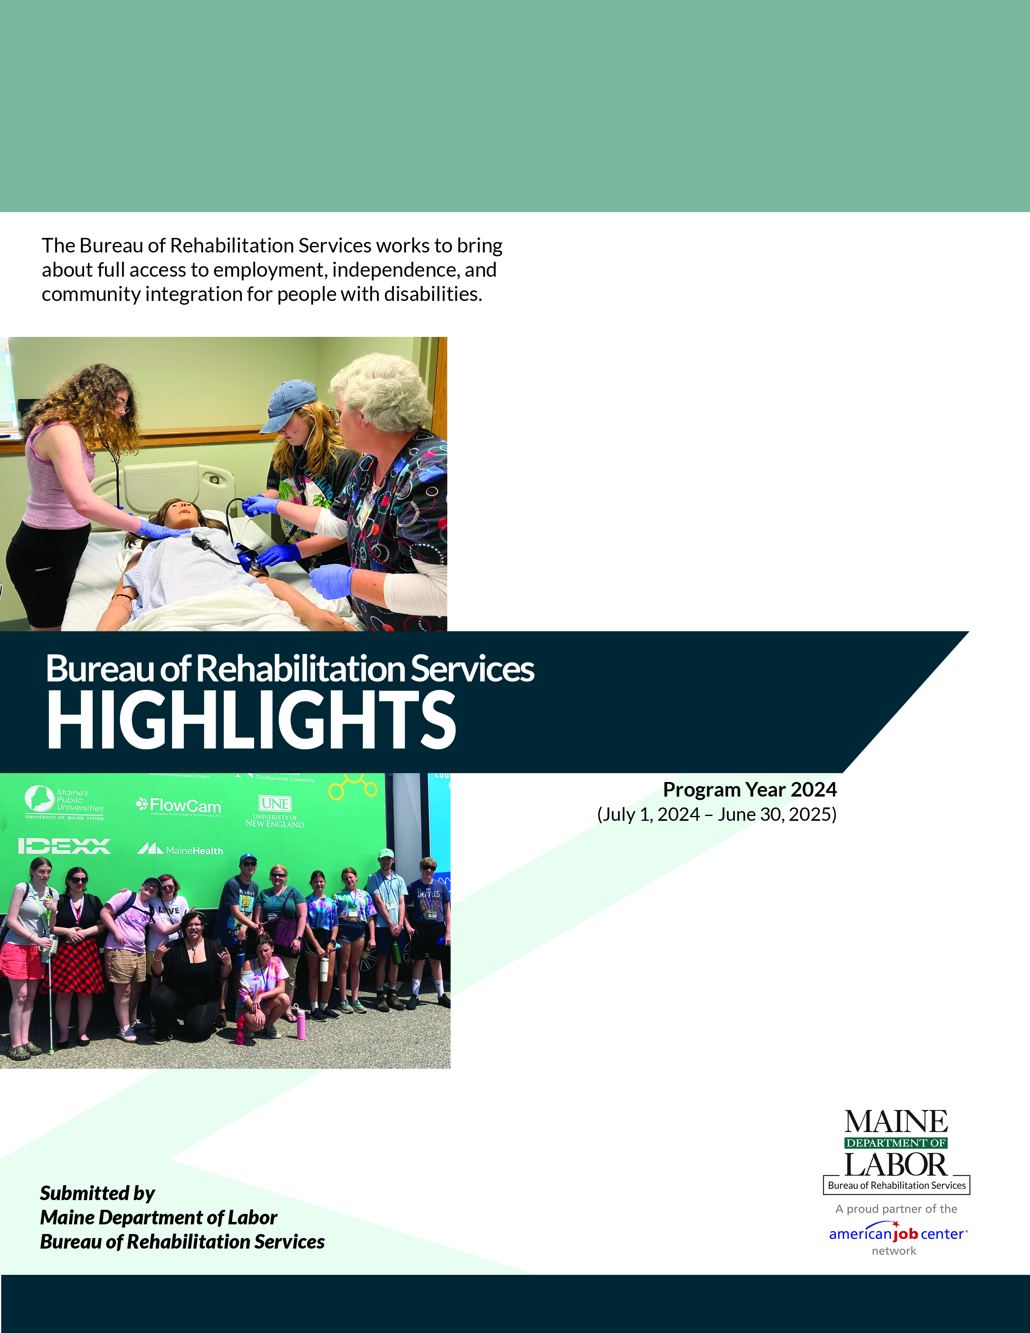

Cover Photo: Two students on the College Bus Tour get hands-on experience in health care and below, a group of students in the VIBE program in front of the Maine Mobile Bio Lab
The Maine Department of Labor provides Equal Opportunity in employment and programs.
Auxiliary aids and services are available to individuals with disabilities upon request.
STATE OF MAINE
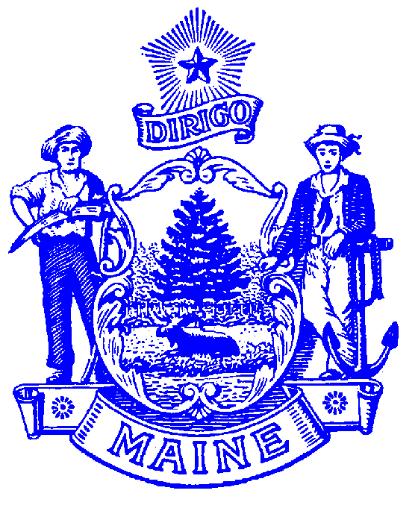
DEPARTMENT OF LABOR
BUREAU OF REHABILITATION SERVICES
150 STATE HOUSE STATION
AUGUSTA, MAINE 04333-0054

LAURA A. FORTMAN
COMMISSIONER

JANET T. MILLS
GOVERNOR

Bureau Director’s Message

This has been another busy Program Year in the Bureau of Rehabilitation Services (BRS)!
This edition of the annual BRS Highlights report is full of great information about the Bureau’s programs and services. You’ll read about success stories, new initiatives, new staff, and innovative approaches to helping the individuals we serve reach their employment and independent living goals. Every year has its challenges—and this year was no different—but what stood out was a renewed sense of excitement about how to meet those challenges. Cross-division work blossomed between the Division for the Blind and Visually Impaired and the Division of Vocational Rehabilitation. While most evident in youth programming, there were also many new opportunities that benefited adults. Likewise, staff continued to grow partnerships across the state. By working across regions, staffing and resources were able to more productively meet the needs of more of our clients. BRS staff were encouraged to pilot new approaches and refine them based on participant input and feedback—an approach particularly evident in our Disability Innovation Fund “Pathways to Partnerships” grant.
Speaking of creativity and innovation, this year marked the 10th anniversary of Progressive Employment—a dual-customer (employer/jobseeker) model originally developed in Vermont. What started in Maine as a way to address the needs of young people who left high school disconnected from employment opportunities has grown into a statewide model serving both youth and adults. Embodying the belief that “everyone is ready for something,” and recognizing the importance of meeting employers and jobseekers where they are, Progressive Employment has become an important tool for connecting individuals with barriers to employment to employers seeking new talent pools. In partnership with the Bureau of Employment Services and other workforce partners, Progressive Employment has expanded to serve individuals in recovery and reentry.
As you review this report, I hope you come away with helpful data about our programs—but more importantly, that you feel excited and inspired by the work happening every day at the Bureau. On behalf of all of BRS, I invite you to reach out to learn more, meet our talented and dedicated staff, and partner with us to expand opportunities as we fulfill our mission to “bring about full access to employment, independence, and community integration for people with disabilities.”
With thanks,

Libby Stone-Sterling, PhD
Bureau Director
PHONE: (207) 623-7943 TTY users call Maine Relay 711 FAX: (207) 287-5292
The Maine Department of Labor provides equal opportunity in programs, services and employment.
Auxiliary aids and services are available to individuals with disabilities upon request.Programs are provided as a proud partner of the American Job Center network.

Table of Contents

Bureau of Rehabilitation Services (BRS) Overview 1
How We Define Success 3
Division of Vocational Rehabilitation (DVR) 5
DVR Initiatives & Innovations 6
Division for Deaf Hard of Hearing and Late Deafened 9
BRS Apprenticeship Program 10
Pathways to Partnerships (P2P) Program 12
Division for the Blind and Visually Impaired (DBVI) 13
DBVI Initiatives & Innovations 14
Systems Improvement Quality Assurance (SIQA) 18
Office of State ADA Coordinator 19
Partners in Advocacy 21
BRS Office Directory 22

Bureau of Rehabilitation Services Overview
The Bureau of Rehabilitation Services (BRS) is comprised of four Divisions – the Division of Vocational Rehabilitation (DVR), the Division for the Deaf, Hard of Hearing, and Late Deafened (DODHHLD), the Division for the Blind and Visually Impaired (DBVI), and the Division of Systems Improvement and Quality Assurance (SIQA). As Maine’s tight labor market continues, BRS has had an average of 152 employees delivering public vocational rehabilitation and independent living services to people with disabilities throughout the last year. Co-located at CareerCenters statewide, BRS also houses the Office of the State Accessibility Coordinator, who leads the State’s compliance under the Americans with Disabilities Act (ADA) and Section 504 (see page 10).

The Rehabilitation Act of 1973, as amended by the Workforce Innovation and Opportunity Act (WIOA) of 2014, establishes program eligibility and the scope of services provided through DVR and DBVI. Included are vocational counseling and guidance, physical restoration services, education and skills training, and job placement services. DBVI, in conjunction with the Maine Department of Education, also serves all children who are blind in Maine.

This past year, 9,785 Mainers with disabilities received services from BRS via the Vocational Rehabilitation, Independent Living, Orientation & Mobility, and education programs; of those participants, 7,493 received services with a plan for employment. Counselors worked with clients who had an employment plan, on average, for 703 days or about 23 months. A total of 448 clients were successfully employed earning an average wage of $675.69 per week.

BRS receives most of its funding from federal grants, some of which require matching state funds. The largest (one administered by DVR and one administered by DBVI) are from the Department of Education’s Title I grant program for vocational rehabilitation services.

Federal Grants Required General Fund Match
Vocational Rehabilitation 4:1 (21%)
Independent Living 9:1 (11%)
Supported Employment - Youth 10%
Supported Employment - Adult None

Special Revenue income is received from the Business Enterprise Program and the Public Utilities
Commission for telecommunications. The use of the Special Revenue funds is
restricted for these specific purposes.

How We Define Success…

“Kay” applied for Vocational Rehabilitation (VR) services while she was a student at Washington County Community College. At the time, Kay was living near her school with a friend and had no family support. She experienced academic challenges in high school due to learning disabilities; however, with the support of her Vocational Rehabilitation Counselor (VRC), Kay learned to advocate for her educational needs and successfully completed two associate degrees in Adventure Recreation and Tourism and Conservation Law.
Kay hopes to further her education in Outdoor Leadership with a concentration in Adventure Therapy. In the meantime, she was hired as a Direct Support Professional in Calais, where she is already incorporating elements of adventure therapy into her work with the individuals she supports.
Kay shared, “Thank you very much! I appreciate the program so much. I don’t have words to fully explain how grateful I am. I don’t think I would be this far or this happy in life without this program, and I am very thankful.”
Kay understands that she can reconnect with Vocational Rehabilitation when she is ready to take the next step in her career pathway. For now, she reports that she has “found the job that I want to stay in for the rest of my life.”

“John,” a high school senior, participated in Bootcamp, a work readiness program. While he was engaged in in-class activities, he initially did not express interest in participating in exploration activities offered outside of the Bootcamp classroom. Over time, John’s attendance and participation began to decline; however, his Vocational Rehabilitation Counselor (VRC) met with his teacher, and together they developed a plan to reengage him.
John continued with limited engagement until he learned that a friend who also received VR services had obtained employment. This motivated John to contact his VRC and began actively participating in VR services.
John completed a paid work experience at a local hardware store, where he had a very positive experience and received strong feedback regarding his work skills and abilities. Through this experience, he developed new job skills, recognized strengths he already possessed, and gained significant confidence. He was also able to use the store manager as a professional reference as he pursued his next career opportunity.
With support from his VRC, John applied to another local employer and spent time practicing interview skills, becoming more comfortable with the application process and understanding employer expectations.

“Jason” began working with Vocational Rehabilitation (VR) with an initial vocational goal of becoming a Network Support Specialist. He participated in a Career Exploration Workshop (CEW), during which he completed the World of Work Inventory Assessment. The results indicated a strong aptitude in mechanical and electrical areas. Based on these findings, Jason revised his vocational goal to become an electrician.
Jason completed a paid summer work experience with a local electrical company, working as an electrical assistant, as well as a paid summer work experience as a helper for a local electrician. He later enrolled at Central Maine Community College, where he graduated in 2023 with his Electrical Journeyman In-Training Certification. Jason obtained full-time employment in Rumford as an electrician and has remained successfully employed. He is currently working toward earning his Electrical Master’s License.

In 2011, “Andrew” lost his job as a warehouse carpet cutter due to untreated mental health challenges and difficult circumstances. “I began treatment for opioid dependency several years earlier and needed health care coverage to afford my medications. Experiencing significant anxiety, I visited the CareerCenter in Augusta, Maine, seeking assistance with applying for MaineCare. Through this process, I learned about multiple resources and programs that were available to support me when I was ready to engage.
“Between 2011 and 2013, Vocational Rehabilitation (VR) provided critical support by helping me secure health care coverage and SNAP benefits, obtain a neuropsychological evaluation, connect with a case manager, participate in Dialectical Behavior Therapy (DBT) and Cognitive Behavioral Therapy (CBT) groups, find an addiction counselor, and maintain consistent care with a physician and medication manager. Gaining a better understanding of my developmental differences gave me a new perspective on life and renewed optimism for my future.”
In 2013, Andrew successfully transitioned off opioid maintenance medication and began pursuing an education in addiction and mental health. Vocational Rehabilitation supported him in attending a computer refresher course, applying to community college, completing prerequisite coursework, applying for federal and state grants, maintaining health care while working part-time, and ultimately graduating with an associate degree in Mental Health (MHRT-C).
“Through VRC’s guidance, I learned that my education and lived experience opened doors to multiple career paths. I participated in career-matching group seminars, developed a professional resume, and collaborated with employment specialists.” With weekly check-ins and ongoing support, Andrew applied for a Recovery Coach position at a nonprofit mental health organization. Andrew was hired – and he loves the work.
Andrew first sought help from Vocational Rehabilitation 14 years ago to obtain health care, today he has a fulfilling career. Words cannot fully express his gratitude to the state of Maine and the resources available to those willing to engage and follow through.
As a Recovery Coach, he provides free and confidential support to individuals and families affected by addiction. He helps bridge people to resources and guide them as they navigate recovery. Andrew is a member of a local Community Impact Unit at the local police station, where he represents OPTIONS (Overdose Prevention Through Intensive Outreach, Narcan, and Safety) for the county. In this role, he provides training, counseling, and advocacy for those impacted by addiction, as well as for community members seeing education.
Working for a nonprofit allows Andrew to collaborate with a wide range of community organizations, including Vocational Rehabilitation – where he now refers clients and considers many of the staff his professional colleagues.

Division of Vocational Rehabilitation (DVR)
Samantha Fenderson, MA, Director
Maine’s DVR assists individuals with disabilities who wish to achieve, retain, or advance in employment. Any person who wants to pursue employment and has a disability that creates a barrier to employment is encouraged to apply. Once determined eligible, individuals develop a plan for employment, which outlines the services needed to successfully achieve their employment goal.

Contributing to the Maine Economy
While maintaining a wait list for services, DVR assisted 435 people to find employment success over the last year. This resulted in these individuals earning an anticipated total of $15,431,300.30 in annual wages. Across the state and across industry sectors, DVR clients are joining or rejoining the workforce in jobs such as:

Accountants and Auditors | Fast Food and Counter Workers | Magnetic Resonance Imaging Technologists
Administrative Services Managers | General and Operations Managers | Marketing Managers
Bakers | Graphic Designers | Nonfarm Animal Caretakers
Barbers | Health Specialties Teachers, Postsecondary | Office and Administrative Support Workers
Carpenters | Healthcare Support Workers | Packers and Packagers
Cashiers | Industrial Machinery Mechanics | Receptionists and Information Clerks
Dental Hygienists | Insurance Sales Agents | Sales Workers
Dishwashers | Janitors and Cleaners | Tax Examiners, Collectors and Revenue Agents
Editors | Kindergarten Teachers | Ushers, Lobby Attendants, and Ticket Takers
Electricians | Laborers and Freight, Stock, and Material Movers | Veterinary Technologists and Technicians
Farm Labor Contractors | Landscaping and Groundskeeping Workers | Waiters and Waitresses

Individuals Served
3,675 New VR Applicants
2,916 Youth with Disabilities who received Transition Services
7,250 Received Services through Employment Plans
435 Individuals Successfully Employed

DVR Initiatives and Innovations
DVR celebrated 10 years of Progressive Employment! Progressive Employment is a dual customer strategy that is designed to promoteengagement and employment outcomes through work-based learning activities that meet the needs of jobseekers and employers. Jobsville is an opportunity for Regional teams to discuss Progressive Employment referrals, labor market information and employer engagement. Progressive Employment is available throughout the State for both youth and adult jobseekers.

The Bureau of Employment Services and additional community partners joined DVR in several locations which has enhanced the Jobsville meeting and created increased opportunities for individuals that are facing barriers to employment.

The following success story highlights how Progressive Employment supports the career exploration and leads to meangingful employment.

John was referred to Progressive Employment by his VR Counselor to support his exploration of potential career paths. He participated in several employer tours to learn about different positions and job tasks, as well as completed vocational assessments to identify his interests, strengths, and preferred work environments.

Following the employer tours and informational interviews, John expressed interest in trying a position with a local business. He completed a six-week paid work experience that allowed him to gain hands-on exposure to the day-to-day operations of a greenhouse. Due to his success during the work experience, the employer hired John, and he has since expanded his role into other areas of the business.

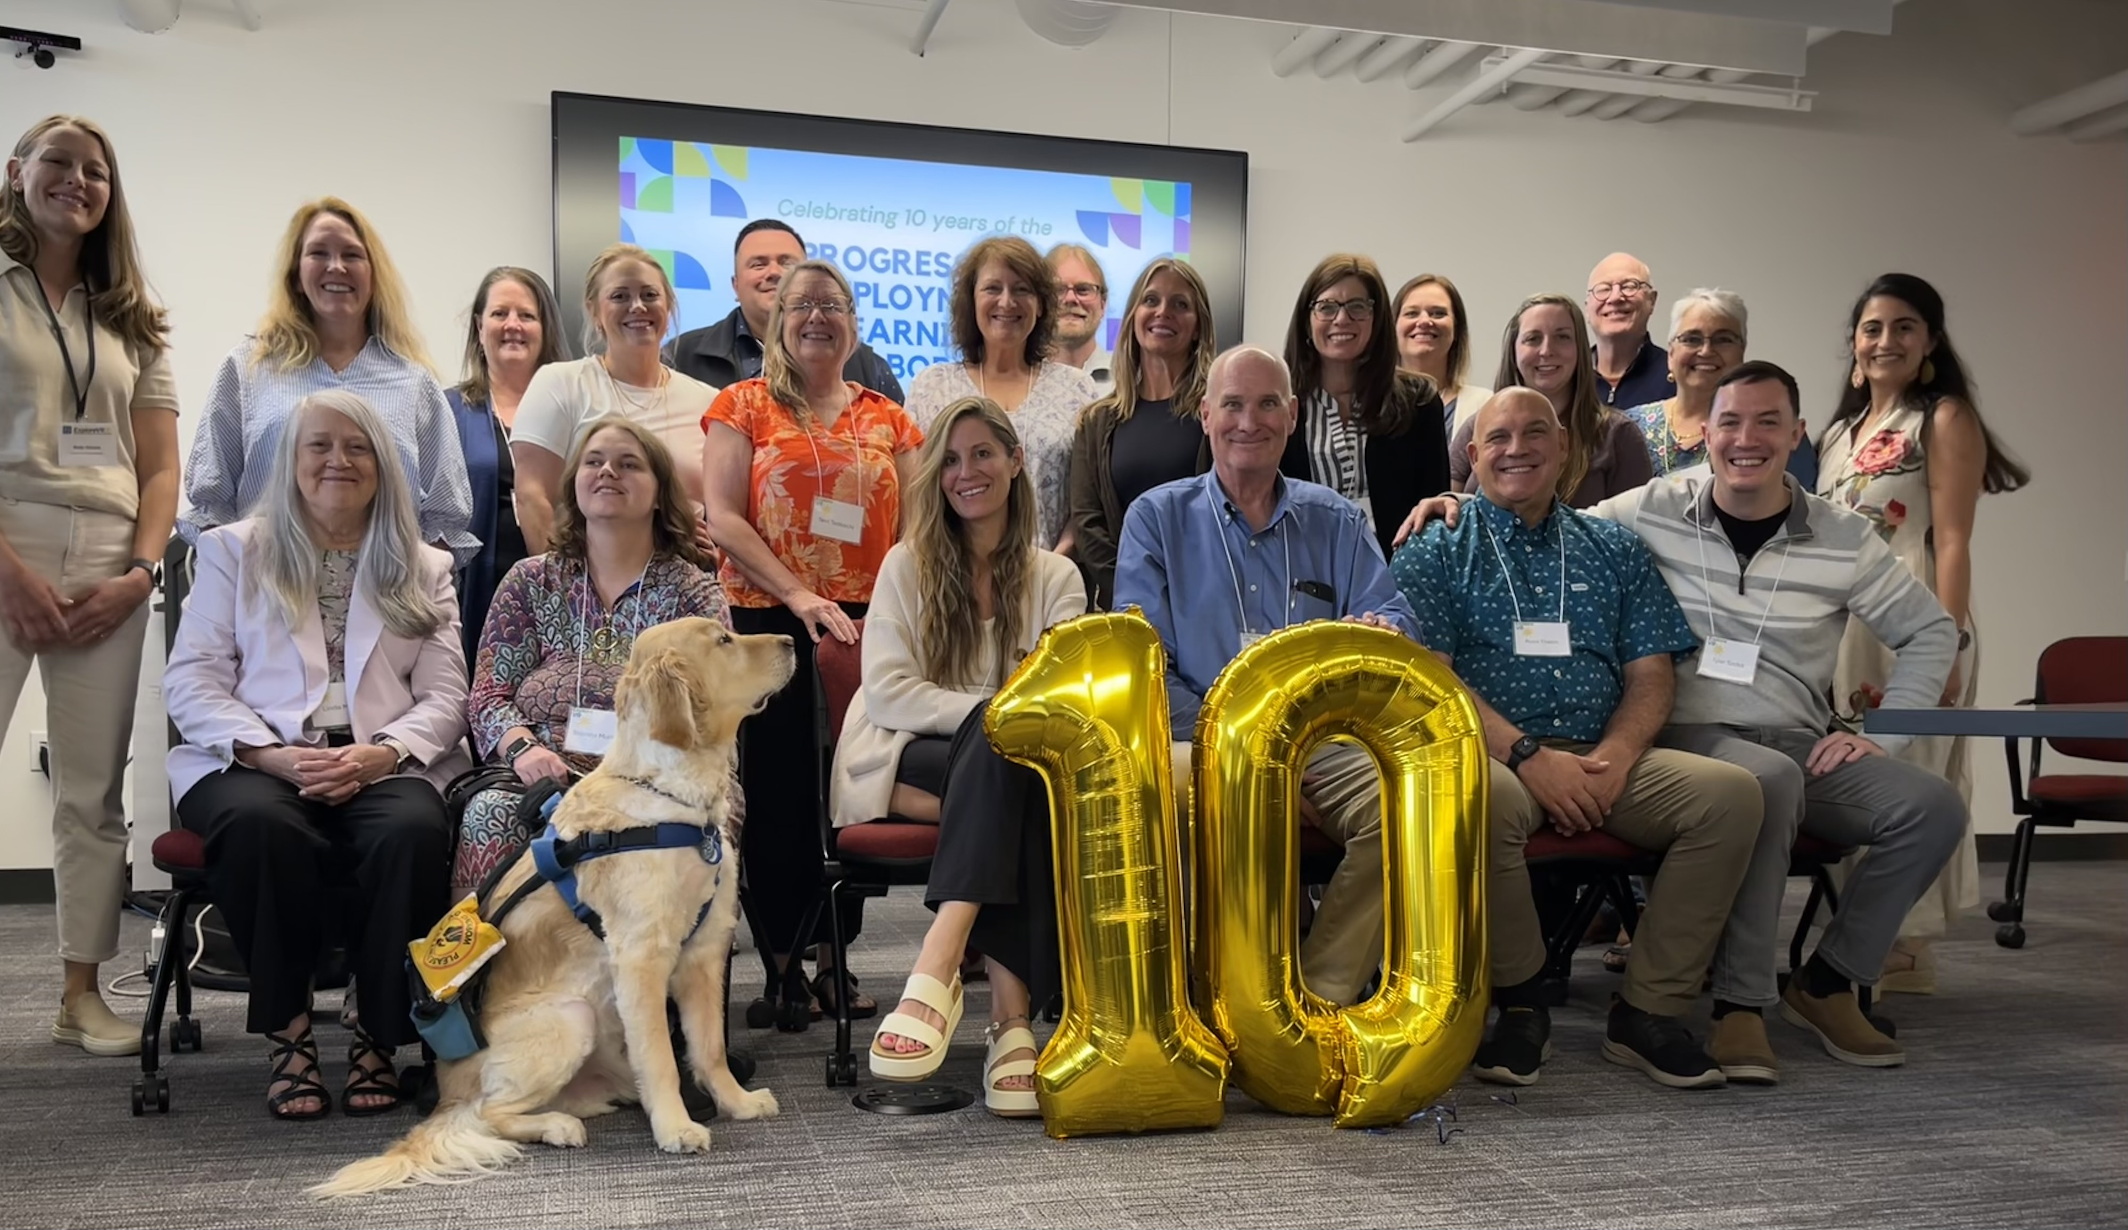
Ryan Fitzgerald, Casework Supervisor, and Liz Nitzel, DVR Statewide Business Consultant, attended the Progressive Employment Learning Collaborative

New in 2025! DVR, alongside Department of Health and Human Services, Office of Behavioral Health are working together to support Individual Placement and Support (IPS), a model of supported employment for people with serious mental illness. Up to eight statewide DVR IPS liaisons will work as part of a team with the Certified Community Behavioral Health Clinics (CCBHCs), including the participant, to provide the eight core principles of IPS.

The eight core principles of IPS are:
- Competitive Employment
- Systematic Job Development
- Rapid Job Search
- Integrated Services
- Benefits Planning
- Zero Exclusion
- Time Unlimited Supports
- Worker Preferences

New in 2025! Drop-In Job Club The Job Club, originally developed in 2020 as a virtual program covering seven topics: resume writing, navigating online applications, job search strategies, interview tips, disability disclosure, workplace culture and professionalism, and communication in the workplace. Due to increased demand for in-person support, the Job Club has transitioned to an in-person, drop-in format. Participants may attend as many sessions as they wish or focus only on the topics that interest them. The Job Club is a great compliment to the Career Exploration Workshop (CEW), a three-day virtual or in-person program centered on career pathway discovery.

DVR Business Engagement team as connected with multiple businesses across the state leading to 363 jobseekers attending business tours.

DVR eliminated the waitlist in July 2025. A waitlist is generated by a lack of resources (funding or staffing). The elimination of the waitlist is a significant milestone for our state, as it means that individuals can now access voccational rehabilitation services without being placed on a waitlist.

Youth Services DVR facilitated several Pre-Employment Transition Services programs, in addition to coordinating paid work experiences for youth.

The College Bus Tour hosted 41 students, who visted 14 colleges and participated in campus tours, targeted career-readiness discussions, and career-pathway exploration.

The Youth Maine Apprenticeship Tour (MAP) introduced10 high school students to three industry sectors: construction, health care, and farming.

The Venturing into Independence and Building Skills for Employment (VIBE) program, a collaborative initiative with the Division for the Blind and Visually Impaired, provided seven DVR youth with a two-week traning focused on developing core pre-employment skills.

Career Compass, a career-readiness program offered through the Community Rehabilitation Provider Living Innovations, in its first year the program, worked with 27 students across four high schools. Bootcamp, a similar career-readiness program delivered by the Community Rehabilitation Provider Goodwill, supported 575 students across 87 high schools.

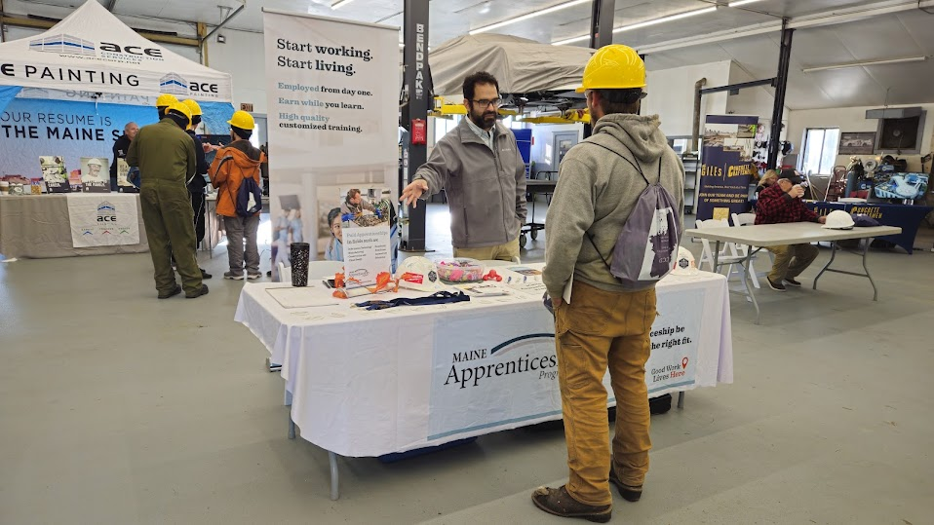
Construction Career Days Event on October 9th. A hands on, immersive event designed to introduce high school students to careers in the trades and construction industries through interactive exhibits and equipment demonstrations, opportunities to meet professionals from construction, engineering, and related fields, and educational resources and career guidance.

Division for the Deaf, Hard of Hearing and Late Deafened (DDHHLD)
The Division for the Deaf, Hard of Hearing and Late Deafened (DDHHLD) provides information and referrals for resources of interest to people who have hearing loss throughout the state. This includes such things as interpreting services, hearing aids, and advocacy. The Commission for the Deaf, Hard of Hearing and Late Deafened (CDHHLD) created and actively works on an ongoing Five-Year Plan, which can be found at https://www.maine.gov/rehab/dod/index.shtml.

The Department of Health and Human Services (DHHS) recently launched Project Transforming Interpreting Maine (TIME). This project has been a collaborative effort from the beginning and is overseen by a steering committee comprised of individuals from various organizations and state agencies, which include the Department of Labor (DOL) and DDHHLD. This committee has been working in partnership with Innivee Strategies with the goal of expanding access to American Sign Language (ASL) and English interpreting services. This initiative aims to improve communication access to Deaf, DeafBlind, and hard-of-hearing individuals across Maine, ensuring they receive timely and effective support.

The project focuses on addressing long-standing gaps in interpreting services, increasing availability, and fostering greater inclusion in community spaces, healthcare settings, and public services. For more information about this important initiative, visit www.maine.gov/dhhs/TIME

Other accomplishments of the Division included providing Deaf Awareness trainings to a wide range of audiences, including E911 dispatchers. Also, since the initiation of the Deaf identification cards and vehicle placards there have been a total of 479 cards and placards distributed. Four of these were re-issued or duplicates.

Each year the Division and Commission organize the Annual Deaf Culture Tea Awards ceremony. The 33rd Annual Deaf Culture Tea Awards celebration took place on September 19, 2024, at the Hall of Flags, State House, in Augusta. The keynote speaker was Kellynette Gomez, LCSWE. This year we awarded seven deserving Deaf community members.

The Division also continues to be involved with the National Deaf Center (NDC), which focuses on the needs of Deaf and hard-of-hearing transition students. Maine’s NDC team includes the Division of Vocational Rehabilitation, Maine Education Center for Deaf and Hard of Hearing, Maine Behavioral Health, Disability Rights Maine, and the Department of Education. The priority that Maine’s NDC team chose to focus on is using Data for Transition and Promoting Higher Expectations. This work is still happening.

Currently, there are 157 active, licensed interpreters. Fourteen hearing, legal interpreters, two in New Hampshire, one in Massachusetts, and one in South Carolina. Four certified Deaf Interpreters (CDI), two in Maine, one in Massachusetts,and one in Maryland.
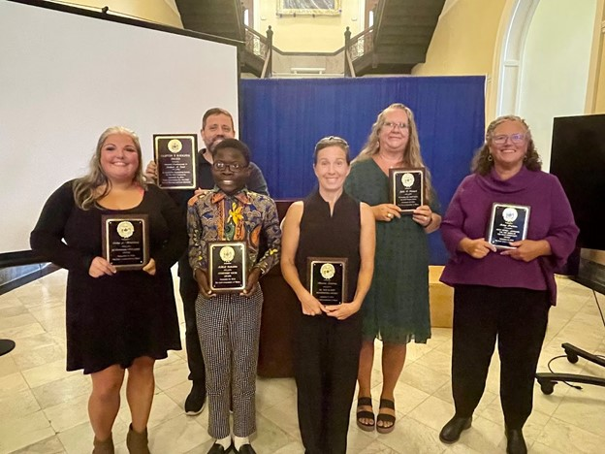
The 33rd Annual Deaf Tea Awards Celebration took place on September 19, 2024.
Pictured left to right: Erika L. Martinez, Tommy Minch holding the Joshua A. Seal-Posthumous Award (Accepted by Tommy Minch on behalf of Liz Seal), ABEL Celestino, Marisa Zastrow, Julie A. Novack, and Betsy Hopkins
1

Bureau of Rehabilitation Services (BRS) Apprenticeship Program
In 2025, participation in apprenticeship and pre-apprenticeship among individuals with disabilities in Maine continued to rise, reaching 4.59%, showing that targeted outreach, career exploration opportunities and support efforts are paying off. BRS continues to help individuals with disabilities connect with employers and pursue skilled career paths.
Mentoring
Participating Registered Apprenticeship Sponsors provide on-site mentors as a requirement of apprenticeship.

Flexibility
Apprenticeships vary in duration (generally 1 to 4 years), are offered by both small and large businesses, and are tailored to meet the needs of the employer.

Earn While You Learn
Apprentices are paid employees from the first day of the apprenticeship.

National Occupation Credential
Upon completion of an apprenticeship, the apprentice is awarded a nationally recognized, portable credential.

The Maine Bureau of Rehabilitation Services (BRS), in continued partnership with the Bureau of Employment Services (BES), and the Maine Apprenticeship Program (MAP), apprenticeship accomplishments include:
- 2025 placements: 5 DVR clients entered apprenticeships; 14 DVR clients entered into pre-apprenticeships.
- Met quarterly with Maine workforce development partners, Apprenticeship Sponsors, and technical training institutions.
- Engaged directly with youth through school visits, sharing recorded videos on apprenticeship and pre-apprenticeship through Pathful Explore, and through business tours and hands-on career exploration activities.
- Hosted the second annual Youth Apprenticeship Tour, where 10 high school students participated in hands-on activities, including virtual reality construction safety simulations, a welding workshop, an oyster farm boat tour, and a healthcare workshop with patient mannequins and hospital equipment.
- Arranged tours with a range of businesses to showcase their programs and worksites, including at Industrial Roofing Company, Maine Health, MDI Biological Laboratory, Bangor Savings Bank, People’s Inclusive Welding, Panolam, Casella Waste and others.
- Conducted outreach across Maine by attending multiple table events to share how apprenticeship benefits both businesses and jobseekers, including Maine Construction Career Days in West Bath, the Common Ground Fair in Unity, and the Maine HR Convention in Rockport.
- Provided New Vocational Rehabilitation Counselor Training on Registered Apprenticeship & Certified Pre-Apprenticeship.

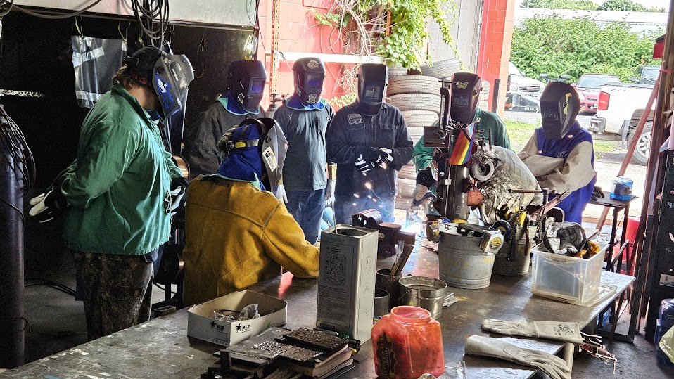
Above: People’s Inclusive Welding – Youth Welding workshop.

Below: Participant practicing chest compressions on a hospital mannequin during a
workshop at Maine Health Professional Park.
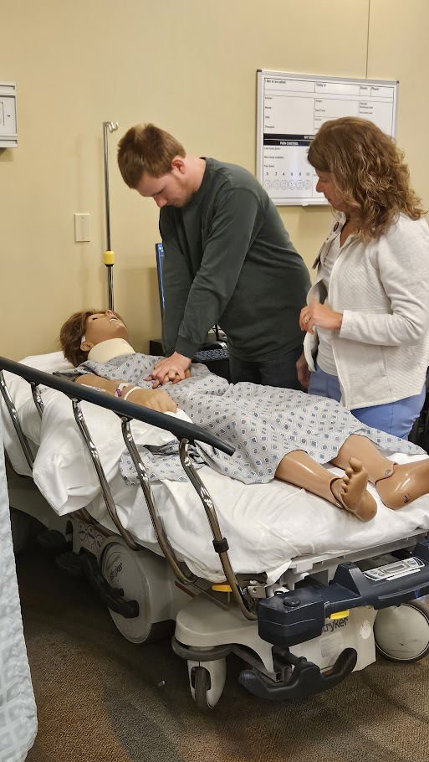

Pathways to Partnerships (P2P) Grant
In September 2023, Maine was one of 20 states awarded a Pathways to Partnerships (P2P) Disability Innovation Grant through the US Department of Education’s Office of Special Education and Rehabilitative Services (OSERS). The purpose of the five-year grant is to support innovative model demonstration projects focused on the creation of systemic approaches to transition services for children and youth with disabilities. To ensure that key agents of change are actively collaborating to support coordinated transition processes, the grant required State vocational rehabilitation agencies (SVRAs), State educational agencies (SEAs), local educational agencies (LEAs), and federally funded Centers for Independent Living (CILs) to partner on the application. In Maine, the Division of Vocational Rehabilitation (DVR) is the grant lead in collaboration with Maine Department of Education, RSU 71 (Belfast Area School District), RSU 29 (Houlton Area School District), AlphaOne and the Division for the Blind and Visually Impaired (DBVI).

P2P is an exciting opportunity to build on the strong Pre-Employment Transition Services work of DVR and DBVI and the agencies’ close relationships and shared transition approaches with partners. The ability to serve children as young as age 10 will help raise aspirations and offer families and educators resources and training well before traditional transition planning.P2P encourages piloting innovative initiatives that can be tried and refined – scaling up from pilot to statewide implementation over the grant’s five years. These initiatives include:

(1) Launch of a web-based sustainable site to serve as a primary hub for cross-agency transition information, training, and learning opportunities across the state

(2) Development of accessible on-demand curricula on transition topics (including benefits counseling, financial literacy, Pre-Employment Transition Services, etc.) for a wide range of stakeholders including children, parents, educators, and service providers,

(3) Enrollment of participants in virtual services including career exploration, peer mentoring, independent living skill building and Pre-Employment Transition Services,

(4) Increased stakeholder knowledge of work incentives and benefits counseling for individuals who receive Social Security benefits,

(5) Increased awareness and use of work-based learning, internships, pre-apprenticeship, and Registered Apprenticeship – for children ages 10-13 and youth ages 14-24 as well as educators, families, service providers and other stakeholders.

P2P expects to increase enrollment in Pre-Employment Transition Services and increase career readiness and employability skills for 300-500 children ages 10-13 and to improve the employment rate and quarterly earnings of 300-500 transition-age youth 14-24. To evaluate the grant’s progress and outcomes, Maine has contracted with Northwestern University. The project’s technical assistance providers come from the National Technical Assistance Center on Transition: the Collaborative (University of Maryland, George Washington University).

This past year, P2P launched its grant website, www.maine.gov/pathways , which serves as a place for grant resources and products. P2P also began offering its model services https://www.maine.gov/pathways/docs/2025/P2PPathwaystoPartnerships2.pdf in the pilot school districts. Expansion to additional schools is underway. The P2P Advisory Group – made up of a broad group of Maine organizations and state agencies – also includes youth and family voice. This spring, the project hired a P2P grant manager and a P2P youth specialist to lead implementation with the P2P project director. They may be reached at p2p.grant@maine.gov .

Division for the Blind and Visually Impaired (DBVI)
Elissa Rowe, MSW, Director
Maine’s DBVI provides a continuum of rehabilitation services to individuals who are blind or have low vision. Services may include individual counseling and guidance related to employment and adjustment to blindness, use of adaptive technology, low vision therapy, alternative skill training in communication (such as braille), instruction to develop independent travel skills (orientation and mobility), and instruction of daily living skills geared to being more self-sufficient. These services are provided through various programs:

Vocational Rehabilitation Program (VR) is primarily for working-age youth and adults who seek competitive, integrated employment. Services may include individual vocational counseling and guidance, vocational assessment, orientation and mobility instruction, low vision services, independent living services (vision rehabilitation therapy), and more.

The Division for the Blind and Visually Impaired (DBVI) Business Enterprise Program (BEP) allows individuals who are blind or visually impaired to own and operate businesses in state and federal facilities. Participants run vending services, cafés, and convenience stores in government buildings while receiving training in business management and customer services. The program promotes independence, economic self-sufficiency, and professional growth for blind entrepreneurs. Maine’s BEP has six managers.

Independent Living Services (IL) provides training in adaptive skills and alternative techniques for accomplishing daily tasks that enable adults who are blind or visually impaired to be more self-sufficient. This year, 293 individuals applied for IL services and 538 received services through an individualized plan. Of the total 538 individuals served, eighty-three percent were over age 65.

Education Services for Children Who Are Blind or Visually Impaired provides adaptive instruction services or consultation to approximately 300 students annually at home or at local schools related to academics and independence.
Individuals Served
80 New VR Applicants
59 Youth with Disabilities Received Transition Services
243 Received VR Services through Employment Plans
13 VR Individuals Successfully Employed

DBVI Initiatives and Innovations

The Division for the Blind and Visually Impaired (DBVI) Business Enterprise Program (BEP) The BEP facilities operated are in the State and Federal buildings, on University and Community College campuses, and at the Portsmouth Naval Shipyard in Kittery. The BEP is in the process of launching a Strategic Plan with goals in areas of training, exploring the use of Artificial Intelligence (AI) for vending and Micro Markets, outreach and recruitment and evaluating best practices in Randolph-Sheppard programs nationally as well as within our state. Gross sales for FY24 were $1,810,739 with average earnings for BEP Managers of $128,895. At the end of FY24, the BEP had 17 facilities on State property and 3 facilities on Federal property.

Independent Living (IL) Program This year, the Maine State Legislature provided funding for the individuals served in the IL program so they can have access to the most updated assistive technology devises and services which will allow them to remain independent in their homes and avoid more restrictive placement.

Blindness Awareness Month Proclamation! Governor Janet Mills officially proclaimed October as Blindness Awareness Month in the State of Maine! This special recognition came to life thanks to the passion and dedication of a valued team member at the Division for the Blind and Visually Impaired (DBVI), who thoughtfully drafted the proclamation with the support of the DBVI State Rehabilitation Council (SRC), before it was brought forward and officially recognized by the Governor for the first time! https://www.maine.gov/rehab/docs/2025/dbvi/BlindnessAwarenessMonth.pdf

Services for Students:

WOLF Camp (Winter Outdoor Leadership & Fun – Spring Edition) WOLF Camp is a two-day program offered in partnership with the University of Maine, Maine Bound program and focused on team building and leadership skills in a fun and active environment. Students participated in exercises that emphasized working collaboratively, communication skills, and participated in activities such as ropes courses and rock wall climbing. On day two of the program, WOLF participants had the opportunity to plan and lead activities for younger students with blindness and low vision.

Regional Afterschool Groups Middle and high school students participate in regional afterschool groups, focusing on areas of the Expanded Core Curriculum and developing important skills for independence and preparing for life after high school. These groups focus on a wide range of topics, including simulated work activities, scavenger hunts designed to build orientation & mobility skills, food prep, social skills, cleaning skills, and more. The groups are fun, interactive, supportive, and a great opportunity for building peer connections.

Regional Career Exploration Groups The Career Exploration Group helped students explore jobs in a hands-on way by participating in a variety of employer visits. Students tour worksites, learn about the types of jobs available, talk to employees about their position, background, and career journey, and with many employers, students have the opportunity to participate in a hands-on activity related to one of the jobs at the worksite. Students are exposed to different work environments to help them identify their interests and preferences.

Statewide Blindness Rehabilitation Specialist Roles and Collaboratives In addition to assisting in the Regional Afterschool and Career Exploration Groups, DBVI’s three Blindness Rehabilitation Specialists coordinate with students and their families and teams across the state to provide support, advocacy, resources and referrals, and connections to services and to their communities. The scope of these Rehabilitation Specialists’ tasks is intentionally broad, to encompass supporting a diverse set of needs and challenges that our students and their families may experience. These dynamics can include geographic, social, or cultural isolation, transportation barriers, navigating the special education process, and parenting challenges in general. The Rehabilitation Specialists also work to connect parents and families with similar experiences and situations together through groups, both in person and virtually.

Taking A Bigger RISK (Responsibility and Independent Living Skills for Kids) Taking A Bigger RISK is a six-week program focused on Workplace Readiness Training and Instruction in Self-Advocacy. Teachers of the Visually Impaired, from Catholic Charities Maine, provided direct instruction to students on a variety of independent living skills and offered many opportunities for students to practice advocacy skills through a choice and supported practice of learned skills.
Students learned about a variety of adaptive tools and strategies to support independent living skills. Each student was assigned a “skills coach” to help them identify a goal they wanted to work on and met with them weekly to support progress on their goal and troubleshoot any challenges that arose.

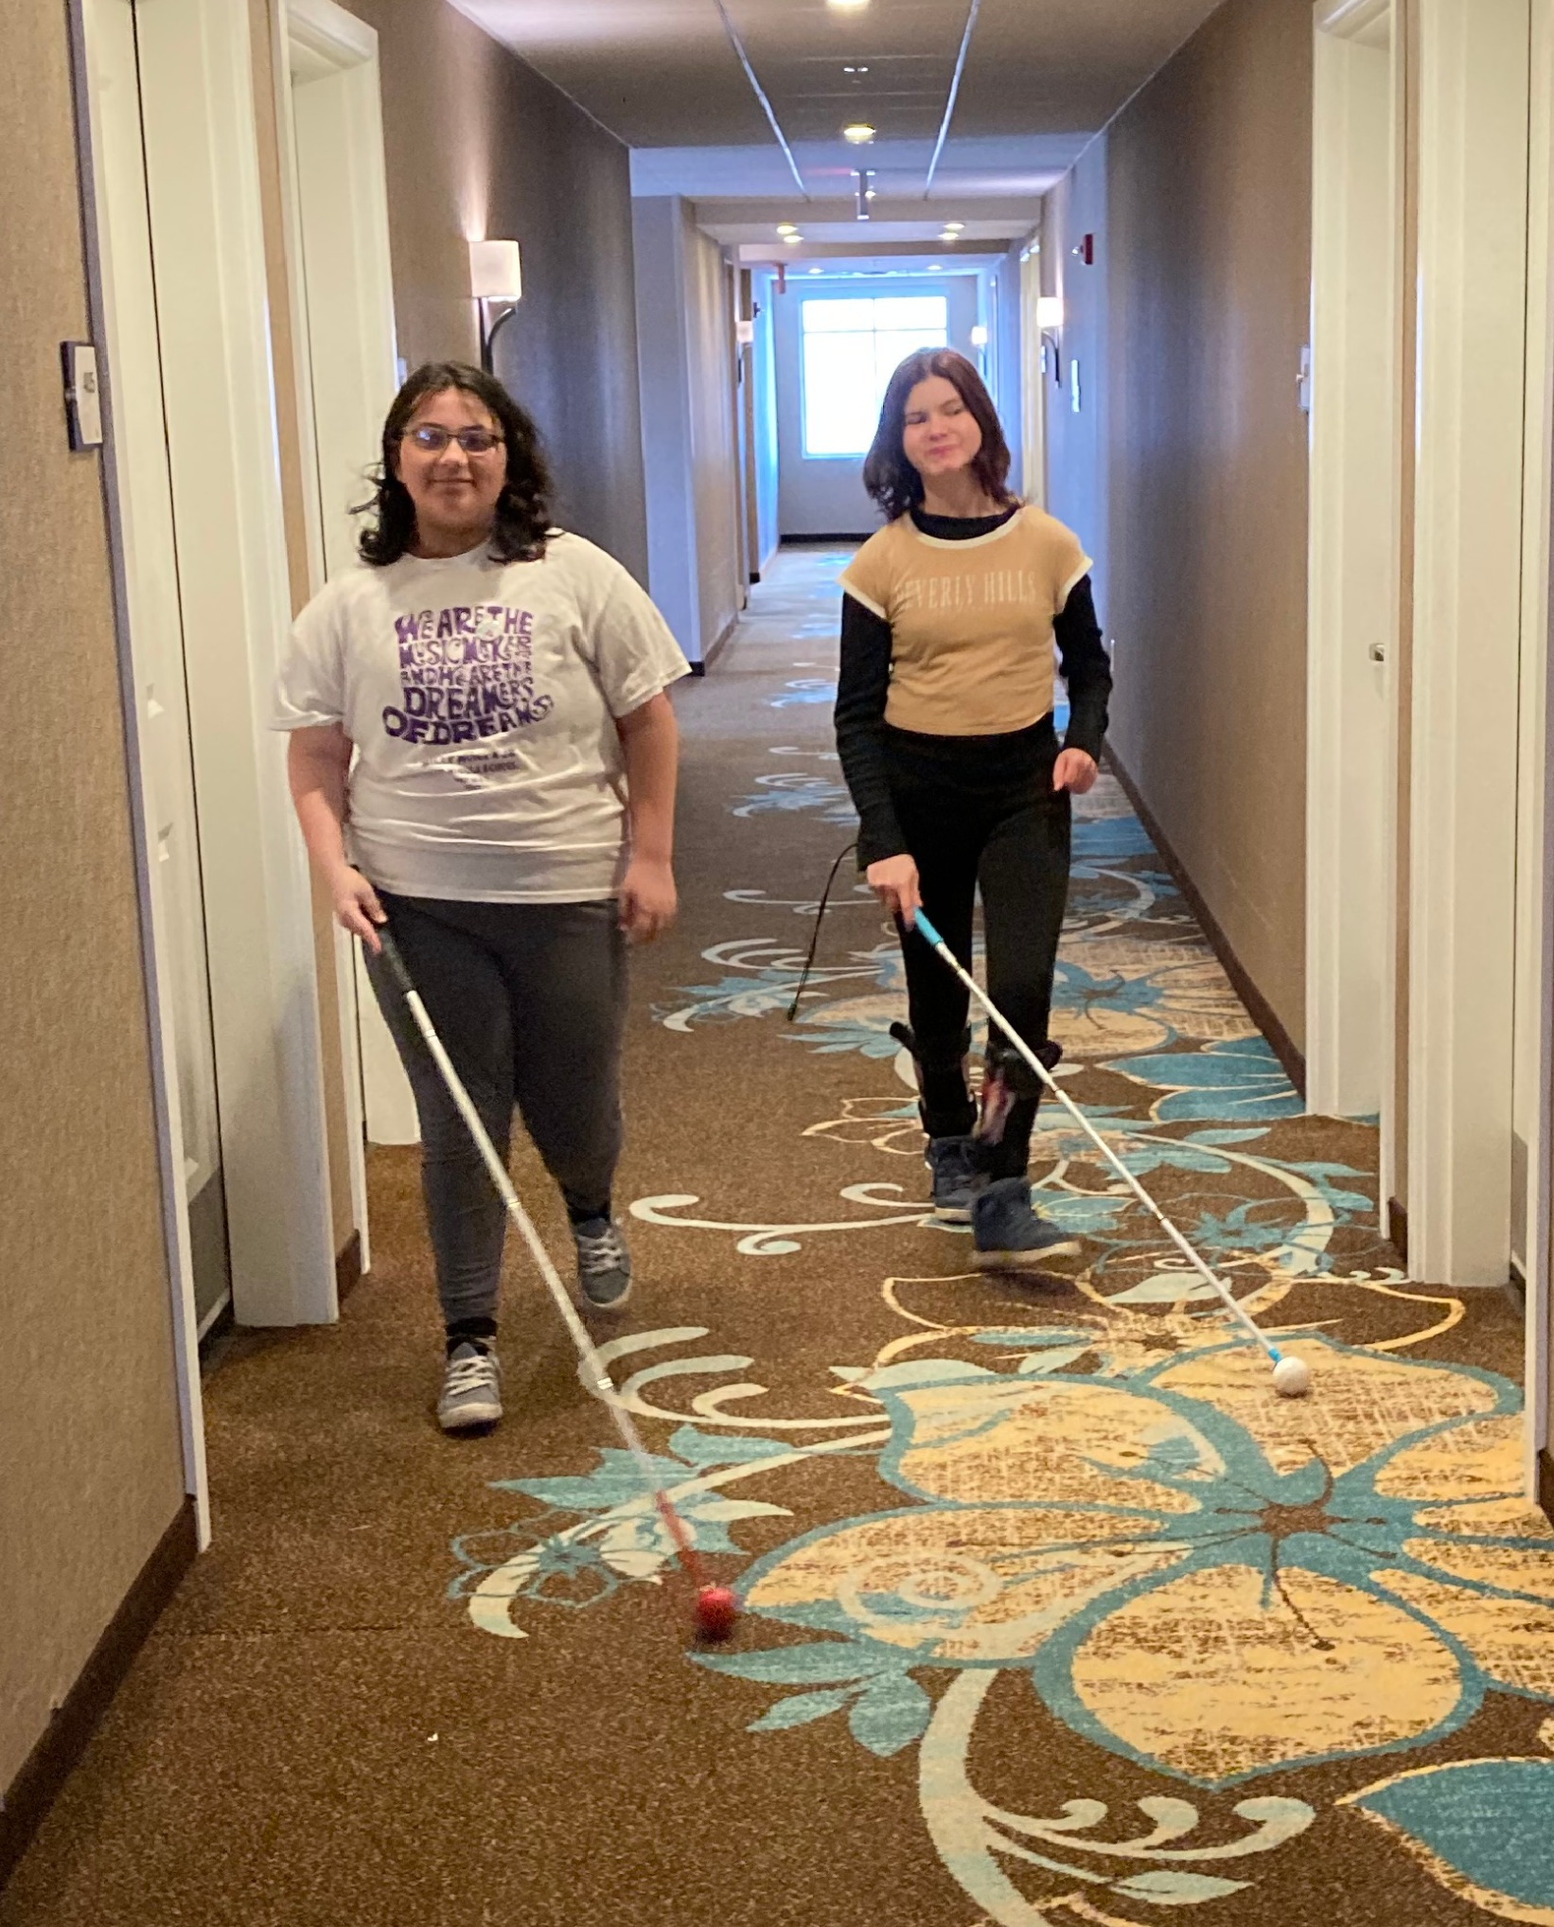
Photo Description: Two students, at the Taking a Bigger Risk Program, walking side-by-side, using their white canes to navigate down a long hallway carpet designed with large white and blue floral designs.

No Barriers No Barriers was a 4-day residential program for DBVI and DVR students held at Bryant Pond 4-H Camp. The No Barriers curriculum focuses on Erik Wiehenmyer’s 7 elements of a “No Barriers” life. Students participate in team building exercises and activities such as aqua ziplining, hiking, canoeing, archery, and more. The program empowers students to build peer connections, challenge themselves, overcome barriers, build confidence, and develop self-advocacy skills.

Blind and Visually Impaired Persons (B A VIP) Orientation and Mobility Support Group is a group of current and former DBVI clients who received Orientation and Mobility who continue to meet monthly at the Lewiston Career Center to assist one another with problem solving mobility difficulties with the support of Orientation and Mobility Instructors, Vocational Rehabilitation Counselors, and other professionals with expertise in visual impairments and blindness. This year BAVIP worked on creating a website to organize the resources available to blind and visually impaired individuals. The site features an interactive county-by-county map that helps users easily locate eye doctors, specialists, vision professionals, library services, and other supports available throughout the state. The goal is to make Maine’s Vision services accessible, understandable, and easy to find for the people who rely on them.

Interns joined DBVI from The Margaret Chase Maine Government Summer Internship Program. While they were working with DBVI, they focused on statewide projects in case management, research and outreach. One of the interns worked on creating a statewide 866 phone number (866-DBVI-4-ME), updating the overview rack card and ordering DBVI magnets. The other intern focused on accessible presentations and employment trends. Together they worked on transportation research and recommendations.

Outreach
- DBVI and DVR staff presented Disability Etiquette for the UMA TRIO Open House at the Bangor campus to UMA students and staff. Staff instructed on the Windmills module Fact or Fiction, Implicit and Explicit Bias, Disability facts and figures, Blindness awareness and supportive strategies, Deaf Culture Awareness, University Design and ADA.

- DBVI and DVR staff presented a workshop for the University of Maine at Augusta- Bangor Campus Dental Health Programs. This workshop was customized to meet the needs of the educators and students. They wanted information on reducing bias, understanding inclusion, and creating it and understanding diversity.

- DBVI staff collaborated with UMaine Orono’s Intro to Special Education class. DBVI staff reviewed visual impairments, employment opportunities, supportive strategies, and lead hands-on learning activities. Students completed a variety of tasks under blindfolds and vision simulators. Students had the opportunity to use low tech and high-tech assistive technology devices, such as video magnifiers, NaviLens codes, liquid level indicator, JAWS screen reader, bold line pen, and Pen Friend labeler. They also navigated the building under blindfold while using a white cane as their partner provided human guide and gave descriptive feedback to maintain their safety.

- DBVI staff provided two staff trainings to 15 Goodwill Career Advisors and 10 Goodwill Boot Camp Career Advisors. Topics covered included DBVI services, an overview of vision loss, an overview of Progressive Employment, considerations for working with employers, accommodations, an overview of O&M and VRT services, and best practices for supporting clients who are blind and low vision. Staff participated in hands-on blindfold and simulator experiences, VRT activities, Human Guide and White Cane travel.

- The Division for the Blind and Visually Impaired and Portland Ovations hosted an Audio Descriptions Pilot at the Merrill Auditorium for the live performance, A Year with Frog and Toad. Approximately 20 visually impaired and blind students, adults, and staff from DBVI, the Iris Network and Catholic Charities Maine attended the performance. They were able to use listening devices to watch the performance with audio descriptions and engage in a “touch tour’ after the performance where they could touch the set pieces, costumes, props, and interact with performance staff on stage. The feedback gathered from the attendees will be used to improve the accommodation that will be offered by Portland Ovations next season.

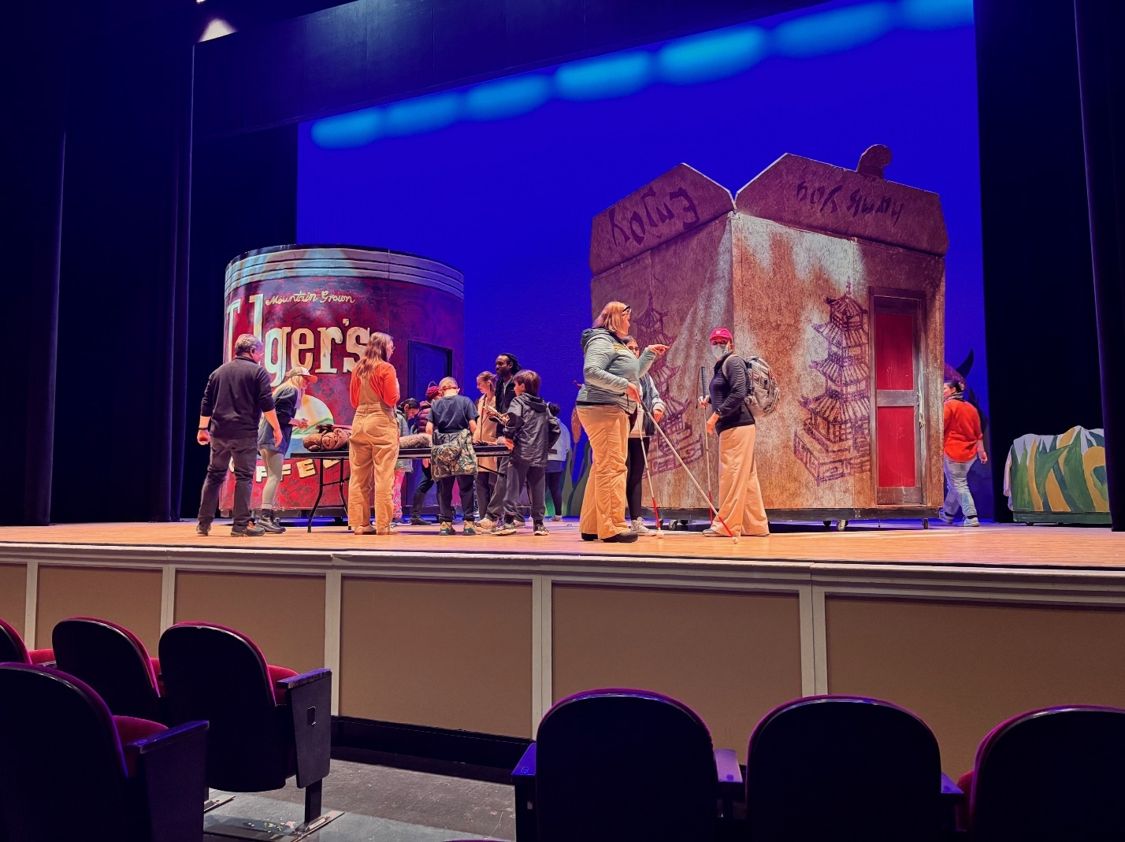
Photo Description: The image above shows a theater stage with a group of staff and students gathered around two large, mobile set pieces. On the left, there is a cylindrical structure resembling a can. To the right, there is a large set piece designed to look like a takeout box with Chinese architectural drawings on it. A red door is part of this structure. The backdrop is lit in a bright blue, adding a vibrant touch to the scene. The people on stage are engaged in conversation, walking around using white canes and also appear to be examining a table of props. The stage is viewed from an audience perspective, with the tops of red theater seats visible at the bottom of the image.

System Improvement and Quality Assurance (SIQA)
Christopher Montagna, Director

The role of the System Improvement and Quality Assurance Unit (SIQA) is to support the mission of the State’s Division of Vocational Rehabilitation (DVR) and Division for the Blind and Visually Impaired (DBVI) programs by providing data, data analysis, procurement and contracting, and central administration of the Bureau of Rehabilitation Services’ (BRS) AwareVR electronic case management system. These services result in systems improvement and ensure the delivery of quality services and outcomes consistent with the BRS mission.

The SIQA Unit works with DVR and DBVI contract administrators to execute State of Maine procurement procedures, ensure smooth payment for providers, resolve customer problems, and conduct management audits of vendor/provider performance.

The SIQA Unit also oversees the Social Security Administration (SSA) Cost Reimbursement Program. Under this program, the SSA pays Maine BRS compensation in the form of reimbursement when beneficiaries served by State VR agencies enter the workforce and achieve continuous months of earnings. In the time period for FFY 2024 the total claims reimbursed by SSA totaled $453,097.61.

In 2025, the program purchased the Vocational Rehabilitation (VR) Ticket to Work and Reimbursement Tracker system. This system is used by the majority of State VR agencies that are a part of the Cost Reimbursement program. Using this system will reduce the time it takes for BRS to process and track Cost Reimbursement payments and potentially increase Cost Reimbursement revenue.
2

Office of the State Accessibility and Independent Living Coordinator
State ADA Accessibility Highlights
The State ADA Accessibility Coordinator ensures that all State agencies comply with the Americans with Disabilities Act (ADA) and Section 504 of the Rehabilitation Act. The Coordinator collaborates with State agencies to develop and carry out policies and practices regarding services, facilities, web design, and communication. The Coordinator works with customers and departments to resolve disability-based discrimination complaints.
In March 2025,
Jason Angel became the State Accessibility Coordinator for the State of Maine. A person with lived disability experience, he ensures state agency compliance with the Americans with Disabilities Act, Section 504 of the Rehabilitation Act, the Maine Human Rights Act, and related laws. He previously served as a Technical Assistant, Trainer, and Researcher at the New England ADA Center, which he joined in 2017, conducting investigations into user experience and accessibility standards in parks and institutional settings. Jason works not only to maintain compliance but to advance inclusion across environments, including transportation. He holds ADA Coordinator Certification and two Master’s degrees: one in Environmental Studies (focused on Tourism, Policy, and Planning) and another in Planning.
A portion of this year’s initiatives have included:

- Jason serves a member of the Information Technology Accessibility Committee (ITAC) of MaineIT – a collaboration of many departmental representatives carrying out the Digital Accessibility and Usability Policy (DAUP). The committee also addresses a wide range of digital accessibility topics, including:
  - Supporting adherence to the DAUP, which requires access to all State services, programs, and communications using the Internet.
  - Share knowledge, identify best practices, and promote consistency in digital access.
  - Provide guidance and resources to state agencies that need to comply with the ADA Title II Web and Mobile Application Accessibility Rule by April 24, 2026.

- ADA coordinators are designated in each State agency. Since his start, Jason has worked to establish a rapport with all the agencies’ ADA coordinators to foster a collaborative environment of compliance with disability laws. Future efforts are to establish regular contact through meetings and a newsletter to further enhance communication across agencies.

- Provided technical assistance to several different state agencies and individuals on a variety of topics to eliminate barriers to any state programs, services, or activities.

- Provided training to state agencies and associations regarding their obligations under the ADA (State Fire Marshal’s Office, DVR/DBVI, Maine School Management, Maine Municipal Association).

The coordinator sits and participates on several committees, which includes: ITAC, the Commission on Disability and Employment, the Moving Maine Advisory Committee, and the Assistive Technology Advisory Committee (Maine CITE).

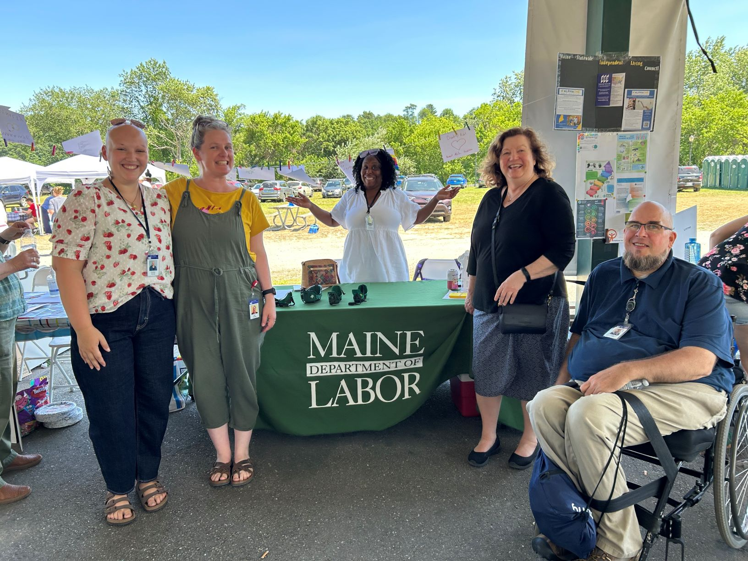

Maine Department of Labor Commissioner and staff (pictured left to right): Carolyn Kinney - Intern, Erin Okane - Intern, Meli Stamp - Pathways to Partnership Youth Specialist, Commissioner Laura Fortman, Jason Angel - State Accessibility Coordinator represent the department at Disability Rights Maine’s Disability Pride 2025 event at Mill Park in Augusta.

Independent Living Highlights
As the State Independent Living (IL) Coordinator, Jason oversees contracts with the Independent Living Services Program at Alpha One and the Maine Statewide Independent Living Council (SILC), which empowers people with disabilities to live as independently as possible within their communities. The IL Coordinator works with the Kim Wallace Adaptive Equipment Loan Program, Maine’s flexible loan program for assistive technology, as well as the Assistive Technology Accessibility Committee.

Jason also serves on the Maine Outdoor Recreation for Everyone (M.O.R.E.) Committee. It is a committee of the Statewide Independent Living Council to advance the goals established under Title 26, Chapter 19, Subchapter 2, Article 5 – ensuring that people with disabilities have full access to Maine’s recreational opportunities.

M.O.R.E.’s priorities are to advise commissioners, educate the public, provide information, and conduct evaluations to promote, expand, and ensure accessible recreational opportunities for people with disabilities. Jason’s ongoing site visits have begun to achieve a portion of these goals. The IL Coordinator is available to provide technical assistance and training for Maine businesses and individuals about disability rights in places of public accommodation and housing.

Partners in Advocacy, Advisory Boards and Councils
Client Assistance Program at Disability Rights Maine provides information, advice, advocacy, and (if determined necessary) legal representation to persons who have concerns about the rehabilitation services they receive from DVR and DBVI. Website: https://drme.org/client-assistance-program

Commission for the Deaf, Hard of Hearing and Late Deafened is an advisory council that provides a review of the status of services to Deaf and hard-of-hearing persons, recommends priorities for development, evaluates the progress made as a result of recommendations, and sets goals for activities of the division to carry out its obligations and responsibilities to the Deaf and hard of hearing communities.
Website: https://www.maine.gov/rehab/advisory_councils/dod

Commission on Disability and Employment (CDE) is a subcommittee of the State Workforce Board. The Commission promotes collaboration with the public and private sectors to increase awareness and influence policy related to employment for people with disabilities. Its members envision a Maine workforce that includes all people with disabilities employed in jobs that meet both their economic and personal needs.
Website: https://www.maine.gov/swb/committees/disability_employment/index.shtml

DBVI State Rehabilitation Council (SRC) is a diverse group of people concerned with the quality of vocational rehabilitation services provided to blind Maine citizens. The SRC’s core functions are to review, analyze, and advise on the policies and other related entities involved with the employment of people who are blind or have vision impairments. Website: https://maine-src-dbvi.org

DVR State Rehabilitation Council (SRC) is a statewide citizens group that advises DVR about how well its programs and services match the needs of people with disabilities in Maine. In partnership, the SRC works with DVR to review, analyze, and advise the state agency regarding its performance in providing vocational rehabilitation services. Website: https://mainesrc.org

Maine Statewide Independent Living Council (SILC) is dedicated to ensuring that citizens with disabilities have control over their lives and environments with equal access to option, opportunities, and choices, as do all citizens. The Maine SILC is a federally mandated council under the Rehabilitation Act of 1973. The Maine SILC advances independent living by engaging in or supporting research, publication, employment, community organizing, advocacy, and systems reform. Federal statute requires that a Statewide Independent Living Council be established and not within a State agency. If you are interested in attending a Maine SILC meeting, please contact the Chairperson – chair@mainesilc.org Website: https://northstarworks.org/sites/silc/

BRS Office Directory
Central Administrative Office  Bureau of Rehabilitation Services  45 Commerce Drive, 150 State House Station  Augusta, ME 04333  Tel: 207-623-6799  Fax: 207-287-5292 | From any location:  Tel.: 1-888-457-8883  TTY users call Maine Relay 711
Augusta CareerCenter  45 Commerce Drive, 73 State House Station  Augusta, ME 04333-0073  Tel: 207-624-5120  Fax: 207-287-6249 | Lewiston CareerCenter  5 Mollison Way  Lewiston, ME 04240-5805  Tel: 207-753-9000 or 1-800-741-2991 (Voice)  Fax: 207-753-9051
Bangor CareerCenter  45 Oak Street, Suite 1  Bangor, ME 04401-6664  Tel: 207-561-4000  Fax: 207-561-4027 | Machias CareerCenter  53 Prescott Drive  Suite 2,  Machias, ME 04654-9751  Tel: 207-255-1926  Fax: 207-255-3091
Northern Kennebec Valley CareerCenter  23 Stanley Road  Hinckley, ME 04944  Tel: 207-474-4958 or 1-800-760-1572  Fax: 207-474-4914 | Greater Portland CareerCenter  151 Jetport Boulevard  Portland, ME 04102  Tel: 207-822-3300  Fax: 207-775-7870
Houlton DVR Office  11 High Street  Houlton, ME 04730-2421  Tel: 207-592-0520 or 1-800-432-7338 (Voice)  Fax: 207-532-7995 | Presque Isle CareerCenter  66 Spruce Street  Suite 3,  Presque Isle, ME 04769-3222  Tel: 207-768-6835  Fax: 207-768-6837

https://www.maine.gov/oit/sites/maine.gov.oit/files/inline-files/DigitalAccessibilityPolicy.pdf

