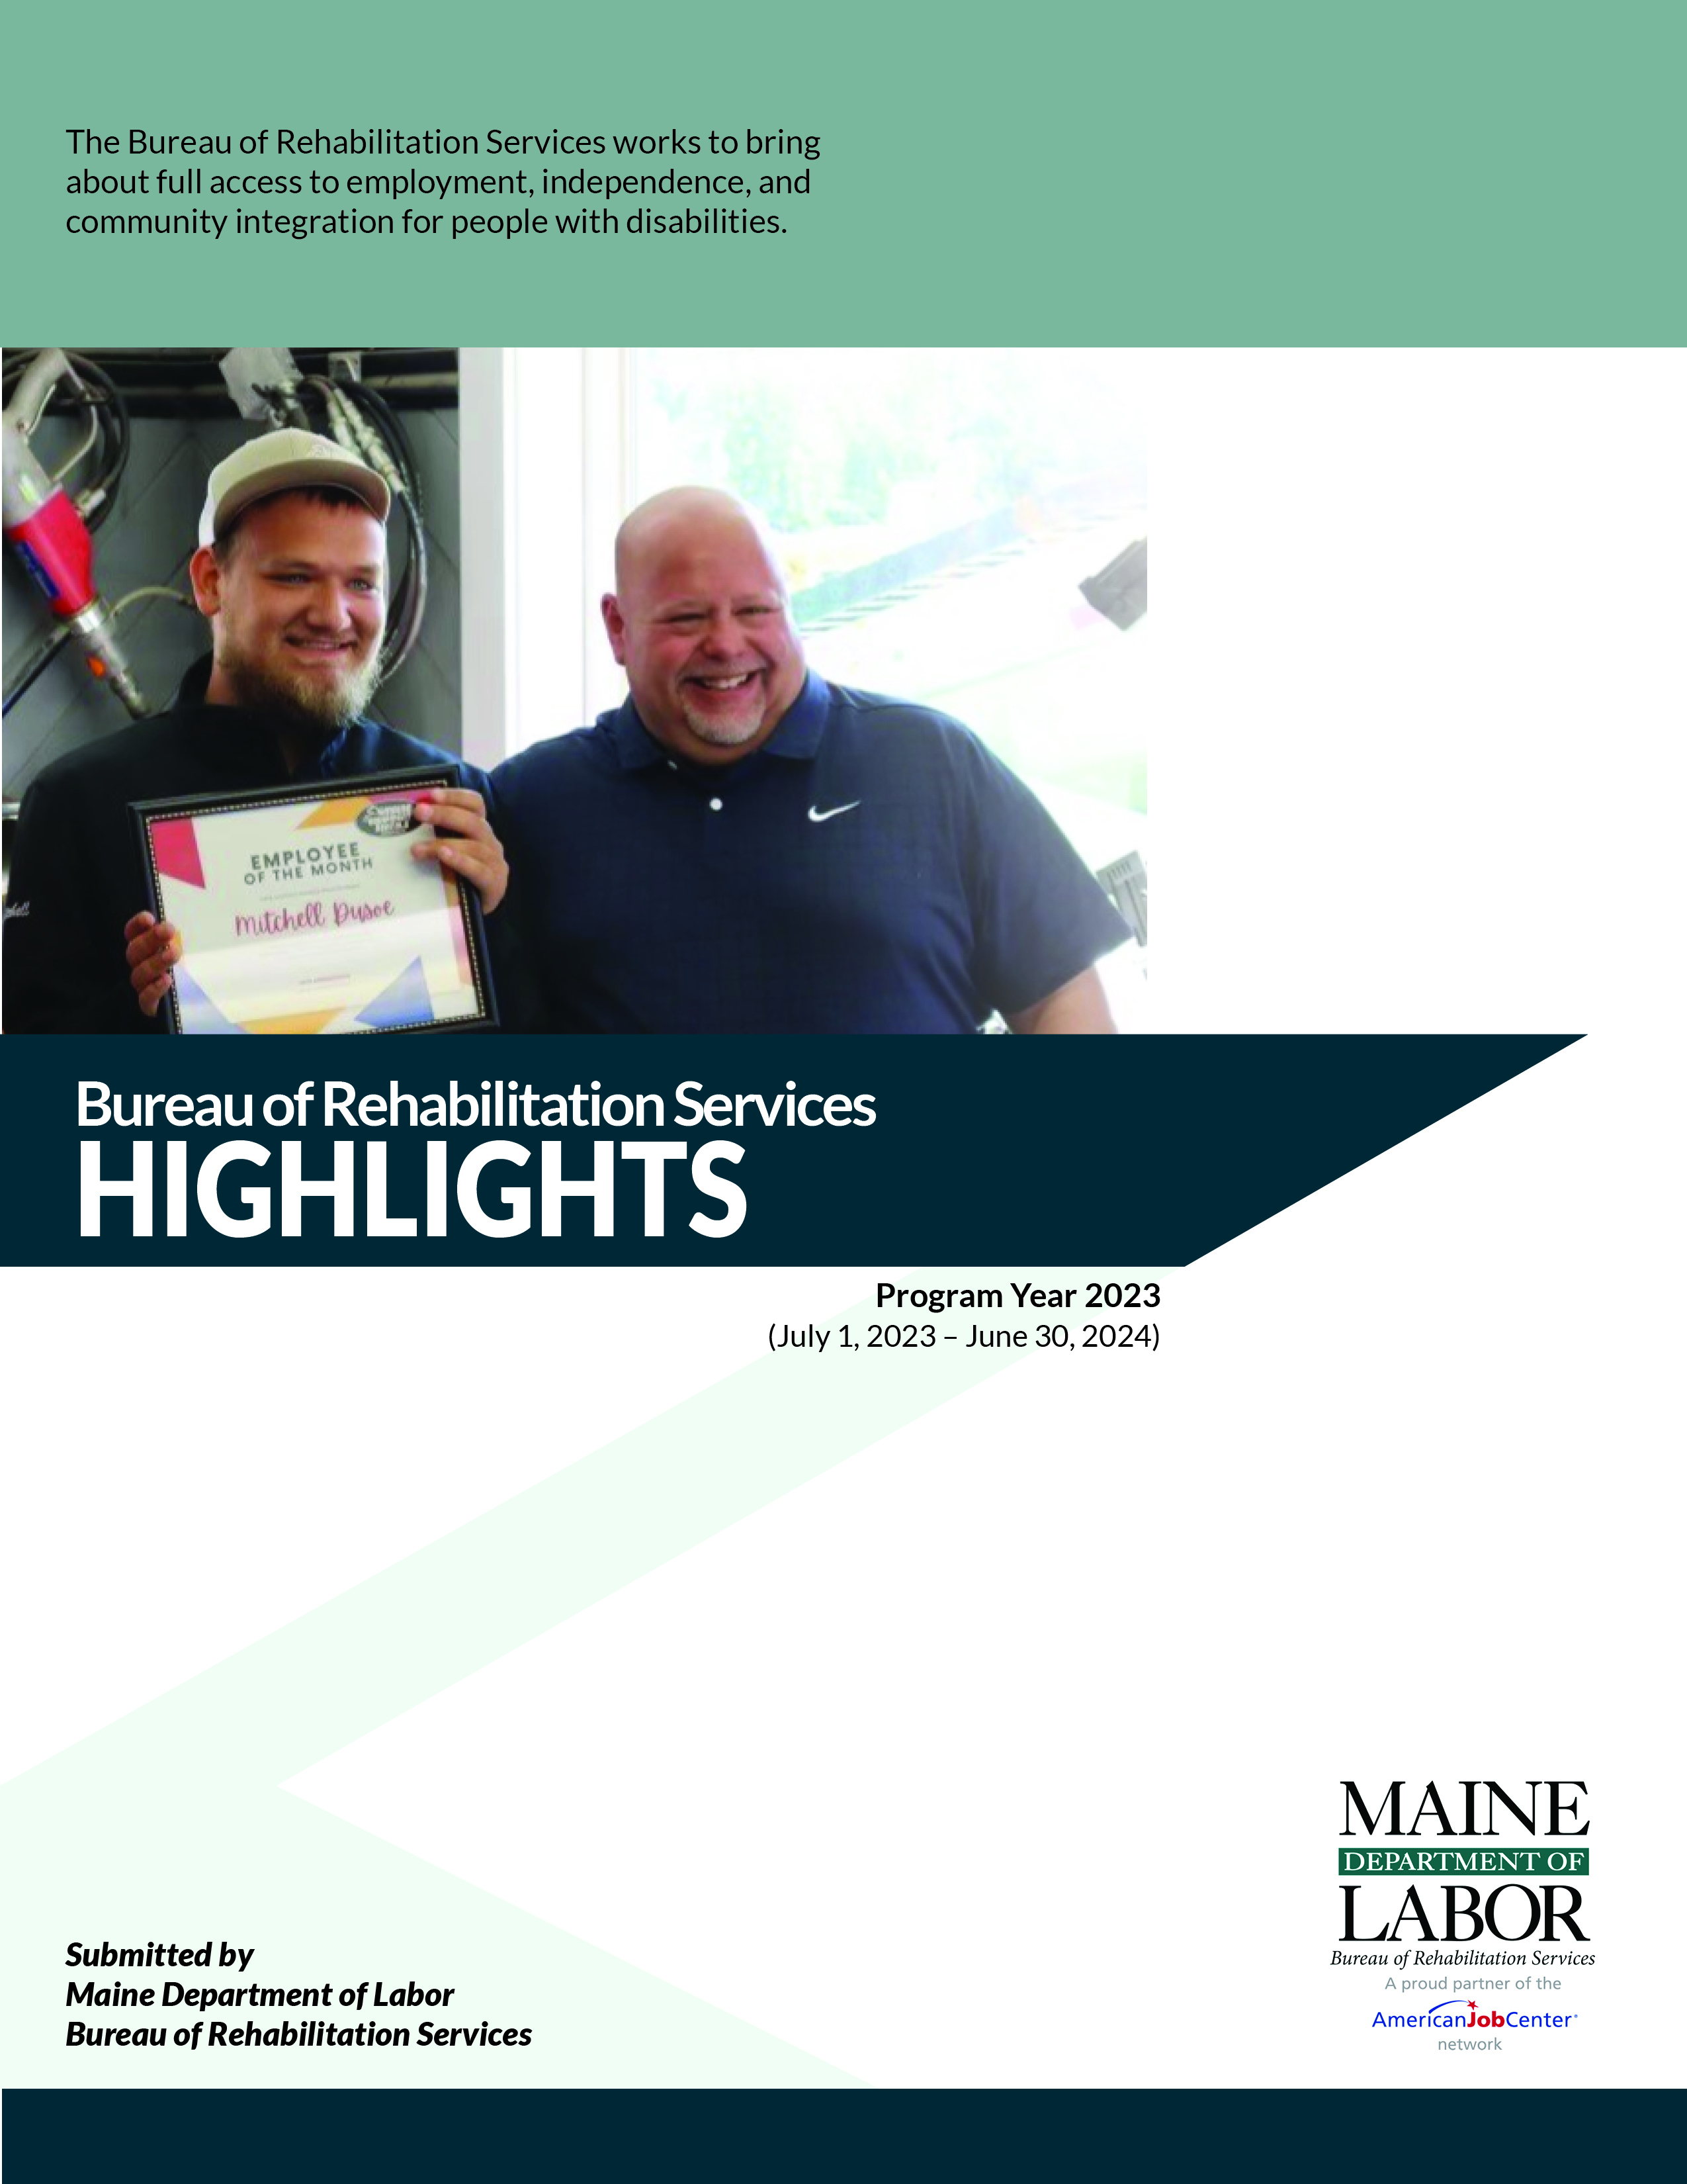

Cover Photo: Shown, employee Mitchell Dusoe displays his   
certificate for being selected “Employee of the Month”.

The Maine Department of Labor provides Equal Opportunity in employment and programs. Auxiliary aids and services are available to individuals with disabilities upon request.

STATE OF MAINE

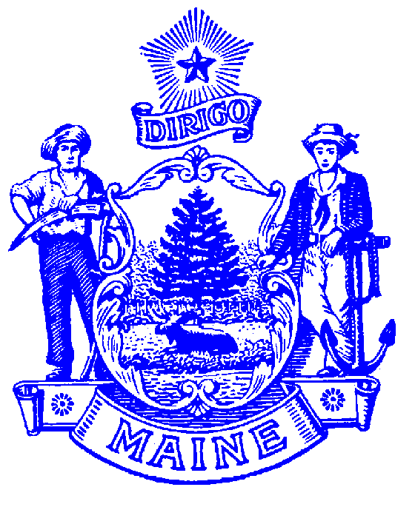

DEPARTMENT OF LABOR

BUREAU OF REHABILITATION SERVICES

150 STATE HOUSE STATION

AUGUSTA, MAINE 04333-0054

LAURA A. FORTMAN

COMMISSIONER

JANET T. MILLS

GOVERNOR

**Bureau Director’s Message**

Welcome to the 2024 edition of the BRS Highlights! On behalf of the Bureau of Rehabilitation Services (BRS) team, I invite you to explore these pages and learn more about the exciting work that is going on at BRS every day. From new initiatives to improved initiatives to completed initiatives, change is always afoot at BRS as we strive to meet the needs of our diverse jobseeker and employer customers.

If you would like more information about anything you read in this report, I hope you will reach out to us. Whether you are a person with a disability looking for a new employment opportunity or a business looking to meet your workforce needs or a family member supporting an individual – we welcome the opportunity tell you more about the benefits of working with the Bureau of Rehabilitation Services.

The world of work is changing. From the terrible challenges of the COVID-19 pandemic, we learned how to work remotely with new technological advances increasing access to employment for many individuals with disabilities. Across the state, Pre-Apprenticeships and Registered Apprenticeships are opening doors to new career pathways for youth and adults with disabilities. Artificial Intelligence (AI) is promising to rapidly reshape how we work and BRS is committed to making sure that the individuals we serve have a voice and the training to participate fully in these opportunities. Technology advances are also allowing individuals to live independently in their homes and achieve community integration.

While you will read about much good work that is happening, we continue to strive to close the gap in employment participation, unemployment, and wages that exists between those with and without disabilities.

BRS looks forward to another year of partnering with the individuals we serve to improve education, employment and independent living outcomes for Maine people with disabilities.

Libby Stone-Sterling, PhD

Bureau Director

PHONE: (207) 623-7943 TTY users call Maine Relay 711 FAX: (207) 287-5292

The Maine Department of Labor provides equal opportunity in programs, services and employment.

Auxiliary aids and services are available to individuals with disabilities upon request.

Programs are provided as a proud partner of the American Job Center network.

Table of Contents

Bureau of Rehabilitation Services Overview 1

DVR Initiatives and Innovations 5

Division for the Deaf, Hard of Hearing and Late Deafened (DDHHLD) 7

Bureau of Rehabilitation Services (BRS) Apprenticeship Program 8

Division for the Blind and Visually Impaired (DBVI) 9

DBVI Initiatives and Innovations 10

Office of the State Accessibility and Independent Living Coordinator 12

Partners in Advocacy, Advisory Boards and Councils 13

BRS Office Directory 14

Bureau of Rehabilitation Services Overview

The Bureau of Rehabilitation Services (BRS) is comprised of three Divisions – the Division of Vocational Rehabilitation (DVR), the Division for the Blind and Visually Impaired (DBVI), and the Division of Systems Improvement and Quality Assurance (SIQA). As Maine’s tight labor market continues, BRS has had an average of **138** employees delivering public vocational rehabilitation and independent living services to people with disabilities throughout the last year. Co-located at CareerCenters statewide, BRS also houses the Office of the State Accessibility Coordinator, who leads the State’s compliance under the Americans with Disabilities Act (ADA) and Section 504 *(see page 10).*

The Rehabilitation Act of 1973, as amended by the Workforce Innovation and Opportunity Act (WIOA) of 2014, establishes program eligibility and the scope of services provided through DVR and DBVI. Included are vocational counseling and guidance, physical restoration services, education and skills training, and job placement services. DBVI, in conjunction with the Department of Education, also serves all children who are blind in Maine.

This past year, **8,179** Mainers with disabilities received services from BRS; of those participants, **6,621** received services with a plan for employment. Counselors worked with clients who had an employment plan, on average, for **685** days or about **23** months. A total of **401** clients were successfully employed earning an average wage of **$556.99** per week.

BRS receives most of its funding from federal grants, some of which require matching state funds. The largest *(one administered by DVR and one administered by DBVI)* are from the Department of Education’s Title I grant program for vocational rehabilitation services.

**Federal Grants Required General Fund Match**

Vocational Rehabilitation 4:1 (21%)

Independent Living 9:1 (11%)  
Supported Employment - Youth 10%

Supported Employment - Adult None

Special Revenue income is received from the Business Enterprise Program and the Public Utilities   
Commission for telecommunications. The use of the Special Revenue funds is  
 restricted for these specific purposes.

How We Define Success…

“E” is a psychiatrist who came to DBVI two years ago after losing all of his vision in a traumatic accident. This sudden vision loss had a dramatic impact on all aspects of his life. DBVI mobilized quickly to connect “E” with Orientation & Mobility, Certified Assistive Technology Instructional Support, Vision Rehabilitation Therapist, and personal adjustment counseling services so that he could regain his independence in his employment and community/home environments. In addition to engaging in vision rehabilitation services, “E” worked with his Vocational Rehabilitation Counselor to learn skills for disability disclosure and self-advocacy. With DBVI’s support, “E” acquired adaptive tools and technologies to use in the workplace, and also developed a number of creative strategies for completing job tasks. Through his participation in Vocational Rehabilitation and vision rehab, “E” has maintained his full-time employment and regained his confidence.

“Elaine” a young person with traumatic brain injury, wanted to explore early childhood education. Through the partnership with her Vocational Rehabilitation Counselor and local Recreation Department, “Elaine” completed a paid work experience as a Recreation Assistant. The learnings from this experience solidified her future plans after high school and shared that “I love working at the rec. and working with kids.”

“Trudy” shared, “because of the wonderful team I have at Vocational Rehabilitation, I was able to see myself and really pay attention” and “I found my way. I understand now that I’m a visual artist who will one day become a teacher.” Trudy continues to work with Vocational Rehabilitation and making strides towards her goal.

“Hilda” applied to Vocational Rehabilitation wanting to return to her field as a Registered Nurse (RN) after a workplace injury that occurred several years ago. Unsure if this was an option for her, “Hilda” and her Vocational Rehabilitation Counselor explored the RN field and found that there were many options that would fit “Hilda’s” strengths and interests and physical capacity. After retraining and reinstatement of her RN license, “Hilda” secured employment and is extremely happy to be back doing the work that she loves.

“Patrick” was in the middle of taking college classes to become a lineman but recognized some struggles he had in the classroom. “Patrick” applied to Vocational Rehabilitation not really knowing what to expect but knew he would need assistance to pass the DOT physical which is a requirement of the job. “Patrick” has learning disabilities and recent hearing loss. Working through evaluations, accommodations and hearing aids, “Patrick” successfully passed the physical and was offered a position as a lineman.

Division of Vocational Rehabilitation (DVR)

**Samantha Fenderson, MA, Director**Maine’s DVR assists individuals with disabilities who wish to achieve, retain, or advance in employment. Any person who wants to pursue employment and has a disability that creates a barrier to employment is encouraged to apply. Once determined eligible, individuals develop a plan for employment, which outlines the services needed to successfully achieve their employment goal.

**Contributing to the Maine Economy**

While maintaining a wait list for services, DVR assisted **386** people to find employment success over the last year. This resulted in these individuals earning an anticipated total of **$11,008,166.52** in annual wages. Across the state and across industry sectors, DVR clients are joining or rejoining the workforce in jobs such as:

|  |  |  |
| --- | --- | --- |
| Bakers | Electrical & Electronic Engineering Techs | Maids & Housekeeping Cleaners |
| Bookkeeping, Accounting, & Auditing Clerks | Executive Secretaries | Material Moving Workers |
| Building Cleaning Workers | Farmworkers | Medical Assistants |
| Bus Drivers | Fast Food & Counter Workers | Medical Secretaries |
| Cashiers | First Line Supervisors of Police | Office & Administrative Support Workers |
| Carpenters | Fishing & Hunting Workers | Personal Care Aides |
| Childcare Workers | Food Preparation & Serving Related Workers | Production Workers |
| Clergy | Grounds Maintenance Workers | Receptionists & Information Clerks |
| Community Health Workers | Hairdressers, Hairstylists, & Cosmetologists | Registered Nurses |
| Community & Social Service Specialists | Hosts & Hostesses | Retail Salespersons |
| Cooks | Janitors & Cleaners | Sales Workers |

**Individuals Served**

**3,318** New VR Applicants   
**2,432** Youth with Disabilities who received Transition Services

**6,383** Received Services through Employment Plans

**386** Individuals Successfully Employed

# DVR Initiatives and Innovations

**Pathways to Partnership –** Maine DVR was awarded the Disability Innovation Fund grant by Rehabilitation Services Administration. Under Pathways to Partnership, Maine DVR will be partnering with multiple agencies to achieve five primary objectives: (1) Launch of a web-based sustainable site to serve as a primary hub for cross-agency transition information, training, and learning opportunities across the state, (2) Development of accessible on-demand curricula on transition topics (including benefits counseling, financial literacy, Pre-Employment Transition Services, etc.) for a wide range of stakeholders including children, parents, educators, and service providers, (3) Enrollment of participants in virtual services including career exploration, peer mentoring, independent living skill building and Pre-Employment Transition Services, (4) Increased stakeholder knowledge of work incentives and benefits counseling for individuals who receive Social Security benefits, (5) Increased awareness and use of work-based learning, interships, pre-apprenticeship, and Registered Apprenticeship – for children ages 10-13 and youth ages 14-24 as well as educators, families, service providers and other stakeholders.

**Business Relations –** The importance of employer paternships in developing a diverse and inclusive workforce is a critical service for DVR. Over the course of the year DVR staff and partners made 367 individual employer contacts to discuss workforce needs and opportunities. DVR worked with businesses across the state either in job placement, apprenticeship opportunities, company tours and informational interviews in industries such as retail, shipping, construction, automotive, hospitality, tourism, corporations, hospitals, municipalities, and veterinary care.

**Progressive Employment –** This year Progressive Employment expanded to include a partnership with Bureau of Employment Services in Machias, Bangor, and Lewiston locations. This expansion focuses on serving justice-involved and those in recovery from addiction. This partnership increases networking and employment connections for all referrals to the Progressive Employment model. Progressive Employment is a collaborative team approach through biweekly “Jobsville” meetings to share workforce opportunities.

**Career Exploration Workshop –** The Career Exploration Workshop (CEW) is a series of small group sessions to assist in the development of a career pathway. A career pathway is an identified path that transitions a person from education into the workforce or transitioning within the workforce. Sessions can include self-exploration, career exploration, labor market information and an opportunity to connect with peers. The CEW is offered both virtually and in-person across all age groups. In certain circumstances the CEW can be offered individually.

The most popular rated activities are disability disclosure, workplace culture, transferable skills analysis, and O*Net Interest Profiler rank as the highest most utilized tools within the workshop by participants.

Participants’ survey responses include:

* Tools to help me put me on a path rather than trying to come up with this on my own.
* Opening my eyes to other employment opportunities.
* Learning my rights as a disabled worker.
* Engagement with peers.
* Modules helped rebuild my confidence.

**Job Club –** Division of Vocational Rehabilitation offers a Job Club series to VR clients that are interested in attending some or all sessions. The uniqueness of the Job Club is that each member is a valuable contributor and that everyone will benefit from what is shared in the group. It is a nice compliment to the Career Exploration Workshop.

The Job Club focuses on work readiness topcis such as:

* Resume Writing
* Job Search Tools and Maine JobLink
* Interviewing
* Networking and Informatinal Interviews
* Resources
* Workplace Culture and Nature Supports
* Professionalism in the Workplace

**Transition Career Exploration –** Transition aged youth can take part in three different career clubs offered through Division of Vocational Rehabilitation. Students can participate online or on location with their peers!

* Transition Job Club – Students can explore their strengths and interests, choosing future employment options, workplace readiness training, importance of resumes, how to fill out a job application, and what to expect in an interview.
* Transition Career Exploration Workshop – Topics can include careers and one’s skills, choosing a career pathway, workplace readiness and first jobs.
* Life Skills Job Club – Students will review communication skills, collaboration, flexibility, learning from mistakes and growth, peserverence, and workplace readiness skills.

**Intake Unit –** The DVR Intake Unit, established to provide a welcoming onboarding to VR applicants, began in early Spring 2023. Staffed with Rehabilitation Counselors, the unit remotely meets with applicants to complete an intake and begin vocational planning. Onsite intake meetings are available when requested. **2,356** applications were processed through the Intake Unit between July 2023 through June 2024!

**DVR Veteran and Correction Liaisons –** Coordination of services provided to Veterans involved in the Correctional facilities expanded this year. Partnerships were strengthened by developing regional teams to address the unique needs of Veterans. The regional teams, which include both State/Federal and Veteran Community-Based Organizations, work together within correctional facilities to deliver vocational services to those close to re-entry.

Preparations can include:

* Housing
* Medical
* Transportation
* Other Medical Supports
* Work Readiness
* Job Search

Students attending a Maine Apprenticeship Program Tour - Several high school students participated in the first Maine Apprenticeship and Career Pathways Tour. The overnight tour was an opportunity to learn about career pathways and participate in fun and meaningful hands-on experiences with Maine Apprenticeship employers. Careers included Aquaculture Technician, Commercial Roofer, and a variety of healthcare positions.

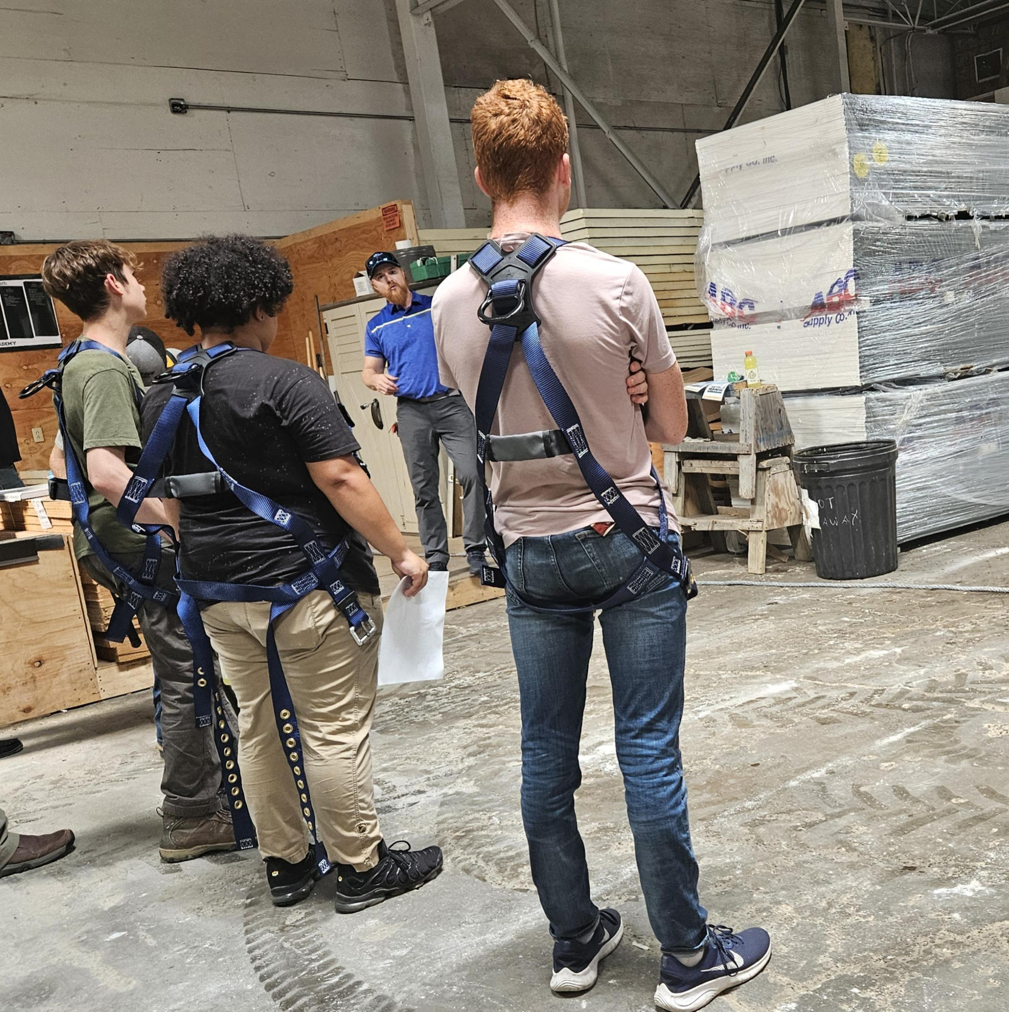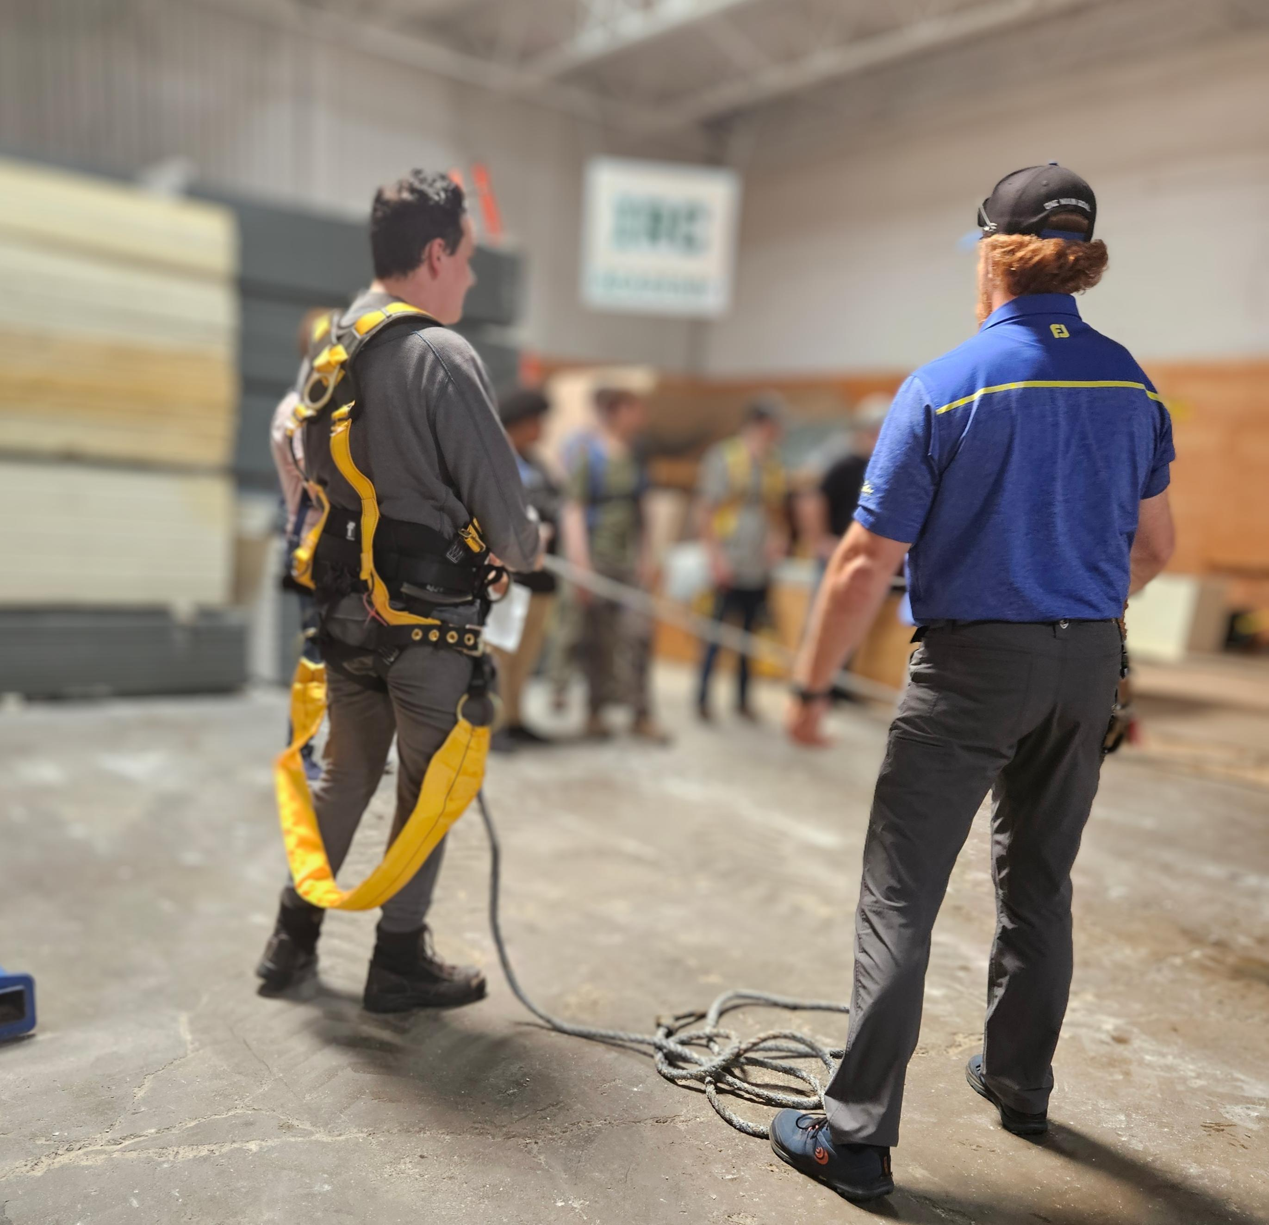

# Division for the Deaf, Hard of Hearing and Late Deafened (DDHHLD)

The Division for the Deaf, Hard of Hearing and Late Deafened (DDHHLD) provides information and referrals for resources of interest to people who have hearing loss throughout the state. This includes such things as interpreting services, hearing aids, and advocacy. The Commission for the Deaf, Hard of Hearing and Late Deafened (CDHHLD) created and actively works on an ongoing Five-Year Plan, which can be found at [https://www.maine.gov/rehab/dod/index.shtml](https://gcc02.safelinks.protection.outlook.com/?url=https%3A%2F%2Fwww.maine.gov%2Frehab%2Fdod%2Findex.shtml&data=05%7C01%7CTerry.L.Morrell%40maine.gov%7C67ac0decb95f461bd21608dbd973cbd7%7C413fa8ab207d4b629bcdea1a8f2f864e%7C0%7C0%7C638342863580388453%7CUnknown%7CTWFpbGZsb3d8eyJWIjoiMC4wLjAwMDAiLCJQIjoiV2luMzIiLCJBTiI6Ik1haWwiLCJXVCI6Mn0%3D%7C3000%7C%7C%7C&sdata=2UThWNkoKnz0PlPXwJ26aD4L3lhtwUGMgTOCxtgtqWc%3D&reserved=0).

Other accomplishments of the Division included providing Deaf Awareness trainings to a wide range of audiences, including E911 dispatchers. Also, since the initiation of the Deaf identification cards and vehicle placards there have been a total of 461 cards and placards distributed.

Each year the Division and Commission organize the Annual Deaf Culture Tea Awards ceremony. The 33rd Annual Deaf Culture Tea Awards celebration will take place on September 19, 2024, at the Hall of Flags, State House, in Augusta. The keynote speaker for the 33rd Deaf Tea will be Kellynette Gomez, LCSW. This year we will be awarding seven deserving Deaf community members.

The Division also continues to be involved with the National Deaf Center (NDC), which focuses on the needs of Deaf and hard-of-hearing transition students. Maine’s NDC team includes the Division of Vocational Rehabilitation, Maine Education Center for Deaf and Hard of Hearing, Maine Behavioral Health, Disability Rights Maine, and the Department of Education. The priority that Maine’s NDC team chose to focus on using Data for Transition *and Promoting Higher Expectations*.

Currently, there are 139 active, licensed interpreters in Maine per the State of Maine Department of Professional and Financial Regulations. Included in the count are 14 hearing, legal interpreters, two in New Hampshire, one in Massachusetts, and one in South Carolina. Also included in the legal interpreter count are four certified Deaf interpreters, two in Maine, one in Massachusetts and one in Maryland.

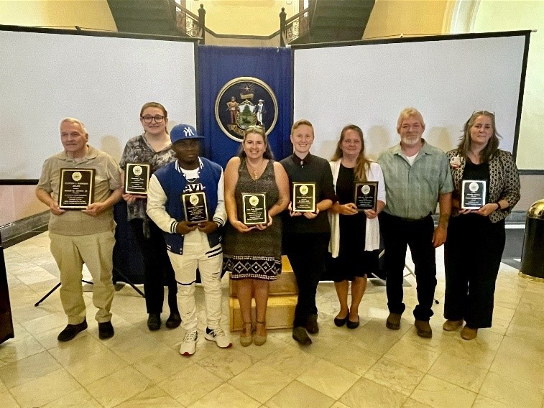

Annual Deaf Tea Award Recipients – Left to Right: Ronald W. Madore Jr., Samantha Jones, Aboua Georges Blanchard Akafou, Amy Richardson, Tristen Evah Hellewell, Kellie Howe, John Howe, and Malvina Gregory.

# Bureau of Rehabilitation Services (BRS) Apprenticeship Program

In 2024 Maine’s Registered Apprenticeship and Certified Pre-Apprenticeship Program Opportunities expanded significantly across the state. The BRS Apprenticeship Navigator actively connected Vocational Rehabilitation jobseekers and counselors, opening doors to career pathways. Maine has solidified its role as a mentor to other state apprenticeship agencies, setting a standard for inclusive workforce development nationwide.

The Maine Apprenticeship Program (MAP) saw the percentage of apprentices with disabilities quadruple to 4.14%.

The Maine Bureau of Rehabilitation Services (BRS), in continued partnership with the Bureau of Employment Services (BES), and the Maine Apprenticeship Program (MAP), apprenticeship accomplishments include:

* 2024 placement to include:
  + 3 DVR clients entered apprenticeships
  + 11 DVR clients accepted into pre-apprenticeships
  + 7 DVR clients completed a pre-apprenticeship.
* Worked with Vocational Rehabilitation Technical Assistance Center for Quality Employment (VRTAC-QE) to develop a [National Apprenticeship Toolkit](https://tacqe.com/apprenticeship-toolkit/) for use by state Vocational Rehabilitation (VR) agencies to support career-seekers in entering registered apprenticeships and pre-apprenticeships.
* Continuing to meet quarterly with Maine workforce partners, including the Eastern Maine Development Corporation, Coastal Counties Workforce, Aroostook County Action Program, Jobs for Maine Graduates, apprenticeship sponsor grant recipients, Maine community college workforce development staff.
* Participation in Rural Youth Apprenticeship Development Learning Collaborative (Institutes for Community Inclusion / UMass) Annual Learning Collaborative in Vermont with state partners from Vermont, Iowa, Washington, Massachusetts, and Wyoming.
* Coordinated apprenticeship tours of Panolam, Industrial Roofing Company, Ferda Farms, Northern Light, Casella Waste, and Cianbro.
* Hosted 5 webinars for youth on apprenticeships, pre-apprenticeships, and MAP Tour.

**Mentoring**

Participating Registered Apprenticeship Sponsors provide on-site mentors as a requirement of apprenticeship.

**Flexibility**

Apprenticeships vary in duration (generally 1 to 4 years), are offered by both small and large businesses, and are tailored to meet the needs of the employer.

**Earn While You Learn**

Apprentices are paid employees from the first day of the apprenticeship.

**National Occupation Credential**

Upon completion of an apprenticeship, the apprentice is awarded a nationally recognized, portable credential.

* Hosted Lunch & Learn on *Fostering a Supportive Environment for Disability Disclosure* to Apprenticeship Sponsors.
* Visited 7 schools to present on apprenticeship and pre-apprenticeship to students.
* Provided New Vocational Rehabilitation Counselor Training on Registered Apprenticeship & Certified Pre-Apprenticeship.
* BRS Apprenticeship Navigator began serving on the EEO committee for the General Sullivan Bridge Federal Megaproject.
* Held monthly Apprenticeship News webinar for Vocational Rehabilitation Counselors and Community Rehabilitation Providers.
* Provided Windmills Disability Employment Awareness training for BES staff.
* Connected a dog trainer employer to MAP, registered.

# Division for the Blind and Visually Impaired (DBVI)

**Elissa Rowe, MSW, Director**Maine’s DBVI provides a continuum of rehabilitation services to individuals who are blind or have low vision. Services may include individual counseling and guidance related to employment and adjustment to blindness issues, use of adaptive technology, low vision therapy, alternative skill training in communication (such as braille), instruction to develop independent travel skills (orientation and mobility), and instruction of daily living skills geared to being more self-sufficient. These services are provided through various programs:

**Vocational Rehabilitation Program (VR)** is primarily for working-age youth and adults who seek competitive, integrated employment. Services may include individual vocational counseling and guidance, vocational assessment, orientation and mobility instruction, low vision services, independent living services (vision rehabilitation therapy), and more.

**Business Enterprise Program (BEP)** provided training and support to four licensed managers who operate snack bars, cafeterias, micro markets, and vending machines at 19 sites on state, federal, and municipal properties across Maine. BEP Managers also provide employment to many other individuals with and without disabilities. Some of the key areas of focus over the past year have included the exploration of more accessible Micro Market Kiosks, expanding opportunities for people interested in the BEP as well as those in Career Exploration and participating in RSA webinars, National Organization podcasts and other events that contribute to innovative business ownership. The BEP also published new Rules in December.

**Independent Living Services (IL)** provides training in adaptive skills and alternative techniques for accomplishing daily tasks that enable adults who are blind or visually impaired to be more self-sufficient. This year, 336 individuals applied for IL services and 561 received services through an individualized plan. Of the total 561 individuals served, eighty-four percent were over age 65.

**Education Services for Children Who Are Blind or Visually Impaired** provides adaptive instruction services or consultation to approximately 300 students annually in home or at local schools related to academics and independence.

**Individuals Served**

**92**  New VR Applicants  
 **62** Youth with Disabilities Received Transition Services

**238** Received VR Services through Employment Plans

**15 VR Individuals Successfully Employed**

# DBVI Initiatives and Innovations

**Business Enterprise Program (BEP)** continued to provide support for existing managers and new opportunities for blind and visually impaired individuals seeking self-employment in the food and vending service business. One such opportunity is providing vending services to Federal Emergency Management Agency (FEMA), while they resided in Maine and provided restorations after the major storm damage sustained in December 2023. Other changes on the horizon include the transition to new management at the Cross Café and working with the University of Maine System to provide vending services at the Fort Kent and Presque Isle campuses. In December 2023, new BEP rules were adopted and promulgated. One of the newly licensed BEP managers attended a National Randolph-Sheppard training this past year. Managers are encouraged to participate in events and activities that build skills, knowledge, and resourcefulness that lead to the provision of excellent food and vending services and strong partnerships with State, Federal, and public agencies, as well as the private sector.

**Learning, Independence, Fun and Employment (LIFE) Camp** is a one-week residential program, located at the Iris Network, focused on pre-employment transition services (Pre-ETS) for students with visual impairments and blindness. Students worked on adaptive home and personal management skills, including cleaning, budgeting, food prep, organization, and orientation & mobility. They identified their strengths and interests and how those related to employment. Students participated in hands-on career exploration of three different worksites and toured a Business Enterprise Program (BEP) Micromarket at the Portland Career Center. They also participated in assistive technology classes, identifying individual accessibility options to meet their needs, and practiced basic computer skills. Self-advocacy skills were an integral part of the program, emphasizing choice, workplace preferences, interests, and work accommodations. LIFE Camp introduced students to independence, employment, and empowerment!

**No Barriers** was a 4-day, extended weekend, residential camp held at the UMaine Camp and Learning Center at Bryant Pond, ME. For the fourth year, students ages 14-21, participated in team building activities based on the “7 life elements” of the No Barriers curriculum, developed by Erik Weihenmayer, the first blind individual to climb to the summit of Mt. Everest. The seven elements include Vision, Reach, Pioneer, Alchemy, Ropes teams, Summits, and Elevate. Each student participant creates a vision board at the beginning of the camp with what they would like to accomplish/overcome during the program. Through the activities, that included rock wall climbing, zip lining, hiking, and canoeing, students worked to overcome these personal barriers and encourage others to achieve their goals.

**Blind and Visually Impaired Persons (B A VIP) Orientation and Mobility Support Group** is a group of current and former orientation and mobility clients who meet monthly at the Lewiston Career Center to assist one another with problem solving mobility difficulties with the support of Orientation and Mobility Instructors, Vocational Rehabilitation Counselors, and other professionals with expertise in visual impairments and blindness. The group identifies the agenda for the meetings which has included things such as the latest technology and mobility techniques. Participants benefit from increasing their mobility skills, independence, and peer support.

**Boston Bound!** The Division for the Blind & Visually Impaired, in conjunction with Catholic Charities Maine, offered for the first time, Boston Bound! Boston Bound is a two-day program for transition age students and recent high school graduates that addressed the five required areas of Pre-Employment Transition Services and multiple areas of the Expanded Core Curriculum. The program took place in Boston, MA on August 7-8, 2024. Boston Bound included a visit to Harvard University to explore opportunities in postsecondary education and career exploration. Participants spoke with various Harvard staff to learn about their roles and career journeys, met with staff from the Disability Access office, and received a tour of the Harvard campus. Participants also received a tour of Google and met with a panel of Google employees. This broadened their understanding of different jobs and work environments, enabled them to explore their own work values and preferences, learn about various career pathways to jobs in tech, and learn about the importance of interview preparation and networking. Participants made strong connections with peers with visual impairments and were given opportunities to take on leadership roles. Orientation and Mobility was interwoven throughout the program, as participants were exposed to various modes of public transportation, including buses, the subway system, and uber, and provided them many opportunities to navigate a variety of environments in an urban setting.

**Region 1 Career Exploration Group** Back by popular demand, Region 1 offered their career exploration group for the second year in a row. The group is designed for middle and high school students with visual impairments to support them with exploring various jobs/careers in a hands-on way. Throughout the schoolyear, the group visited a different employer once a month. On these visits, students participated in a worksite tour, learned about the various jobs available, spoke with employees at the worksite to learn about their roles, backgrounds, and career journeys, and often participated in a hands-on activity related to a particular job in the business. This has been an effective way for students to explore jobs in a meaningful way. It has helped them identify interests and explore jobs that they may have never considered and enabled them to begin developing a sense of their own work preferences. Students also benefited from the opportunities to connect with peers with visual impairments and practice orientation and mobility skills in a variety of settings.

**In-Person Training** During 2023 – 2024, DBVI staff presented an in-person training on Considerations & Strategies for Working with Blind and Low Vision Clients to our Community Rehabilitation Providers: Living Innovations and Goodwill. The training focused on DBVI services, vision loss, client considerations, Progressive Employment, employer considerations, orientation and mobility, human guide, vision rehabilitation therapy, case examples, best practices for supporting our clients, and provided resources/references as well as interactive activities for the staff to engage in.

**Employability Skills Program Retreat** During April 2023, vocational rehabilitation adult clients engaged in a week-long Employability Skills Program Retreat in Bangor focused on employment skills, career pathways, networking, confidence building, advocacy, peer connections, and resource gathering. Guest speakers, Joe Strechay and David DeNotaris, attended the program to provide their perspectives as experts in employment and visually impaired individuals. Individuals from a variety of employment sectors attended in-person and virtually for a networking activity.

**Published Journal Article** DBVI partnered with Catholic Charities Maine (CCME) to write an article in the summer issue of *Visual Impairment and Deafblind Education Quarterly* Journal. The article focuses on the array of services and support for children who are blind and visually impaired in Maine. The journal used a photo from DBVI of a Maine student, standing in a barn and brushing a horse, as the cover of the issue! <http://dvi.uberflip.com/i/1524859-vidbe-q-69-3-summer-2024/0>?

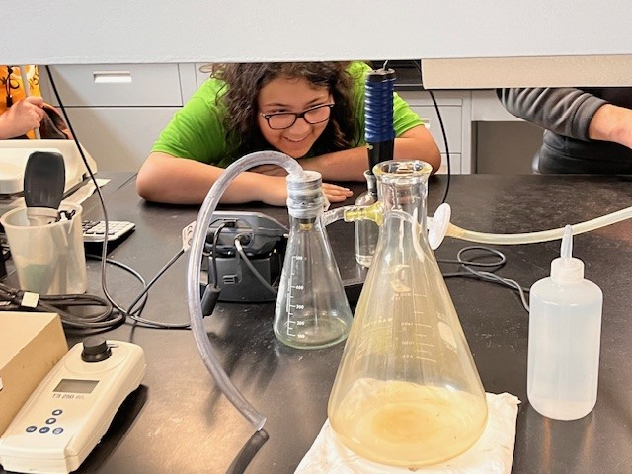

Students toured the lab at the Biddeford Wastewater Treatment Plant, observing bacteria under a microscope and examining water samples before and after filtration.

2

# Office of the State Accessibility and Independent Living Coordinator

**State ADA Accessibility Highlights**

The Accessibility Coordinator leads the State’s compliance under the Americans with Disabilities Act (ADA) and Section 504. The Coordinator works with State agencies to develop and carry out policies and practices regarding services, facilities, web design, and communication. The Coordinator works with customers and departments to resolve any disability-based discrimination complaints.

Examples of some of the 2023 initiatives include:

* Information Technology Accessibility Committee (ITAC) of MaineIT – ITAC is a collaboration of many departmental representatives carrying out the [Digital Accessibility and Usability Policy](https://www.maine.gov/oit/sites/maine.gov.oit/files/inline-files/DigitalAccessibilityPolicy.pdf)[1]. The policy requires access to all State services, programs, and communications using the Internet. Some of the work of the ITAC includes:
  + The much awaited release of the State of Maine Digital Accessibility [for State of Maine Employees](https://rise.articulate.com/share/wHcZ_2olT7l3EKMpZutc92kkuss8zHg7#/), a high-level awareness about functional issues and disability rights for all staff.
  + Monitoring and guidance around new laws. On April 24, 2024 the Department of Justice signed into law the final [guidelines](https://www.ada.gov/resources/2024-03-08-web-rule/) to ensure that people with disabilities have access to web and mobile content. ITAC continues to monitor and advise on these changes.
* With direction from the Department of Administrative and Financial Services, accessibility/ADA coordinators are designated in each State agency. The State Accessibility Coordinator provides quarterly meetings to interested department accessibility/ADA coordinators to provide ongoing ADA technical assistance. There is continued development and growth of a webpage dedicated to the accessibility/ADA coordinators. This includes short videos on ADA coordinator responsibilities to a broad repository of resources.
* Moderated and provided content for the Maine Employer’s Summit’s break out session ***Creating Inclusive Workplaces Through Modifications and Accommodations.***
* Provided training to state agencies regarding their obligations under the ADA.
* Provided technical assistance to members of the assistance around the ADA.

The Coordinator continues to sit and participate in several committees to include: the Information Technology Accessibility Committee, the Commission on Disability and Employment, the Moving Maine Advisory Committee, the Assistive Technology Advisory Committee, and the Alpha One Adaptive Loan Program.

**Independent Living Highlights**

The State Independent Living (IL) Coordinator oversees contracts with the Independent Living Services Program at Alpha One and the Maine Statewide Independent Living Council (SILC), which support improved community and housing access for people with disabilities. The IL Coordinator works with the Kim Wallace Adaptive Equipment Loan Program, Maine’s flexible loan program for assistive technology, as well as the Assistive Technology Consortia, and others. The IL Coordinator provides technical assistance and training for Maine businesses and individuals about use of service animals and about disability rights in public accommodations and housing. Public access to outdoor recreation in Maine has garnered widespread recognition and resulted in numerous new State and private [trails being built for accessibility](https://www.pbs.org/video/accessible-trails-4ep1zd/)[2], particularly using Recreational Trails Program funding and incorporating user design.

# Partners in Advocacy, Advisory Boards and Councils

**Client Assistance Program** at Disability Rights Maine provides information, advice, advocacy, and (if determined necessary) legal representation to persons who have concerns about the rehabilitation services they receive from DVR and DBVI. Website: <https://drme.org/client-assistance-program>

**Commission for the Deaf, Hard of Hearing and Late Deafened** is anadvisory council that provides a review of the status of services to Deaf and hard-of-hearing persons, recommends priorities for development, evaluates the progress made as a result of recommendations, and sets goals for activities of the division to carry out its obligations and responsibilities to the Deaf and hard of hearing communities.

Website: <https://www.maine.gov/rehab/advisory_councils/dod>

**Commission on Disability and Employment (CDE)** is a subcommittee of the State Workforce Board. The Commission promotes collaboration with the public and private sectors to increase awareness and influence policy related to employment for people with disabilities. Its members envision a Maine workforce that includes all people with disabilities employed in jobs that meet both their economic and personal needs.

Website: <https://www.maine.gov/swb/committees/disability_employment/index.shtml>

**DBVI State Rehabilitation Council (SRC)** is a diverse group of people concerned with the quality of vocational rehabilitation services provided to blind Maine citizens. The SRC’s core functions are to review, analyze, and advise on the policies and other related entities involved with the employment of people who are blind or have vision impairments. Website: <https://maine-src-dbvi.org>

[**DVR State Rehabilitation Council (SRC)**](http://www.mainesrc.org/home) is a statewide citizens group that advises DVR about how well its programs and services match the needs of people with disabilities in Maine. In partnership, the SRC works with DVR to review, analyze, and advise the state agency regarding its performance in providing vocational rehabilitation services. Website: <https://mainesrc.org>

# BRS Office Directory

|  |  |
| --- | --- |
| **Central Administrative Office**  Bureau of Rehabilitation Services  45 Commerce Drive, 150 State House Station Augusta, ME 04333  Tel: 207-623-6799 Fax: 207-287-5292 | **From any location:**Tel.: 1-888-457-8883  TTY users call Maine Relay 711 |
| **Augusta CareerCenter**  45 Commerce Drive, 73 State House Station Augusta, ME 04333-0073  Tel: 207-624-5120  Fax: 207-287-6249 | **Lewiston CareerCenter**  5 Mollison Way Lewiston, ME 04240-5805  Tel: 207-753-9001 Fax: 207-753-9051 |
| **Bangor CareerCenter**  45 Oak Street, Suite 1 Bangor, ME 04401-6664  Tel: 207-561-4000 Fax: 207-561-4027 | **Machias CareerCenter**  53 Prescott Drive Suite 2, Machias, ME 04654-9751  Tel: 207-255-1926 Fax: 207-255-3091 |
| **Northern Kennebec Valley CareerCenter**  23 Stanley Road Hinckley, ME 04944  Tel: 207-474-4958 or 1-800-760-1572  Fax: 207-474-4914 | **Greater Portland CareerCenter**  151 Jetport Boulevard Portland, ME 04102  Tel: 207-822-3300 Fax: 207-775-7870 |
| **Houlton DVR Office**  11 High Street Houlton, ME 04730-2421  Tel: 207-532-5019 Fax: 207-532-5309 | **Presque Isle CareerCenter**  66 Spruce Street Suite 3,  Presque Isle, ME 04769-3222  Tel: 207-768-6835 Fax: 207-768-6837 |

1. <https://www.maine.gov/oit/sites/maine.gov.oit/files/inline-files/DigitalAccessibilityPolicy.pdf>
2. <https://www.pbs.org/video/accessible-trails-4ep1zd/>