Peer Mentoring
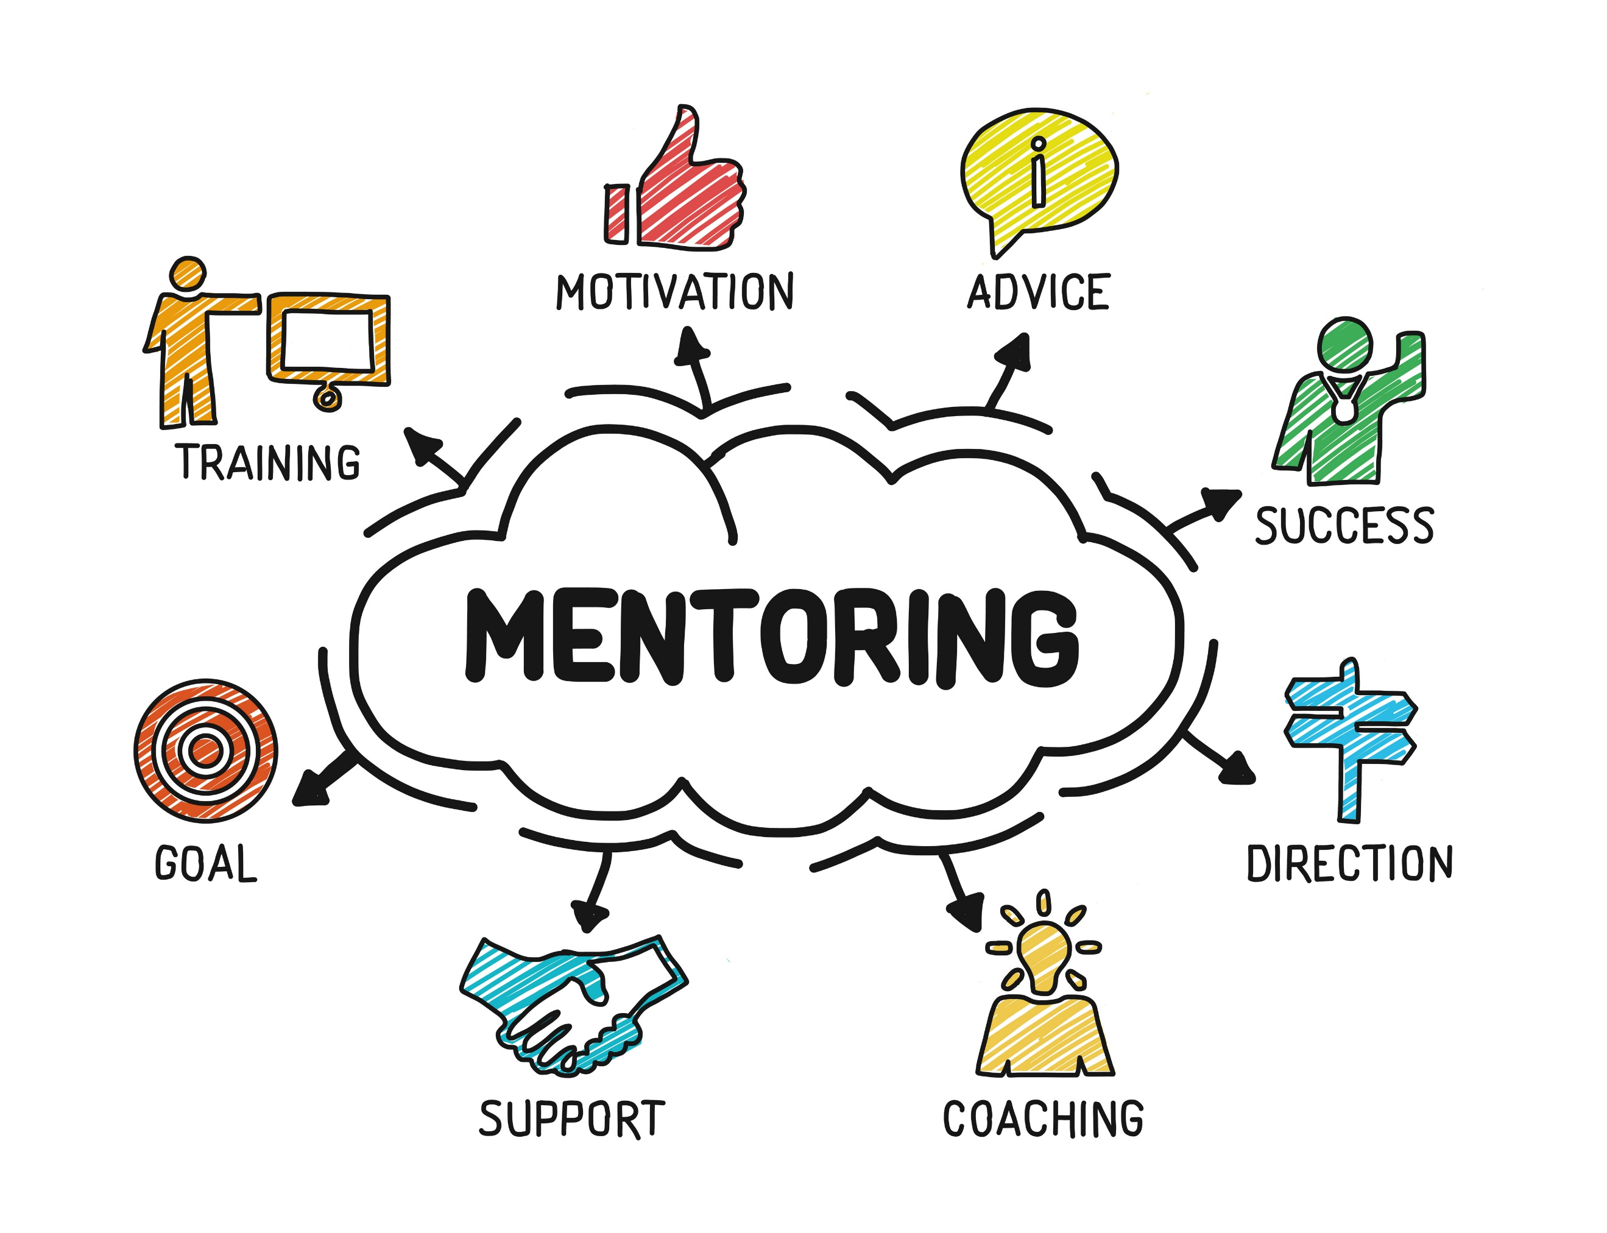
Peer mentoring is a relationship between people in which one person has more experience than the other and can provide support as well as knowledge and skills.
The Maine Vocational Rehabilitation (VR) virtual peer mentoring program is available to Potentially Eligible and VR eligible high school and post-secondary students from ages 14 through 21.
Peer Mentors are typically between the ages of 18–25 and are persons with a disability or have personal experience with a disability. Peer Mentors complete an extensive mentoring training to become certified Peer Mentors, which includes a background check. Below are some examples of how a peer mentor can provide support.

Examples of potential services:
High school students | Peer connections, self-advocacy in preparing for 504 or IEP meetings, interpersonal communication, organization/study habits, disability related conversations, career exploration.
High school students entering the workforce | Career exploration/job fairs, first jobs, postsecondary research, preparing disability statement and identifying workplace/postsecondary accommodations, career planning.
Postsecondary students | Career exploration/job fairs, first jobs, postsecondary research, preparing disability statement and identifying workplace/postsecondary accommodations, career planning. Self-advocacy in preparing for needed accommodations, assisting in self-advocacy with disability services, preparing disability statement and verbalizing needed accommodations, social career networking, organization/study habits, interpersonal communication.

How are services provided?
Once you have established your goals with your Vocational Rehabilitation Counselor a referral will be made to connect you with a peer mentor. You and your peer mentor will decide on how you would like to communicate. Peer Mentoring can be delivered through many formats that is agreed upon, examples: Skype, Facetime, Duo, phone call, Zoom, and texting. You can decide which would be the best for you!

Peer Mentoring program is available through Maine Division of Vocational Rehabilitation and Division for the Blind and Visually Impaired Please contact your Vocational Rehabilitation Counselor for more information or reach out to timothy.e.small@maine.gov, 207-530-2563.

