Program Year 2020 (July 1, 2020 – June 30, 2021)

Bureau of Rehabilitation Services Highlights
The Bureau of Rehabilitation Services works to bring about full access to employment, independence, and community integration for people with disabilities.

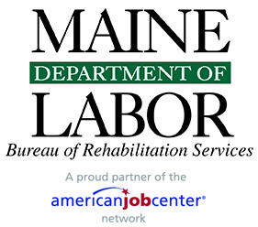

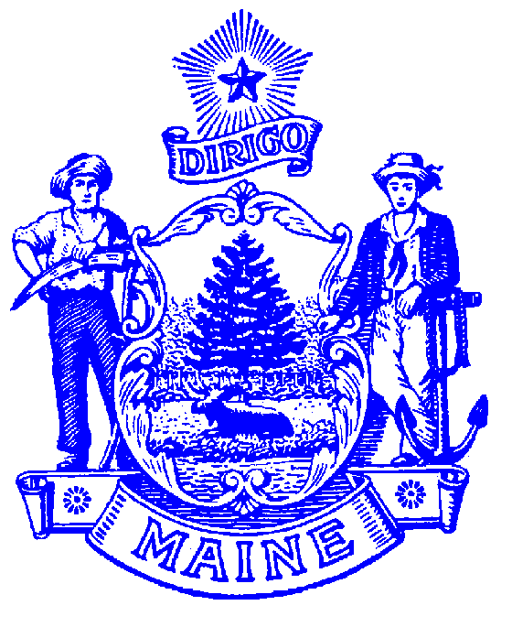
STATE OF MAINE
DEPARTMENT OF LABOR
BUREAU OF REHABILITATION SERVICES
150 STATE HOUSE STATION
AUGUSTA, MAINE 04333-0054

LAURA A. FORTMAN
COMMISSIONER

JANET T. MILLS
GOVERNOR

Bureau Director’s Message

It is with great pleasure that I welcome you to the 2021 edition of BRS Highlights. The Maine Department of Labor (MDOL) is committed to serving Maine residents and businesses, ensuring that our beautiful state prospers and is a diverse and inclusive place to live and work. Never has that been more important than during our recovery from the COVID-19 pandemic!

Within MDOL, the Bureau of Rehabilitation Services (BRS) has worked alongside many partners this year to safely and effectively help people with disabilities to live independently and pursue the many benefits that employment brings, including financial, social, and psychological. Both our staff and the individuals that we serve have demonstrated remarkable fortitude and focus during an unchartered and everchanging landscape. This was resoundingly evident during the 2020 Maine Vocational Rehabilitation Consumer Experience Survey conducted by Market Decisions Research of Portland for the Division of Vocational Rehabilitation (DVR) and the Division for the Blind and Visually Impaired (DBVI). Approximately two-thirds of the 916 respondents indicated that they did not stop services or looking for work during the pandemic and the overall customer satisfaction rates with staff and counselors remained consistent with pre-pandemic levels, at 88%. Most importantly, a high majority (over 92%) would tell their friends and family to go to DVR or DBVI for help!

The Oxford Dictionary of English defines “resilience” as being able to withstand or recover quickly from difficult conditions. People who are resilient use their strengths and supports to overcome adversity and resolve problems. This happens each and every day at BRS and I could not be prouder of our staff and the individuals with disabilities that we assist. Please enjoy this publication and the many highlights shared.

Another year gone by and what a year it has been!
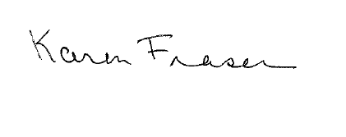

Karen Fraser, Bureau Director

PHONE: (207) 623-6799 TTY users call Maine Relay 711 FAX: (207) 287-5292
The Maine Department of Labor provides equal opportunity in programs, services and employment.
Auxiliary aids and services are available to individuals with disabilities upon request.
Programs are provided as a proud partner of the American Job Center network.
Table of Contents

Bureau of Rehabilitation Services Overview 4

How We Define Success 5

Division of Vocational Rehabilitation (DVR) 6

DVR Initiatives and Innovations 7

Bureau of Rehabilitation Services Apprenticeship Program 8

Division for the Blind and Visually Impaired (DBVI) 9

DBVI Initiatives and Innovations 10

Division for the Deaf, Hard of Hearing and Late Deafened (DDHHLD) 11

Office of the State Accessibility and Independent Living Coordinator 11

Partners in Advocacy, Advisory Boards and Councils 12

BRS Office Directory 12

Bureau of Rehabilitation Services Overview
The Bureau of Rehabilitation Services (BRS) is comprised of three Divisions – the Division of Vocational Rehabilitation (DVR), the Division for the Blind and Visually Impaired (DBVI), and the Division of Systems Improvement and Quality Assurance (SIQA). An average of 133 BRS employees deliver public vocational rehabilitation and independent living services to Maine people with disabilities and are co-located at CareerCenters statewide. BRS also houses the Office of the State Accessibility Coordinator, who leads the State’s compliance under the Americans with Disabilities Act (ADA) and Section 504 (see page 11).

The Rehabilitation Act of 1973, as amended by the Workforce Innovation and Opportunity Act (WIOA) of 2014, establishes program eligibility and the scope of services provided through DVR and DBVI. Included are vocational counseling and guidance, physical restoration services, education and skills training, and job placement services. DBVI, in conjunction with the Department of Education, also serves all children who are blind in Maine.

This past year, 8,110 Mainers with disabilities received services from BRS; of those participants, 6,004 received services with a plan for employment. Counselors worked with clients who had an employment plan for 21.6 months on average. A total of 472 clients were successfully employed for at least ninety days earning an average wage of $547.73 per week.

BRS receives most of its funding from federal grants, some of which require matching state funds. The largest (one administered by DVR and one administered by DBVI) are from the Department of Education’s Title I grant program for vocational rehabilitation services.
Federal Grants Required General Fund Match
Vocational Rehabilitation 4:1 (21%)
Independent Living 9:1 (11%)
Supported Employment None
Client Assistance None

Special Revenue income is received from the Business Enterprise Program (see page 10) managed by DBVI, from the Worker’s Compensation Board through a memorandum of understanding with DVR (see page 7), and from the Public Utilities Commission for telecommunications managed by the Division for the Deaf, Hard of Hearing and Late Deafened (see page 11). The use of the Special Revenue funds is restricted for these specific purposes.

How We Define Success…
“Johnny” has been a long-time client of Vocational Rehabilitation services. Johnny is Deaf and communicates using American Sign Language. He also experiences barriers related to his mental health and these barriers impacted his ability to find a job. An assessment with VR revealed that Johnny had real aptitude for hands-on work. Working with a Community Rehabilitation Provider, his Rehabilitation Counselor for the Deaf (RCD) helped find him a job at a large building supply store. After reaching employment stability, he now has access to long-term job coaching through MaineCare waiver funding. The reports from his managers and team have been positive – everyone enjoys working with him and his sense of humor. He has been recognized with awards and thanks for his work with customers. Johnny told his RCD, “I love my job and everyone at (the store).” He is proud of himself and his job!
When “PJ” experienced a setback in their personal life, they were concerned that their job with a Maine-based specialty food company might be in jeopardy. VR was able to step in and help PJ with some short-term job coaching, as well as working with the employer to develop natural supports, that could assist PJ to remain a valued employee!

When “Jose,” a VR client who is blind moved to a new area, he needed the services of a DBVI Orientation & Mobility Specialist to help him learn how to get around safely. The O&M Specialist provided him with a tactile map that he could use with his spouse to get to know the area and to practice between lessons as a family. Jose was thrilled with the map, which included a braille and tactile key for destinations nearby and worked with his Soundscape app navigation skills.

“Martina’s” drive to reach her employment goals in the social service field were recently recognized by her college, which named her “Student of the Year” noting her leadership skills and mentorship of other students!

The support of his DBVI team helped “Robert” reach his goal of working as a therapist. Robert has a visual impairment, is hard of hearing, and has some physical health issues. DBVI helped Robert find the right assistive technology to allow him to easily access his employer’s computer programs, as well as to provide technical assistance on his set up of his home office. Robert earns $50 an hour!

“Julie,” a young woman with diagnoses of anxiety, autism, and a learning disability, came to VR after trying unsuccessfully to find employment on her own for nearly 10 years. Despite the challenges of COVID-19, her VR Counselor and Community Rehabilitation Provider worked together with Julie and her family – using the Progressive Employment model – to help uncover her employment interests. Julie was able to do a work experience with a large pharmacy chain. She was so successful in the work experience that she was hired! Julie’s mother recently shared that her daughter is extremely happy with her job and she can see Julie’s confidence building every day. Julie now has her own bank account and is learning to manage her money!

Division of Vocational Rehabilitation (DVR)
Maine’s DVR assists eligible individuals with disabilities who wish to achieve or retain employment in the community. Any individual who is committed to work and has a disability that creates a barrier to employment is encouraged to apply. Once determined eligible, individuals develop a plan for employment, which outlines the services needed to successfully achieve their employment goal.

Contributing to the Maine Economy
While maintaining a wait list for services and during a pandemic, DVR assisted 447 people to find employment success. This resulted in these individuals earning a total of $12,803,781.12 in annual wages. Across the state and across industry sectors, DVR clients are joining or rejoining the workforce in such jobs as:

Administrative Services Manager | Community Health Worker | Graphic Designer
Automotive Service Technician | Construction Laborer | Healthcare Support Worker
Barber | Cook | Highway Maintenance Worker
Biological Scientist | Customer Service Representative | Home Health Aide
Building Cleaning Worker | Dental Assistant | Interpreter
Bus and Truck Mechanic | Dispatcher | Janitor
Bus Driver | Education Administrator | Laborer
Business Operations Specialist | Electrical Engineer | Material Moving Worker
Carpenter | Executive Secretary | Medical Assistant
Cashier | Farmer | Pharmacy Technician
Chief Executive | Firefighter | Registered Nurse
Childcare Worker | First-Line Supervisor | Sales Worker
Clergy | Fitness Trainer | Special Education Teacher
Coach | Food Preparation Worker | Teacher

Individuals Served
2,040 New Applicants
5,746 Received Services through Employment Plans
447 Individuals Placed in Competitive Employment

DVR Initiatives and Innovations

NEW! DVR Launches PEERS® The Program for the Education and Enrichment of Relational Skills (PEERS®) is world-renowned for providing evidence-based social skills treatment. Through a research partnership with Dr. Sarah Howorth at the University of Maine, DVR staff became certified to deliver PEERS® via telehealth to youth and young adult ages 14 to 24 with Autism Spectrum Disorders (ASD) around the state. DVR was excited to offer PEERS®., knowing how difficulties with interpersonal skills can negatively impact attainment of employment goals for individuals with ASD. The partnership is believed to be the first of its kind in the nation!

Virtual Job Shadows (VJS) In response to enhancing remote services to clients, VJS became integral in the delivery of Pre-Employment Transition Services and DVR’s Career Exploration Workshop (CEW). Virtual Job Shadow is a web-based career exploration platform, which can be tailored to the individual or small group aiding in counseling and guidance. Virtual Job Shadow offers thousands of real-time careers, career and interest assessments, soft skills videos, job and college search and flex lessons. Flex lessons, in conjunction with facilitator-led Zoom, allowed DVR to deliver the Career Exploration Workshop remotely. In addition, DVR began a computer and hotspot loan program, so that all clients had access to the Career Exploration Workshop and Virtual Job Shadow to aid in their career exploration and discovery.

Transition Work-Based Learning Model Demonstration (TWBL) grant nears completion. The Rehabilitation Services Administration-funded Disability Innovation Fund grant on work-based learning was awarded to Maine DVR in 2016 for a five-year period. During that time DVR implemented and researched two interventions – Enhanced Jobs for Maine’s Grads (JMG) and Progressive Employment – with high school students in the Augusta and Bangor areas. Findings look very promising and will add to the body of knowledge about effective work-based learning strategies that lead to improved post-secondary employment outcomes for youth with disabilities.

Speaking Up For Us (SUFU) provides consumer feedback on Career Exploration modules – DVR partnered with SUFU self-advocates this year to gather feedback and input on a targeted series of Career Exploration modules that were delivered over Zoom. SUFU members participated in four modules that covered a wide range of topics including: resume writing, job search tools, dressing for success, workplace culture, and natural supports among others. Their feedback will be used to strengthen the modules in advance of future use.

Motivational Interviewing (MI) is an evidence-based practice that has been used in many human services settings to increase client engagement. Over the last two years, the Bureau of Rehabilitation Services (BRS) focused on increasing staff awareness and use of Motivational Interviewing to increase client success. Vocational Rehabilitation Counselors, Casework Supervisors, and Regional Managers participated in small group learning sessions on how to incorporate MI within client meetings to support client importance, readiness, and confidence for change. In addition, supervisors and managers include MI discussions and techniques in staff/unit meetings and supervision with staff members. A BRS MI team was formed to support the growth of MI across all BRS professions. Over the next year, the MI team will be responsible for issuing the MI Tip of the Month, a monthly focus on a specific MI concept that will involve implementing and practicing the concept across a variety of settings.

Targeted Population Liaisons with subject area knowledge related to Foster Care, Corrections, and Veterans have been established in each office to best support coordination and improved outcomes for mutual clients. These liaisons serve as a point of contact and assist with promoting connections within and outside Vocational Rehabilitation.

Bureau of Rehabilitation Services (BRS) Apprenticeship Program
Throughout the pandemic of 2020-2021, the Maine Bureau of Rehabilitation Services (BRS), in partnership with the Bureau of Employment Services (BES) and the Maine Apprenticeship Program (MAP), continued to work with Maine workforce partners to help increase and engage employer sponsors and apprentices in Maine. Despite the pandemic’s impact on the economy and apprenticeship opportunities, much was accomplished:
- Produced two statewide remote “Employer Spotlights” where VR staff, VR clients, and the general public were invited to join Reed & Reed, Inc., and Paradigm Windows, apprenticeship employer sponsors noted for hiring inclusivity, as they discussed their business platforms, apprenticeship programs, and hiring practices.
- Participated in the nationally recognized Windmills Training Program, a program that addresses working with employers around disability and specifically the fears, biases and myths that create hiring barriers.
- Collaborated with the Mountain View Correctional Facility to help develop and support apprenticeship pathways for residents re-entering Maine communities and economies.
- Sponsored a statewide remote “Apprenticeship Townhall” providing an opportunity for VR clients, VR staff, and the public to ask questions and provide input regarding apprenticeship to expand knowledge of apprenticeship as a career pathway.
- Joined the Rural Youth Apprenticeship Advisory Council, a national initiative sponsored by the Institute for Community Inclusion, to identify and develop best practices and platforms to increase youth apprenticeship across the country.
- Met with staff from the U.S. Department of Labor’s Office of Disability Employment Policy to discuss how Maine is approaching inclusion in apprenticeship and also with SAFAL Partners to help increase the hiring of persons with disabilities in Information Technology and Cyber Security.
- Helped BRS clients enter several new apprenticeships with employers, such as Bath Iron Works, Revision Energy, St. Mary’s Healthcare, and the Limerick Supermarket.
- Continued to meet quarterly with Maine workforce partners, including Eastern Maine Development Corporation, Coastal Counties Workforce, Inc., the Cutler Institute, the Urban Institute, and the Maine Department of Health and Human Services.
Some of the key elements of apprenticeship include:

Mentoring
Participating Registered Apprenticeship Sponsors provide on-site mentors as a requirement of apprenticeship.

Flexibility
Apprenticeships, vary in duration (generally 1 to 4 years), are offered by both small and large businesses, and are tailored to meet the needs of the employer.

Earn While You Learn
Apprentices are employees at the inception of the training and, as such, are paid employees from the first day of the apprenticeship.

National Occupation Credential
Upon completion of an apprenticeship, the apprentice is awarded a nationally recognized, portable credential.

For more information, contact Peter Diplock at: Peter.D.Diplock@maine.gov or call 207-215-3580.

Division for the Blind and Visually Impaired (DBVI)
Maine’s DBVI provides a continuum of rehabilitation services to individuals who are blind or have low vision. Services may include individual counseling and guidance related to employment and adjustment to blindness issues, use of adaptive technology, low vision therapy, alternative skill training in communication (such as braille), instruction to develop independent travel skills (orientation and mobility), and instruction of daily living skills geared to being more self-sufficient. These services are provided through various programs, including:

Vocational Rehabilitation Program is primarily for working-age adults who seek competitive, integrated employment. Services may include individual vocational counseling and guidance, vocational assessment, orientation and mobility instruction, low vision services, independent living services (vision rehabilitation therapy), and more.

Business Enterprise Program (BEP) provides training and support to 7 licensed managers who operate snack bars, cafeterias, micro markets, and vending machines at 21 sites on state, federal and municipal properties across Maine. BEP also provides employment to many other individuals with disabilities.

Independent Living Services (IL) provides training in adaptive skills and alternative techniques for accomplishing daily tasks that enable approximately 400 individuals who are older and blind to be more self-sufficient each year.

Education Services for Children Who Are Blind or Visually Impaired provides adaptive instruction services or consultation to approximately 300 students annually in home or at local schools related to academics and independence.

VR Program

Individuals Served
64 New Applicants
258 Received Services through Employment Plans
25 Individuals Placed in Competitive Employment

DBVI Initiatives and Innovations
Maine’s Business Enterprise Program (BEP) had a year unlike any other due to the COVID-19 pandemic. When State and Federal facilities sent employees home to telework in March 2020, self-employed blind and visually impaired managers were all significantly impacted due to BEP facilities, including cafeterias, snack bars, Micro Markets and vending operations either shutting down food service operations completely or keeping the Micro Markets open for the few who continued to work onsite. As many of us discovered, sometimes challenges propel us in directions and cause us to forge new paths that turn into positive and productive ventures. This happened with the BEP. Over the past 17 months, one BEP manager utilized his facility to provide “take out” and “grab and go” services to customers. This facility also provided fresh food to a few Micro Markets in the area. In other locations, the BEP is in the process of converting snack bars with customer facing services into 24/7 self-service Micro Markets. In order to thrive and continue to provide meaningful self-employment opportunities for individuals who are blind and visually impaired, the BEP must adapt to our ever-changing work environments and the world around us. BEP managers get into this business because they thoroughly enjoy the food and vending industry, serving and interacting with customers, and being self-employed. They are committed to persevering through adversity for the benefit of others, themselves, and this program.

NEW! Mission Fit, a new fitness program, included 12 students who participated in the program from March through mid-June 2021 to learn about nutrition and healthy eating habits. A fitness trainer, who also has a visual impairment, taught program students to look beyond their fears, to take ownership, and to develop good habits. Staff from the Education Services for Blind and Visually Impaired Children’s (ESBVIC) program and DBVI supported the students as they established and embraced their fitness goals. Participants met virtually every two weeks and were taught how to establish performance and procedural goals, which provided them with an understanding of the frequency and duration of the exercises. The trainer met with students monthly to provide motivation and resources for continued success in their fitness programs. Guest speakers spoke with the students about being active and the many activities and sports that can be adapted for individuals with visual impairments. These speakers were individuals with a visual impairment who participate in adaptive sports, such as skiing, ice hockey, hiking and rowing.

DBVI College Prep Program in the past was a program that lasted five weeks, but due to COVID and the desire to have a residential program, the 2021 program was held for three weeks. Seven students completed the program where they were involved in an intensive three-credit college course while they lived on the University of Maine campus and participated in blindness rehabilitation instruction, such as Orientation and Mobility and Vision Rehabilitation Therapy. The students were able to experience new things, such as what it was like to live away from home, to have a roommate, and to learn the expectations of a college level course. Students also participated in a paid work experience.

Life Camp 2021 was offered as a two-week program focused on Pre-Employment Transition Services (Pre-ETS) activities for students with low vision and additional disabilities. Pre-ETS activities included workplace readiness; job exploration; instruction in self-advocacy; work-based learning; and counseling on post-secondary opportunities. Five students stayed in a Portland neighborhood in housing used for residential rehabilitation at the Iris Network. Students were introduced to adaptive home and personal management skills, as well as workplace readiness skills. Students also attended a panel presentation of successfully employed adults who were blind or had low vision and visited the Portland CareerCenter where they engaged in simulated work activities. This program was a great way to introduce students to independence, employment, and empowerment!

DBVI Family Field Day 2021, hosted by the Division for the Blind and Visually Impaired (DBVI), brought families together who have children ages birth to 24 with visual impairments. The goal of the event was to help students and their families make connections with other families experiencing vision loss and to participate in a variety of accessible indoor and outdoor activities adapted for individuals with visual impairments. The event also addressed areas of the Expanded Core Curriculum and Pre-Employment Transition Services, including Independent Living Skills; Orientation and Mobility; Recreation and Leisure; Self-Determination; Social Interaction Skills; Self-Advocacy; and Work Readiness Training. These areas are critical for successful employment outcomes for people with visual impairments.

Division for the Deaf, Hard of Hearing and Late Deafened (DDHHLD)
The Division for the Deaf, Hard of Hearing and Late Deafened (DDHHLD) provides information and referrals for resources of interest to people who have hearing loss throughout the state. These resources include interpreting services, Deaf identification cards, Deaf vehicle placards, Deaf Awareness trainings, hearing aids, and advocacy. This year, DDHHLD provided information regarding face masks/coverings, Deaf Culture, a Resource Guide for Deaf and Hard of Hearing, and a newsletter, Maine-Lines, which was published four times and included several interviews with Deaf and hard of hearing people. DDHHLD was also involved in legislation related to American Sign Language interpreting licenses and provided information regarding how the terminology of “Hearing Impaired” is offensive to the Deaf community. The Division remains active with the National Deaf Center (NDC) with other team members from the Division of Vocational Rehabilitation, Maine Education Center for Deaf and Hard of Hearing, Maine Behavioral Health, Disability Rights Maine, and the Department of Education. With a focus on the needs of Deaf and hard of hearing transition students, this year’s NDC priority is Leveraging Community Resources and Promoting Higher Expectations.

The Commission for the Deaf, Hard of Hearing and Late Deafened (CDHHLD) created and actively works on an ongoing Five-Year Plan to improve access for individuals who are Deaf and hard of hearing in Maine. Each year, the Division and Commission also organize the Annual Deaf Culture Tea Awards ceremony. This past year, the Tea was held via Zoom and broadcast from the Maine Educational Center for the Deaf and Hard of Hearing (MECDHH). Following a welcome from Maine Department of Labor Commissioner Laura Fortman and a keynote address, awards were presented to active community members. The Tea was also honored with remarks from Governor Janet Mills.

Office of the State Accessibility and Independent Living Coordinator
State ADA Accessibility Highlights
The Accessibility Coordinator leads the State’s compliance under the Americans with Disabilities Act (ADA) and Section 504. The Coordinator also works with State agencies to resolve any disability-based discrimination complaints and to develop and carry out policies and practices regarding services, facilities, web design, and communication. The Coordinator was involved in several initiatives during the 2020-2021 year:
- Drafted legislation (LD 1336) to remove “handicapped” and “hearing impaired” language from Maine statutes and documents.
- Published guidance with the IT Accessibility Committee (ITAC) for accessible digital media and events with online links available at: The Accessibility Guide - Maine State Accessibility; Guidelines for Accessible Recorded and Streamed Video and Audio Materials; and Tips for Accessible Remote Meetings.
- Arranged contracts with the Division of Purchases for statewide services for assistive technology and captioning.
- Developed trail standards for accessibility and reviewed local projects funded by the Recreational Trails Program.

Independent Living Highlights
The State Independent Living (IL) Coordinator oversees DVR’s contracts with the Independent Living Services Program and the Maine Statewide Independent Living Council (SILC) to provide opportunities for improved community and housing access for people with disabilities. The IL Coordinator also provides technical assistance and training for Maine businesses and individuals about disability rights. In 2020-2021, the IL Coordinator helped the Maine CDC with the implementation of the State’s mask mandates to ensure safety and accessibility for customers and employees. The IL Coordinator worked on several boards, including the Kim Wallace Adaptive Equipment Loan Program, Maine’s flexible loan program for assistive technology; the Travel Helpers Training Program; and the Assistive Technology Consortia.
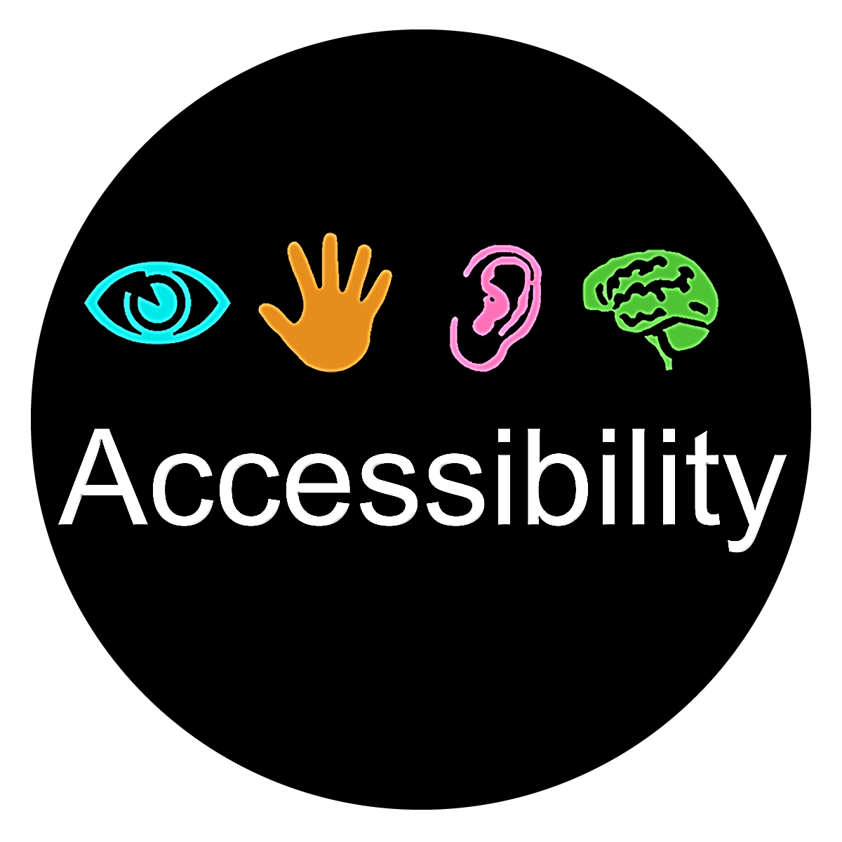

Contact: | Eric Dibner, ADA Accessibility and IL Coordinator
Tel: | 207-623-7950 (Voice)
TTY: | Maine Relay 7-1-1
Fax: | (207) 287-5292
E-mail: | Eric.Dibner@maine.gov
Website: | https://www.maine.gov/rehab/ada

Partners in Advocacy, Advisory Boards and Councils
Client Assistance Program, operated by Disability Rights Maine, provides information, advice, advocacy, and (if determined necessary) legal representation to persons who have concerns about the rehabilitation services they receive from DVR and DBVI. Website: https://drme.org/client-assistance-program

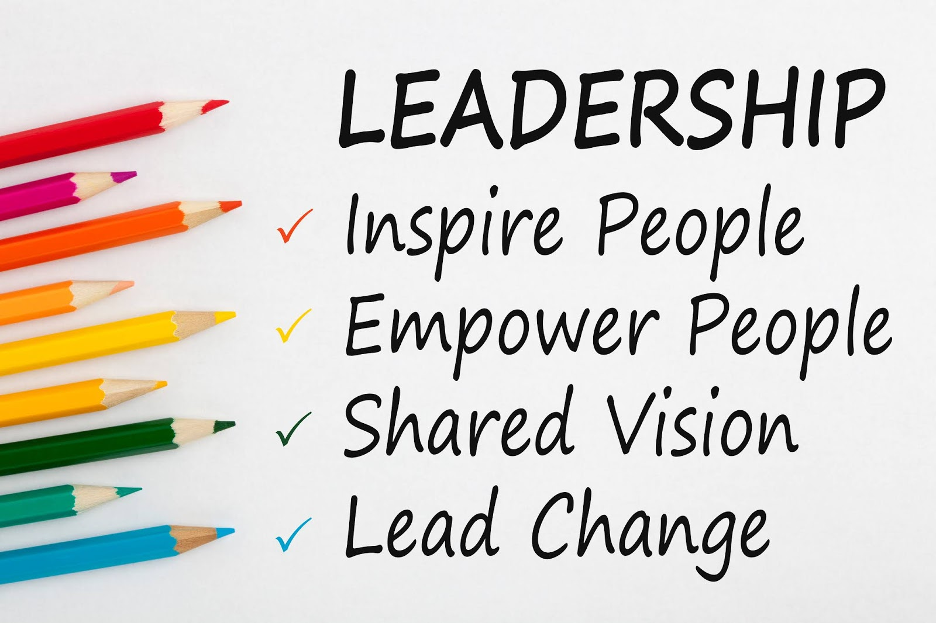
Commission for the Deaf, Hard of Hearing and Late Deafened is an advisory council that provides a review of the status of services to deaf and hard-of-hearing persons; recommends priorities for development; evaluates the progress made as a result of recommendations; and sets goals for activities of the division to carry out its obligations and responsibilities to the deaf and hard-of-hearing communities.
Website: https://www.maine.gov/rehab/advisory_councils/dod

Commission on Disability and Employment (CDE) is a subcommittee of the State Workforce Board. The commission fosters workforce development in Maine that includes meaningful employment and equal opportunity for people with disabilities and promotes collaboration to increase public awareness and influence public policy.
Website: https://www.maine.gov/swb/committees/disability_employment/index.shtml

DBVI State Rehabilitation Council (SRC) is a diverse group of people concerned with the quality of vocational rehabilitation services provided to blind Maine citizens. The SRC’s core functions are to review, analyze and advise on the policies and practices of DBVI and other related entities involved with the employment of people who are blind or have vision impairments. Website: https://maine-src-dbvi.org

DVR State Rehabilitation Council (SRC) is a statewide citizens group that advises DVR about how well its programs and services match the needs of people with disabilities in Maine. In partnership, the SRC works with DVR to review, analyze, and advise the state agency regarding its performance in providing vocational rehabilitation services.
Website: https://mainesrc.org

State Independent Living Council (SILC) promotes a philosophy of independent living, which encompasses consumer control, peer support, self-help, self-determination, and equal access, as well as individual and system advocacy to maximize the leadership, empowerment, independence, and productivity of individuals with significant disabilities. Website: http://mainesilc.org

BRS Office Directory
Central Administrative Office  Bureau of Rehabilitation Services  150 State House Station, Augusta, ME 04333  Tel: 207-623-6799 Fax: 207-287-5292 | From any location, TTY users call Maine Relay 711
Augusta CareerCenter  45 Commerce Drive, Augusta, ME 04333-0073  Tel: 207-624-5120 or 1-800-760-1573 Fax: 207-287-6249 | Lewiston CareerCenter  5 Mollison Way, Lewiston, ME 04240-5805  Tel: 207-753-9000 or 1-800-741-2991 Fax: 207-753-9051
Bangor CareerCenter  45 Oak Street, Suite 1, Bangor, ME 04401-6664  Tel: 207-561-4000 or 1-888-545-8811 Fax: 207-561-4027 | Machias CareerCenter  53 Prescott Drive, Suite 2, Machias, ME 04654-9751  Tel: 207-255-1926 or 1-800-770-7774 Fax: 207-255-3091
Northern Kennebec Valley CareerCenter  23 Stanley Road, Hinckley, ME 04944  Tel: 207-474-4958 or 1-800-760-1572 Fax: 207-474-4914 | Greater Portland CareerCenter  151 Jetport Boulevard, Portland, ME 04102  Tel: 207-822-3300 or 1-877-594-5627 Fax: 207-775-7870
Houlton DVR Office  11 High Street, Houlton, ME 04730-2421  Tel: 207-532-5019 or 1-800-432-7338 Fax: 207-532-5309 | Presque Isle CareerCenter  66 Spruce Street, Suite 3, Presque Isle, ME 04769-3222  Tel: 207-768-6835 or 1-800-635-0357 Fax: 207-768-6837

