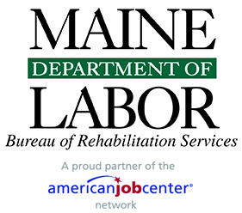

W.O.R.K Services-Online VR Application
workservices.maine.gov
W.O.R.K Services is an online portal that provides you the option to connect with community partners at the Career Center, Adult Ed, Division of Vocational Rehabilitation, and the Division for the Blind and Visually Impaired. The hope is to make your education, training, and employment needs more of a collaborative approach. Participants have the choice to connect and exchange information with one, two, or all three agencies. If you’re only interested in Voc Rehab that’s fine too. To apply for Vocational Rehabilitation please follow the steps below and visit Maine’s WORK Services.

Steps to Apply for Vocational Rehabilitation Online

- Visit WORK Services or workservices.maine.gov
- Choose Sign Up (upper right-hand corner of the page)
- Complete Participant Portal Quick Intake
- Click Submit
- Complete the brief Overview Survey and click Confirm
- Confirm your responses and click Submit
- Retrieve the one-time acct set up email in your inbox (be sure to check your Spam too).
- Generate a unique password
- Login to W.O.R.K Services account
- Read and sign the Participant Data Exchange Agreement
- Click on Vocational Rehabilitation application in the Participant Dashboard (upper left-hand side)
- Locate additional required documents like the Health Checklist, Hearing Loss Assessments, and releases on the W.O.R.K Services Dashboard under Additional Links.
VR Application Online
workservices.maine.gov
7/2020

