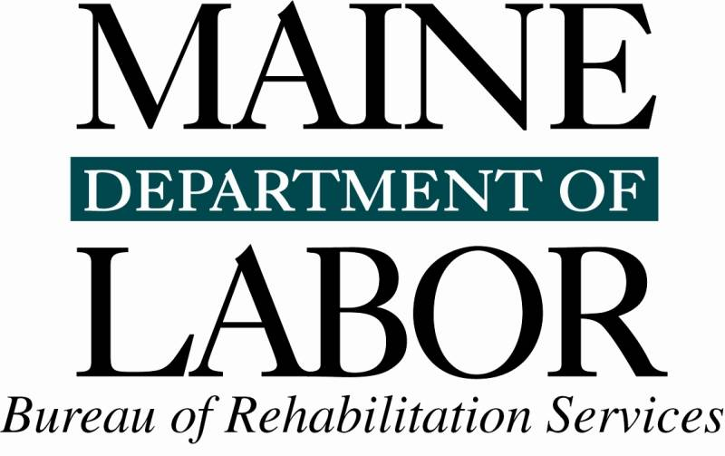

Application for In-State Approval
For Community Rehabilitation Providers

Date of Application: __________________

Name of Provider: ________________________________________________________
Name of Legal Entity Sponsoring Provider (if different from above):
________________________________________________________________________

Providers Address: _______________________________________________________

________________________________________________________________________

Name & Title of Contact Person: ____________________________________________

(Name of CEO if different from above): ______________________________________

Telephone: _________________ Cell: ________________ Fax: ________________

E-mail address: _________________________________________________________

Proposed Services: (please check all applicable service categories)
___ Situational Assessment ___ Job Development/Placement ___⁭ Job Coaching
___ Long-term Supports Other: ____________________________________

Please check all counties where you will provide these services:
___ Androscoggin ___ Aroostook ___ Cumberland ___ Franklin
___ Hancock ___ Kennebec ___ Knox ___ Lincoln
___ Oxford ___ Penobscot ___ Piscataquis ___ Sagadahoc
___ Somerset ___ Waldo ___ Washington ___ York

Names and dates of birth (required for background check) of all individuals who will be providing the above employment services (or verification if agency does its’ own background checks): (Note: please attach a resume with relevant education & training for each individual listed)

Name DOB Background check
________________________________________________________________________________________________________________________________________________________________________________________________________________________________________________________________________________________________________________________________________________________________________________________________________________________________________________

Please attach the following documents:
- A mission statement specific to your employment programs
- Articles of incorporation or Statement of Ownership
- Resumes/Proof of qualifying training for all staff providing employment services
- Proof of current auto insurance and valid Maine Driver’s license for each staff person providing employment services
- Proof of Background Checks for all staff providing employment services (if this is an application for an independent Provider, BRS will conduct the background check)
- Proof of Professional liability coverage (we require a minimum of $400,000)
- Written policy to inform clients, advocates and stakeholders of their right to file a complaint against the CRP without repercussions; and the proper procedures to do so. Include information about the Client Assistance Program (CAP), CAREs Inc.
- Written policies and procedures to assure clients are informed of and supported, to exercise their fundamental rights and responsibilities as a recipient of services
- Written policies and procedures to assure client has input and informed choices regarding services
- Written policy and procedure to ensure client is provided a copy of all reports generated on their behalf, that are provided to BRS
- Safeguards and security measures to allow only authorized people to access client files (paper and electronic)
- Written policy and procedures for client/legal guardian’s access to client’s records
- Written policy and procedures that specify under what conditions services may be discontinued or interrupted, which minimally indicate how and when client and state agency representative are notified
- Written procedures for a documented internal records review process
- Written Plan of Accessibility or a policy statement that explains how the CRP will assure access to services as required by state and federal laws. In the case of an independent CRP operating out of his/her home, the written plan may consist of a statement that all services will be provided at accessible community locations such as the local Career Center.
- A written plan (with specific actions and timelines) to market your employment services during the first year of operation
- Quality Assurance Surveys for each stakeholder: client, employer and VR counselor and a policy concerning distribution and implementation of the surveys.

Service Delivery References (for newly established entities)
Name Title/Relationship Phone
1.
2.
3.

Signature ________________________________________ Date: ________________

Print Name: ___________________________ Title: __________________________

Please send to: Christine Robinson
Bureau of Rehabilitation Services
150 State House Station
Augusta, ME 04333-0150

