2012-2013
Bureau of Rehabilitation Services
Highlights

The Bureau of Rehabilitation Services works to bring about full access to employment, independence and community integration for people with disabilities.

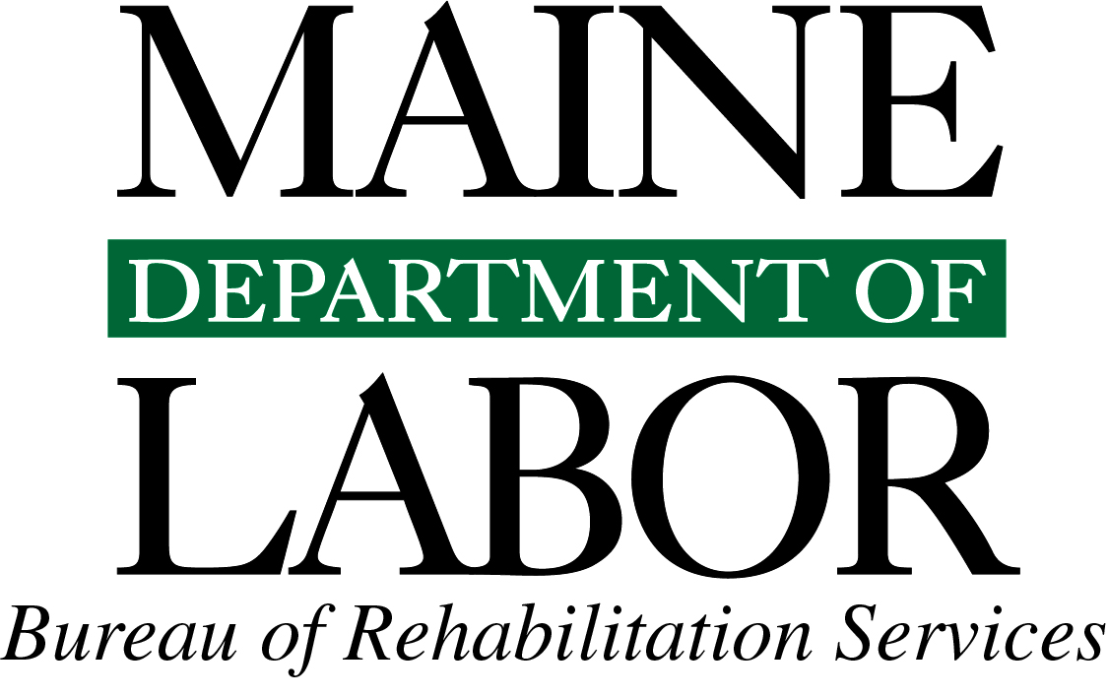

March 24, 2014

The Department of Labor, as a significant part of its focus, connects people with meaningful employment.
The Bureau of Rehabilitation Services in many ways represents the best of this focus. Indeed, BRS’
mission is to ensure that independent living and employment opportunities exist for any Mainer
who wants or needs to work.

This bureau’s leadership in developing employment opportunities for people with disabilities serves as a role model for efficient and effective service delivery. Through the past few years, BRS has enhanced services while at the same time lowering the costs of some services and has eliminated the waiting list for people who want to improve their lives through participation in vocational rehabilitation.

It is a testament to the hard work of the bureau’s staff that they have accomplished these goals, as well as the others you will see described in these highlights. But most importantly, it is a testament to our clients, the citizens of Maine, of all they have achieved.

The Department of Labor is proud to house an agency whose main focus is to assist people with disabilities become self-sufficient and enjoy all the benefits that employment brings – financial, social, and psychological – while serving as role models for their employers, colleagues, families, and communities.

I invite you to learn more about the variety of vocational services the bureau provides. If you have any questions, please reach out to the Bureau’s director, Carolyn Lockwood, or me at any time. If you know of an employer that could benefit by hiring talented and loyal workers, do not hesitate to connect them to the Bureau of Rehabilitation Services.

Sincerely,

Jeanne Paquette
Commissioner

Table of Contents

Message from the Commissioner
Bureau of Rehabilitation Services Overview 4
Division of Vocational Rehabilitation (DVR) 6
DVR Initiatives and Innovations 7
Business Relations Activities & Outcomes 10
Division for the Blind and Visually Impaired (DBVI) 8
DBVI Initiatives & Innovations 9
Office of the State Accessibility Coordinator 11
Partners in Advocacy, Advisory Boards and Councils 12
BRS Office Directory 12

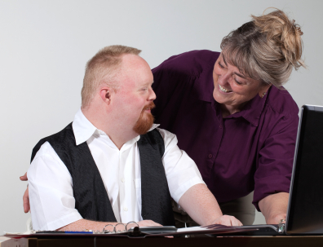
Clients with significant intellectual disabilities are successfully finding community-based employment that pays at or above minimum wage. Some recent placements include: hotel laundry assistant, landscaper, production line worker, school cafeteria worker, dishwasher, daycare worker, and bottle redemption center assistant.

Laurie had worked for the Social Security Administration (SSA) for 13 years when she began to have difficulty with the existing lighting, computer accessibility, fatigue and some mobility issues. Laurie had become legally blind due to a congenital eye condition and worked with DBVI to receive vision rehabilitation services. With orientation and mobility, vision rehabilitation therapy, assistive technology and a low vision assessment, Laurie was able to adjust her workstation, use adaptive equipment, and gain the necessary skills to maintain her employment at the SSA.

Bureau of Rehabilitation Services Overview
The Bureau of Rehabilitation Services (BRS) is comprised of three Divisions—the Division of Vocational Rehabilitation (DVR), the Division for the Blind and Visually Impaired (DBVI), and the Division of Systems Improvement and Quality Assurance. One hundred sixty three BRS employees deliver public vocational rehabilitation and independent living services to Maine people with disabilities and are co-located at CareerCenters statewide. BRS also houses the State Accessibility Coordinator, who leads the State’s compliance under the Americans with Disabilities Act (ADA) and Section 504 (see page 11).
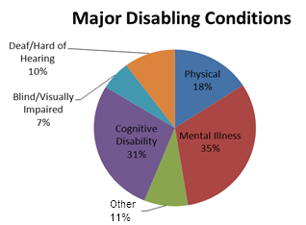
The Rehabilitation Act of 1973, as amended, establishes program eligibility and the scope of services provided through DVR and DBVI. Included are vocational counseling guidance, physical restoration services, education and skills training, and job placement services. DBVI also serves all blind children in Maine working in conjunction with the Department of Education.

In 2012, 10,231 Mainers with disabilities received services from BRS; of those participants, 4,735 received services with a plan for employment. Counselors work with clients who have an employment plan, on average, for 33.2 months. This year, 851 clients were successfully employed earning an average wage of $332 per week.

BRS receives the majority of its funding from the federal Department of Education’s Title I grant program. These grants (one administered by DVR and one by DBVI) provide funding for rehabilitative services to eligible clients. The Title I grant has a 4:1 state matching requirement which is met using the General Fund appropriation.

Federal Grants Required General Fund Match
Independent Living 9:1 state match
Supported Employment None
Client Assistance None
Staff Training 4%DBVI/10%DVR

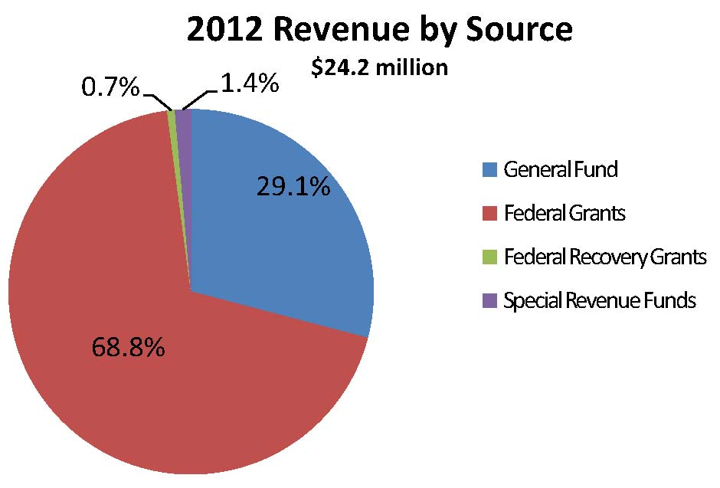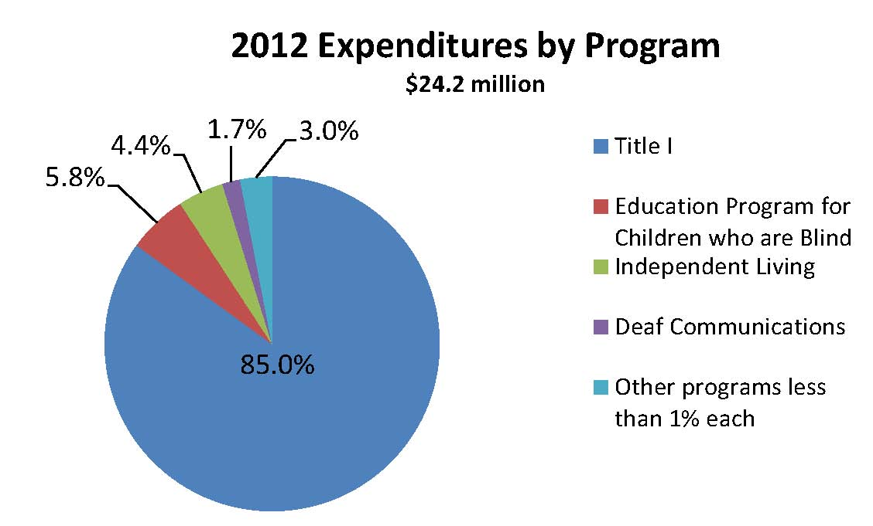

Special Revenue income is received from the Business Enterprise Program (cafeteria and vending machine facilities), managed by DBVI, and from telecommunication funding received from the Public Utilities Commission and managed by the Division for the Deaf, Hard of Hearing and Late Deafened. The use of the Special Revenue funds is restricted for these specific purposes.

How We Define Success…

“Melanie” wanted to attend college to obtain a degree in culinary arts but was not accepted due to her learning needs. Melanie’s VR counselor introduced her to another option – on-the-job training and apprenticeship. Melanie agreed and chose a community provider to work with to find a job. She was offered a job at a café as a Cook’s Apprentice. She has been working there for three months and takes pride in her accomplishments.

When “Valerie” came to Vocational Rehabilitation (VR) for assistance finding a job, she didn’t realize that her experience as a mother of a child with a disability would lead to her dream job. VR worked with Valerie to help her identify the transferrable skills she had acquired raising her son. Valerie now works as a Direct Support Personnel with a teenaged girl with developmental disabilities. Valerie is appreciative of the assistance she received from VR and reports that she is “extremely successfully employed” in her “dream job.”

Raymond founded Diamond Tape Productions in the 1970s, where he produces recordings of guide dog publications. Raymond is totally blind due to glaucoma that developed in early childhood. He recently sought assistive technology services from DBVI that allow him to use a screen reader with sound production and editing software. These skills, in combination with DBVI’s support, allow Raymond to maintain a successful business in Maine.

A Portland-area client found employment in 2011 as a Research Analyst with a starting salary of $55,000. DVR assisted this individual with hearing aids, vocational guidance, counseling, and educational costs. The client reports that the job is going very well and that she loves her work.

Division of Vocational Rehabilitation (DVR)
Maine’s DVR assists eligible individuals with disabilities who wish to achieve or retain employment in the community. Any individual who is committed to work and has a disability that creates a barrier to employment is encouraged to apply. Once determined eligible, individuals develop a plan for employment which outlines the services needed to successfully achieve their employment goal.

Contributing to the Maine Economy
While continuing to maintain no wait list for services, DVR has assisted 921 people to find employment success in Federal Fiscal Year 2013. This resulted in these individuals earning a total of $17,927,412 in annual wages. Across the state and across industry sectors, DVR clients are joining or rejoining the workforce in such jobs as:

Administrative Assistant
Analyst
Associate Professor
Automotive Services Technician
Banquet Services
Cashier
Changing Room Attendant
CNA
Cosmetologist
Customer Service – Retail
Dishwasher
Driving Instructor
Entertainment Coordinator
Environmental Technician
Farmhand
Finance Coordinator
Food Services
Grocery Carry-Out
Human Services Worker
Janitorial Services
Karate Instructor
Laundry Worker
Maine Guide
Maintenance Worker
Mental Health Case Manager
Night Desk Clerk
Nurse
Peer Support Specialist
Personal Fitness Trainer
Photographer
Product Demonstrator
Rehabilitation Counselor
Restaurant Prep
Retail Sales Associate
School Bus Driver
Security Guard
Social Worker
Sterile Processor Technician
Substance Abuse Counselor
Teacher
Transit Dispatcher
TV Studio Assistant
Waterfowl Biologist
Wood Manufacturing

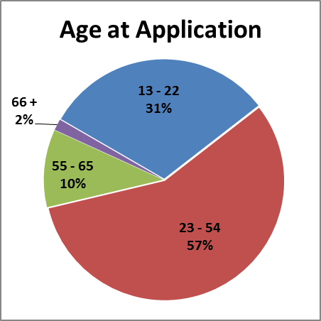
Individuals Served in 2013
3,908 New Applicants
4,703 Received Services through Employment Plans
921 Individuals Placed in Employment

Education Outcomes
341 Individuals Increased their Education Level
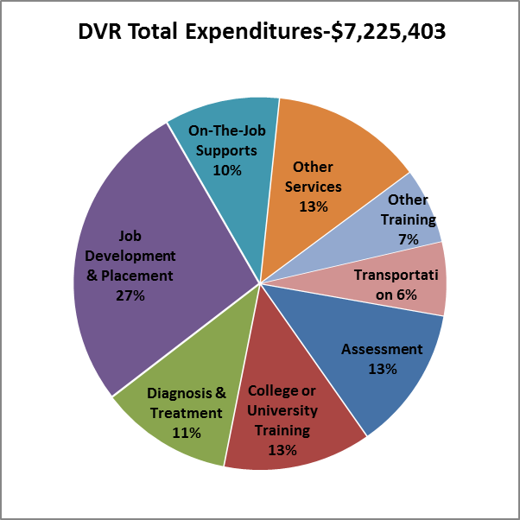

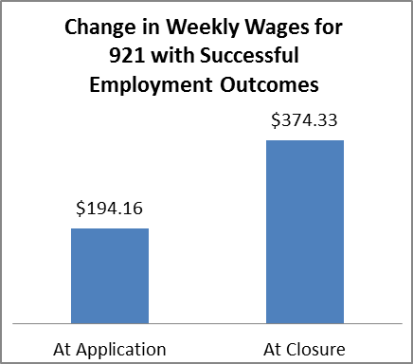

DVR Initiatives & Innovations
Coming Together with Rehabilitation Providers, “The CRP Project,” was launched in the fall of 2011. The CRP Project will ultimately improve employment outcomes for BRS clients and ensure a maximum return on the investment. The CRP Project Steering Team, consisting of CRP and VR staff, developed six work groups focusing on: Access and Availability of CRP Services, Accreditation of CRPs, Billing, Business Relations, Communications, and Referral and Documentation. The Steering Team compiled recommendations from the workgroups and presented them to BRS leadership in March 2012. For more information, please visit: http://www.maine.gov/rehab/crp/crp_project

The Division for the Deaf, Hard of Hearing and Late Deafened (DDHHLD) houses a director, assistant to the director and three Rehabilitation Counselors for the Deaf (RCDs). The RCDs help individuals who are deaf or hard of hearing access and maintain employment. Due to increased referrals, that DVR during the last two years, DDHHLD is hiring two more RCDs. DDHHLD provides referrals, information and training to employers and other state agencies, as well as, deaf, hard of hearing and deaf-blind consumers regarding equal access issues. In addition, DDHHLD administers a contract with the Maine Center on Deafness to provide Telecommunications Equipment, Civil Rights and Advocacy services.

Significant Savings Shown in Hearing Aid Initiative
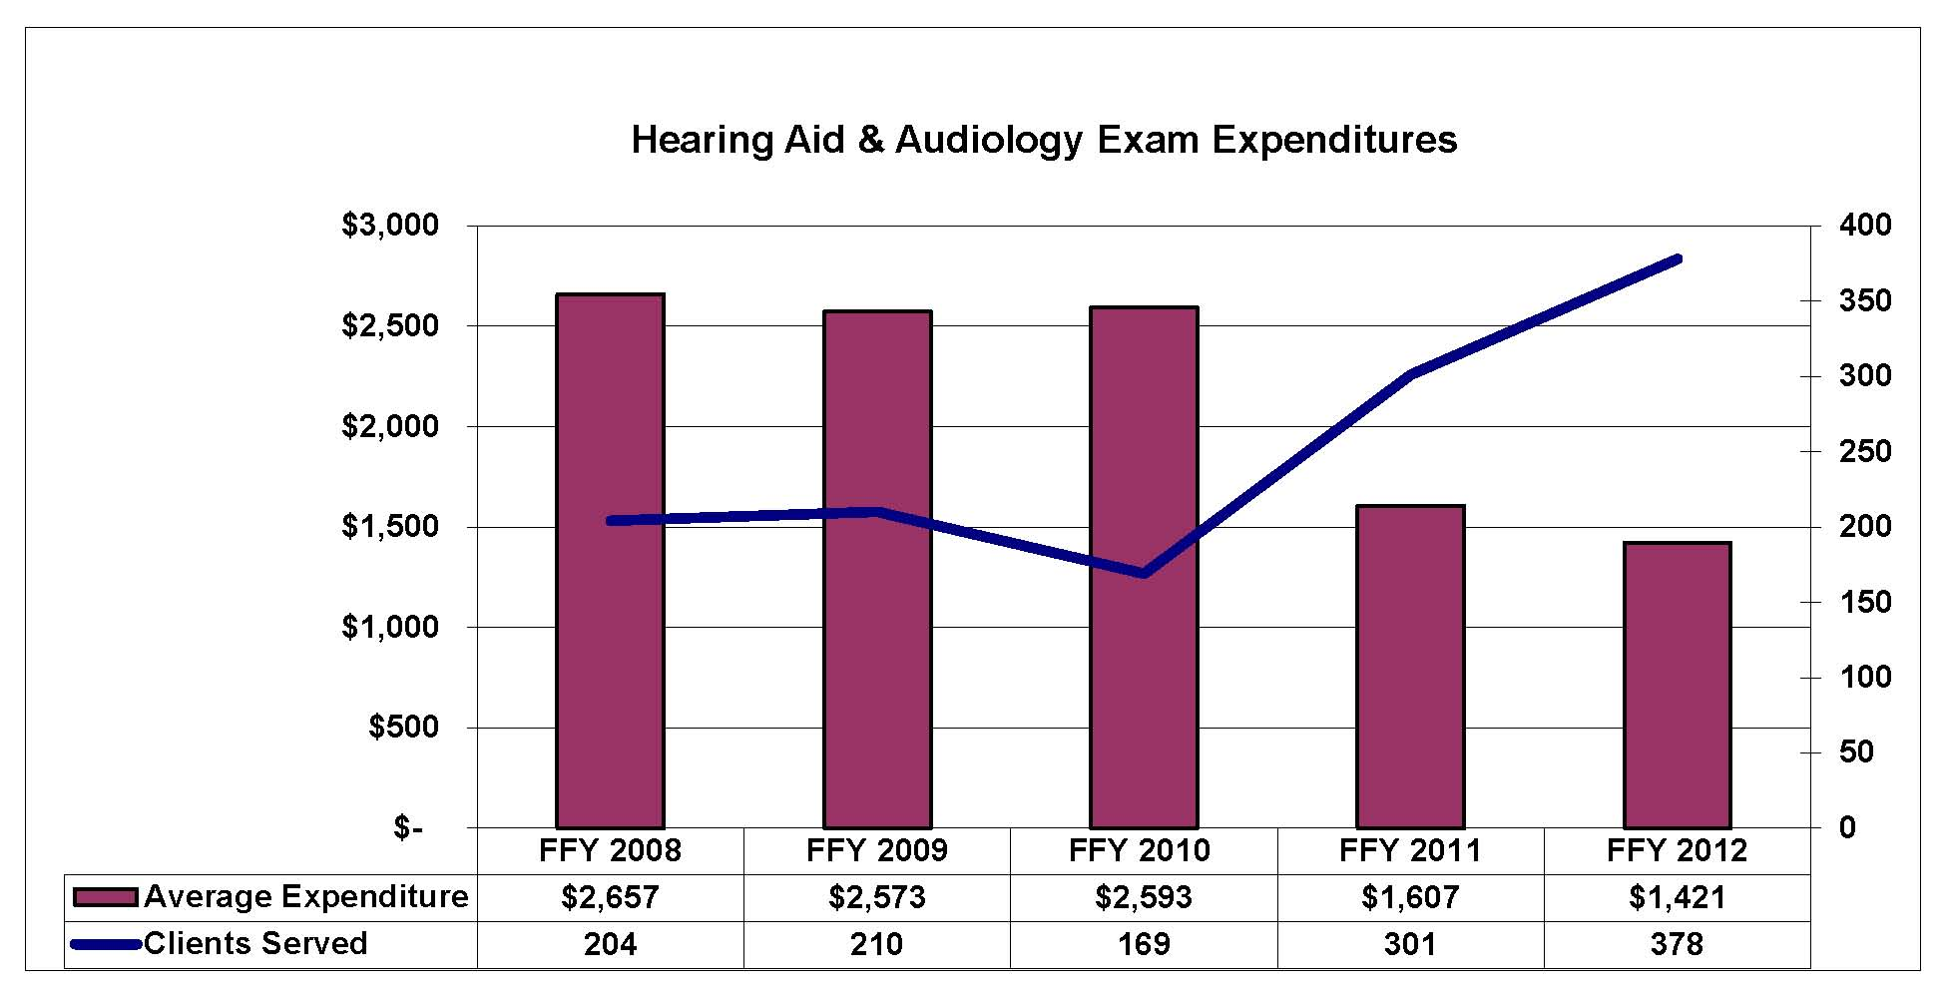
Maine DVR is documenting significant savings as a result of our purchasing agreement developed in conjunction with the State of Minnesota and the State of Maine Purchases Division. Since implementation of changes in hearing aid purchase protocol, DVR has been able to nearly double the number of clients fitted with hearing aids while keeping costs virtually unchanged. DVR staff have presented this new protocol at two national conferences as a successful cost saving measure for other Vocational Rehabilitation agencies to consider.

Adult Career Exploration Workshop (CEW) is a five-day class where individuals explore areas of interest while uncovering skills and talents leading to a specific job goal. When individuals participate in a CEW, they go through the VR program more quickly, resulting in less overall spending on their programs.

The Transition Career Exploration Workshop (TCEW) features a curriculum designed to help students discover employment possibilities in an interactive team environment. It can be delivered in modules, making it flexible for schools, adult ed, community organizations or other settings and provides instruction on topics including disability disclosure and requesting accommodations. It also provides numerous assessments.

“Bridges – Pathway to Employment” Career Exploration Workshop
The curriculum, developed from the Adult CEW and the TCEW, is designed for individuals with intellectual disabilities to help them learn more about their vocational interests and abilities as well as the world of work in preparation for successful employment. BRS developed the curriculum in collaboration with DHHS, DOE, self-advocates and CRPs.

DVR Builds on Partnership with Department of Education. DVR staff continues to engage with the DOE’s efforts to improve transition outcomes for students with disabilities. As a partner in DOE’s 5-year State Personnel Development Grant (SPDG), DVR has committed significant time and resources to the development of an effective system of personnel development for special educators and administrators. As a result, DVR’s Transition Career Exploration Workshop curriculum is being promoted by DOE as an important resource for schools to implement to improve transition planning.

DVR Signs Memorandum of Understanding with Workers’ Compensation Board. DVR has strengthened its services to injured Maine workers thanks to a recently signed MOU with the Workers’ Compensation Board. With approval from the Governor, three new time-limited Rehabilitation Counselor II positions have been added to pilot the initiative. The positions will be based in Augusta, Bangor and Lewiston and will serve Workers’ Compensation referrals across their regions.
DBVI –Initiatives & Innovations

Self-Serve Avanti Markets. Maine’s Business Enterprise Program (BEP) leads the nation in use of a new food service operation – the Avanti Market – an innovative convenience store concept. This system uses an unmanned, self-checkout kiosk designed specifically for use in secure work places and allows for a much larger product selection than customary vending machines. This micro-market allows BEP managers to increase yearly earnings and expand to 24-hour service at Avanti sites. There are currently five sites, located in Bangor, Calais, Portland and Augusta.

Summer Youth Employment Program. The “summer youth employment program” provides transition-age youth with “real world” work-experience while learning more about what they do and don’t enjoy in the world of work. This year was designed to offer students work experience at food service locations. They learned how to arrange for their own transportation to and from the work site; they received hands-on experience; they learned to identify supports that may be necessary for successful employment; and they learned how to utilize resources within their community.

Employability Skills Program. The Employability Skills Program (ESP) is a five-day immersion program utilizing peer mentoring and self-discovery exercises related to acquiring additional blindness-specific competencies to enhance one’s marketability of his/her specific job skills. The program was developed to assist persons who are blind and chronically unemployed or underemployed. Structured individual and group activities are presented that identify and address barriers to employment as well as resolve “discrepancies” between perceived ability and measured ability with respect to job skills, career goal setting, vocational exploration, job seeking skills training, practice interviewing and networking with other successfully employed individuals with vision impairment.

Ray successfully managed his automotive garage and discount battery store, BroadRay Batteries. However, the job became difficult due to his degenerative eye condition, retinitis pigmentosa. Ray contacted DBVI and received vision rehabilitation services, such as adaptive technology, vision rehabilitation therapy and a low vision evaluation. With these services, he was able to develop the necessary skills to use the low vision equipment and technology that enable him to maintain his business.

Division for the Blind and Visually Impaired (DBVI)
DBVI provides a continuum of rehabilitation services to individuals who are blind or have low vision. Services may include individual counseling and guidance related to employment and adjustment to blindness issues, use of adaptive technology, low vision therapy, alternative skill training in communication such as braille, instruction to develop independent travel skills (orientation and mobility) and instruction of daily living skills geared to being more self-sufficient. These services are provided through various programs including:

Vocational Rehabilitation Program: Primarily for working-age adults who seek employment. Services may include individual vocational counseling and guidance, vocational assessment, orientation and mobility instruction, low vision services, independent living services (vision rehabilitation) and more.
Business Enterprise Program: Provides training and support to manage and operate snack bars, cafeterias, and vending-machine facilities on state, federal and municipal properties.
Independent Living Services (IL): Provides training in adaptive skills and alternative techniques for accomplishing daily tasks that enable individuals who are older to be more self-sufficient.
Education Services for Children Who Are Blind or Visually Impaired: Provides for adaptive instruction services to students in home or local schools related to academics and independence.

In 2013, DBVI provided services to more than 608 people seeking employment through its VR Program. In addition, the DBVI IL program has assisted more than 475 individuals who are older and blind in learning the compensatory skills needed to remain independent in their homes and communities. DBVI also provided 262 children, who are blind or visually impaired, with specialized educational services that assist students to access their education curriculum and prepare for life (including employment) after graduation. Most of these educational services are direct instructional services and/or technical assistance within their school system as part of their Individual Education Program (IEP).
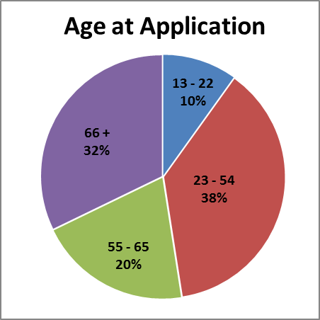
Individuals Served in 2013
158 New Applicants
313 Received Services through Employment Plans

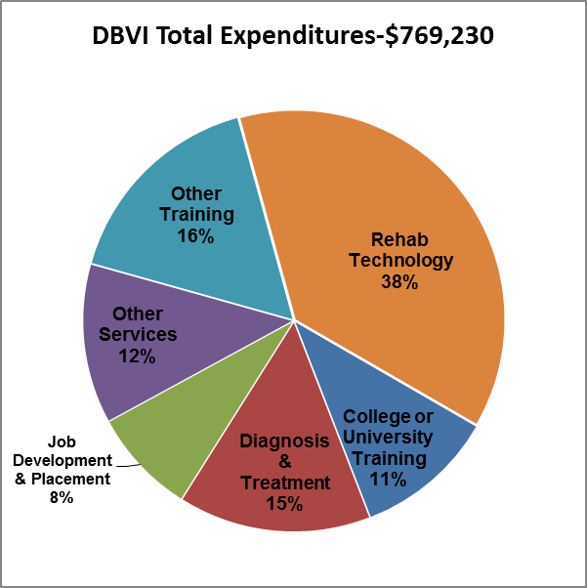
Business Relations Activities & Outcomes
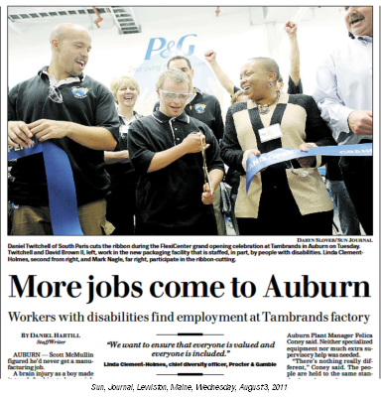
BRS, in collaboration with the Department of Health and Human Services’ Office of Aging and Developmental Services, the Office of Substance Abuse and Mental Health Services, and the Maine State Chamber of Commerce, has been working to engage the business community in the integration of people with disabilities in the workforce.

In April 2012, these agencies held a conference in Freeport for business leaders. Deb Russell of Walgreens was the keynote speaker. She inspired Maine businesses by sharing Walgreens’ “quest for inclusion” story. More detailed information can be found at:
http://www.walgreens.com/topic/sr/ disability_inclusion_home.jsp
The conference also marked the kick-off of the Maine Business Leadership Network (MEBLN), an affiliate of the United States Leadership Network (USBLN). The USBLN® is the national business-led disability organization that serves as the collective voice of more than 60 Business Leadership Network affiliates across North America, representing more than 5,000 employers. The MEBLN has already attracted several key business members to serve on its advisory board. These include Procter & Gamble, L.L. Bean, U.S. Cellular, and the Aroostook Center Mall. The MEBLN also has entered into a partnership with the Maine Society for Human Resources Management (SHRM) to promote the inclusion of people with disabilities in the workforce.

Through partnerships with Maine’s larger businesses, established by BRS, more than 30 individuals with disabilities have been employed in a variety of jobs.

A traffic accident left “Jill” unable to continue training in mortuary studies. She learned about VR services and worked with her counselor to develop an employment goal of becoming a CNA. After completing training, Jill was hired as a CNA. While it wasn’t the career path that Jill originally thought she would be following, she now says, “It was the best decision I could have made…I just love it.”

Office of the State Accessibility Coordinator
The Accessibility Coordinator leads the State’s compliance under the Americans with Disabilities Act (ADA) and Section 504. The office works with all state executive branch departments and the public to ensure that programs and services are not discriminatory with regard to disabilities. State accessibility policies cover facilities, contracted services, web design, telecommunications, and (under Human Resources) employment.

2011 – 2012 Training Programs
- Standards for Accessible Design for code-enforcement officers, architects, engineers
- ADA Title II for Department of Corrections staff
- ADA Amendments Act for CareerCenter staff
- Reasonable Accommodations for University of Maine at Farmington Rehabilitation students
- ADA Employment Rights for DBVI clients

Technical Assistance
Departmental staff consult the office on policies, program accessibility and barrier removal:
- Marine Resources licensing modifications for commercial fishing.
- County correctional compliance with State-mandated ADA requirements.
- Accommodations in testing for teacher’s certificate, in the unemployment appeals process for a Deaf appellant, and for notarizing human rights charges in alternative formats.

Resources and Information
The Accessibility Coordinator answers questions about disability rights, promotes community integration and develops affordable resources for families and businesses:
- With the mPower Adaptive Equipment Loan Board and DVR, reinstated vehicle loans for job seekers who have disabilities.
- With the Information Technology Accessibility Committee, which advises the state’s CIO about effective electronic communication and web design, produced the video: http://media.maine.gov/cgi-bin/media?id=6.
- With researched current best practices for upgrading the CareerCenters’ screen-reading software and for installation of videophones in state offices.

Complaints
Each department is required to have its own ADA coordinator and grievance procedure. The State Coordinator works with departments to resolve any complaints.

Eric Dibner, ADA Accessibility Coordinator
150 State House Station, Augusta, ME 04333
(207) 623-7950 voice, TTY users call Maine Relay 711
Email: Eric.Dibner@maine.gov

A young man with learning disabilities started working a few hours a week at a popular restaurant chain in the Augusta area. As his skills improved, he was offered a full-time position, and he was successfully closed with VR. His employer recently recognized him as the “Employee of the Month”!
Partners in Advocacy, Advisory Boards and Councils

Bruce Archer and Flash at the 2010
BRS Statewide Conference
The Client Assistance Program, operated by CARES Inc., provides information, advice, advocacy and, if determined necessary, legal representation to persons who have concerns about the rehabilitation services they receive from DVR and DBVI. www.caresinc.org

DVR State Rehabilitation Council (SRC): The mission of the SRC is to partner with DVR in developing state goals, priorities, policy and practice and to review and analyze the division’s results and performance in support of securing and maintaining employment, through a process of informed choice, for individuals with disabilities. http://www.mainesrc.org/home

DBVI State Rehabilitation Council: The mission of the SRC for DBVI is to provide leadership in partnership with the DBVI to develop and evaluate programs and services and to identify priorities that help create opportunities, increase independence and broaden access to the workplace for citizens of all ages who are blind or visually impaired.

The Commission for the Deaf, Hard of Hearing and Late Deafened: This Advisory Council provides a review of the status of services to deaf and hard-of-hearing persons, recommends priorities for development and coordination, evaluates the progress made as a result of recommendations, sets goals for activities of the division, and outlines steps to carry out its obligations and responsibilities to the deaf and hard-of-hearing communities. http://www.maine.gov/rehab/advisorycouncils/dod/index.shtml

State Independent Living Council (SILC): SILC promotes a philosophy of independent living (IL), which encompasses consumer control, peer support, self-help, self-determination and equal access as well as individual and system advocacy in order to maximize the leadership, empowerment, independence and productivity of individuals with significant disabilities. It also promotes and maximizes the integration and full inclusion of individuals with significant disabilities into the mainstream of American society. (Sec. 701 of the Act; 34 CFR 364.2). http://www.mainesilc.org/

Commission on Disability and Employment (a subcommittee of the State Workforce Investment Board): The commission fosters workforce development in Maine that includes meaningful employment and equal opportunity for people with disabilities and promotes collaboration to increase public awareness and influence public policy.

BRS Office Directory From any location, TTY users call Maine Relay 711

Augusta CareerCenter  21 Enterprise Dr., Ste. 2, 04333-0073  Tel: 207-624-5120 or 1-800-760-1573  Bangor CareerCenter  45 Oak Street, Ste. 1, 04401-6664  Tel: 207-561-4000 or 1-888-545-8811  Houlton ACAP  91 Military Street, Suite 3, 04730-2421  Tel: 207-532-5300 or 1-800-691-0033  Lewiston CareerCenter  5 Mollison Way, 04240-5805  Tel: 207-753-9000 or 1-800-741-2991  Machias CareerCenter  53 Prescott Drive, Suite 2, 04654-9751  Tel: 207-255-1926 or 1-800-770-7774 | Portland CareerCenter  185 Lancaster St., 04101-2453  Tel: 207-771-5627 or 1-877-594-5627  Presque IsleCareer Center  66 Spruce St., Suite 3, 04769-3222  Tel: 207-760-6300 or 1-800-635-0357  Rockland CareerCenter  91 Camden St., Ste. 202, 04841-0202  Tel: 207-596-2641 Or 1-877-421-7916  Skowhegan CareerCenter  98 North Avenue, Suite 20, 04976-1923  Tel: 207-474-4958 or 1-800-760-1572  Central Administrative Office  Bureau of Rehabilitation Services  150 State House Station, Augusta, ME 04333-0150  207-623-6799

