# **Changes to Maine State Government Email Encryption**

To: All those who have business with the Bureau of Rehabilitation Services, which includes the Division of Vocational Rehabilitation and the Division for the Blind and Visually-Impaired

From: Karen Fraser –Director, Bureau of Rehabilitation Services (BRS)

Betsy Hopkins – Director, Division of Vocational Rehabilitation (DVR)

Brenda Drummond – Director, Division for the Blind and Visually Impaired (DBVI)

Date: June 12, 2017

**Re: Change in State of Maine Email Encryption Process starting 6/14/2017**

***Beginning June 14th, the method in which email messages coming from Maine state government (including BRS, DVR and DBVI) are encrypted is changing. Please see instructions below regarding how to view these messages.***

## **Opening an Encrypted Message**

Here are basic instructions for opening a Microsoft Office 365 Encrypted Email:

•         The MS Office 365 encrypted email will include an attachment, ‘message.html’, that needs to be downloaded and then opened by the recipient.

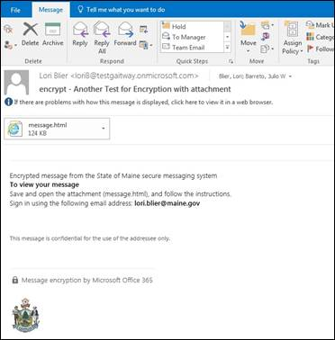

•         Once the attachment is opened, the recipient will have two options to sign-in to Microsoft and view the email:

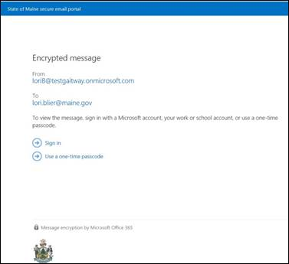

o   Option 1: Sign in with a Microsoft Account (Windows Live, Hotmail, Outlook.com, etc.) – If the recipient does not already have a Microsoft Account, they can set one up in a few easy steps.

**Important Note:** The recipient’s email address will become the username for their Microsoft account and the password will be specific to their Microsoft account. This will not change the recipient’s existing email password and will need a one-time setup.

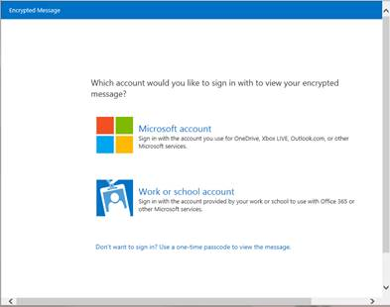

o   Option 2: Use a single-use passcode – Upon selecting this option, the recipient will receive an additional email with the passcode that will need to be used for login.

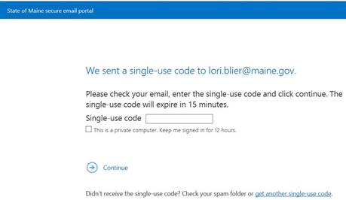

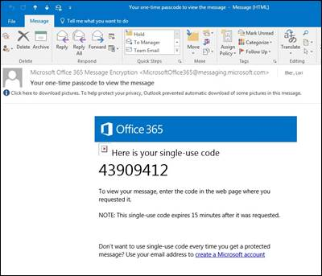

Once the recipient has logged in, they will be able to view the email, open any attachments, and reply if needed.

