Values Card Game

“Life is What You Do While You’re Making Other Plans.”
John Lennon, The Beatles

Don’t wait for things to happen to you. Make them happen for you. Find out about yourself. What are the things that you like to do? What are the things you do well? And how can they fit together? This section includes a few activities that might help you answer some of these questions.


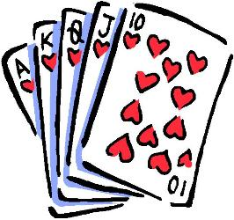

ACTIVITY

CARD GAME
What is of value to you in a job situation?

You can play this game with 2 or more people. One person can read the directions step by step; the other person can be the player. The game will help you (the player) find out what things are important to you in a job and in your life.

Cut apart the 14 cards on the following pages. There is a card for each of the words listed below.

Service – To contribute to making the world a better place
Location – To live where I want to live
Loyalty – To be loyal to the company and my boss and to have their loyalty in return
Security – To have a secure and stable position
Prestige – To be seen as being successful, as having stature
Expertise – To be recognized as an authority in what I do
Power – To have influence over others
Health – To maintain physical fitness and enjoy normal good health
Enjoyment – To like my work, to have fun in it
Family – To have ample time with my family
Wealth – To have a great deal of money
Achievement – To accomplish important things, to do work that is personally challenging, that helps me grow.
Friendship – To work with people I like and to be liked by them
Independence – To have freedom of thought and action

Values Card Game Directions

Game Directions
What is of value to you in a job situation?

- Cut apart the 14 cards
- Lay out the cards and read them over carefully. Think about each quality as it applies to you.
- Which of the 14 qualities are most important to you? Choose your ten most important and write the words here

- Pretend you have been offered a job. Are these the ten qualities you would like to have in a new job?
______________________________________________________________
- Un-oh. You’re going to have to give up one of your ten qualities. Which one will you sacrifice? Why?
______________________________________________________________
- Now two more qualities have to go. Think about your decision carefully. What reasons did you have for making the choices you did?
______________________________________________________________
- GOOD NEWS? You can take one of the old qualities back. Which one will you take back?
______________________________________________________________
- Suppose you could have only one quality? Which would you choose? Why?
______________________________________________________________

Have you ever had a job that didn’t include enough of these qualities? How did you feel about it?
_________________________________________________________________
Take a few minutes to think about what decisions you just made. Why would you like to have the qualities you finally chose? Are these the things in life and in a job that really matter to you?

__________________________________________________________________
How do you think this information will help you? ___________________________________________________________________

Values Card Game Vocabulary

  Service | Location
To contribute to making the world a better place | To live where I want to live
Loyalty |   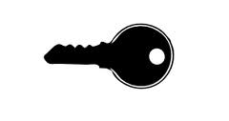  Security
To be loyal to the company and my boss and to have their loyalty in return | To have a secure and stable position
  Prestige |   Expertise
To be seen as being successful, as having stature | To be recognized as an authority in what I do
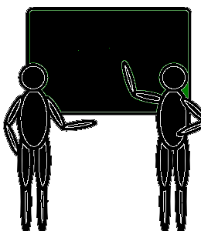  Power |   Health
To have influence over others | To maintain physical fitness and enjoy normal good health

  Enjoyment | 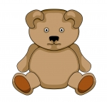  Family
To like my work, to have fun at it   | To have ample time with my family
Wealth | Achievement
To have a great deal of money | To accomplish important things, to do work that is personally challenging, that helps me grow
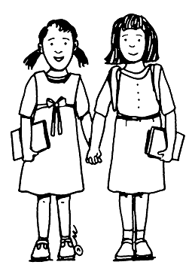  Friendship |   Independence
To work with people I like and to be liked by them | To have freedom of thought and action

