People You Know
Job Network

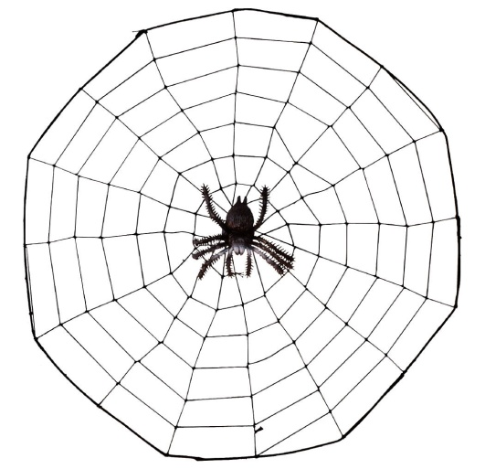
- Think of it like the rings of a spider web and you’re in the middle……..
- People, such as…..
  - Family/relatives/neighbors
  - Friends
  - Teachers/guidance counselor
  - VR Counselor
  - People in your community, clubs, church, etc.
  - Your support people

