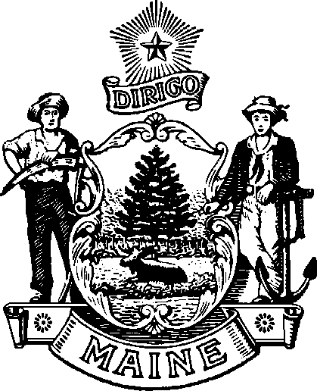
maine Boar d of Op tome tr y
113 ST ATE HO U SE S TATI ON A U G US TA , M AINE
04333 - 0035

Janet T. Mills James Patrick Smith, OD, MS
GOVERNOR BOARD PRESIDENT

Board Meeting
Friday, February 6, 2026
At 9:00 A.M. in the Central Conference Room
Department of Professional and Occupational Regulation
76 Northern Ave. Gardiner, ME 04345
Tel: (207) 624-8691
Or you may attend the meeting by Zoom
You can log in to the zoom meeting by going to the board’s website:

AGENDA

CALL TO ORDER

OLD BUSINESS
- Action on Minutes of January 30, 2026, Meeting
- Photobiomodulation MOA

NEW BUSINESS
- LD 1803 Work Sessions
- Discuss New Hire process
- Review Office Space information
- Sponsorship for NBEO examination

COMPLAINTS
- 2025-OPT-20897

OTHER BUSINESS

PUBLIC COMMENTS

PRESIDENT’S REPORT

SECRETARY’S REPORT

VIII. ADJOURN

