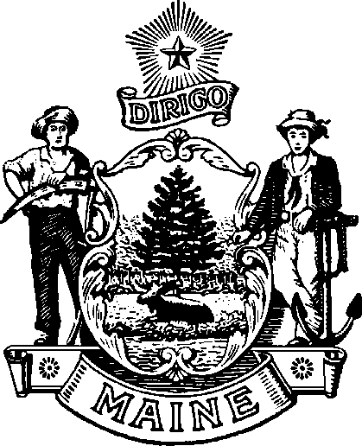
maine Boar d of Op tome tr y
113 ST ATE HO U SE S TATI ON A U G US TA , M AINE
04333 - 0035

Janet T. Mills James Patrick Smith, OD, MS
GOVERNOR BOARD PRESIDENT

Board Meeting
Friday , January 30, 2026
At 1:00 P.M. in the Kennebec Conference Room
Department of Professional and Occupational Regulation
76 Northern Ave. Gardiner, ME 04345
Tel: (207) 624-8691
Or you may attend the meeting by Zoom
You can log in to the zoom meeting by going to the board’s website:

AGENDA

CALL TO ORDER

OLD BUSINESS
- Action on Minutes of December 3, 2025, Meeting

NEW BUSINESS

- LD 1803 Work Sessions
- Review comments on proposal for fee change.

OTHER BUSINESS/PUBLIC COMMENTS

PRESIDENT’S REPORT

SECRETARY’S REPORT

VIII. ADJOURN

