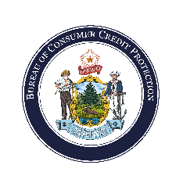**Collection Agency Activity Report**

Maine Bureau of Consumer Credit Protection

Company Name:

NMLS ID:

Activity Report:

Start Date: 01/01/

Through: 09/30/

This form is to report annual consumer collection activity in Maine. Commercial collections should not be included as part of this report. The figures represent the gross amount of funds collected from Maine residents only, for a 12-month period ending December 31 of each year, as well as the most recent quarter end prior to this renewal application. The amount outstanding at year end should represent the amount of funds the company is attempting to collect in Maine for the date specified. The number of accounts must represent how many separate debtor accounts comprise the outstanding amount for the same period specified.

|  |  |  |
| --- | --- | --- |
| Maine Collection Agency Activity | 12/31/ | 09/30/ |
| 1. Gross funds collected from Maine consumers for the period end: | Click or tap here to enter text. | Click or tap here to enter text. |
| 1. Dollar amount of funds outstanding the business is attempting to collect from Maine consumers as of the period end: | Click or tap here to enter text. | Click or tap here to enter text. |
| 1. Number of Maine consumer accounts outstanding as of period end: | Click or tap here to enter text. | Click or tap here to enter text. |