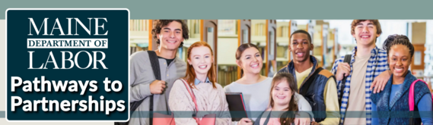

P2P NEWS
Spring 2026 Edition
Grant Year 3

The Maine Pathways to Partnerships (P2P) Grant is offering a special Pilot Summer Professional Development Series! Educators from partner schools that complete the training and requirements will receive a stipend! Click here to register.
Check out our Maine Fireside Pathways to Partnerships Interview published on the National Clearinghouse of Rehabilitation Training Materials (NCRTM) in April 2026.

SERVICE SPOTLIGHT

Independent Living: Alpha One and students at both Troy Howard Middle School and Belfast Area High School are continuing to work together to learn independent living skills such as housekeeping, hygiene, and food preparation. Students also worked on career soft skills, self-advocacy, conflict resolution, and employment readiness activities with Pathful and Ed Kits.
As the students are wrapping up their school year, teachers from Belfast have been pleased with P2P results:
I’m truly so happy with how fully involved the students are and how well they’re working together…I love seeing all the positives they continue to share each day and how they’re taking on challenges while feeling supported. Thank you both so much for creating a space where students feel safe being vulnerable, trying new things, and learning so many amazing skills.

 |  | PARTNER SPOTLIGHT  P2P Partner of the Month -  Dylan Campbell of Maine Parent Federation

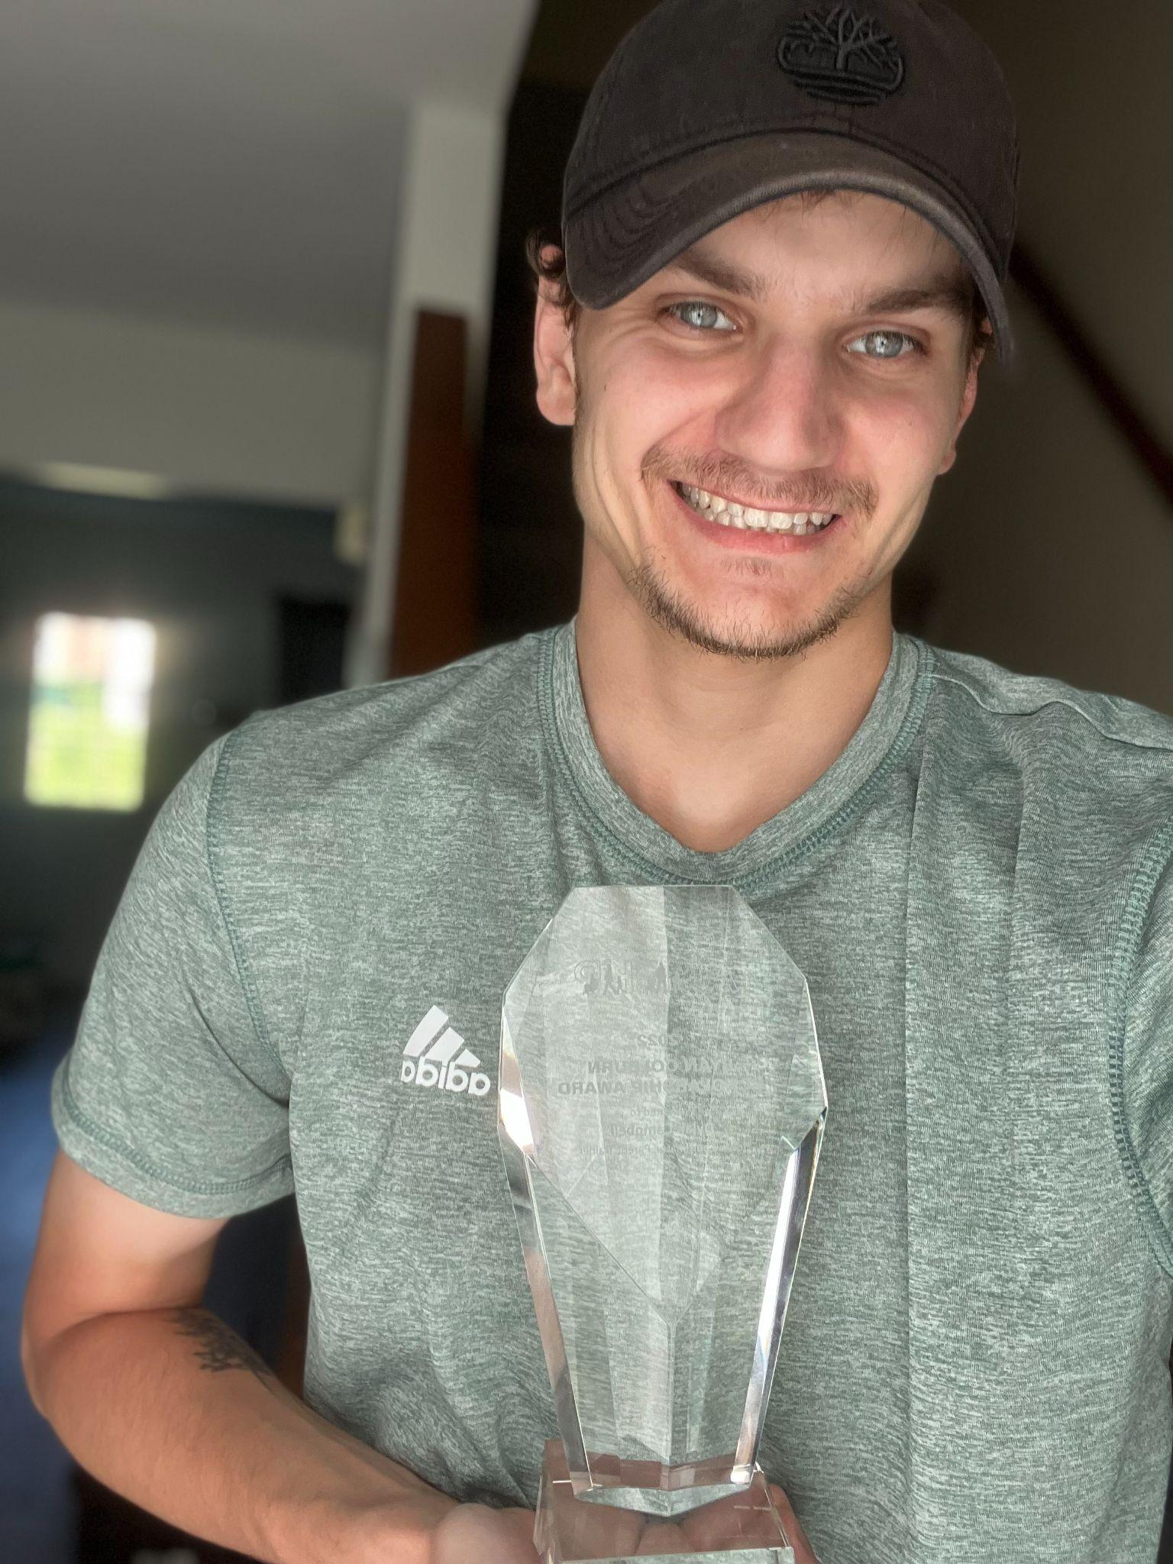
Like many nonprofit staff, I have many roles, but the majority of my work is in Youth Program and Training Management. I began working with Maine Parent Federation in 2017 as an independent contractor, initially introducing self-advocacy in districts and group settings. Today, my team works directly with youth and families through our network, schools and community organizations, developing and leading webinars and trainings across a variety of topics, with a personal focus on transition planning to adulthood. I also manage virtual youth opportunities and partner with community organizations and state agencies. One of my favorite aspects of my role is sharing opportunities, helping others get connected, affirming that their voice matters, and providing platforms for leadership. My family utilized MPF services nearly 16 years ago, which continue to deeply inform my work. My personal goals align closely with the broader mission of Maine Parent Federation, which supports families across the state in a variety of ways.

Maine Parent Federation is our state’s Parent Training and Information Center, and through our various grants and program offerings, we strive to be a one-stop shop for resources, training, and referral in Maine. From birth to adulthood, our team works with families to help them understand their rights and responsibilities, put their families first, and learn best practices to become strong advocates.
Our youth programming extends this same vision through solution-focused skill building. We support students in developing self-advocacy skills, understanding their role in their transition plans, and authentically leading their futures. Through in-person workshops and activities, as well as virtual support groups and networking sessions, we aim to meaningfully connect families, youth, professionals, and educators. I may be biased, but the work of Maine Parent Federation is truly invaluable.

As someone involved in many Maine communities, participating in P2P is personally important. While I value the work and collaboration, what truly drives me is my lived experience navigating the transition to adulthood with my siblings. I am also realistic about the barriers in Maine, including isolated communities, transportation, funding, and in many cases, a lack of awareness about what supports are available for young people. I see the vision of P2P and know what is possible when partners align their goals and build relationships with one another. We each carry a different piece and play a different role in reaching the same outcome.

My involvement in P2P reflects the last nine years of my work with our Parent Center, existing between projects and acting as a link and connector. It is not about reinventing the wheel. It is about being efficient with resources, combining efforts, and streamlining systems for districts, professionals, and most importantly, for families. How can we use each other? How can we use technology? What are our strengths as partners and state leaders?

Building on the experiences above, the most exciting part of P2P is thinking about the possibilities for where we can go. One of the most powerful takeaways from the P2P team has been the focus on creating a sustainable platform that lives-on beyond P2P, a transition hub. How can we use cutting-edge technology to launch Maine as a successful model, putting families and students at the forefront? Imagine a parent-facing portal where families can manage a child’s IEP, connect with Vocational Rehabilitation, and access opportunities, or a student-facing portal that conducts transition assessments through games and activities. What if this were an app that allowed people to manage, plan for, and access the information they need to advocate for themselves? What if we examined current systems of care, identified barriers, and built a system that truly functions as assistive technology?

Prior to P2P, collaboration and partnerships certainly existed. Many partners and agencies shared a grassroots vision to bring together a diverse group that represents families. P2P helped formalize that work and provide structure. Instead of collaboration existing in silos or as one-off projects, P2P brought momentum and sustainability. These opportunities are already translating into real impact, and the success stories are being created every day. Many of our partners would agree that when we meet with potential districts to introduce our services, outline who is involved, explain what can be provided, and show how flexible the model can be, there is often surprise. Remarks like, “Is this free?” or a general amazement at how few barriers exist, are common. P2P truly offers a “menu of services,” where districts can “order an appetizer or the whole meal.” Many districts are surprised to learn that a project like P2P has been developing and is already available to support them.

Another measure of success is the scope of where P2P is already working. From the start, rural and underserved communities have been a focus, as these areas are often overlooked. The differences in regions of Maine and the unique populations in each of our partnering districts reinforce the need for this work. From Houlton and Belfast, to Millinocket, Jackman, Sanford, South Portland, and Berwick-as more people hear about P2P, excitement grows, and districts are asking, “What can we do to get P2P services implemented here?” The areas being served are wide, but our team’s passion to serve is even greater. A key factor in our continued success will be districts understanding that the P2P model is flexible. It is not one-size-fits-all; it is about adapting to the needs of each district and the individuals they serve.

 |  | DID YOU KNOW...

The National Technical Assistance Center on Transition: the Collaborative (NTACT:C)’s website has lots of helpful information about the Predictors of Post-School Success. Want to learn more about what works? Go to https://transitionta.org/effective-practices/all-predictors/

 |  | UPCOMING EVENTS

Upcoming events:
- Maine Parent Federation Ask Us Anything, Last Tuesdays (except July and August) - May 26th and June 30th @ Noontime.
- Alpha One at Belfast Area High School and Troy Howard Middle School 5/26
- Alpha One at Belfast Area High School and Troy Howard Middle School 6/2
- Disability Rights Maine at Sanford High School 6/3
- Maine Parent Federation at Sanford High School 6/8
- Maine Parent Federation Shared Living Services on June 10th at Noon
- In-Person Core and Technical Assistance (P2P Team) 6/9-6/10, Portland CareerCenter
- Disability Pride Day in Augusta, 7/17

The contents of this newsletter were developed under grant H421E230028 from the U.S. Department of Education (Department). The Department does not mandate or prescribe practices, models, or other activities described or discussed in this document. The contents of this [insert type of publication] may contain examples of, adaptations of, and links to resources created and maintained by another public or private organization. The Department does not control or guarantee the accuracy, relevance, timeliness, or completeness of this outside information. The content of this [insert type of publication] does not necessarily represent the policy of the Department. This publication is not intended to represent the views or policy of or be an endorsement of any views expressed, or materials provided by any Federal agency (EDGAR 75.620).

