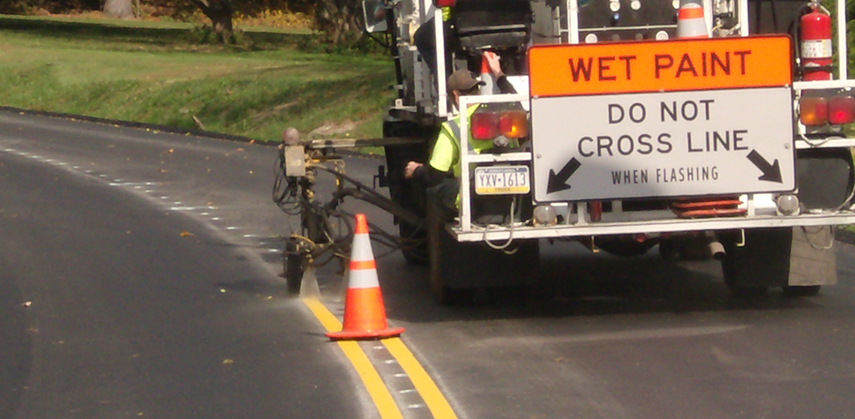

Risk Management Division does not compensate
for any damage that results from driving on wet paint.

Your first line of defense is to heed the warnings and follow instructions outlined on Maine DOT's painting vehicles.
Allow plenty of space between you and the painting vehicle.
The key to successful paint removal is taking swift action.

Motorists are urged to watch out for safety cones and other markers indicating wet paint.

When possible, motorists are encouraged to take alternative routes to avoid painting operations. Additional information regarding location of painting & construction sites can be found here www.newengland511.org

PROCEDURES FOR REMOVING PAINT
DO NOT SCRUB! This may damage the finish.
Apply with a wet rag or sponge

- As soon as possible after getting road striping paint on any vehicle, pressure wash the vehicle. This loosens and removes most paint unless it has dried for more than a day.
- If the pressure wash does not remove the paint, allow the water to dry, spray the residue with WD-40, let the WD-40 saturate the area for 1-2 hours, pressure wash again. The WD-40 usually softens the paint without hurting the vehicle’s finish. Repeat if necessary.
- For heavy accumulations, apply a generous coat of Vaseline to the affected area. Allow 8-12 hours of saturation. Once fully saturated, pressure wash again. Repeat if necessary.
- After paint removal, apply car wax. This should remove any lasting signs of paint.
- Paint removal from wheel wells can be difficult. Apply a generous coat of Vaseline to the area, leave it on for several days, pressure wash again.
- After Vaseline saturation, applying rubbing alcohol to the wheel well may also help soften and remove any remaining residue.

