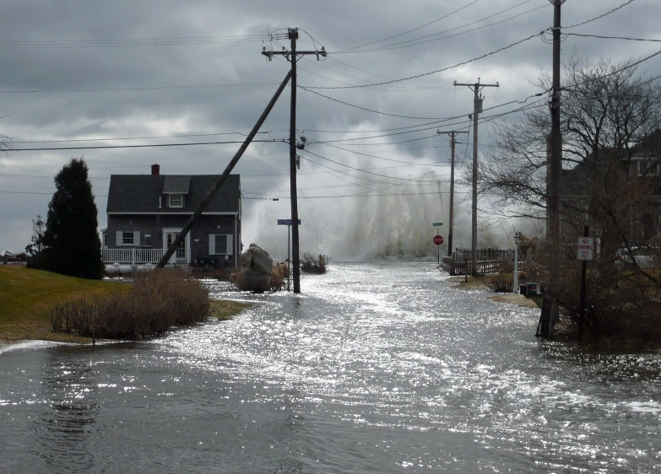

If your business is in a hurricane region, don’t wait for a hurricane warning to begin preparing. Actions to protect your business and reduce the effects of a disaster can require weeks - even months to plan and execute.
Here are some steps to include in your hurricane preparation plans that can help safeguard your employees and business.

Long-Term Preparation
Long-term planning can improve your property’s overall “hurricane resistance”:
- Inspect roof-mounted signs, communications towers, equipment, guy wires and supports. Verify they are anchored and in good repair.
- Establish a system to protect all windows and building openings (shutters, plywood, etc.).
- Repair or replace weak or damaged windows, door hinges and latches.
- Inspect roofs to insure there are no loose shingles, tears in the membrane covering on flat or low slope roofs. Ensure roof penetrations are sealed, check duct work to ensure no elements can enter the building.
- Assemble & safeguard generators or other means of emergency power. Test periodically.
- If you are in a flood zone, the following may help protect against water damage:
  - Protect low-lying building entrances/openings. Create levees or flood walls where possible. Plan where to place sandbags to divert water away from buildings.
  - Do not use basements to store critical assets.
  - Store water damageable materials and stock on pallets or in racks.
  - Install shut-off valves on sewer and other drainage lines to prevent reverse flow.
  - Provide flood protection for fire sprinkler pump houses.
- Establish an emergency response team and assemble necessary supplies & equipment at a central, secure location. Inspect these supplies each year before hurricane season. Supplies & equipment to have available include:
- Portable pumps & hoses, extra fuel | - Mops & Squeegees | - Emergency Lighting
- Sand & Sandbags | - Shovels & axes | - Tarps/plastic sheeting
- Lumber & nails | - Power & manual tools | - Building diagrams/schematics
- Ropes/fasteners
- Keep an inventory of outside equipment and materials that will need to be secured, including hazardous materials such as propane tanks, gas cylinders and flammable liquid drums.
- Move vehicles and mobile equipment to protect them from strong winds and water damage.
- Establish contracts for critical equipment and machinery restoration & building cleanup.

Short-Term Preparation: As a Hurricane Approaches
Short-term plans are most effective when developed well in advance. Monitor forecasts closely to know when to act.
- Confirm your employee contact lists are current.
- Secure all doors and shutter or board up windows to help protect them from flying debris.
- Clean out floor drains, catch basins, and roof drains. Check drainage pumps.
- Anchor & fill above-ground tanks to capacity with product or water.
- Fill emergency generators and fire pump fuel tanks.
- Verify fire protection equipment is operational.
- Duplicate important records secure them offsite.
- Safely shut down production and turn off power to non-critical equipment. Sump pumps & fire pumps should remain operational.
- Shut off all flammable liquid, combustible liquid and gas lines in case a pipe breaks during the storm.
- Evacuate.
Don’t forget to tie down sheds, small outbuildings or similar structures that may not be designed for high winds. Move items inside that could blow away. Benches, chairs, plants, signs, etc. could become flying debris during a storm.

Plan for Hurricane Recovery
Post-storm planning can ensure the right people and resources are there to assist in your business recovery. Identify key recovery employees.
The recovery team leader ensures the team has necessary supplies, replacement parts & equipment. He or She evaluates the damage and develops an action plan, addressing priorities including:
- Safety hazards: including downed power lines, exposed electrical wires and leaking gas.
- Structural damage to buildings or foundations.
- Impaired fire protection equipment & alarms.
- Critical production equipment & valuable stock required to restore production.
- Completion of temporary repairs for access to the building safely.
The recovery team includes qualified electricians, mechanics, plumbers, fire protection systems technicians, and general cleanup:
- Require strict precautionary measures for any cutting or welding, including a formal hot work permit system such as found in NFPA 51B, Standard for Fire Prevention During Welding, Cutting, and Other Hot Work.
- Eliminate unnecessary ignition sources and enforce “No Smoking” regulations.
- Establish a procedure for removing storm related debris.
- Temporarily repair any holes or damage to the building roof if safe to do so.
- Assess damaged contents to see what can be salvaged. Prioritize repair or replacement.
- Photograph and/or record a video of any damage.
- Assess and repair fire protection equipment, security alarms & sprinkler systems. Notify the fire department if any of those systems will be out of service.
- It is critical to be cautious during electrical restoration. Be sure an electrician has checked, thoroughly dried and tested all systems and equipment before energizing electrical circuits.
Wet insulation should be stripped and replaced. All mechanical equipment and systems should be checked for leaks and damage, and cleaned and dried, as needed. Check the water supply for contamination.
- Maintain adequate security by performing a continual fire watch until normal operations can resume.
- Provide employees with portable radios/cell phones, instruct them how to contact emergency response units.
- Provide updates to employees regarding unsafe conditions & salvage operations.

Resources
- Maine.gov/mema Maine Emergency Management Agency – Response & Recovery
- Ready.gov – Hurricanes
- NOAA – Hurricanes (Hurricane tracking, forecasts and alerts based on your zip code)
- Red Cross – Hurricane Preparedness

