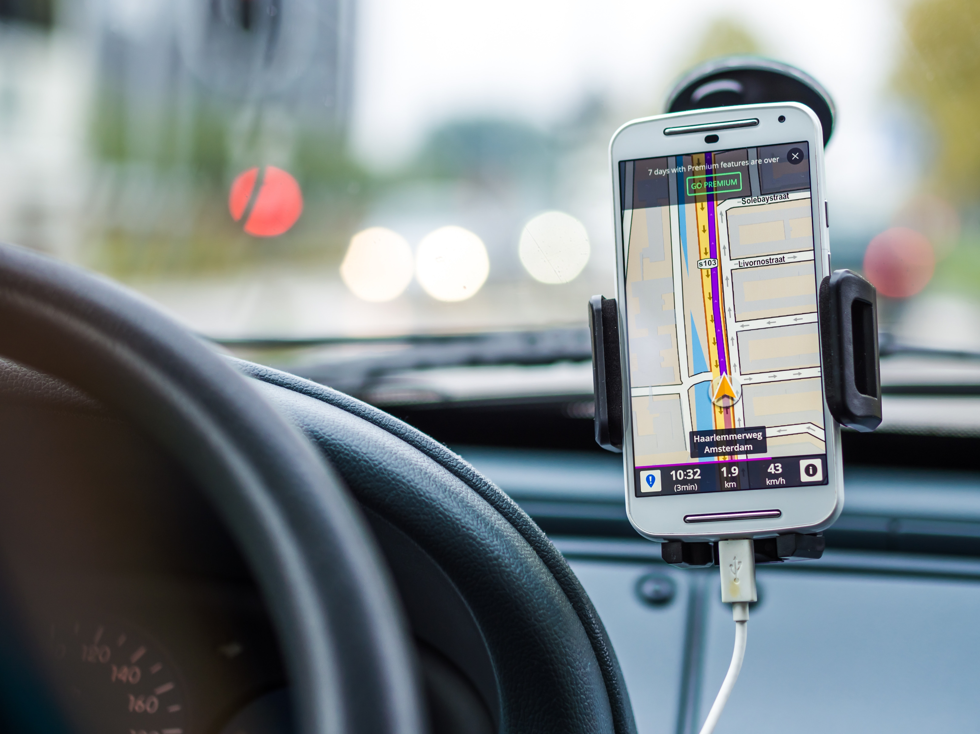
CELL PHONE SAFETY TIPS
It you must use a phone while driving, know your state’s Laws before getting behind the wheel. As of 2019, it is illegal to use a hand-held cell phone while driving in Maine.
A cell phone can be helpful, but only if you use it safely. Following a few simple safety measures can lessen the risk of injury or property damage.
- Familiarize yourself with your cell phone’s features.
- Set your phone to driving mode - this provides an auto-response that you are driving.
- Set the GPS & review the map before traveling. Let the device guide you so that your eyes can stay on the road.
- Keep it mounted. When in a crash, unsecured items can cause injuries. A secured phone is more likely to be within reach for that potentially life-saving call.
- If you are traveling with a passenger, allow them to operate the phone.
- If the call is urgent, pull off the road and park your vehicle in a safe place before utilizing your phone.
- In Case of Emergency (ICE) contacts: ICE in your phone’s contact list. This can be helpful to emergency personnel, but only works if your phone isn’t password protected.
Stopping senseless accidents is best accomplished by changing driver behavior.
Let’s be a part of the solution together. 