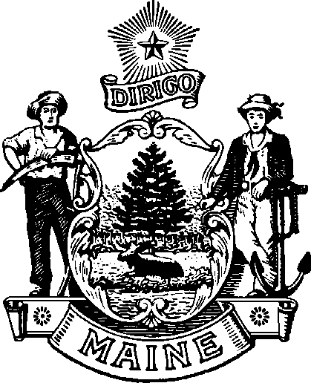
maine Boar d of Op tome tr y
113 ST ATE HO U SE S TATI ON A U G US TA , M AINE
04333 - 0035

Janet T. Mills James Patrick Smith, OD, MS
GOVERNOR BOARD PRESIDENT

Board Meeting
Friday, February 27, 2026
At 9:00 A.M. in the Kennebec Conference Room
Department of Professional and Occupational Regulation
76 Northern Ave. Gardiner, ME 04345
Tel: (207) 624-8691
Or you may attend the meeting by Zoom
You can log in to the zoom meeting by going following these links:

Join Zoom Meeting
https://mainestate.zoom.us/j/8473310550?pwd=VmNKQzZaS0dOY0VpUU45aHBjWExRZz09&omn=81224403747
Meeting ID: 847 331 0550
Passcode: q$3Q#CjE
---
One tap mobile
+13017158592,,8473310550# US (Washington DC)
+13052241968,,8473310550# US
Join instructions
https://mainestate.zoom.us/meetings/81224403747/invitations?signature=op_Ax8IQNiqJrXPR94KeuDAIayTq0QtAmUaTtnqPY_Q

AGENDA

CALL TO ORDER

OLD BUSINESS
- Action on Minutes of February 6, 2026, Meeting

NEW BUSINESS
- Discuss New Hire process and Budget (Rachel Hensbee and Philip Javier-Wong)

OTHER BUSINESS

PUBLIC COMMENTS

PRESIDENT’S REPORT

SECRETARY’S REPORT

VIII. ADJOURN

