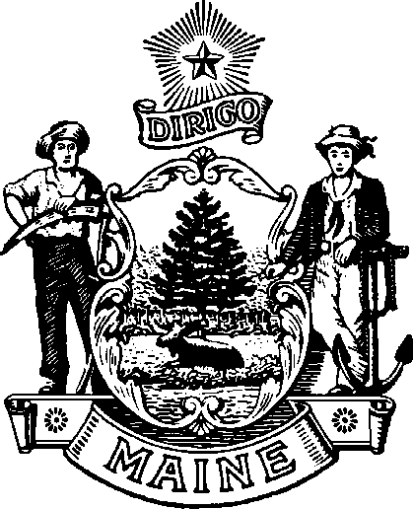
ma ine Bo ar d of Op tome tr y
113 ST ATE HO U SE S TATI ON A U G US TA , M AINE
04333 - 0035

Janet T. Mills James Patrick Smith, OD, MS
GOVERNOR BOARD PRESIDENT

Board Meeting October 3, 2025
At 8:00 a.m. in the Kennebec conference room Department of Professional and Occupational Regulation 76 Northern Ave. Gardiner ME 04345
Tel: (207) 624-8691
Or you may attend the meeting by Zoom
Visit the Boards website to log into the zoom meeting.

Join Zoom Meeting
https://mainestate.zoom.us/j/85038936069?pwd=PO4uRrlBgdWYscK64GDLLsS4x91Q15.1
Meeting ID: 850 3893 6069
Passcode: 58820832
---
One tap mobile
+13126266799,,85038936069# US (Chicago)
+16468769923,,85038936069# US (New York)

AGENDA

- CALL TO ORDER

- OLD BUSINESS

  - Action on Minutes of August 22, 2025, Meeting.
  - Update on website
  - Update on strategic plan

- NEW BUSINESS

  - Review of LD 1803 first Stakeholders meeting.

- OTHER BUSINESS AND PUBLIC COMMENTS

- PRESIDENT’S REPORT

- SECRETARY’S REPORT

- ADJOURN

