Account Coding Solution
for Nicus Application
(a.k.a M-PWR ME)

User Guide

Last Update: February 15, 2024

Contents
The Account Coding Solution (ACS) is used to: 3
Control Tab 4
Constant Data Tab 5
Maintenance Tab ..…………………………………………………………………………………………………………………………………6
Account Codes Tab 8
M-PWR ME Output Tab 10
Summary Template Tab ………………………………………………………………………………………………………………………11
Output Template Tab 12
Data Output Tab 13
SummaryWorksheet Tab ..……………………………………………………………………………………………………………………14
Validating the Account Codes Tab 15
Validating the Maintenance Tab ………………………………………………………………………………………………………….17
Process Billing Worksheet 19
Modifying Tracking Data 22
How to Filter All New Product Keys on the M-PWR ME Output Tab 24
Generating IETM Upload………………………………………………………………………………………………………………………26

The Account Coding Solution (ACS) is used to:

    - Find and assign the account coding for all billing lines
    - Split billing charges into 2 or more account codes
    - Maintain a list of active account codes for your agency
    - Maintain any optional data you would like to track and report with your billing (i.e. budget template, office, in budget or not, etc.)
    - Update/replace old product key(s) with new product key(s) for existing record(s) ~ new
    - Summary output for bill processing ~ new

ACS is an excel spreadsheet macro solution. The workbook is divided into seven tabs:
    - Control
    - Constant Data
    - Maintenance ~ new
    - Account Codes
    - M-PWR ME Output
    - Summary Template ~ new
    - Output Template

Control Tab

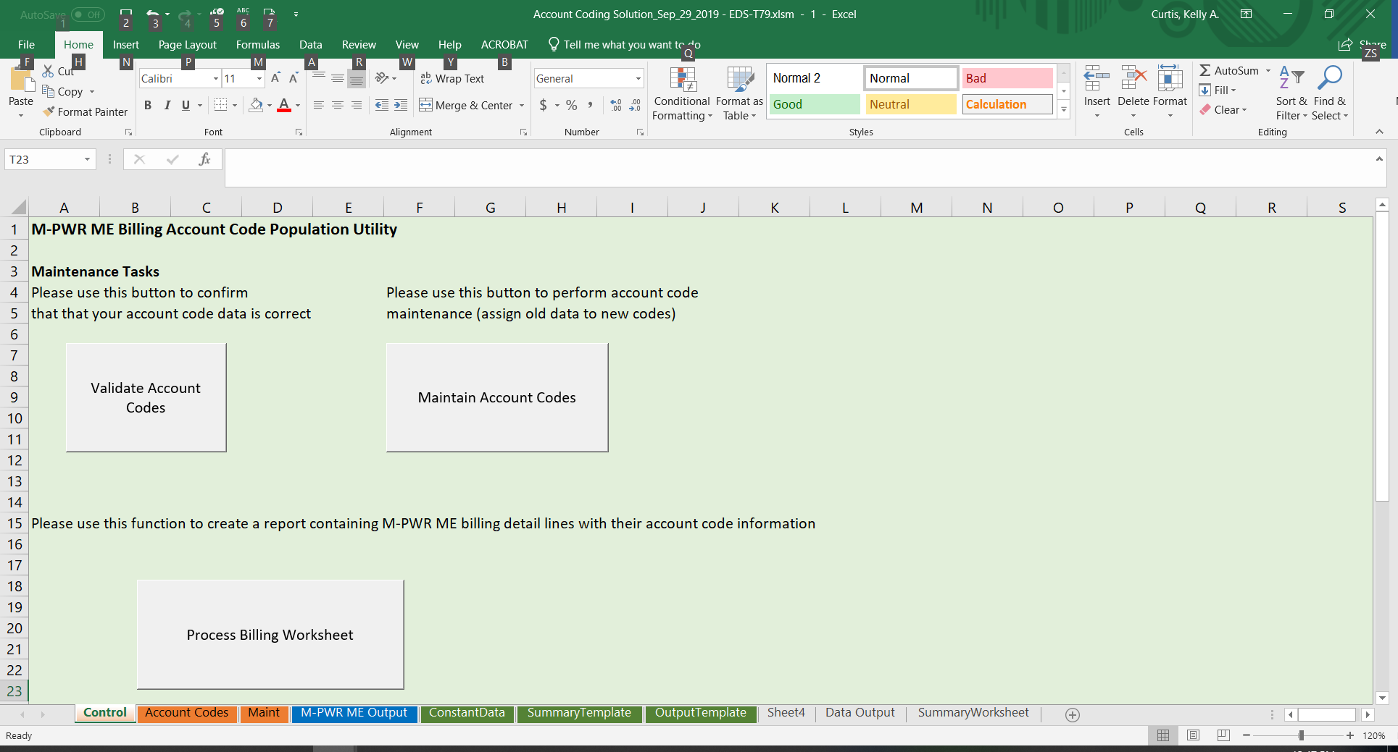

From this sheet you can:
    - Validate Account Codes – This macro validates the Account Code information on the Account Codes sheet to ensure information was entered correctly for the Process Billing Worksheet function.
    - Maintain Account Codes – This macro validates the Maintenance information on the Maintenance sheet to ensure information was entered correctly for the Account Codes sheet. ~ new
    - Process Billing Worksheet – This macro runs the Validate Account Codes macro to ensure that all lines billed have appropriate account coding assigned. If there are no errors, this macro appends the Account Code data and any additional tracking data to the end of the bill detail lines producing the Data Output tab(s).

See Account Codes Tab for more information on the above processes.

Constant Data Tab

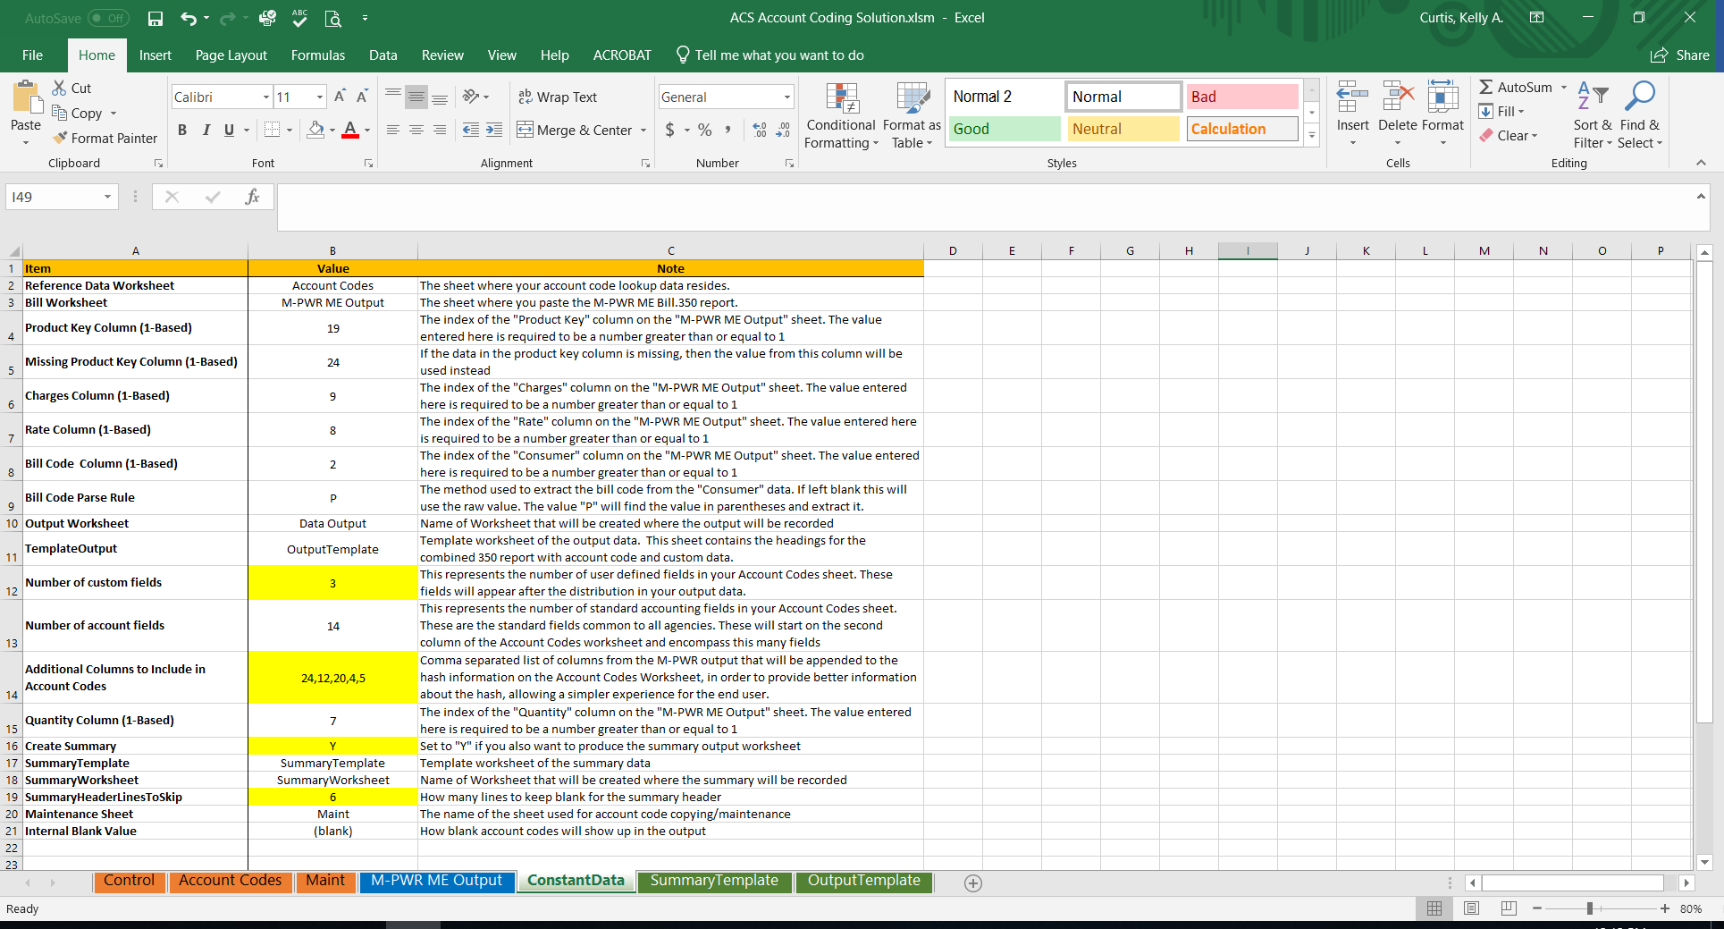

This is a control values worksheet. It contains information that the excel macros utilize to process correctly. These values should never be changed, unless you decide to track more or less data than provided on the Account Codes tab; you decide to bring in other identifiable data from the M-PWR ME Output tab; you decide you do not want to create a summary worksheet; and/or you decide you want more or less space on the summary output tab for labeling above the accounting data. ~ new

To track more or less data, please see Modifying Tracking Data.

Maintenance Tab ~ new

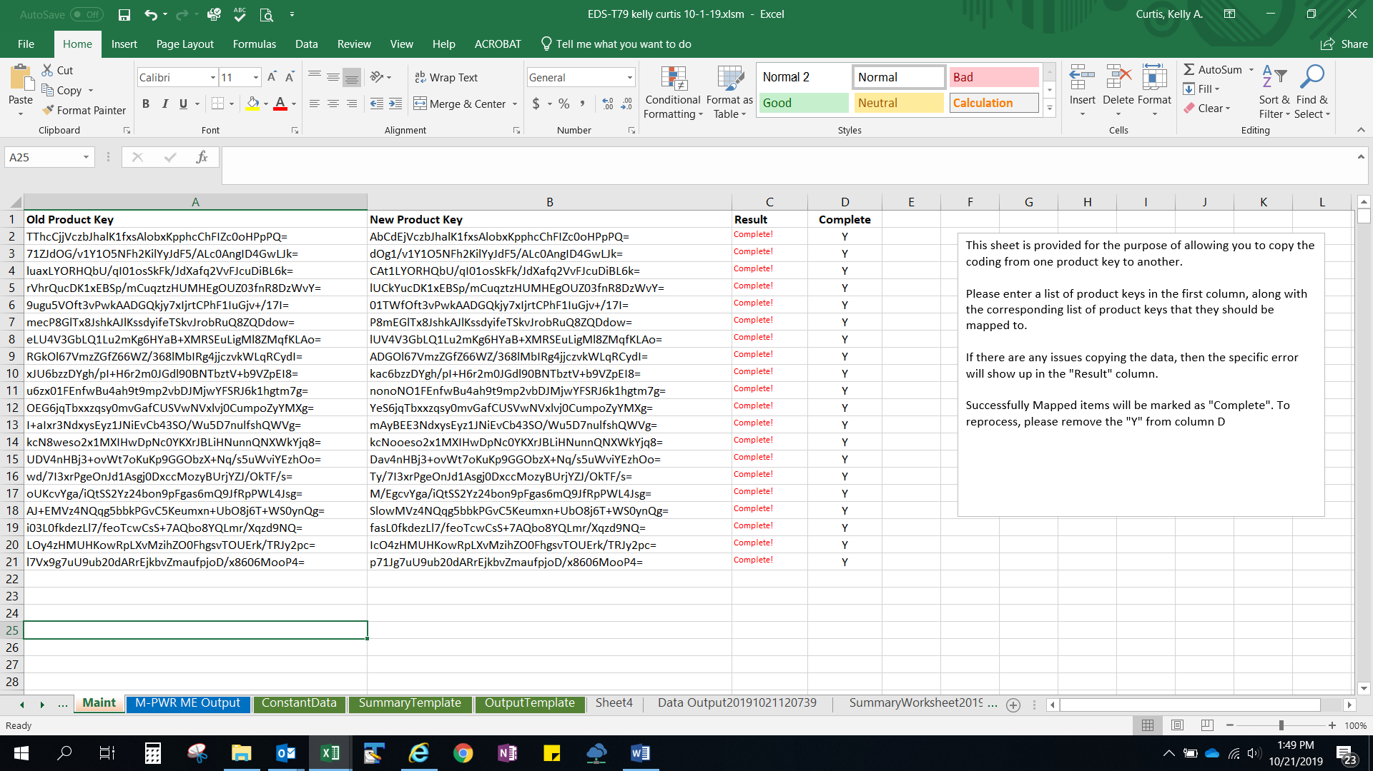

This sheet is provided for the purpose of allowing you to copy the coding from one product key to another for an existing record in the Account Codes tab.

You will need to enter a list of old product keys in column A and then the corresponding list of new product keys that they should be mapped to in column B for existing record(s).

Go to the Control tab and click the Maintain Account Codes button. Upon receiving the message ‘Account Coding Maintenance Successfully Completed’ OR ‘Account Coding Maintenance Had Errors, please review messages’, go to the Maintenance tab.

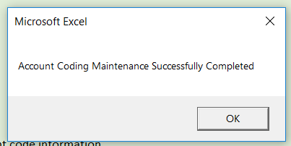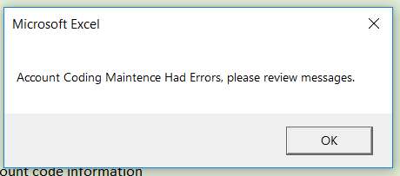

Note: If there are any issues copying the data, then the specific error will show up in the "Result" column. Successfully Mapped items will be marked as "Complete". To reprocess, please remove the "Y" from column D.

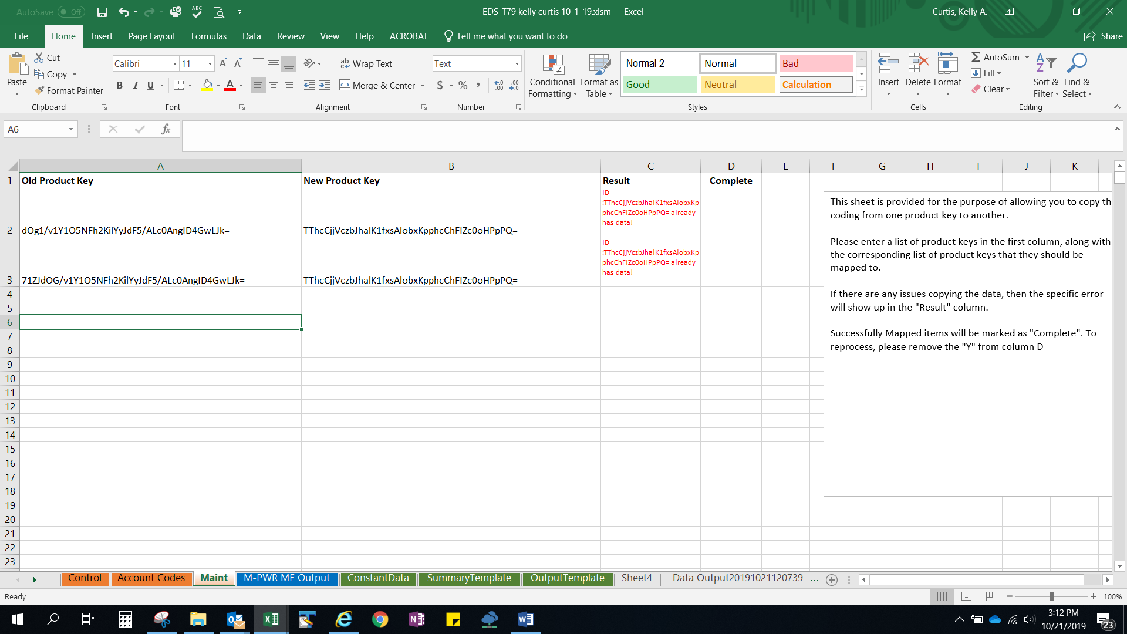

Once you receive the message ‘Account Coding Maintenance Successfully Completed’ on the Control tab upon clicking the Maintain Account Codes button, the new product key will override and replace the old product key in the Account Codes tab.

Account Codes Tab

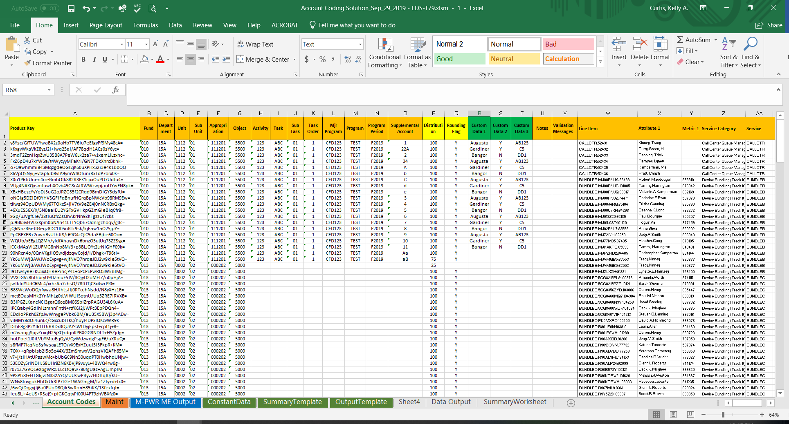

This sheet contains the account coding for the billing detail. The data on this sheet is:
Product Key - Each bill line/record from the M-PWR ME Output tab will contain a unique product key. The product key can be found in the attribute 5 column. The data must be pulled from Nicus via the Bill.350 report. Upon the report rendering on screen, you must open this report as on the Nicus Bill.350 report. This report is downloaded from Nicus by opening up as a CSV and is in input into the Account Coding Solution. See M-PWR ME Output Sheet for more information.

Your agency’s Advantage accounting fields, including but not limited to:
Fund – Department – Unit (formerly report org) - Sub Unit –Appropriation – Object – Activity – Task - Sub Task - Task Order – Major Program – Program – Program Period – Supplemental Account

Note: Since agencies and service centers do their accounting differently, none of the above Advantage account code fields are required. On the account codes tab, required data elements are denoted by their yellow background on their column header (product key, distribution and rounding flag are required).

Distribution – Specifies how to distribute/allocate the billed line amount into the account codes. If the amount is to be billed to just one account, specify 100 for the distribution value.
If the amount is to be billed to 2 or more accounts:
      - enter the percentage that is allocated to this account as a whole number (i.e. 10% equals 10),
      - ensuring that the total percentage for all accounts the billed amount is distributed to equals 100.

Rounding Flag – If the billing charge will not be split, set the rounding flag to be the single line of coding by entering a ‘X’. For billing charges that are split between multiple accounts, set the rounding flag for the one account you want to receive the rounded amount.

Custom Data 1, 2 and 3 – If you would like to track additional data than the data on the Account Code tab, here is where you can do this. These 3 custom data fields can be used to store numeric or alphanumeric data. You can also add additional columns or subtract these columns. To do that please see Modifying Tacking Data.

Notes – You can enter whatever notes you would like.

Validation Message – This is the column that will contain the error message if there are any errors in your Account Codes sheet.

Five columns of identifiable data for each unique product key: ~ new
This data is automatically pulled from the M-PWR ME Output tab. The line item (unique to each bill line/record). The attribute 1 column lists the names (such as end user, server, database), metric 1 lists the footprint ticket number (latest/most recent ticket), service category and service code.

Recommendations/Guidance:

After you update the Account Codes sheet, you should validate it. To do that, click on the Control Sheet tab and click on the ‘Validate Account Codes’ box. For further instructions, please see Validating the Account Codes tab.

Note: Because agency account coding varies, no Advantage account code fields are required.

M-PWR ME Output Tab

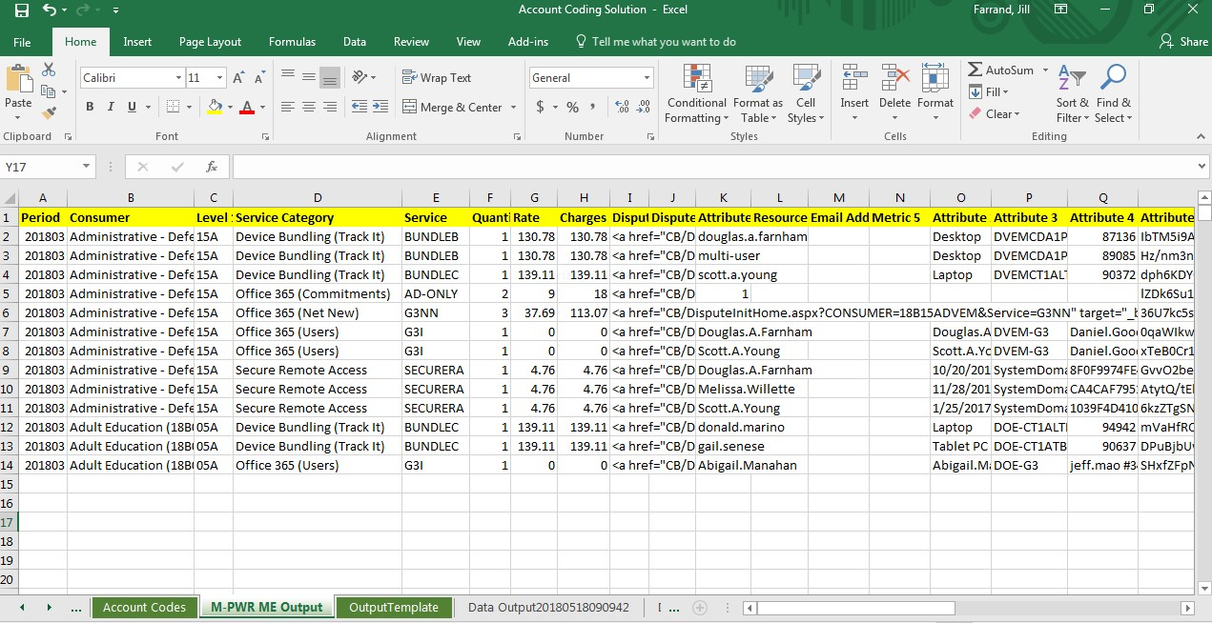
This tab contains the input file for ACS and the account coding process. The input file is the BILL.350 Billing Details by Consumer and Service Report that is exported into a CSV file from Nicus (a.k.a. M-PWR ME).
To load the Bill.350 data into the ACS spreadsheet tab labeled M-PWR ME Output:
    - View the Bill.350 report for the most current billing period within Nicus (a.k.a. M-PWR ME)
    - Click on the ‘Open in CSV’ option in the upper left-hand side of the screen
    - Save the CSV file
    - Open your latest ACS workbook
    - Go back to the CSV file you just saved that contains your Bill.350 data
    - Copy all data (excluding row 1 – column headers) from the Bill.350 report that opened and saved as a CSV to the ACS workbook on the tab labeled M-PWR ME Output (overlaying the existing data) in the ACS workbook.

Note: Product key values are located in the Attribute 5 column.
For most services:
    - Metric 1 column contains the footprints ticket associated with providing the service
    - Attribute 1 column contains the name of the person who received the service

Summary Template ~ new

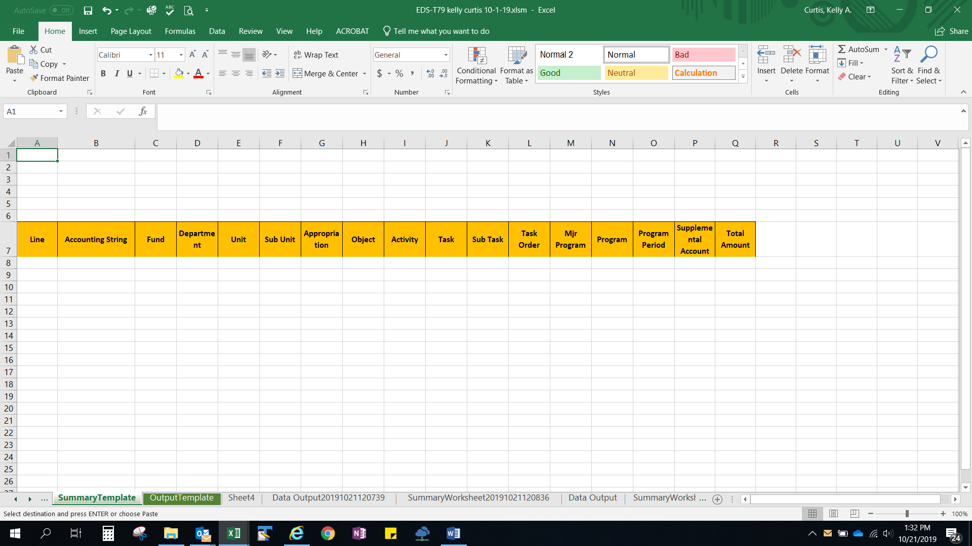

This tab lists the headings of the summary worksheet columns which will be displayed on the report generated to the SummaryWorksheet tab.

Output Template Tab

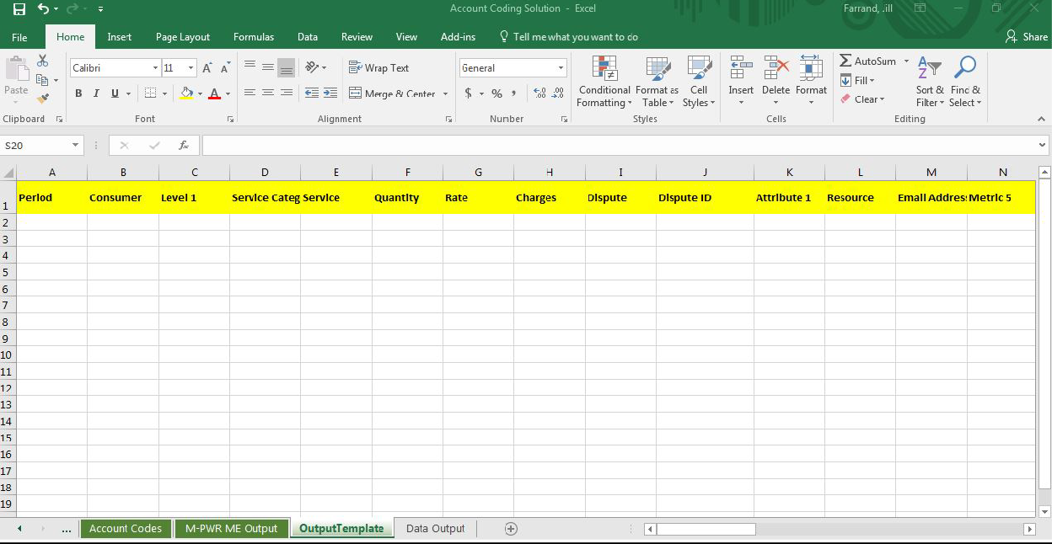

This tab lists the headings of the output columns which will be displayed on the report generated to the Data Output tab. If you are using the custom data fields, change their headings on this tab to a label that reflects your usage of the columns. Account code and custom data fields can be found by scrolling to the right.

Data Output Tab

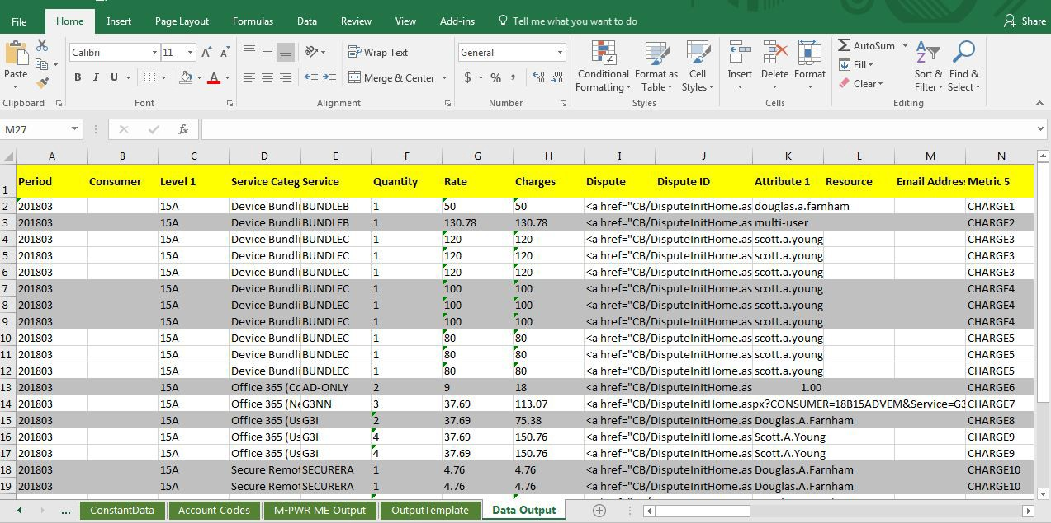

This tab shows your final report containing the data from Bill.350 report with account coding and custom data appended at the end of each row.

Once these Data Output reports are generated, they should be saved either as separate workbooks or as separate sheets within a workbook. The dispute column can only be utilized within Nicus (a.k.a. M-PWR ME); therefore, we recommend deleting this column from your copy of the final data output report.

Considerations:
A separate excel sheet is created each time you click on ‘Process Billing Worksheet’.

When you run the “Process Billing Worksheet” process, the macro process first copies the Data Output sheet to a new worksheet named Data OutputYYYYMMDDHHMMSS where YYYYMMDD equals the current date and HHMMSS equals the current time. It then copies the contents of the Output Template with the Account Codes information appended on the end of each line to the Data Output sheet.

We recommend you delete previously created Output sheets that you do not want to keep.

Summary Worksheet Tab ~ new

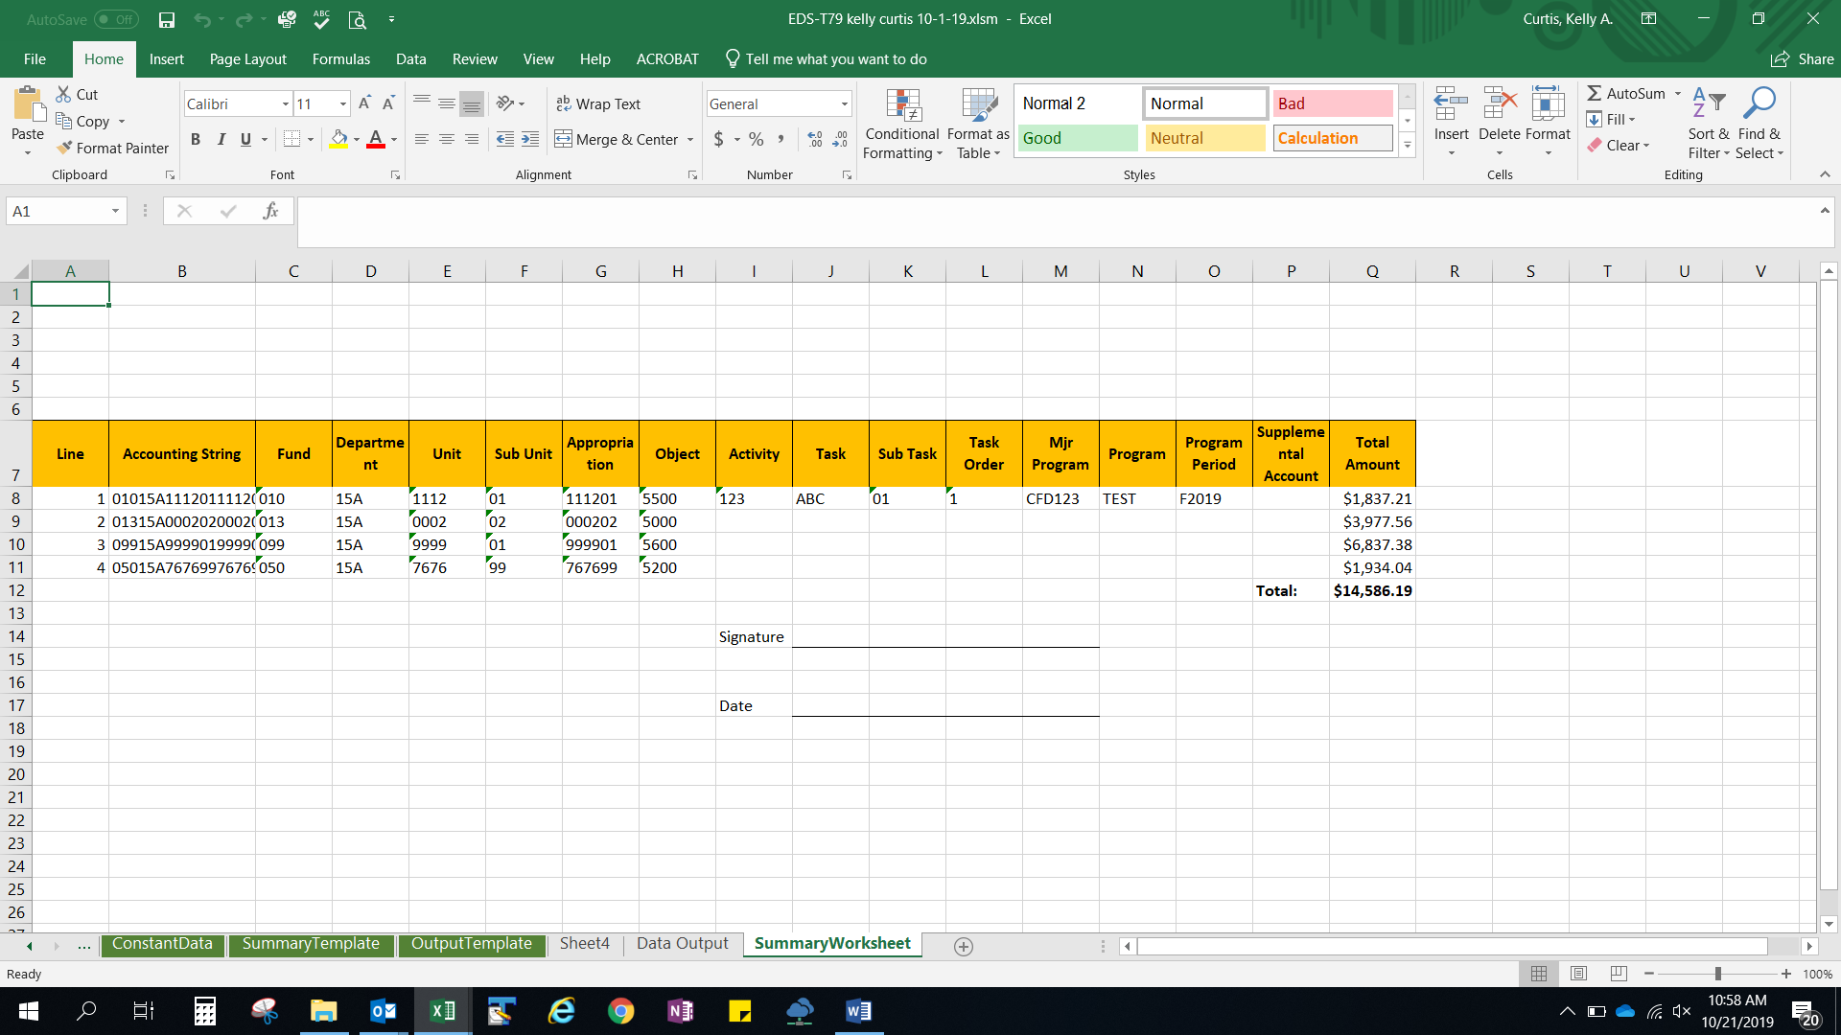

This tab shows your final report summarizing total amount due by account code(s). The information is pulled from the account codes tab and the data output tab.

Once these Summary Worksheet reports are generated, they should be saved either as separate workbook or as separate sheet within a workbook.

Considerations:
A separate excel sheet is created each time you click on ‘Process Billing Worksheet’.

When you run the “Process Billing Worksheet” process, the macro process first copies the Summary Worksheet sheet to a new worksheet named SummaryWorksheetYYYYMMDDHHMMSS where YYYYMMDD equals the current date and HHMMSS equals the current time. It then copies the contents of the Account Codes information with the information from the Data Output sheet.

We recommend you delete previously created SummaryWorksheet sheets that you do not want to keep.

Validating the Account Codes tab

After you update your Account Codes Worksheet, you should validate it. Go to the Control Tab and Click on the ‘Validate Account Code’ box.

If there are errors on the Account Codes sheet, the following error message will be displayed:
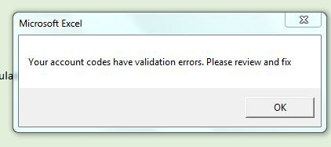

After you click the OK button on this error, click on the Account Codes tab to see what errors were generated. Error messages are listed in the “Validation Messages” column.

Validation Performed:

Ensures the total distribution for a product key adds up to 100. If total allocations sum to more or less than 100, the error message ‘M: Distribution does not add up to 100’ is generated for each row of the product key in error.

Ensures that one of the rounding flags is indicated for each product key. If the rounding flag has not been selected for a product key, or more than one rounding flag has been selected for the same product key, the error message ‘M: Product Key should have exactly one rounding flag’ is generated for each row of the product key in error.

An example of both errors follow.

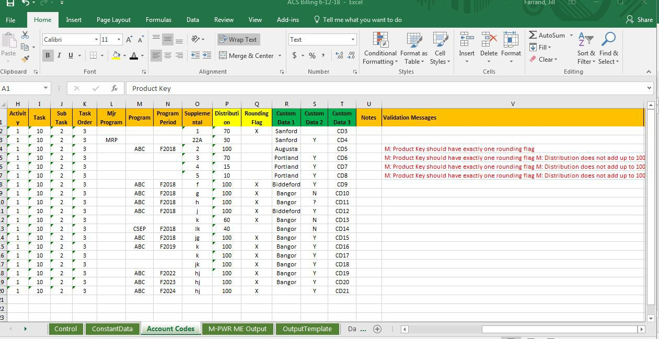

If there are no validation errors on the Account Codes sheet, you will get the following message:

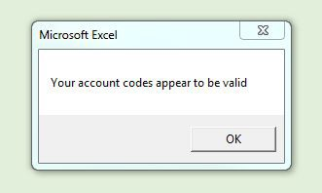

You are now ready to generate your report with account code information.

Validating the Maintenance tab ~ new

After you update your Maintenance Worksheet, you should validate it. Go to the Control Tab and Click on the ‘Maintain Account Codes’ box.

If there are errors on the Maintenance sheet, the following error message will be displayed:

After you click the OK button on this error, click on the Maintenance tab to see what errors were generated. Error messages are listed in the “Results” column.

Validation Performed:

Ensures that the coding from one product key to another successfully maps. If the coding does not map, the error message will be displayed in the ‘Result’ column on the Maintenance tab and the old product key on the Account Codes tab will not change.

Ensures that the old product key is replaced with the new product key.

An example of the error is as follows.

Successfully Mapped items will be marked as "Complete". To reprocess, please remove the "Y" from column D.

If there are no validation errors on the Maintenance sheet, you will get the following message:

You are now ready to generate your report with account code information.

Process Billing Worksheet:

After you have downloaded the Nicus (a.k.a. M-PWR ME) Bill.350 report to a CSV and copied/pasted values (all data except row 1) it to the ACS tab labeled M-PWR ME Output, you are ready to identify new billing line items and/or apply account codes to the billing detail.
In the ACS, go to the tab labeled Control and click on the “Process Billing Worksheet” box.

The Process Billing Worksheet macro runs the Validate Account Codes macro to ensure there are no errors in the Account Codes. If there are no errors, the ‘Processing Billing Worksheet’ macro appends the Account Code data and any additional data previously entered for tracking (the custom columns) to the end of the bill detail lines from the M-PWR ME Output tab, producing the Data Output sheet(s).

If the Bill.350 report (in the M-PWR ME Output tab) contains new product keys that are not listed on the Account Codes tab, the following error will be generated:
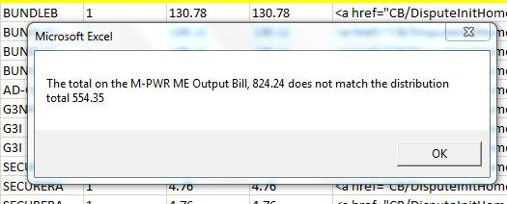

When you click OK, ACS will tell you that there are missing product keys on the Account Codes tab.
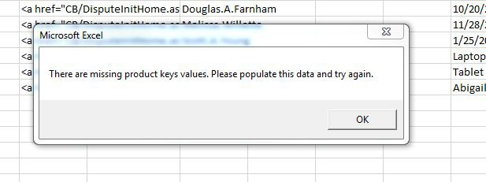

When you click on the OK button, you are brought to the Account Codes tab where any missing product keys are added to the end of the Account Codes list with a message stating, “Please Populate this Value”.

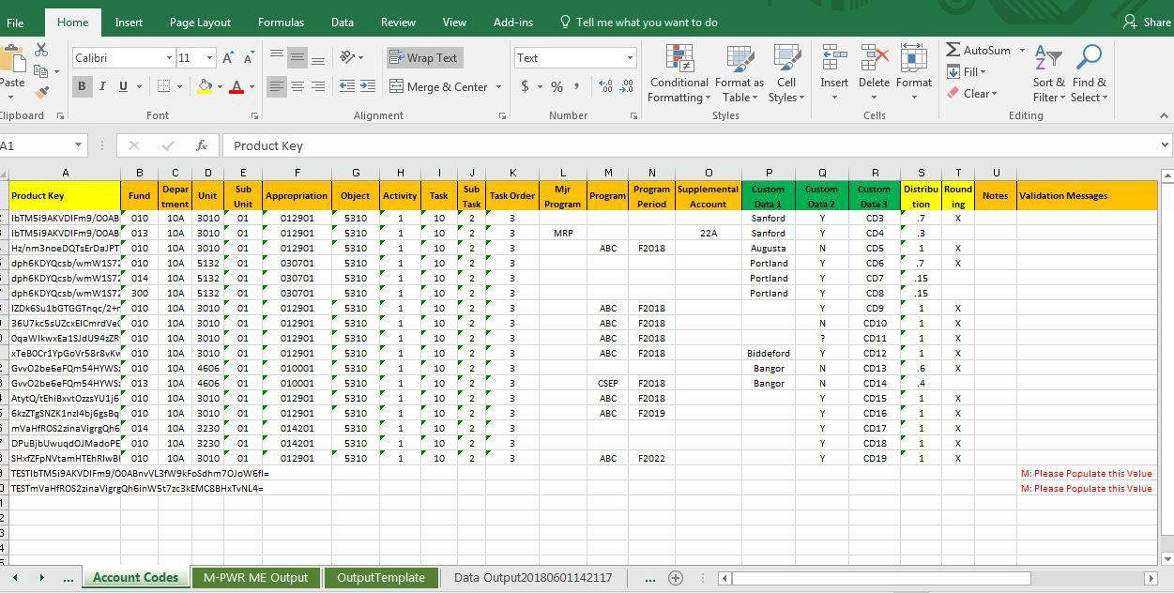

To find the billing detail lines for the new product keys, you have two choices:
You can scroll to the right of the Account Codes tab to columns W through AA. Identifying data for each product key such as Line Item, Attribute 1 (Name), Metric 1 (Footprints ticket #), Service Category, and Service Code pulls the applicable data from the M-PWR ME Output tab. ~ new

You no longer need to copy a new product key from the end of the account code list and on the M-PWR ME Output tab do a find (find and select in upper right-hand corner on the excel ribbon) on the product key.

Or:

On the M-PWR ME Output tab, all new product keys will have their font changed to red and will be bolded. You can filter the new product keys by adding a filter to the Attribute 5 column (column R where product key is stored) on the M-PWR ME tab and then filtering on red font. For instructions on how to do this, please see How to Filter All New Product Keys on the M-PWR ME Output Tab.

Determine your account code values for your new product keys. If you need additional data, the metric 1 column lists the footprint ticket for many services, so you can research the ticket.

Now enter your Account Code information and additional custom data for the new product key(s) and click on the ‘Process Billing Worksheet’ macro box on the Control tab.

Upon completion, you will be brought to the Data Output tab and SummaryWorksheet tab where your reports are populated, and you receive the success message below: ~ new
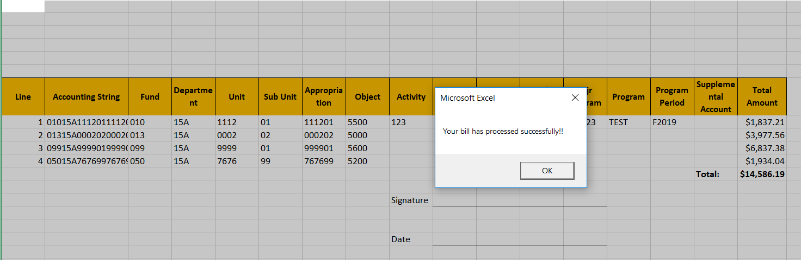

Things to Remember:
All final output reports should be saved as separate workbooks or as separate sheets within an annual workbook. Note: Because the dispute column is only utilized within M-PWR ME, we recommend deleting this column from your copy of the final report.

A separate excel sheet is created each time you click on ‘Process Billing Worksheet’.

When you run the “Process Billing Worksheet” process, the macro first copies the Data Output sheet to a new worksheet named Data OutputYYYYMMDDHHMMSS where YYYYMMDD equals the current date and HHMMSS equals the current time. It then copies the contents of the Output Template with the Account Code and tracking data appended on the end of each bill line (from the M-PWR ME Output tab) to the Data Output sheet. Then the macro second copies the Account Codes account code string(s) (columns B-O) and Data Output distribution (column AZ) and compiles that information on the SummaryWorksheet. Each account code string is auto numbered on this sheet.

Your most current output is always on the Data Output tab and the SummaryWorksheet tab.

We recommend you delete previously created Output sheets that you do not want to keep.

Modifying Tracking Data
If you would like to track additional or less data with your Account Coding data, you can by: On the Account Codes tab:
Insert any additional columns between the Custom Data 3 and Distribution columns. Or delete any of the Custom Data columns if you want to track less data.

On the Output Template tab:
Give heading names to the additional columns you added. Enter these column names (labels) in the first row after the Custom Data 3 column.
Or delete columns containing custom data labels for any custom data you do not want to track.

On the Constant Data Tab:
If you added additional custom data fields to track, add 1 to the number stored in the following row for every column you added.
Or if you deleted custom tracking data, subtract 1 from the number stored in the following row for every column you deleted.
Number of custom fields
2
1

- # 1 ~ Add 1 for every column of tracking data
  - Or subtract 1 for every column of tracking data deleted to the values of: Number of custom fields

- # 2 ~ Add additional identifying information from the M-PWR ME Output tab in the Account Codes tab ~ new
  - Or you can change the order of the existing identifying information by rearranging the numbers. Note: The numbers represent the columns located on the M-PWR ME Output tab

How to Filter All New Product Keys on the M-PWR ME Output Tab

Product key is stored in the Attribute 5 column. Select the Attribute 5 column (column R) by clicking on the Attribute 5 column, then click on the Sort & Filter icon located in the upper right hand corner of the excel ribbon. Select filter and a filter is added to the product key column.
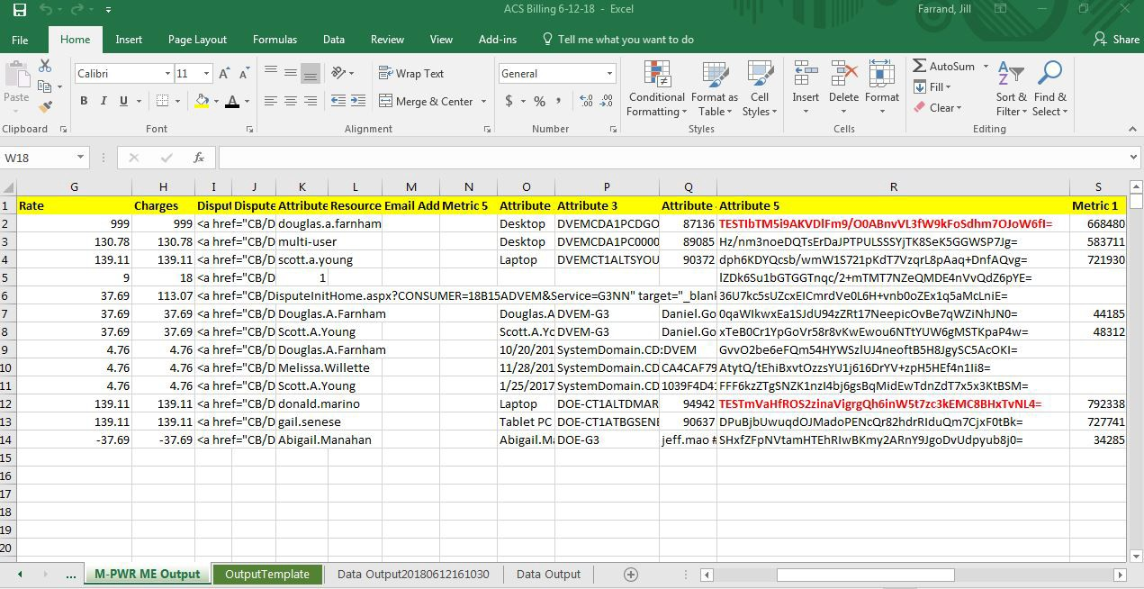
Click on the filter and put your cursor on the ‘Filter by Color’ entry, then click on the red rectangle in the ‘Filter by Font Color’ box.
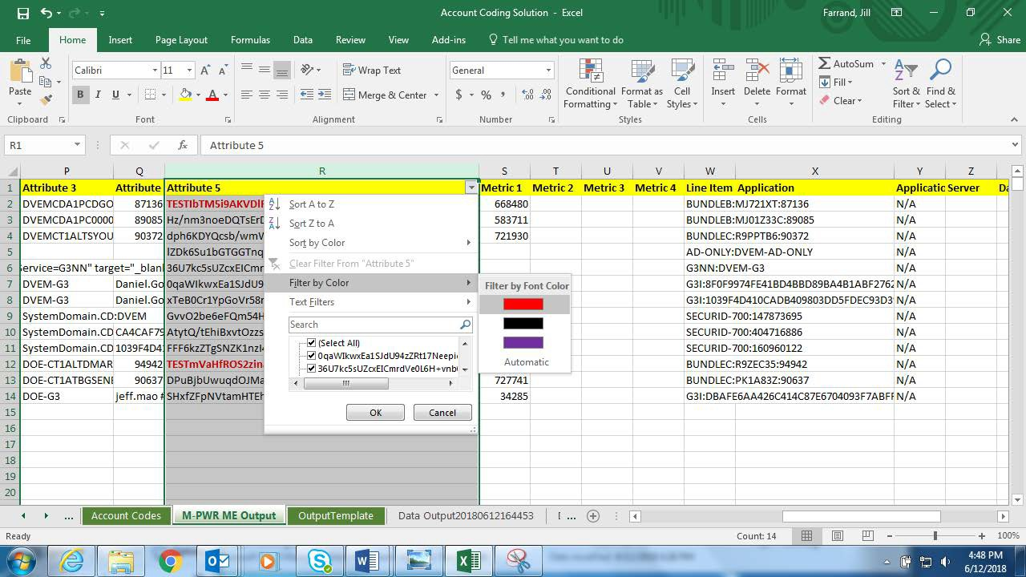

Viola! You can now review your billing detail line and data to determine your account code coding.

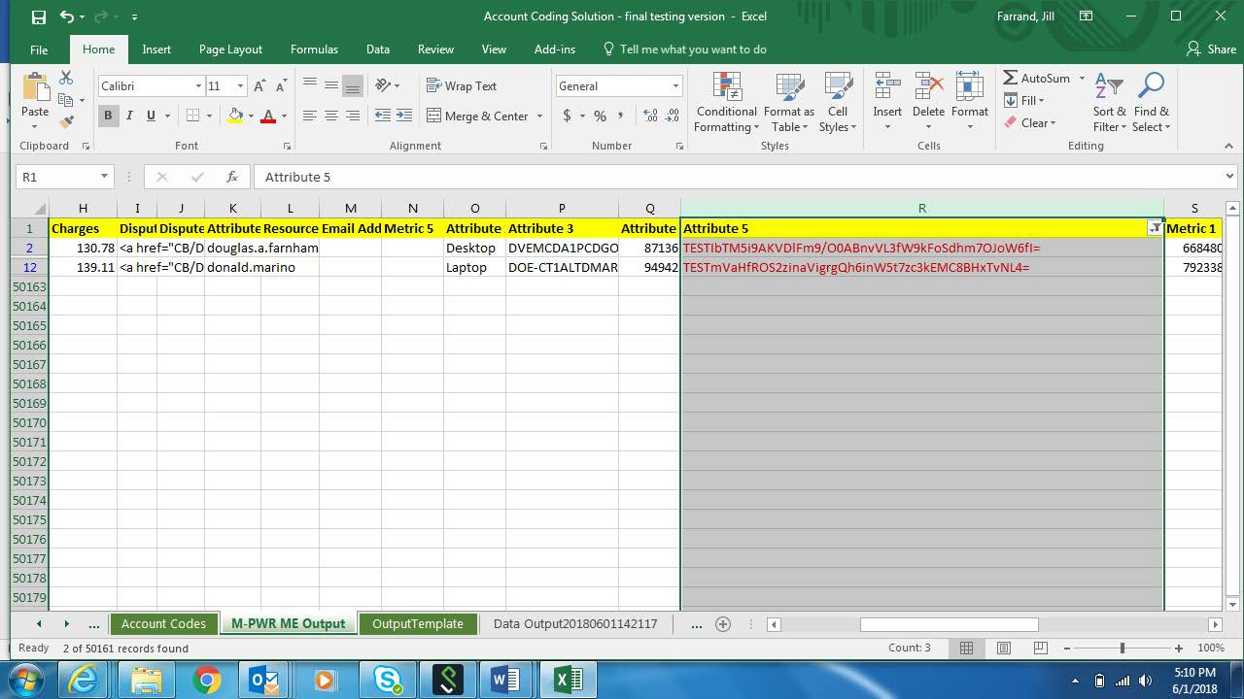

Generating IETM Upload

- Bill tab
  - Copy SummaryWorksheet information to the Bill tab, columns B-P as necessary
    - There is a macro button on the bill tab (Copy ACS SummaryWorksheet Data) that will copy the information for you, or you can manually move the data
    - Please make sure that funding lines are correct before generating a template from the data either by updating the SummaryWorksheet tab before copying over or by updating Bill tab columns B-P manually
  - Before generating an upload template, update the fields in column S as necessary
    - Grayed out fields do not need to be updated
    - Rows 2-7 are needed for MPY template
    - Rows 2-14 are needed for UPDOCS template
    - RE Number: Document ID for REM
    - DOCID: Document ID for the IETM
      - Edit the existing formula
        - The period will need to be edited to reflect the period you are working on. Example: If your MaineIT bill is for period 202407 (January 2024’s bill run), you will need to change the period in the formula from 202406 to 202407.
      - If there are more than 200 lines, the Document ID will be appended with letters corresponding to the number of documents uploaded (i.e., If 3 documents are needed, Document ID will be appended with A, B, or C)
    - BILL TYPE: OIT (field is grayed out as this IETM upload is specific to the OIT bill)
    - BILL DATE: Date of the OIT bill
    - CONSUMER: Consumer code (if needed)
      - If filled out, it will be included in the DOC DESC
    - DOC DESC: OIT + Bill Date
    - UPDOCS specific fields
      - These fields do not need to be completed if generating an MPY template
      - BFY: Budget Fiscal Year
      - FY: Fiscal Year
      - Period: Period
      - SERVICE FROM: Service start date
      - SERVICE TO: Service end date
      - SPREDSHEET DOCID: Spreadsheet ID for UPDOCS upload
      - RECORD DATE: Date of upload
  - Once information has been updated, generate the necessary template by clicking the relevant macro button:
    - Generate MPY Template
      - This will fill out the template on the MPY tab
      - For upload to MainePays
    - Generate UPDOCS Template
      - This will fill out the template on the UPDOCS tab
      - For upload into Advantage
    - The generated template will open up into a new workbook; this can be uploaded to the applicable system, or copied into a template spreadsheet and uploaded

