Office of Affordable Health Care

2023 Public Hearing Comment Solicitation – **Individual Consumers**

*Written comments are due by midnight on Friday October 6th, 2023.*

*Comments may be emailed to* [*meg.garratt-reed@maine.gov*](mailto:meg.garratt-reed@maine.gov)*, and can be attached as a word document/ PDF or copied into the body of an email. Please note that comments are not confidential and will be posted publicly.*

Submitter Information

Name: Julie Keller Pease, MD. Jkpeasemd@gmail.com

City/town of residence (optional): Topsham, ME

I am a semi-retired psychiatrist, now working 3-6 months per year in New Zealand. I am a past president of the Maine Association of Psychiatric Physicians, and a founding board member and former chair of the board of Maine AllCare. However, my comments reflect my personal experiences as a patient, and a shared story (with permission) of my summer neighbor, Donna Wiegle of Swan’s Island.

I am also sharing the link to an article in Health Affairs, which outlines administrative costs/waste as a driver of high healthcare costs, and makes some specific suggestions for savings from standardizing administrative activities, with targeting proposals to reduce administrative waste.

Comments

*You may answer some or all of the following questions.*

1. Has the cost of health care created a barrier to accessing care, or an undue financial burden on you or your family? Please share any information you are willing to about the experience, including the type of cost(s) (e.g. out-of-pocket costs, insurance premiums) and the health care services you were trying to access? Before I turned 65 and became eligible for Medicare, I was fortunate to have been able to afford high deductible insurance, albeit at a ridiculous cost of $1400 per month for myself and my spouse with a $10,000 deductible. When I needed emergency after injuring my shoulder in 2019, all of my expenses from that visit, and the follow-up visits with the orthopedist (in network) went to my deductible. I paid out of pocket in New Zealand for 8-10 visits with a physical therapist: $65 for the initial visit, and $45 for subsequent visit. The follow-up X-rays were done at the hospital for no cost. Back to Ellsworth, Maine: The first person I saw was administrative, not clinical: the intake person, who offered me the option to pay out of pocket at an allegedly discounted rate for the ED charge, since they claimed to be unable to verify my insurance coverage on the weekend. I was then seen by the nurse who took a brief history, the doctor who ordered the X-ray, the X-ray tech who took the X-ray. After a long wait for the results of the X-ray, the doctor gave me the diagnosis of a fracture of the head of my humerus, followed by 10-minute visit from the nurse who put on the sling. The doctor also gave a prescription for tramadol, which I never filled. My pharmacy bill was about $10 for a bottle of ibuprofen and a bottle of acetaminophen. The emergency visit generated 4-5 bills, which took several days to weeks to work their way through the insurance system before I learned what I would be charged. I eventually received a bill for $1043.79 from Northern Light in Ellsworth, a second bill for $98 for a sling (identical sling could have been purchased at a drug store for $25 or less, but I was not advised of this), a charge for the X-ray and the radiologist, and a charge of about $800 for “complex care” for treatment of a fractured humerus from a billing service in Ohio for the physician (group) who treated me. Because of my experience as a provider, I knew to question this physician bill, and MCHO (my insurer at the time) was able to negotiate a different fee in the range of $200 by appealing for a more appropriate billing code. With my deductible, the cost to MCHO (their medical loss ratio) was ZERO as the whole charge got applied to the deductible. My total cost for this 1.5 hour visit was about $1500. Costs for 3 visits to the orthopedic surgeon, one visit to PT, and X-rays totaled about $750. In addition, I spent far more time dealing with billing clerks and the insurance company that I spent receiving actual health care .
2. Contrast this with Donna’s 30-hour emergency visit to a similar size hospital ED in Quebec, where she was evaluated and treated for a small bowel obstruction. As a non-resident of Canada, she had to pay full price for her treatment in Canada. Yet her costs in 2023 were about half of my costs in 2019, and she received much more treatment and spent 30 hours rather than 1.5 hours in the ED. She received one simple, transparent bill/statement immediately upon discharge, rather than 4 separate bills from 4 sources. (And of course, if she had been a resident of any province in Canada, her out of pocket cost would have been ZERO, as she would have paid in advance through income and GST.) 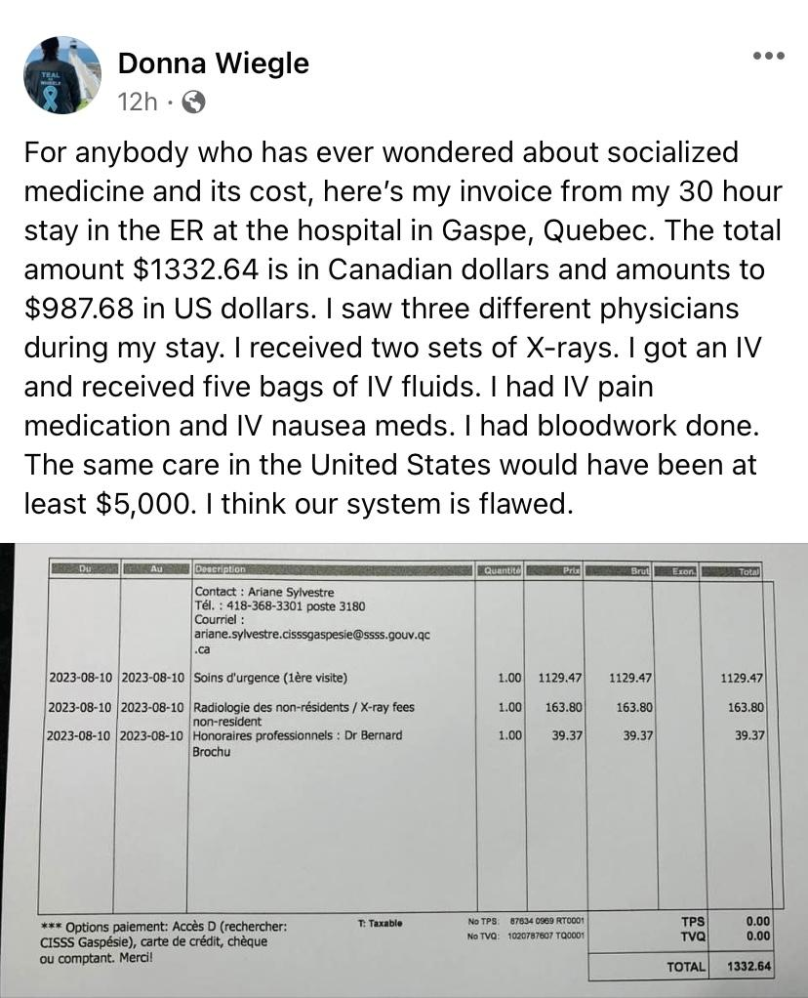

3. Another story, this one from New Zealand, where EVERY outpatient prescription costs $5 for a 3-month prescription. There is ONE formulary for the entire country of 5 million people. Most of the drugs on this formulary are subsidized so that they cost just $5 for 3-months. Example: Here in the US, my husband’s Breo Ellipta inhaler has a co-pay of $42 per month, with insurance. If he did not have insurance it would cost anywhere from $160 up to $400+ per month, shopping around for the best deal. In NZ, the cost is $5 for 3 months. This is possible because the government establishes a budget for prescription drugs and medical devices, and there is a public agency called Pharmac that negotiates prices and creates the formulary. Some medications require prior authorization, which is electronic, so providers can get prior authorization approvals within minutes (or even seconds).

1. Or are there policy ideas you believe would benefit yourself and/or other consumers?

The way we pay for health care is complicated and inefficient. Our payment system in Maine includes out-of-pocket, dozens of different insurance plans with almost as many different charges for the same procedures as there are insurance plans. Providers have to employ armies of administrative staff, and patients have to spend hours of their time trying to negotiate the system, appealing denials of insurers, waiting for authorizations to come through before they can pick up their prescriptions

<https://www.healthaffairs.org/do/10.1377/hpb20220909.830296/>

The BEST solution to our cost problem is to developing a single health plan for everyone in Maine - publicly and equitably funded through premiums or taxes paid to a state entity to administer claims from providers, and to set global budgets for hospitals.

However, that may be beyond the purview of the OAHC. Therefore, here are my ideas.

* A single formulary with standardized, electronic prior authorizations for providers to submit for approval. Establish a state entity or have a contract with a private entity to negotiate drug prices, with prices the same whether the payor is MaineCare or Insurance. Goold Health Systems does a good job with Mainecare pharmacy benefit management. PHARMAC is a public entity that manages the pharmacy budget in New Zealand. The negotiation and standardization could be done by either a public or a private entity in Maine.
* A statewide, central clearinghouse for the submission of claims.
* A single standardized Claim form for providers to submit.
* A standardized super bill given to patients at the time of an emergency room visit (such the bill given to my friend Donna) or potentially setting up a more simplified and transparent means of hospital billing.

Thank you for your consideration of my comments.

Sincerely,

Julie Keller Pease, MD

23 Beryl Loop

Topsham, ME 04086

207-522-2267

jkpeasemd@gmail.com