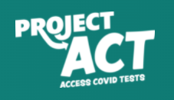

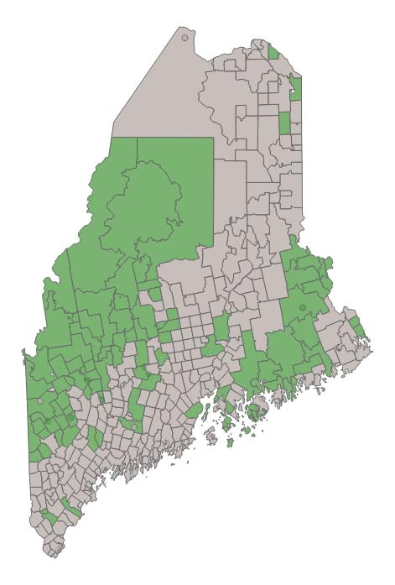
GET YOUR FREE AT HOME TEST KITS!

Available to eligible Mainers living in our community with Zip Code:
04240
Only while supplies last – 5 kits per household
Order online at: https://www.accesscovidtests.org/

Ask your librarian if you need assistance ordering online

