

#______

Registered Borrowers, X % of our community.

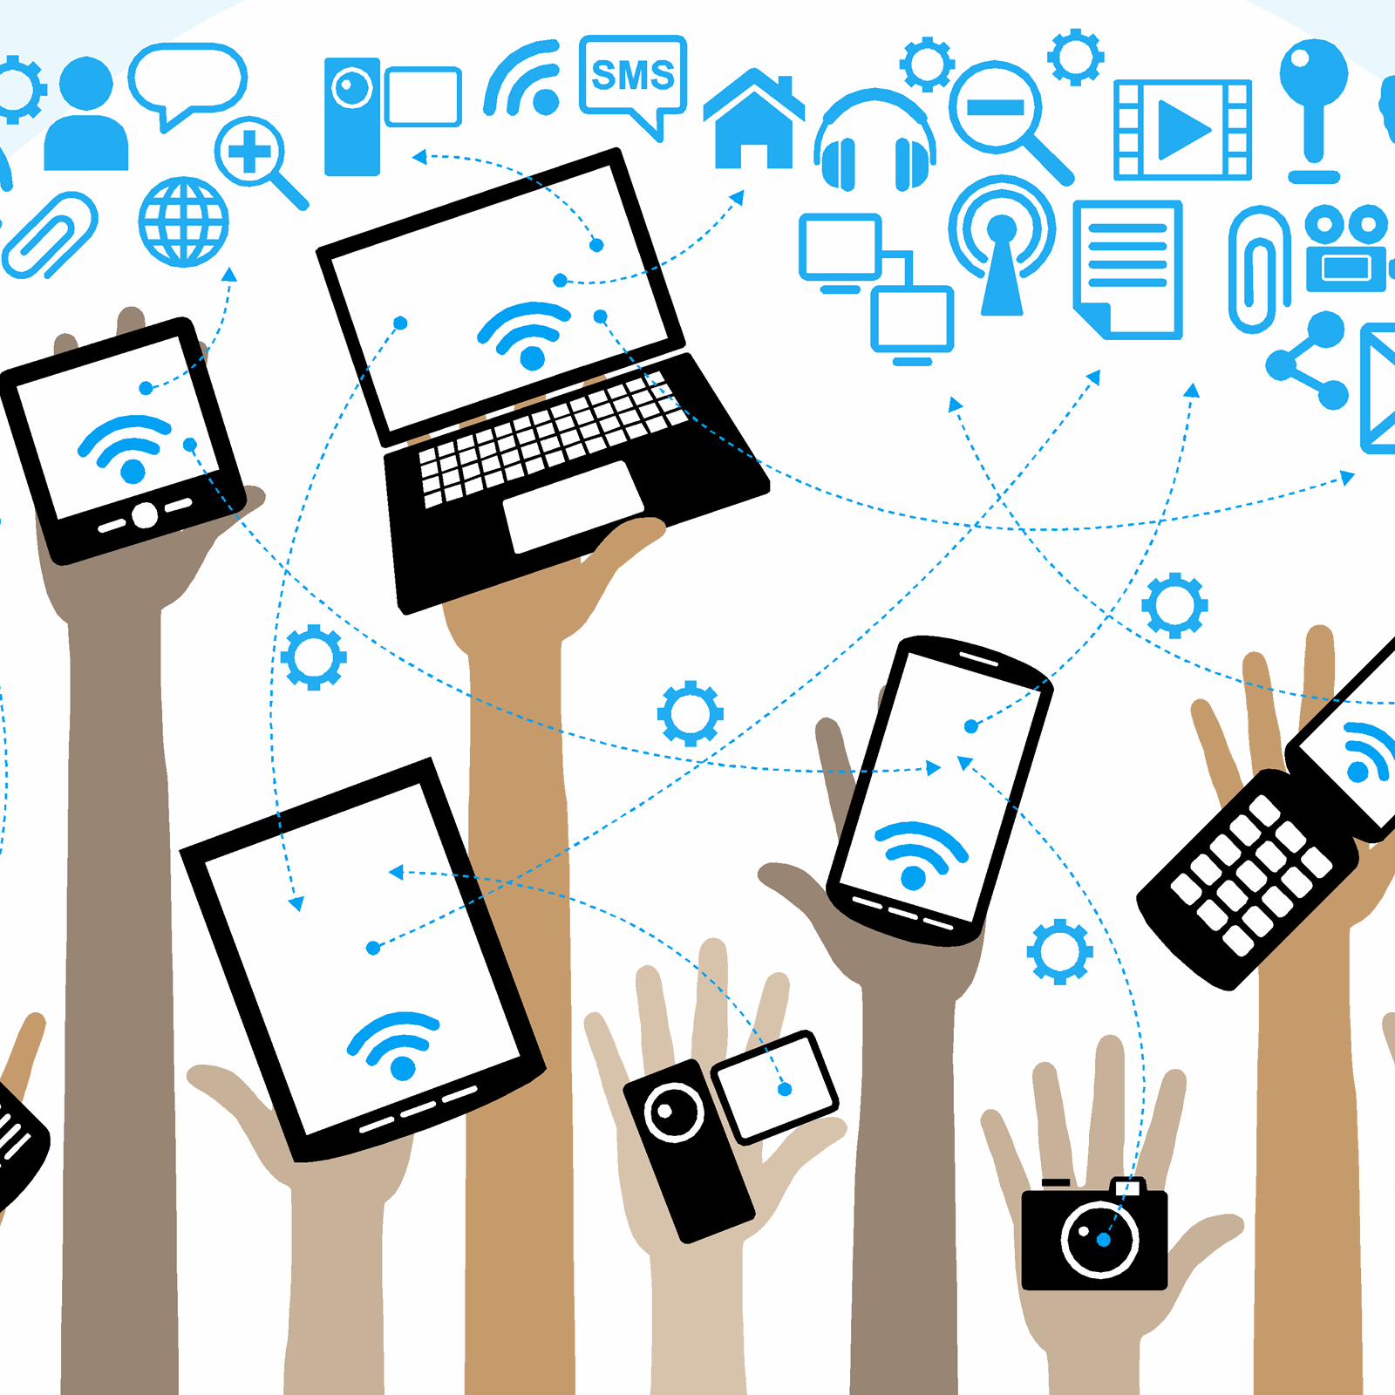

#______

WiFi Connections

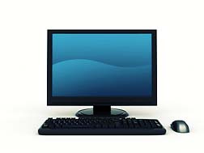

#______

Computer Sessions



#______

Checkouts

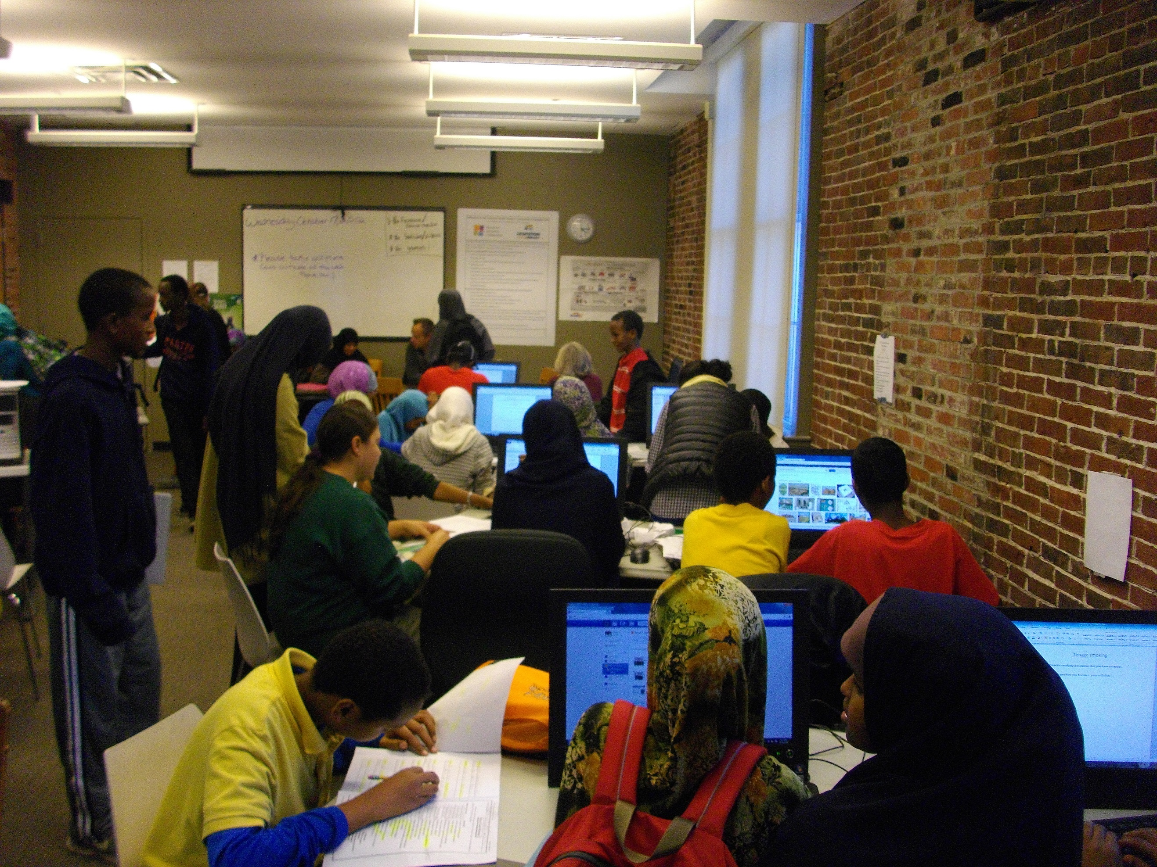

#______

Library Visits



#______

People Attended

#______

Programs

Address Winter Hours

City, Zip ­­­­­­________________________

Phone Summer Hours

Website address ________________________



_____Library Website Page Views

Library Name

Year in Review

[Year]



______ Volunteer Hours



#______

Meeting or Study Room Use

Notable Numbers