**[Library Name]**

Place Library Logo here

is transforming lives every day in our community by providing access to technology, early literacy programs and career development resources. Here’s a look at how many lives we touched in **[Year]**, and we’ve got even more planned for this year!

**THE LIBRARY AS A LEARNING CENTER**

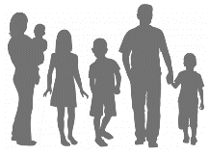

library programs were attended by **[number]** people.

**[number]**

The library offered:

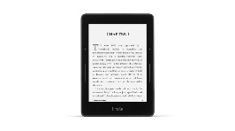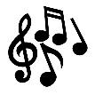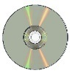

Early literacy and children’s and youth programs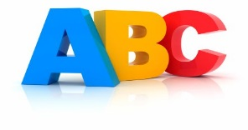

**[number]**

Programs for adults

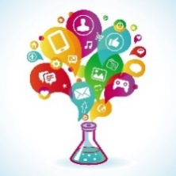

Workforce development programs **[number]**

**THE LIBRARY AS A TECHNOLOGY HUB**

**Assistance**

That’s almost **[card holders/population]%** of [town]’s residents

**[number]**

That’s over **[total circ/ population]** per resident

That’s more than

**[visits/population]**

visits per resident.



**[number]** Wi-Fi Sessions

**[number]** items borrowed

You can access library materials **24/7**! Download e-books, stream films or learn a language all through the library’s website:

**[website]**

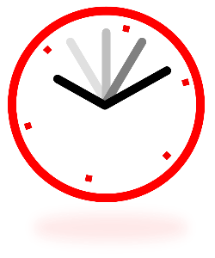

A [Library name] card gives you access to over **[number]** items including books, e-books, audiobooks, movies, music and more!



**[number]** Library visits

Active library users



**«LIBNAME» provides access to millions of resources**



Technology questions answered **[number]**

Technology classes offered

**[number]** 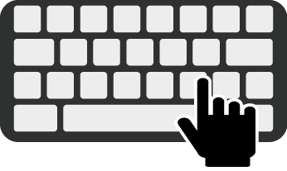

Computer Uses

**[number]**

**Access**

**[number]**