How to Training
For
Annual Report Revision
The External Registered User or the Internal Staff can revise Annual Reports. The authorized user will submit a revision to any analysis field. The revision submission will function like Update Annual Report functionality wherein the Submitter will be able to update the information submitted previously for the Annual Report. To access the Annual Report Revision Screen, authorized users should click on the Annual Report File link on the Access Menu.

Some of the fields on this screen are mandatory entry fields as denoted by the red (*) asterisk; others fields are optional.

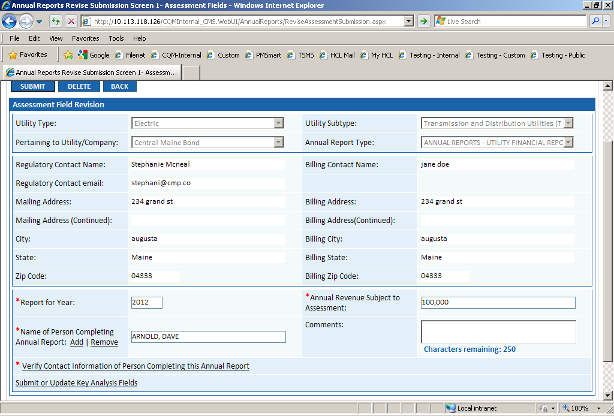
Objective:

- Revise a Annual Report
Step | Action
 | From the Home Page Access Menu, click on Annual Report File Revise Annual Report
Enter the Tracking Number which needs to be revised and click on Go Button.

If the Tracking Number is not known, click on Search Button and search for the required Tracking Number.

In the Assessment Fields Submission Section

- In case of revision, no information on the Assessment Field Screen can be updated by the External Registered User. Whereas the Internal Staff can update the Report for Year and Annual Revenue Subject to Assessment fields.

- For the Internal Staff, click on mandatory Verify Contact Information of Person Completing this Annual Report
- If the information satisfies, then click on Confirm
- Else, update the information and click on Update Button

- For updating the Key Analysis Fields click on Submit or Update Key Analysis Fields hyperlink

- The Analysis Fields Submission Screen depends on the Utility Type and Subtype of the Pertaining to Utility Company

- Enter the required information for the Analysis Fields

For Attaching Documents

- Select the security type as Public or Confidential
- For Public document, click on Attach Document Button
- Click on Browse and select the document you wish to attach
- Click on Open
- Click on Attach
- Selected document should be displayed in the Attached Documents grid
- By clicking on Red X associated with attached document, the document can be deleted prior to submitting

- For Confidential document, click on Attach Confidential Document Button
- Click on Browse and select the Confidential Document you wish to attach
- Click on Browse and select the Redacted Version Document you wish to attach

- Associate Protective Order by clicking on the hyperlink
- Search for protective order and attach
- Selected document should be displayed in the Attached Documents grid
- By clicking on Red X associated with attached document, the document can be deleted prior to submitting

- Click on Submit Button

 | To revise another Annual Report, click on Back Button and follow step1; otherwise, click on Home hyperlink to return to the Home Page

