How to Training
For
Annual Report Search
The External Registered User, Internal Staff or Public User can search and view the annual reports. To access the Annual Report search screen, authorized users should click on the Annual Report File link on the Access Menu. Public Users click on View Annual Reports on the Home Page.

The user should enter the desired search criteria for searching the annual report. Some of the fields on this screen are mandatory entry fields as denoted by the red (*) asterisk; others fields are optional.

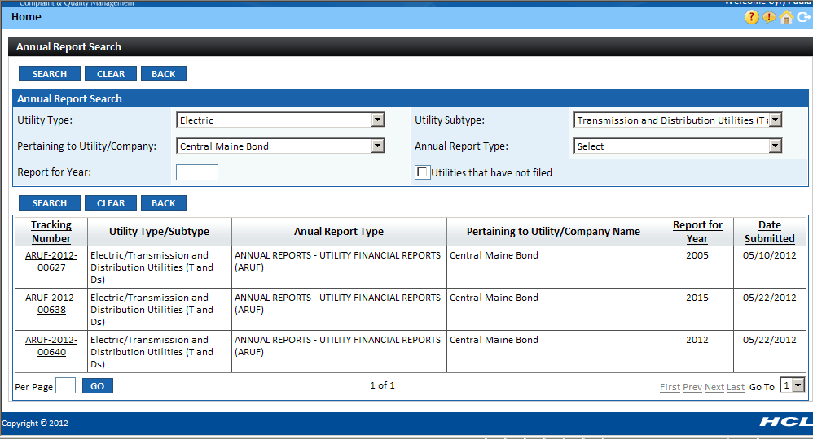

Objective:

- Search a Annual Report
Step | Action
 | From the Home Page, from Access Menu click on Annual Report File View/Search Annual Reports
In the Annual Report Search section

- Enter the known search criteria and click on Search Button

- Result gets displayed according to the search criteria.

- For another search, click on Reset Button and re-enter the known search criteria to get the results.
How to view the Annual Report Details

- Click on the Tracking Number against the record in grid being displayed.

- A pop-up window will open containing the document details for selected Annual Report
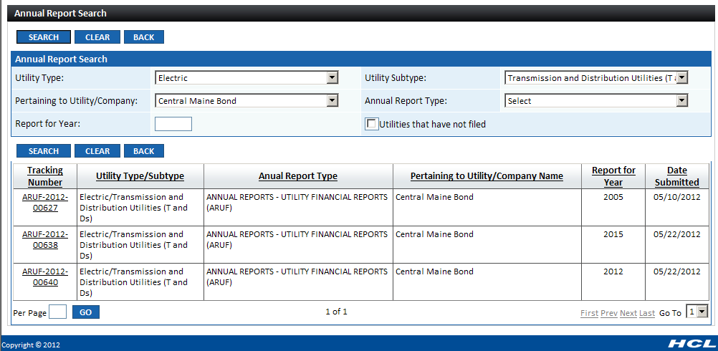

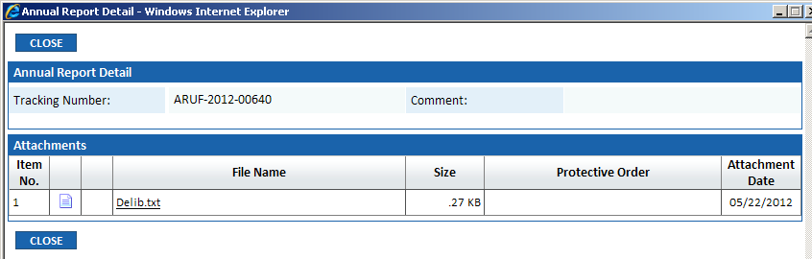

- The Internal Staff can view all the documents associated with the Annual Report by clicking on the File Name hyperlink.

- The External Registered User can view all the public documents, but for the Confidential document, he/she can view only those documents on which protective order he/she has the access rights

- The Public User (non registered external user) can only view the public documents. They do not have access rights to view the confidential document.
 | Click on Home hyperlink to return to the Home Page

