How To Training
for
Data Requests – Create, Save and Submit
This Data Request Question and Response staging area provides the ability for Internal and External Registered Users to create and save draft DR Questions and Responses. They can also be submitted from the staging area.

Confidential DR Question or DR Response attachments must be associated with a protective order existing in a Case filing with the same security and functionality as is in place for case filings.

Create/Save/Submit Questions

Objective:

- Manage Data Request Questions

Step | Action
 | From the Home Page Click on Data Requests/Responses Create/Save/Submit Questions on the access menu list
Case Search will be displayed
- Enter Case Number in Text Box
- Click on GO Button to display specified Case File.
- OR -
If user does not know case number:

- Click on Search Button, enter known search criteria
- Click on Search Button
- Search result will display all cases matching entered parameters
- Click on Case Number hyperlink to be navigated to the Case File Screen for the specified case.

Draft DR Sets Screen will be displayed with the following for any Saved but not Submitted Sets.
- Case Details
- Requested By
- Propounded Upon
- Description
- Last Updated Date
- Last Updated By
- Edit icon
- Red X to Delete questions without submitting
- Create New DR Set and Back Buttons

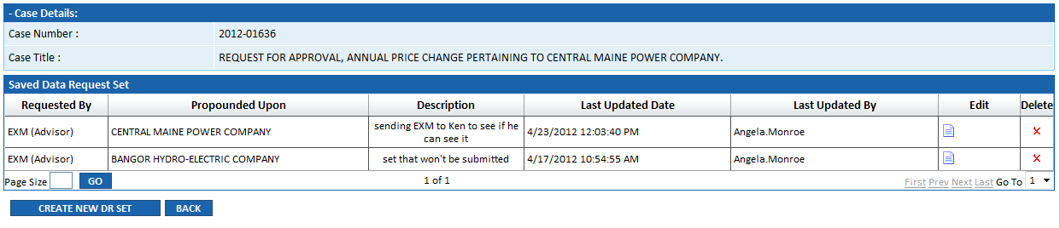

Create/Update DR Sets Screen will be displayed
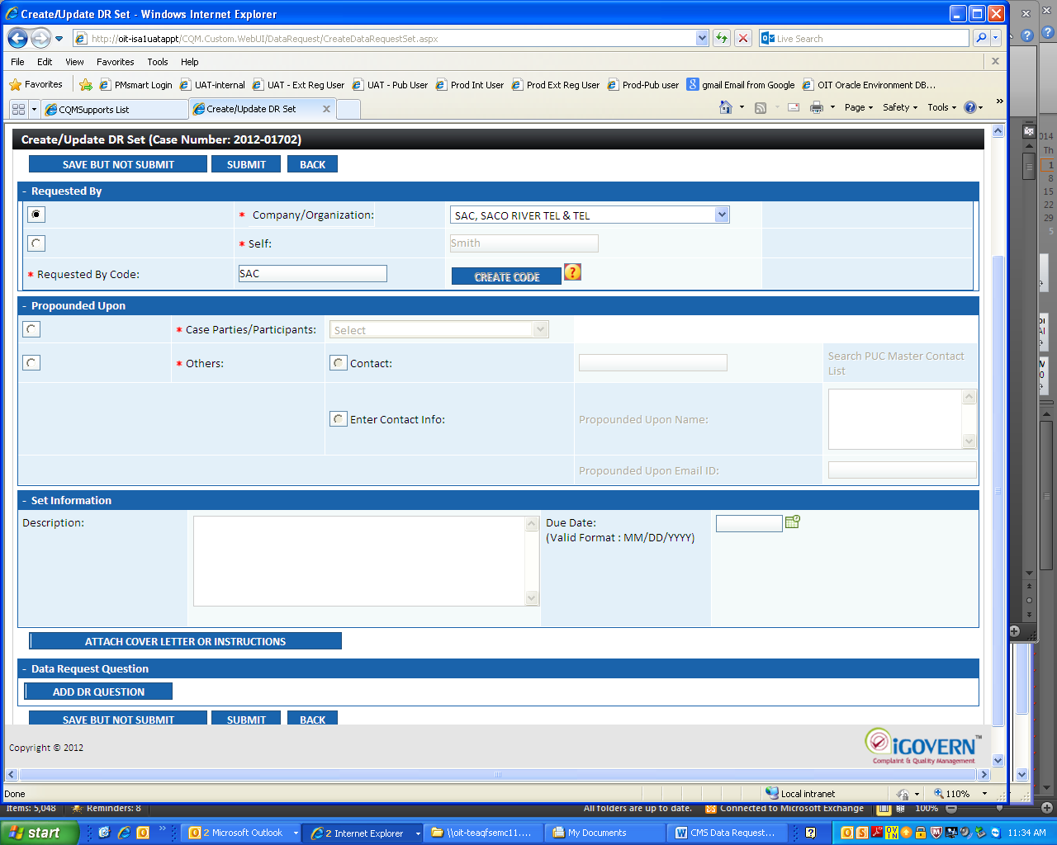

Four sections will be displayed on the screen
- Requested By Section
  - Select Requested By from drop down list – if you are representing a company select Company, otherwise select Self. A prefix will be shown upon selection. If none shows, this is because it is the first time you have created a DR set. In this case, enter a 3 to 5 character and click Create Code button. This code will be used as the prefix for your DR sets hereafter.
- Propounded By Section – this is the entity to whom the DR Set of questions is being directed for response:
  - To select Case/Parties/Participants, select Radio Button to enable drop down list which displays Case Parties/ Participants
Or
  - Radio Button to enable Others Radio Buttons
    - If Contact Radio Button is selected user will click on Search PUC Master Contact List hyperlink to search for or add a contact person
    - If Enter Contact Info Radio Button is selected, user will enter contact in text box and contact's email in that box.
- Set Information Section
  - Enter Description in text box
  - Enter Due Date, if applicable
  - Click on Attach Cover Letter or Instructions Button to include, if applicable
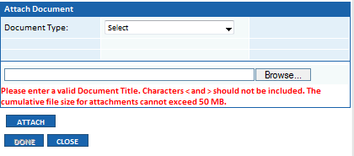
- Data Request Section
  - Click on Add DR Question Button – produces a pop-up window to type in a question
  - Enter Question in text box
  - Add or modify Due Date, if applicable
  - Attach documents, if applicable
  - Select either Save Question or Save Question and Add Another button depending on whether you have more than one question to enter into the set. Select Close to back out without saving. When no more questions are to be added Click Save DR Question

- User can include an attachment by clicking on Click on Attach Confidential/Non-Confidential Information Button
  - If attachment is Confidential, select Radio Button, click on Indicate Protective Order hyperlink to associate confidential attachment with respective Protective Order
  - If attaching is non-confidential, select Radio Button
  - Click on Browse Button to select document (public or confidential ) from computer files
  - Click on Attach Button

When all attachments have been appended, click on Done Button
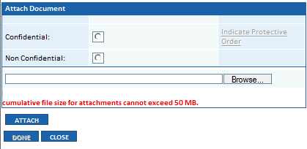

- After User has click on Save DR Question Button
- If a wrong question has been entered, click on Delete for that question.

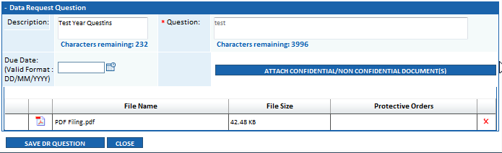

- User will be able to either click on
  - Save but not Submit Button
  - Submit Button
  - Back Button to be navigated to previous screen
- On Submit, a message will be displayed:
  - e.g., Data Request Set EXM-018 with 2 question(s) submitted
  - a notification email will be sent to the Propounded Upon party

- To submit a previously saved DR Question, click on Edit Icon
- Create/Update DR Sets Screen will be displayed
- Click on Submit Button
- On Submit a message will be displayed:
  - e.g., Data Request Set EXM-019 with 2 question(s) submitted

Create/Save/Submit Responses

Objective:

- Manage Data Request Responses
Step | Action
 | From the Home Page Click on Data Requests/Responses Create/Save/Submit Response on the access menu list
Case Number Entry box will be displayed, as well as any previously drafted but not submitted responses by the user or other members of the propounded upon party.
- Enter Case Number in Text Box
- Click on GO Button to display specified Case File.
Or
- Click Respond or Edit hyperlink for a question in the draft list.

DR Question Listing will be displayed with the following
- Case Number

- DR Question ID
- Question Text
- Response Text
- Propounded Upon
- Due Date
- Status – Pending, Overdue, or Responded to
- View Complete DR hyperlink
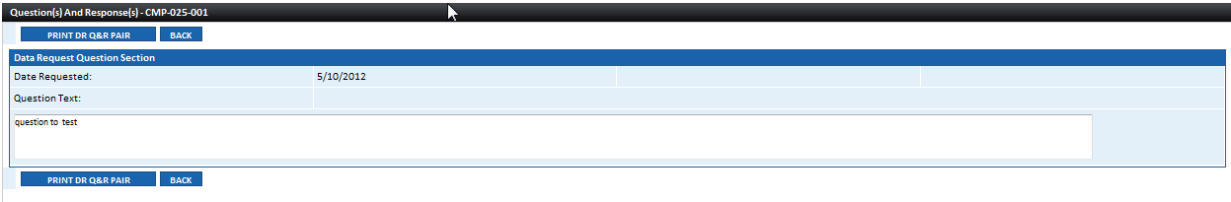

- Question Attachments and Response Attachments hyperlinks
- Response hyperlink – with either respond or edit
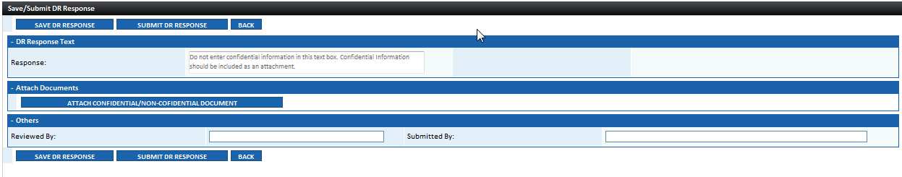

Selecting the Response Hyperlink brings you to the Enter DR Response Screen
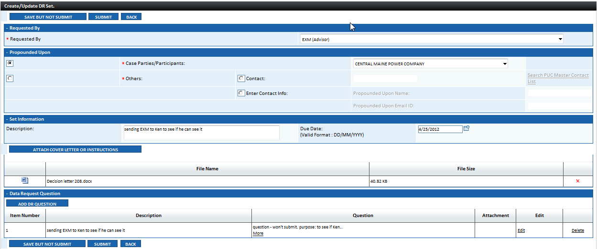

Enter Data Request Response Information
- User can include an attachment by clicking on Click on Attach Confidential/Non-Confidential Information Button
  - See Steps 8,9 and 10 for Attachment Details
- Witness Responsible for Response – free form text box
- Author of Response – free form text box
- Select Save DR Response button to save a draft without submitting or Submit DR Response to finalize the response.

