How To Training
For
CMS Case File
The Case File Screen (1) provides user with a wide array of information and functionality for specific case. The Case File can be accessed by clicking on Case File link on the Access Menu Case Files.

In the upper portion of the Case File Screen, Cases Details (metadata) are displayed. The metadata includes:

- Case Number
- Utility/Industry Type
- Utility/Industry Subtype
- Case Type
- Case Subtype
- Pertaining to Utility/Company
- Case Title
- Initiating Filer
- Case Start Date
- Assigned Staff
- Adjudicatory Case: (Yes/No)
- Statutory Reference
- MPUC Reference

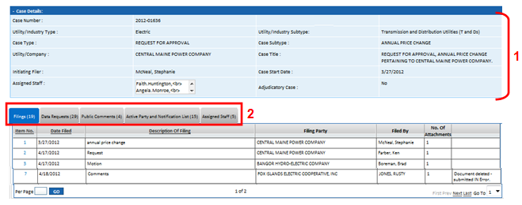

In addition to providing the Case Details (1), the Case File Screen (see Case File Screen Shot above (2) includes the following tabs:
- Filings (Viewable by Staff and External Users - Registered and Public with restrictions for confidential/secured viewing in place )
- Data Requests (Viewable by Staff and External Users - Registered and Public with restrictions for confidential/secured viewing in place )
- Public Comments (Viewable by Staff with Manage Rights to Authorized Staff Users and External Users - Registered and Public with restrictions for confidential viewing in place)
- Active Party and Notification List (Viewable by Staff Users and External Users - Registered and Public)
  - Active Party List (Viewable by Staff Users and External Users - Registered and Public)
- Assigned Staff (Viewable by Staff and External Users - Registered and Public)

