 | HISTORIC COMMUNITY BUILDINGS GRANT PROGRAM APPLICATION - FOR REFERENCE ONLY
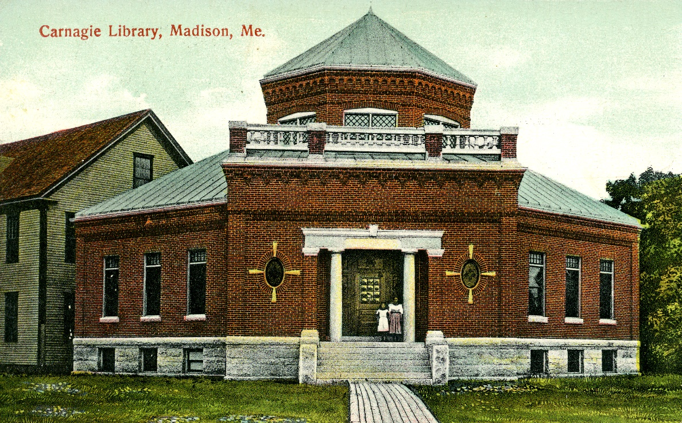

2025 | Round 1

HISTORIC COMMUNITY BUILDINGS GRANT PROGRAM APPLICATION - FOR REFERENCE ONLY

Round 1

IMPORTANT APPLICATION INSTRUCTIONS
This document is for information purposes only. Applications will be filled out and submitted electronically via JotForm. Instructions and resources for submission will be posted along with the application link on the Commission’s website.

A complete application INCLUDEs each of the following:
A. A completed application in JotForm with supplementary documentation.
B. Supplementary documentation submitted with application:
1. Cost proposals from contractors
2. Resumes for donated labor. Attach resumés for all persons to be valued for match purposes at more than the state minimum wage. See Chapter 7.8 of the Grant Manual.
3. Resumes for contractors who provided cost proposals, and any architects, engineers, consultants, conservators, or other professionals who have either provided project drawings and specifications or will be providing project oversight or other services (if known at time of application). Resumes should highlight experience working with historic buildings.
4. Copies of completed drawings and specifications, assessments, stabilization plans or historic structure reports if appropriate.

C. Photographs. See Chapter 6.11 of the Grant Manual.

D. Signed and completed application checklist in JotForm.

The Complete application must be submitted by 5:00 p.m., December 5, 2025

I. APPLICANT OVERVIEW
Applicant Organization: |  | Organization type
Contact Person: |  | Government – State | ☐
Mailing Address: |  | Government - County | ☐
Telephone Number: |  | Government - Local | ☐
E-mail Address: |  | Non-profit  Educational | ☐  ☐
Owner Information
Mailing Address:
Telephone Number:
E-mail Address:

II. BUILDING INFORMATION
Is the building individually listed in the National Register of Historic Places or designated as a contributing resource in a National Register listed historic district? Yes No

If you checked “No”, upload information from the Commission indicating that the building has already been nominated to the National Register of Historic Places.
Name of the building:
Address of the building:

III. PROJECT SUMMARY
Provide a summary statement that identifies the building and describes the project. (60 words maximum).

IV. FUNDING REQUEST. The minimum grant award is $25,000 and the maximum award is $250,000
Grant Amount Requested (75% of total project cost maximum) $
Match Amount (25% of total project cost minimum) $
Total Project Cost (100%) $

INCLUDE cost proposals USED TO CALCULATE the budget.

V. DRAWINGS AND SPECIFICATIONS

ALL APPLICATIONS MUST BE ACCOMPANIED BY DRAWINGS AND SPECIFICATIONS IN ORDER TO BE CONSIDERED FOR FUNDING. See Chapter 6.1-6.3 of the Grants Manual.
Have these drawings and specifications been previously reviewed and approved by the Commission? Yes☐ No ☐

VI. PROJECT DESCRIPTION AND PROCESS. (See Chapter 5.1 of the Grant Manual.) The response to this section is awarded up to 50 points.

- Is this a continuing project that the Commission has previously funded? Yes No
- Describe in detail the overall scope of the project including the process to initiate, oversee and complete it. If applicable, describe work already completed or planned in each phase of a multi-phase project and identify which phase this grant application applies to. The description should include a timeline for the project that identifies when prior phases were completed and when future phases are planned.
- Submit resumes for contractors who have submitted cost proposals, as well as for any architects, engineers, consultants, conservators, or other professionals who have either provided project drawings and specifications or will be providing project oversight or other services (if known at time of application). Resumes should primarily highlight experience working with historic buildings in accordance with the Secretary of the Interior’s Standards for Preservation or Restoration. See Appendix B.
- Describe the current condition and use of the building. Explain how the conditions will be addressed with a grant.

VII. PUBLIC BENEFIT/COMMUNITY BUILDING. (See Chapter 5.2 and the definition of Historic Community Building in Chapter 1of the Grant Manual.) The response to this section is awarded up to 25 points.

- The building’s social and cultural value to the community once the project is completed will be reflected in part by how broadly the resource is used by the community. Describe how the project supports the value of the building to the community.
- What is the building’s primary function currently? What is its proposed use or function at the end of the project?
- Describe the type and frequency of public events and uses in the past five years. What is the range of attendance numbers? What is the average number of attendees?
- Describe the community support for this project. Include the names of financial sponsors and any partner organizations.

VIII. ADMINISTRATIVE CAPABILITY. (See Chapter 5.3 of the Grant Manual.) The response to this section is awarded up to 25 points.

Grant recipients must have designated personnel (staff or volunteer) who will manage the Historic Community Buildings Grant financials, as well as an adequate accounting system, audit procedure, effective accountability and record keeping system.

- List up to five prior grant projects administered by this organization and address the following questions for each project: a. Was it completed on schedule? b. Was it completed within the approved budget? c. Provide a reference with email or phone number for each project.

- Describe your accounting and record management system, as well as audit procedures.
- Grant funds are provided on a reimbursement basis (See Chapter 6.7). Describe how you will initially cover costs and pay bills prior to receiving reimbursement from the Commission.
- Do you already have all the required match for this project? ☐ Yes ☐ No
If the answer is “no” what percentage of the match is already in hand? %
Describe how any remaining match will be raised.

- Describe what steps you have taken to determine the project budget and ensure its accuracy. See Chapter 7 in the Grant Manual for more information.

- Describe the contingency plan for unexpected costs/expenses.
- Provide an estimated project schedule based on a September 30, 2027 completion date. Include time for contracting, procurement, project work, billing, and report preparation. All tasks, including billing and reporting, must be completed by this date.
- Budget. Complete budget worksheet.

X. CERTIFICATION
In making this application for state bond funded assistance, I hereby acknowledge my familiarity with the requirements listed in the Historic Community Buildings Grants Manual. I agree that should I receive the assistance herein requested, I will carry out the project according to State requirements. I certify that I am authorized to submit this application.

_____________________________________________
Signature Date
Name & Title (Typed or Printed)
Applicant Organization

APPLICATION CHECKLIST

Applicant must initial each bullet point to acknowledge that they have read these instructions or reminders. Return this page with the application.

- Project expenses incurred before the execution of a contract between the Applicant and the State are not reimbursable and cannot be used for match. (initials)
- Applicant acknowledges that it has or will observe the competitive bidding process described in Chapter 6.12 of the Grant Manual. (initials)
- Check the math. The 75/25 state/private or non-profit match must be correct on the applications. For a $100,000 project, a request for $75,000 state share requires a minimum of $25,000 in matching share. (initials)
- Matching share may only be provided by a private or non-profit (non-governmental) source (initials)
- The completed application has been signed by an authorized individual. (initials)
- Supplemental documentation and photographs have been uploaded. _______(initials)
- The applicant must designate one person to be the point of contact with our office. The Commission requires that grant products be sent directly from the local point of contact, not from the consultants who prepared them. (initials)
- Publicity. All authorized publications and other forms of publicity connected with projects that receive a grant MUST include the following: “This [project name here] is supported with assistance provided by the citizens of Maine through the Historic Community Buildings Program, administered by the Maine Historic Preservation Commission.” (initials)
- Grant Orientation Meeting. The Commission may require a meeting to confirm the budget and the timetable for completion and discuss procurement requirements and reimbursement procedures. (initials)

