**State of Maine**

**Emergency Information for**

**Farmers, Food Processors and Distributors**

**C:\Program Files\Microsoft Office\MEDIA\CAGCAT10\j0233312.wmf**

Important information enclosed. Please read this booklet and keep it in a handy place for

reference in an emergency.

**Table of Contents**

Introduction……………………………………………………………..3

Important Telephone Numbers………………………………………4

Summary of Emergency Instructions……………………………….4

How You Would Learn About an Emergency……………………...5

Actions during an Emergency………………………………………..5

Actions after an Emergency………………………………………......7

Who Might Have to Take Action…………………………………..…9

Why Protective Measures May Be Needed…………………...….…10

You Can Help……………………………………………………………11

Be Prepared……………………………………………………………...11

About Radiation…………………………………………………………12

Seabrook NPP 50 mile Ingestion Pathway Map……………….…..13

Point Lepreau NPP 50 mile Ingestion Pathway Map……………..14

**Introduction**

This booklet has been preparedby the Maine Emergency Management Agency to provide guidance to members of the agricultural community with farms and food processing facilities within 50 miles of a nuclear power station.

This booklet advises Maine farmers, food processors, and food distributors within 50 miles of a nuclear power station on what to do in case of an emergency at the plant.

Emergency plans have been written to protect the public in case of an accident at a nuclear power station. These plans could also be used in many other kinds of emergencies. For instance, they could be used in case of a flood, fire, hurricane, or toxic chemical spill. Similar plans have been used in other places during such emergencies.

In an emergency, farmers, food processors, and food distributors would get help from local, state, and federal officials. The Maine Department of Agriculture, Conservation & Forestry, County Agricultural Extension, and the Maine Emergency Management Agency would advise you on what to do.

**Important Telephone Numbers**

Maine farmers, food processors, and food distributors who have questions now, or who would need help during an emergency, should call the following numbers:

**Non-Emergency Phone Numbers**

|  |  |
| --- | --- |
| Maine Department of Agriculture, Conservation & Forestry  [**www.maine.gov/acf/**](http://www.maine.gov/acf/)  Maine Department of Inland Fisheries & Wildlife  [**http://www.state.me.us/ifw/**](http://www.state.me.us/ifw/)  Maine Department of Marine Resources  [**http://www.maine.gov/dmr/index.htm**](http://www.maine.gov/dmr/index.htm) | (207) 287-3200  (207) 287-8094  (207) 624-6550  (800) 232-4733 |
| University of Maine Cooperative Extension  [**http://extension.umaine.edu/**](http://extension.umaine.edu/) | (800) 287-0274 |
| University of Maine Department of Animal and Veterinary  Sciences  [**http://umaine.edu/animalveterinarysciences/**](http://umaine.edu/animalveterinarysciences/) | (207) 581-2768 |
| Maine Emergency Management Agency  [**www.maine.gov/mema**](http://www.maine.gov/mema) | (207) 624-4400 (800) 452-8735 |

**Emergency Phone Numbers**

|  |  |
| --- | --- |
| Maine Emergency Management Agency  [**www.maine.gov/mema**](http://www.maine.gov/mema) | (207) 624-4400  (800) 452-8735 |
| Maine 211  [**www.211maine.org**](http://www.211maine.org) | 2-1-1 (toll free) |

(Contact the Maine Emergency Management Agency for your County Extension telephone number.)

**Summary of Emergency Instructions**

This short summary of possible actions for farmers during an emergency is explained in greater detail starting on page 4 of this brochure.

* Shelter animals by housing them in a building;
* Place animals on stored feed and water;
* Register with the Maine Department of Agriculture, Conservation & Forestry or the Cooperative Extension if you need to re-enter a restricted area;
* Call the emergency telephone numbers listed on page 2 for any questions you have.

**How You Would Learn About an Emergency**

Farmers, food processors, and food distributors within 50 miles of a plant would be notified through the local media and by contacts from the Maine Emergency Management Agency, the State Department of Agriculture, Conservation & Forestry, or their County Extension educators. You would learn exactly what you should do.

**Actions during an Emergency**

In the unlikely event of an emergency at a nuclear power plant, you would be advised on exactly what to do. You could be asked to take some of the following steps. You would not necessarily have to do any or all of these things. In case of an emergency, follow the detailed instructions provided over the Emergency Alert System (EAS), by state officials, or through the local media.

**Personal Safety**

The State Department of Agriculture, Conservation & Forestry and Maine CDC would monitor the area. They would advise you when it would be safe to work your farm or start processing or selling food again. There could be a period of time when it would not be safe to work the land. Or, you could be advised to take special precautions, such as the following:

* Wash hands thoroughly before eating.
* Wear protective clothing (such as that worn when using pesticides) when working outdoors. Remove outer clothing before going inside.
* Wear a dust filter or equivalent to N95 or better over your nose and mouth when working dry land or harvesting corn.

**Sheltering Animals**

To shelter your animals, house them in a building. In some emergencies, all animals should be sheltered, including cows, swine, sheep, and poultry. You would do this for the same reason you cover an open dish of food. The covering keeps dust-or radioactive particles-from falling on what is inside.

The following are all possible livestock shelters:

* Barns
* Milking parlors
* Machine sheds
* Garages
* Corn cribs
* Poultry buildings
* Swine buildings

If you are advised to shelter your animals, give ***dairy cows*** the most protected areas. It could be hard to shelter ***beef cattle*** and other ***range animals;*** give priority to the most valuable stock.

The buildings in which most ***swine*** are raised provide some protection. Once again, put the best stock in larger, heavier buildings.

Confined housing usually used for ***poultry*** would help protect them; lowering sidewall curtains and panels would also help.

Ventilation is needed to keep sheltered livestock healthy. But radioactive material could come into buildings through the ventilation systems. Therefore, limit outside air as much as you can. Do not use fans for ventilation unless you must for animal safety. If you must use them, set them on low speed so they will bring in less air. Use filters if possible. Ventilation is especially important for hogs; do not overcrowd them.

**Giving Animals Protected Feed and Water**

If necessary, you would be advised to put your animals, especially dairy cows, on protected or stored feed and water. This is food that has not been exposed to radioactive contamination because it has been covered.

Types of protected feed include:

* Grain stored in bins
* Hay in barn
* Ensilage in covered silo
* Round hay bales with outer layers discarded or wrapped in plastic

Safe water would be the animals' most important need. If you had no stored feed during an emergency, animals could live for a few days on water alone.

Water from a covered or deep well, tank, cistern, or freely running spring would be safe for livestock. Water in an open pond could be contaminated. Such water should not be used until you are told it is safe. State officials would check water supplies and tell you if they were safe.

Remember, if you are asked to shelter animals or use protected feed and water, it is most important to take care of dairy animals first. You might also have to put dairy animals on stored feeds for a longer time. This is because dairy animals that eat contaminated food can pass the radioactive material to people through their milk, which is sold in a short time.

If you are advised to evacuate, provide for your animals before leaving. After leaving the area, contact the Maine Department of Agriculture, Conservation & Forestry or the Cooperative Extension. These agencies and the Maine CDC will arrange for you to return for brief periods to care for your animals.

**Actions after an Emergency**

**Following an Evacuation**

Although it is unlikely, during some emergencies you could be advised to evacuate from your farm. If you needed to return to the area during the emergency, you would notify state officials at the Maine Emergency Management Agency (1-800-452-8735) who would provide you with instructions to ensure your protection.

**Farm Products**

State officials would check milk, water, and food to see if they were safe to sell. *Do not destroy any food products unless you are advised to do so by the State Department of Agriculture, Conservation & Forestry.*

Here are some of the things you could be advised to do after an emergency. Remember, state officials would advise you as to exactly which, if any, of these steps to take.

***Milk:*** Milk from dairy animals that have been given shelter and protected feed and water should be safe. If milk were contaminated, food processors could be advised to hold it for a period of time to allow radiation to decay.

***Meat:*** Livestock exposed to external contamination could be used for food if washed and checked by state officials before slaughtering. Radioactive materials could be washed off animals' skin with soap and water. In handling animals, you should wear protective clothing, such as that used in working with pesticides. This would keep you from contaminating yourself. Meat animals with internal contamination could not be slaughtered until you were advised by state officials that it was safe to do so.

***Grain:*** In many cases, it is several months from the time grains are harvested until they are eaten. This time lapse would probably make the grain safe to sell. If other steps were needed, they would include milling and polishing.

***Fruits and Vegetables:*** The time between harvest and market also helps make commercially grown vegetables and fruits safe. Skins and outer leaves of green vegetables could be removed and the rest washed. Potatoes, root crops, peas, melons, and beans would require normal cleaning.

Fruits ripe at the time of an emergency could be lost due to contamination. Fruits that do not have to be picked at once could be saved and picked after the radioactive particles decayed.

Canning, freezing, or other storage of fruits or vegetables would also allow decay of some radioactive particles.

The State Department of Agriculture, Conservation & Forestry would advise you when it was safe to harvest and sell your fruits and vegetables.

***Honey:*** Bee hives would have to be monitored to determine if contamination were present. Actions you could be advised to take include destroying the hive, removing and destroying the affected combs, or storing the honey until the levels of radiation were reduced to an acceptable point.

**Fish and Shellfish:**

Maine Department of Marine Resources (DMR) oversees and regulates a variety of harvested shellfish and other beach harvested organisms.

The State of Maine has a strong program in place to protect the public from any existing contaminated shellfish. This program regularly monitors areas where shellfish are harvested. This monitoring includes increased testing during times of flooding and also in warmer months where biological aka “red tide” contamination can occur. When contamination is identified DMR employees will physically post closure notices in the affected areas, place public notices in local newspapers as well as maintain a hotline where people can call to find out about closures. This same process would be followed in the event of any suspected contamination during a nuclear power plant incident.

Maine Department of Inland Fisheries and Wildlife (IF&W) oversees and regulates recreational fishing.

Recreational fishing in Maine requires a license. Part of the license information includes contact information. In the event that a body of water becomes contaminated IF&W has the capability through contact lists of license holders as well as social media to make notification of any restrictions that may exist. Additionally public boat launch facilities would be posted with the same restrictions that had been sent out by e-mail and social media. If needed IF&W may post individual notice onto private camps that may not have access to electronic media or who would make use of public boat launch facilities.

State officials would issue instructions about fishing operations. Some commercial fishing could be stopped as a precaution.

***Food Processors and Distributors:*** Persons or companies who process or distribute food, milk, or fish could be directly advised to take special precautions by state and federal officials.

**Buildings and Equipment**

Monitoring by the Maine CDC would find out if farm, food processing, or distributing buildings or equipment were contaminated. If so, you would be advised on what to do.

For instance, you might be advised to wash your buildings and/or equipment with soap and water. Cleaning does not destroy radioactivity. However, cleaning is useful in removing radioactive materials. You should wear protective clothing during cleaning activities.

**The Soil**

The State Department of Agriculture, Conservation & Forestry would also take soil samples to see if any precautions were necessary. You might have to keep land fallow for several weeks. After that, land probably could be returned to normal use.

It is unlikely that there would be any need for special soil treatments. In most cases, the radioactive materials naturally decay in a brief time.

County Extension educators would guide you in using your land following an emergency.

**Who Might Have to Take Action**

There are response plans for two areas around any nuclear power plant: the area within about 10 miles from the plant and the area within 50 miles. The plan for the 50-mile area deals with keeping the food chain safe from radioactivity.

**Food Safety Measures Only**

Farmers, food processors, and food distributors more than 10 miles but less than 50 miles from the plant could be told to take steps to keep the food chain safe by protecting farm animals, crops, or food products.

**Food and Personal Safety**

People more than 10 miles but less than 50 miles from the plant should not have to take shelter or leave the area. However, farmers, food processors, and food distributors might need to protect farm animals, crops, or food products to keep the food chain safe.

Remember, in an emergency, follow instructions from local, state, and federal officials given to you in person, over EAS radio stations, and through local news media.

**Why Protective Measures May Be Needed**

If there were an accident at a nuclear power plant, radioactive gases and particles could be released into the air. As the wind carried the radioactive materials, they would mix with the air. Particles would fall to earth at different distances, contaminating people, animals, crops, buildings, or soil. Touching, breathing, or eating these materials is harmful to people. It is unlikely that livestock would be hurt by contamination. But, if animals eat or drink contaminated food or water, this contamination could be passed on to people in meat or milk. This is why you would need to protect meat and dairy animals as well as food products themselves.

Radiation becomes less and less strong away from the source of the accident, just as a puff of smoke grows fainter as it is blown away from a chimney. This is one reason why people outside the 50-mile zone would probably not need to do anything to protect the food chain. Radioactivity also gets weaker with time, because radioactive materials decay at known rates. In an emergency, how far radioactive materials would go and how long they could be a danger would depend on the kind of accident and the weather.

The chief means of protection from exposure to radioactivity are:

* Sheltering (going into a building),
* Going farther away from the radioactivity, and
* Reducing the time of exposure.

Based on these principles, the U.S. Department of Agriculture, Conservation & Forestry recommends two kinds of actions for emergencies which could expose food or milk to radiation:

* ***Preventive actions*** by farmers, food processors, and distributors to avoid or reduce contamination of food. Such steps include putting animals in barns or crops in storage.
* ***Emergency actions*** by public officials to keep contaminated food from being sold or eaten. Such actions include stopping harvests or destroying milk.

**You Can Help**

Ongoing testing of soil, water, milk, and crops is an important part of the overall emergency response program. Samples are taken periodically to determine normal levels of radioactivity. This information would be compared with data obtained during an emergency.

You could be asked to allow such sampling or testing on your property. Your cooperation will be appreciated.

**Be Prepared**

Here are some things you can do *now* to be prepared for an emergency:

Thoroughly read and understand this brochure. *Keep it in a safe place.* Decide where to shelter your animals. Decide which animals would be most important to shelter. Decide how to give livestock and poultry stored feed and water. Food processors and distributors should plan how to store or process food and milk if selling must be delayed for a few days.

**About Radiation**

Radiation is a form of energy that is all around us. Radar, radiowaves, microwaves, ultraviolet (sun) rays, and X rays are common forms of radiation. Some radiation is energy released from radioactive matter. Radioactive matter is present in the fuel in nuclear power plants.

Most radiation comes from natural sources. This is called background radiation. Rocks, water, the sun, and objects in space give off radiation. The ground we walk on, the buildings we live in, and nearly everything we touch contains some radioactive matter. The food we eat and the air we breathe give off radiation. Even our bodies are mildly radioactive.

Some radiation also comes from man-made sources, like medical X rays, some kinds of smoke detectors, and nuclear and coal-fired power plants.

The illustration below shows some sources for radiation received by the general public in one year. You can see that normal operation of a nuclear power plant adds very little to how much radiation we receive.

One kind of radiation can cause changes in the atoms that make up the human body. This class includes ultraviolet rays, X rays, and radiation from radioactive matter. As with other kinds of radiation, care must be taken to protect people.

The amount of radiation that a person gets is measured in "millirem." Very high levels of radiation greater than 100,000 millirem may cause observable health problems. Extremely high levels-several hundred thousand millirem-can cause serious illness or death. Most evidence shows that radiation doses of 25,000 to 50,000 millirem do not cause observable health problems. However, they can cause temporary changes in the blood. Also, they can possibly increase the chance of health problems later in life. To be extra careful, officials would recommend emergency actions if exposure to much lower levels of radiation-1,000 millirem-were possible. In addition, precautionary actions could be recommended even if such levels were not expected.

50 mile ingestion pathway zone for Seabrook Station Nuclear Power Plant

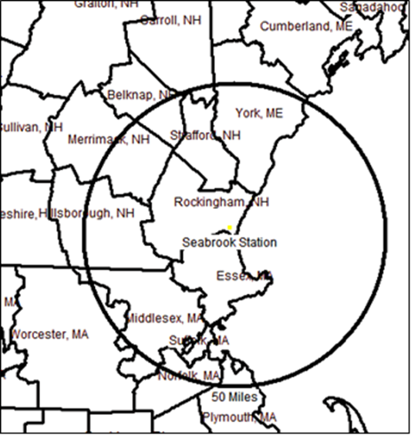

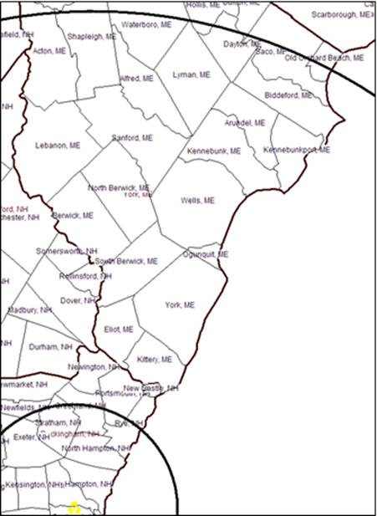

50 mile ingestion pathway zone for Point Lepreau Nuclear Power Plant

